Nourish and Equip 120 Vulnerable Children in Colombia
Summary: In rural Coyaima, poverty forces children to face malnutrition and school dropout. This project provides 120 vulnerable children with comprehensive nutritional food kits and complete school supplies. With a goal of $7,500, we will address immediate hunger and provide the necessary tools for these children to stay in school, fostering their development and a brighter future for the community.
Funding amount/goal: $7,500 USD
This amount will cover the food markets and school kits for 120 children for a specific period
Challenge  Families in rural Coyaima live in extreme poverty, making a balanced diet and basic school supplies an unreachable luxury. This lack of resources leads to physical stunting, poor academic performance, and high dropout rates. Without intervention, these children remain trapped in a cycle of poverty that limits their potential and future opportunities. | Solution  Our foundation delivers "Hope Kits" directly to remote rural areas. Each nutritional kit contains essential grains, proteins, and supplements tailored for child development. Additionally, we provide complete school kits including backpacks, notebooks, and stationery. The $7,500 fund covers high-quality supplies, the complex logistics of rural delivery, and the platform's administrative fees to ensure every child is reached.. | Long-term Impact  By providing consistent nutrition and educational tools, we are investing in the cognitive and physical development of 120 children. This project reduces school absenteeism and improves academic outcomes. In the long run, these empowered and healthy students will be better equipped to break the cycle of poverty and lead their community toward sustainable development.

Donation options:

Amount | Description
$ 15 USD | One Month of Essential Nutrition: Provides a nutritional food package with grains and proteins for one student.
$ 30 USD | Equip a Student for Success: Covers a complete, high-quality school kit including a backpack and all supplies.
$ 65 USD | The Full Impact Kit: Provides both a month of essential nutrition and a complete school kit for one child.
$ 130 USD | Double the Hope: Ensures two children have the nutrition and tools needed to stay healthy and focused on school.

Photo Gallery
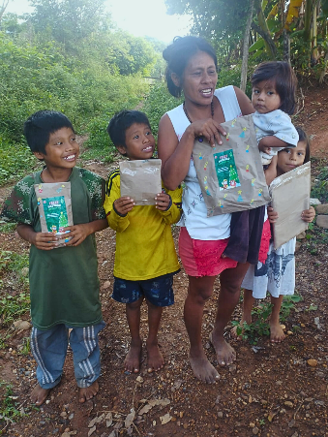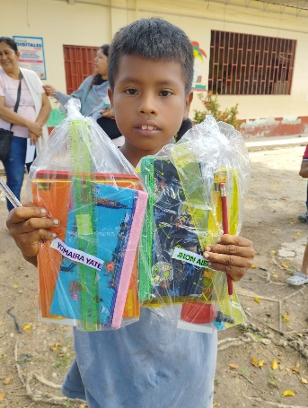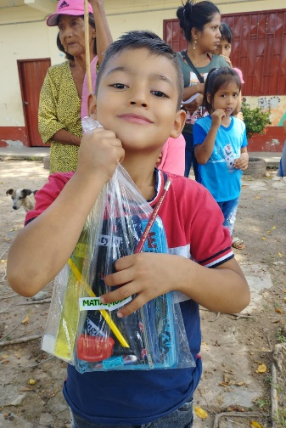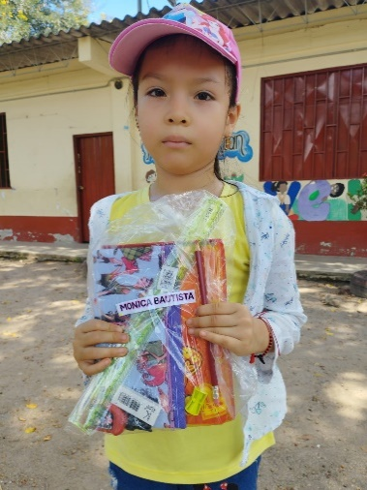 | 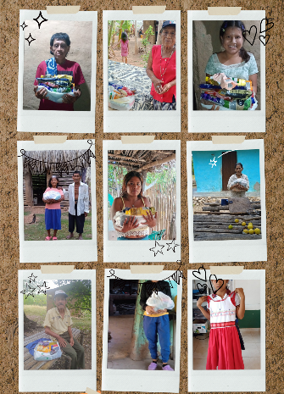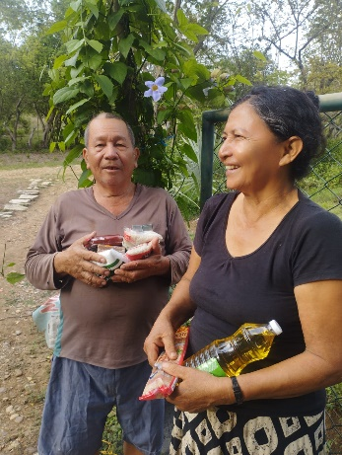  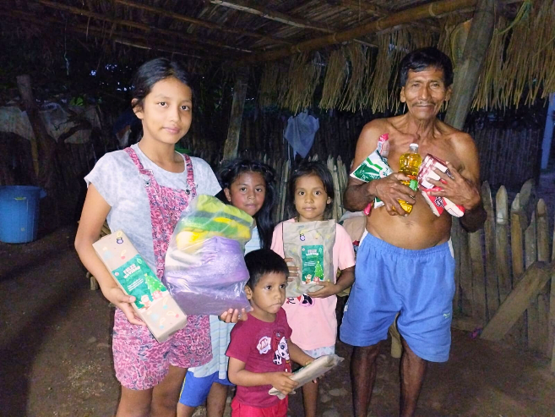
Children receive their first school kit of the year. | A Life-Changing Care Package: Essential support for rural families.
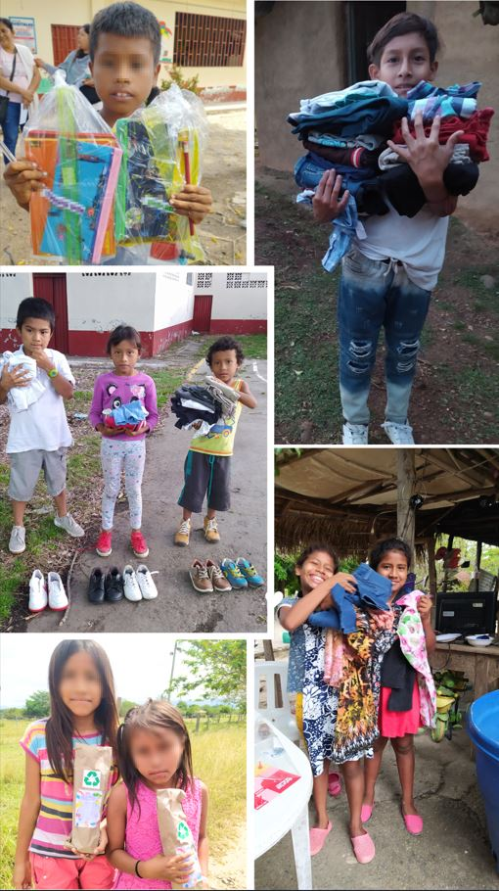 | 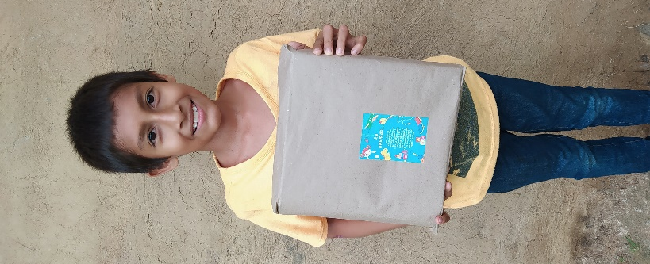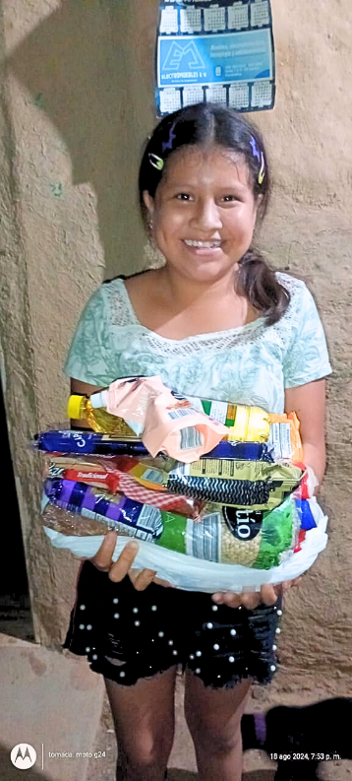  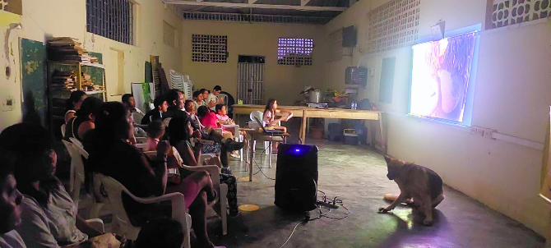
Hope in Action: Children and families during the distribution day in rural Coyaima. | Sharing Joy: Actions That Transform Lives. Beyond kits, we create spaces for community and happiness for children in Coyaima.

