2025: Hope and Life for 6 Little Souls in Coyaima
By Jonatan Urueña | Project Leader Por Jonatan Urueña
Organization: Fundación Patitas y Sonrisas JDUC
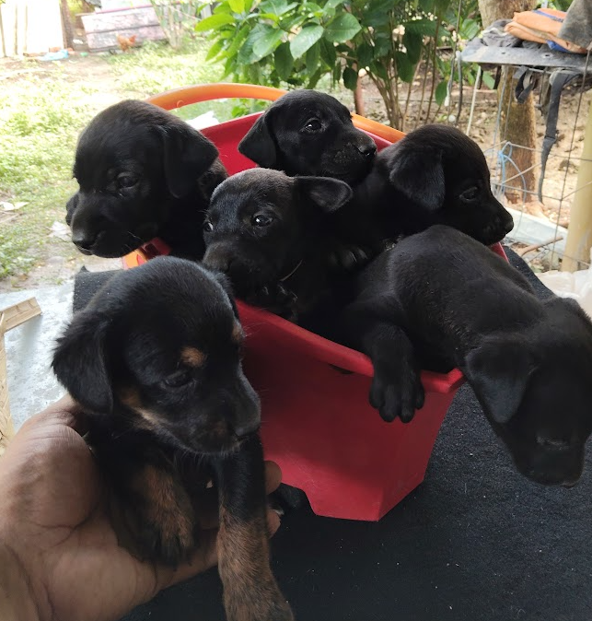
Figure 1 A Basket Full of Hope: Our Little Survivors
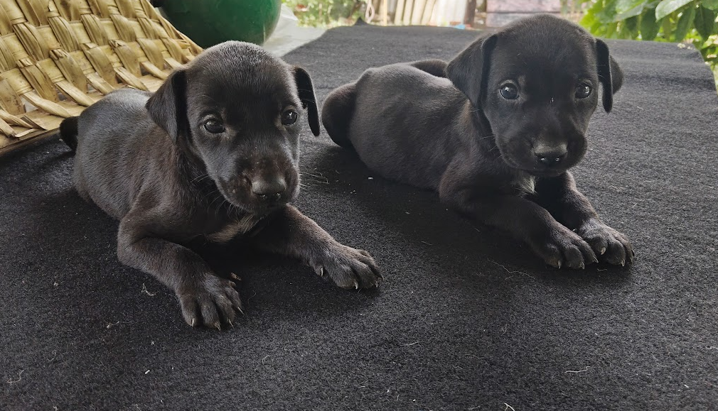
Figure 2 Brotherhood and Hope
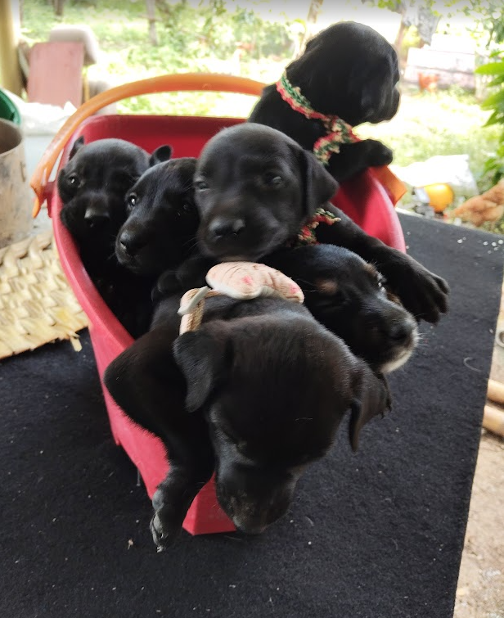
Figure 3 Safe from the Streets: The rescue squad.
From Vulnerability to Hope: The Impact of Your Donations
Thanks to the generosity of our donors during 2025, we have been able to transform good intentions into life-saving actions.
Unlike our beginnings, where we operated only with the strength of volunteering, this year your contributions have made a vital difference in Coyaima.
The Rescue: Six Jet-Black Miracles
This year, our greatest challenge and joy came in the form of six newborn black puppies.
They were found in a situation of extreme vulnerability, exposed to the dangers of the street and without the necessary protection to survive their first weeks of life.

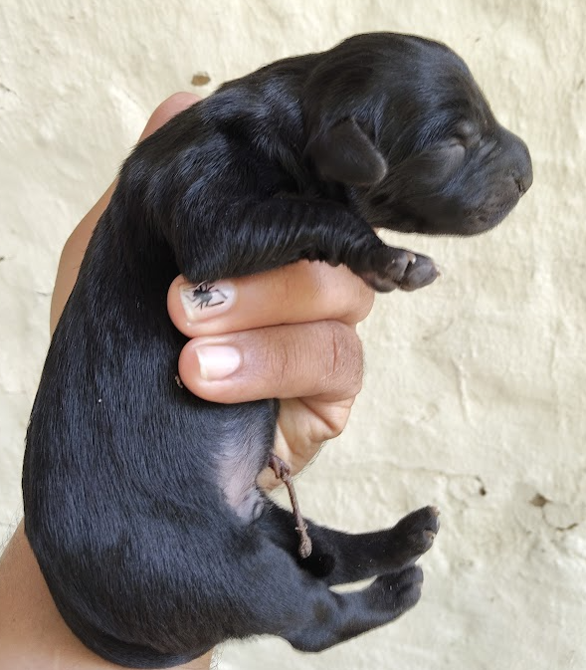
Figure 4 Fragile Lives in Safe Hands
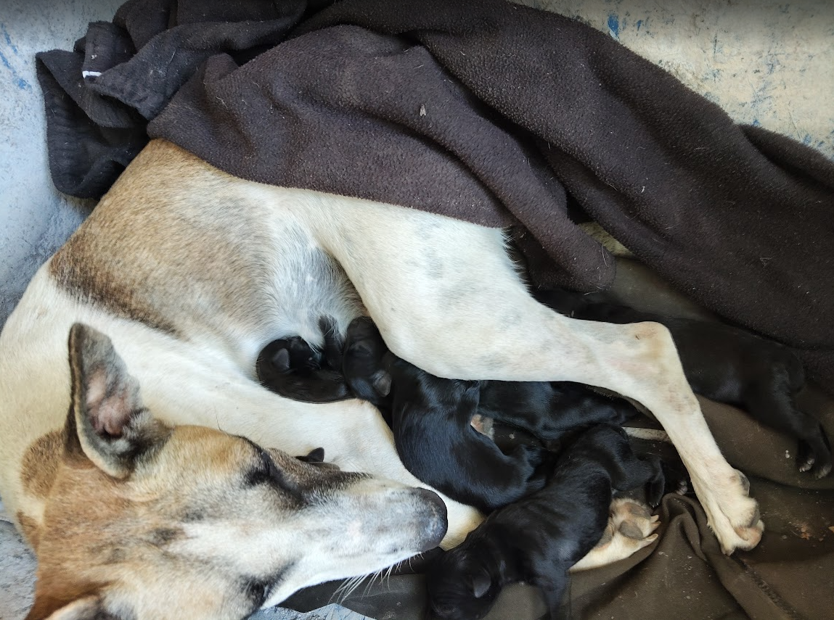
Figure 5 Maternal Warmth: The Beginning of Their Journey
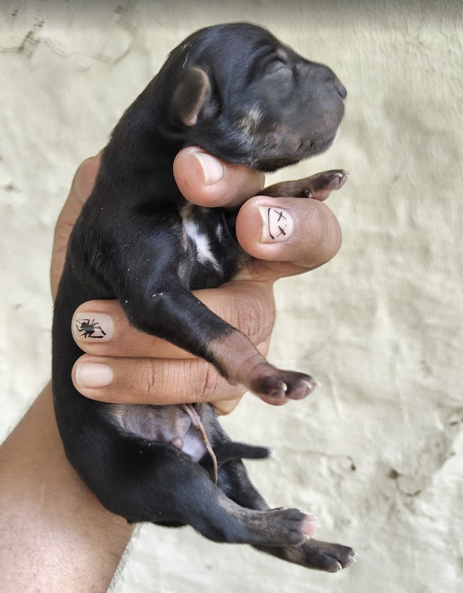
Figure 6 The Face of Vulnerability
We know that black animals often face greater difficulties in being adopted and are frequently marginalized, but at Fundación Patitas y Sonrisas JDUC we believe that every life deserves to shine.
Transparency: How Were Your Donations Invested?
We want to inform you with total transparency that the funds raised recently were immediately allocated to the medical urgency of these little ones.
- Purchase of Dewormers and Parasiticides: Compra de Purgantes y Desparasitantes:
The puppies had a high parasite load that put their lives at risk due to their young age and fragility.
Thanks to your financial support, we were able to acquire food, supplements for their age, and the specialized pediatric dewormers needed to stabilize their digestive health.
This ensured they could absorb the nutrients necessary to grow strong.
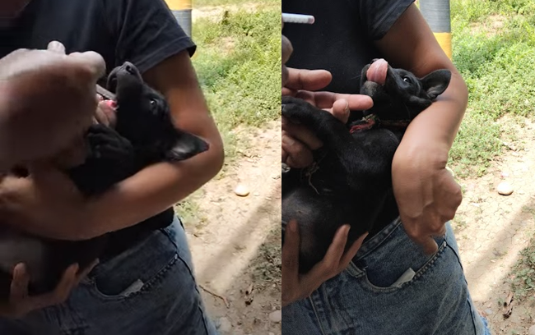
Figure 7 Healthcare in Action: Administering Vital Dewormers
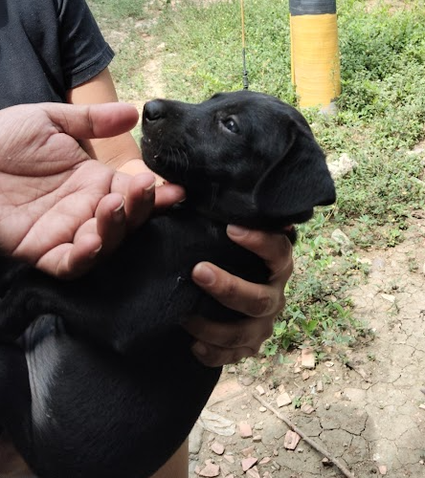
Figure 8 A Healthy Start: Ensuring Their Protection Against Parasites
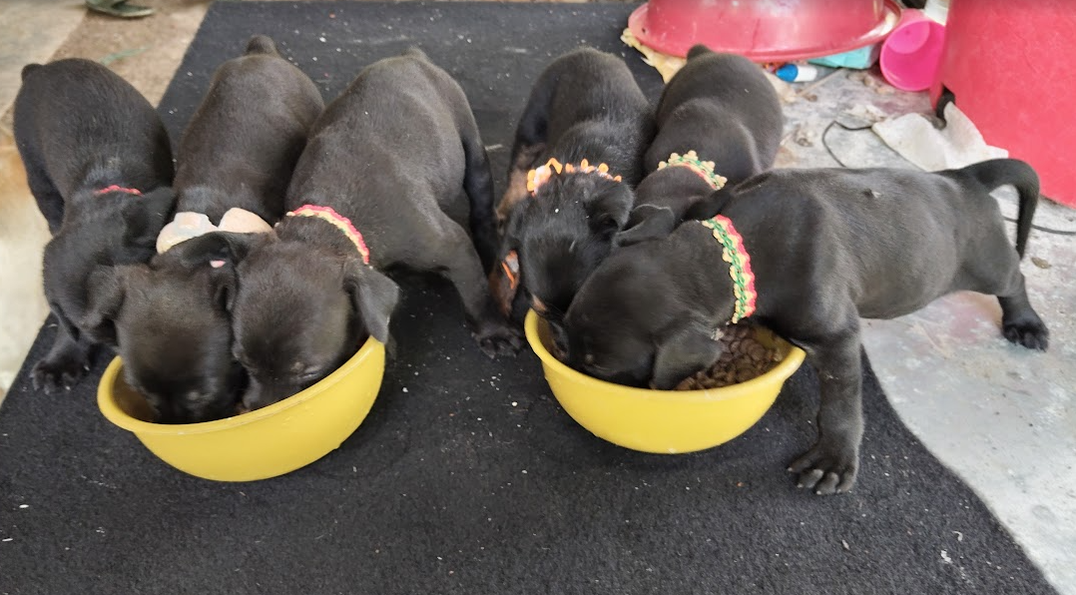
Figure 9 Fueling their Future: Your Donations Filling their Bowls

Current Status: Ready for a Home
Today, we are pleased to report that, thanks to that early intervention funded by you, the five puppies have survived and are growing strong and healthy.
Currently, they are in the adoption process.
We are looking for loving families who can give them the dignified future they almost lost at birth.
Each of these six puppies is a living testimony that your help arrives, transforms, and saves.
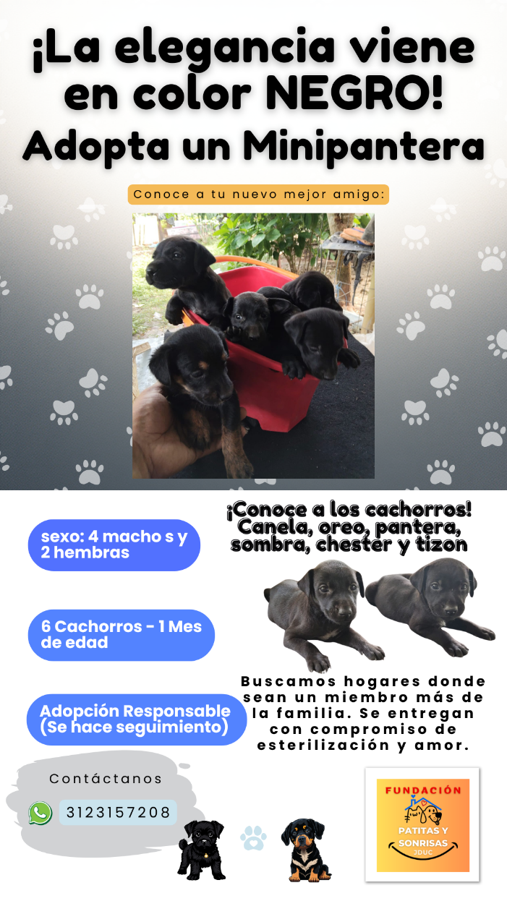
Figure 10 Six Little Miracles Looking for Love
The Road Ahead
Although we celebrate this success, the need in Coyaima remains great.
We continue working to reach our original goal of sterilizations and community feeders.
However, seeing these six little ones wagging their tails today is proof that we are on the right track.
Thank you for being part of this rescue!
Jonatan Urueña Project Leader

