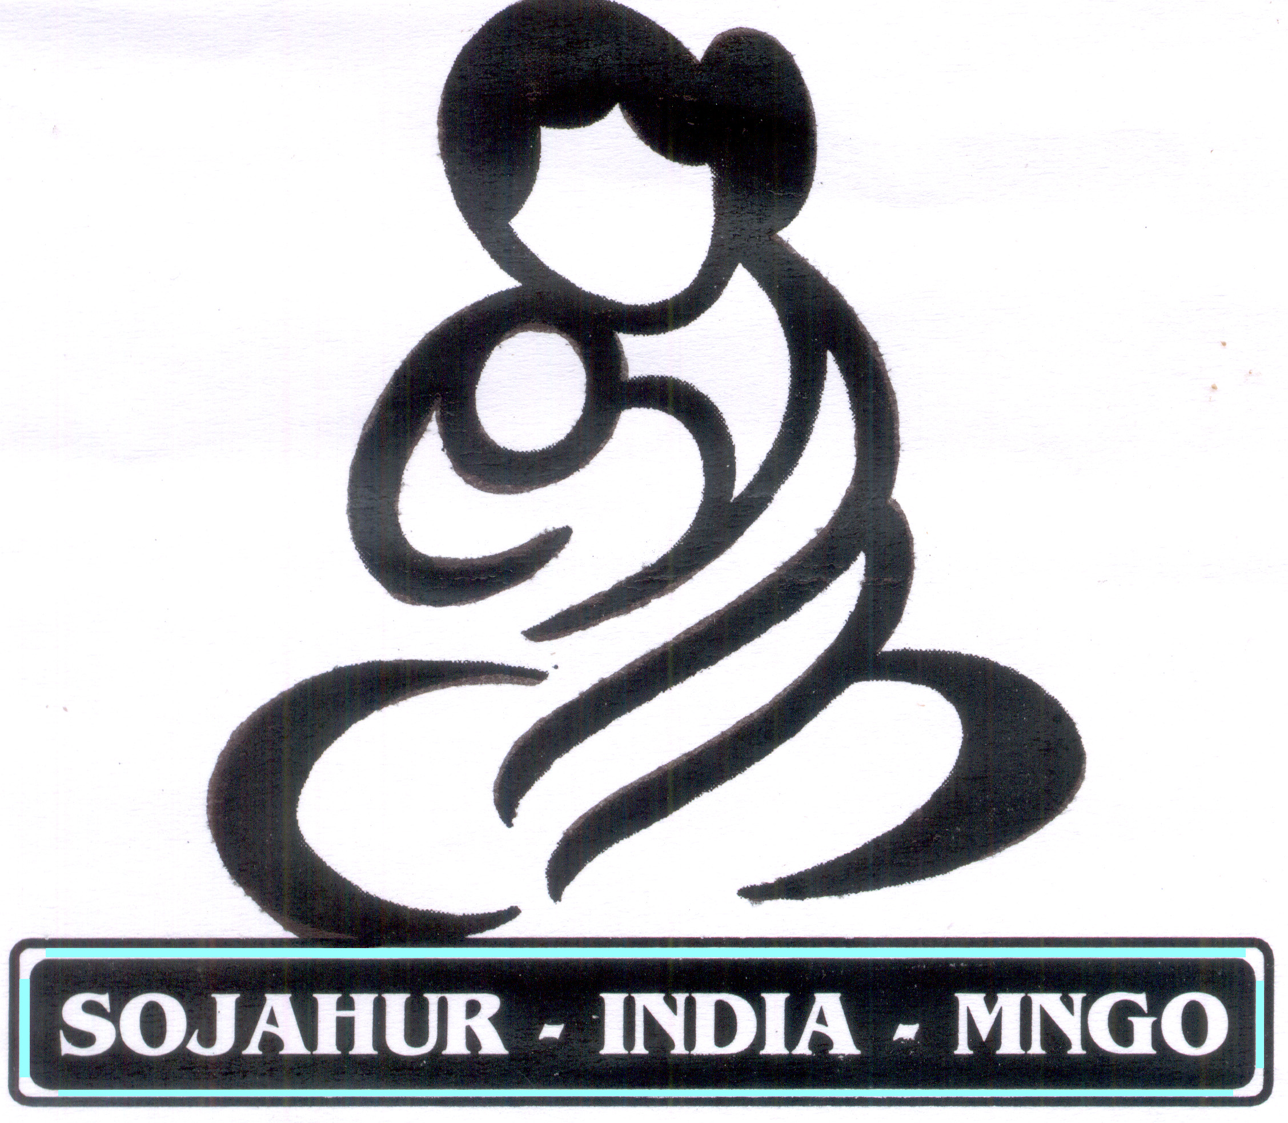
 SOJAHUR INDIA-MNGO
THE SOCIETY FOR SOCIAL JUSTICE AND
HUMAN RESOURCE DEVELOPMENT
565, M.G.Road, Puducherry-1

Phone : 0413-2226269, Website : www.sojahurmngo.com

Cell : 9894039095 Email : sojahur@sojahurmngo.com

( I )

Title of the Project : Educational scholarship for 20 Children for
HIV/AIDS affected Parents

Place of the project : Thirubuvanai, Pondicherry.

Period of the Project : one year

Goal : To provide Education scholarship for the children
of HIV/AIDS affected parents.

Target : HIV/AIDS affected parents and their children

( II) Background of the Organization:

Our organization The Society For Social Justice And Human Resource Development, Popularly known as “SOJAHUR – INDIA” is a Non Governmental and Non profitable Voluntary Organization and its Head Quarters is at 565,, Mahatma Gandhi Road, Puducherry – 1.

The Society For Social Justice And Human Resource Development is a registered body, Registered under the Societies Registration Act 1860 ( Act No. XXI of 1860) and its Reg. No. 126/92 dated 21.05.1992 and also it is registered under Foreign Contribution (Regulation) Act 1970 and its FCRA No. 285130056, dated 20.05.1998.

The Society For Social Justice And Human Resource Development is functioning in democratic set up. It has 980 General Body Members and 9 Executive Members. The General Body is used to convened twice in a year, and Executive meeting is convened once in three months, and election will be conducted once in five years, to elect its Executive Committee Members. Advocates, Doctors, Engineers, Scholars, Professors, Teachers, Business men and all works of people are members of its General Body.

The Society For Social Justice And Human Resource Development is serving in Puducherry State at present it has adopted 40 Villages of Mannadipet Commune, Puducherry (Rural Villages) which is 22 Kms. away from Puducherry. We Extended our services in Tamil Nadu.
We have Five Rural Centre.

- Thirubuvanai
- P.S Palayam
- Kudumiankuppam
- Sorapet
- Vadanoor

Our organization has very good infrastructure we constructed Multipurpose Building at Thirubhuvanai, in 909sq.feet at the cost of Rs 25 Lakhs. Our organization is having Four wheelers, 5 Two wheelers, computer, Xerox machine, Typewriting Machine, Fax and good Library,

At Present our activities are:

- Free Legal Aid to the poor 2. Family Counseling Centre
3. Human Rights 4. Consumer Protection Cell
5. Abolition of Child Labour 6. Women & Child Development
7. Youth Development 8. Counseling Centre for Adolescent
Boys and Girl
9. Vocational Training for youth 10. Home for the Aged, Orphan Children
11. RCH – Programmes – MNGO 12. Formation of Self Help Groups
13. Low cost Housing Project 14. Total sanitation Programme
- Environmental and Pollution 16. Village Knowledge center
Control
- Bio village Development 18. AIDS awareness
19 Voluntary Counseling and 20. Field- Placement Training for Indian /
Testing Centre Foreign Students
21 National NGOs Networking 22. Releasing Monthly Magazine
“Samuthaya Sattam”

( III) Achievement of the Organization

I. Free Legal Aid, Family Counseling, Consumer Protection,

Human Rights:
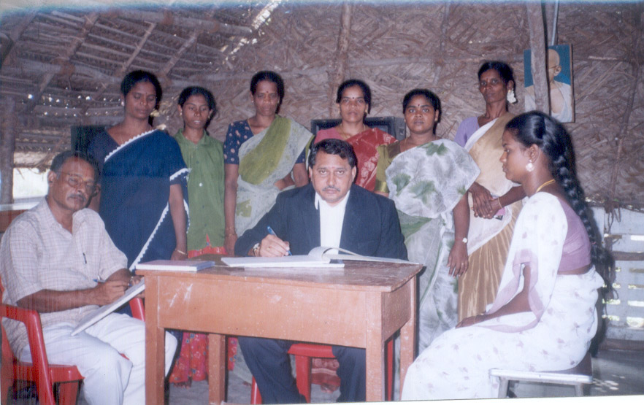
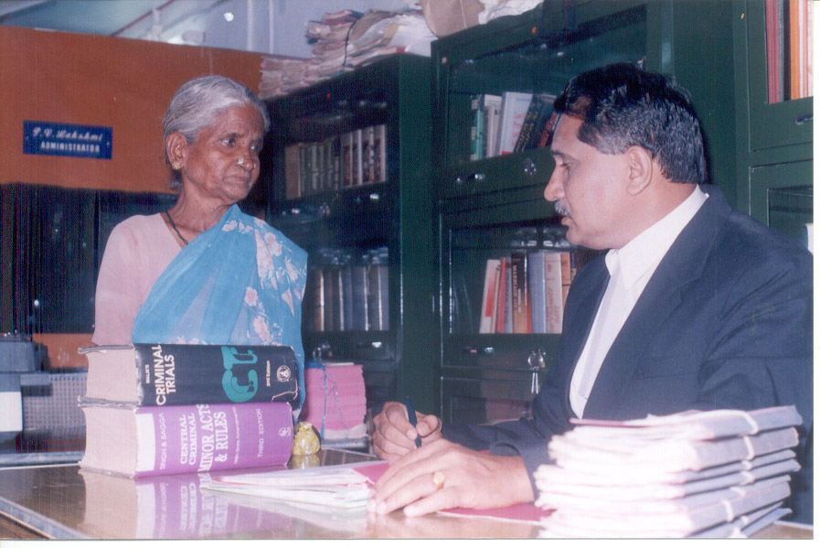
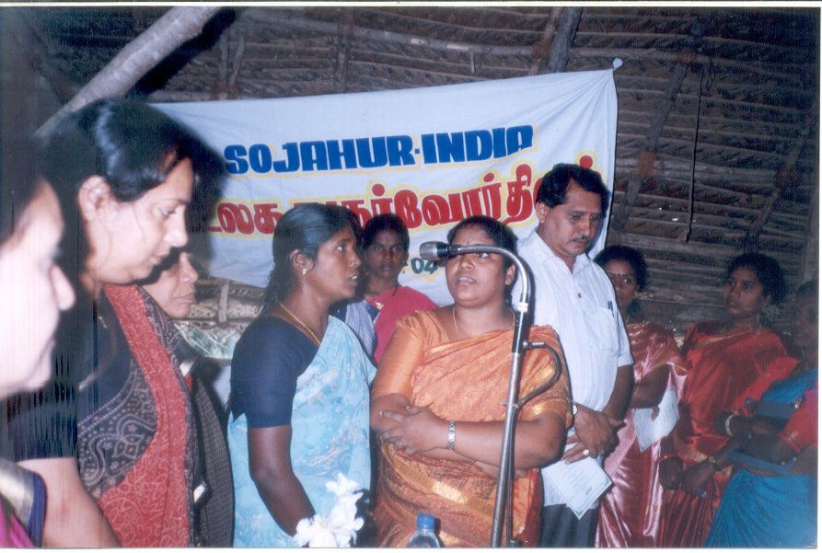
 We conduct free legal Aid camp once in a month in every village, since 1992 more than 7000 men and women were benefited due to this legal Aid Camp. We are giving family counseling to the poor and dealing the cases among husband and wife, children and Parents and also family disputes among relatives.
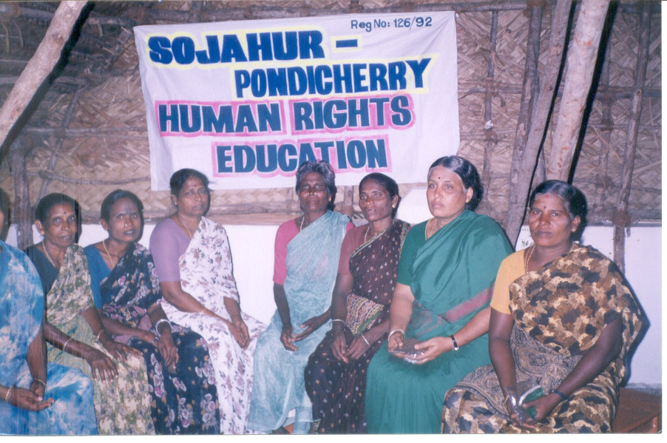
We use to conduct seminar in consumer Awareness programme to rural people in every month. We conduct seminar on Human Rights dealing the Rights, of men, women and children.


II.Women and child Development, Youth Development, Fisherman Development, Self Help Groups, Vocational Training.
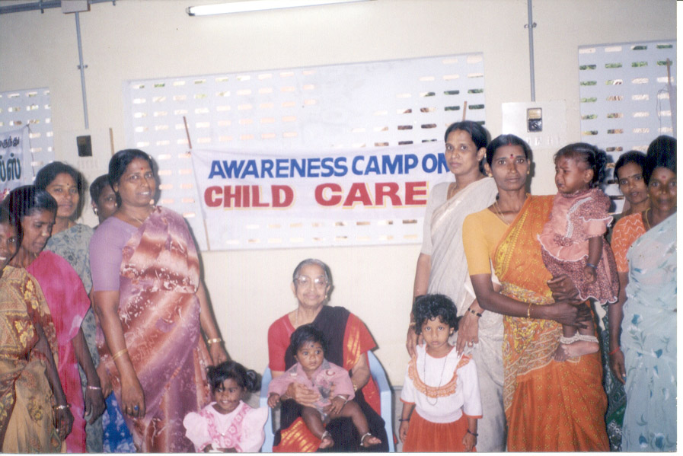
Main focus is on maternal and child health, micronutrients, early childhood care and education, positive mental health in children and childcare support services.

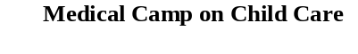

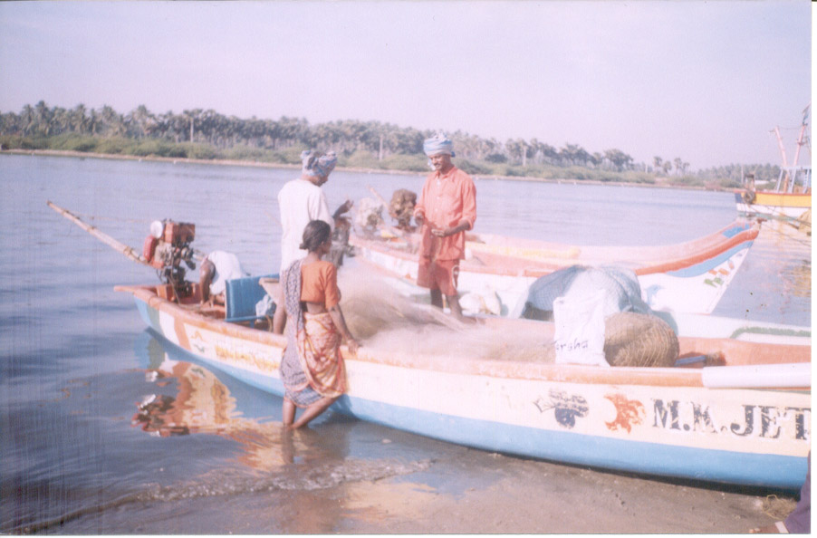
We are doing the following Activities for the welfare of the fishermen community.
Economic Development of Fishermen / Women.
- Hygienic fish proceeding selling, Sun drying fish preparation.
- Preparation of fancy items out of sea Pondicherry.
- Fish net making
- Installation of fish aggregating device.

We have formed 262 SHGs. There 3930 Women are members of the SHGs. We gave more then Rs.50 Lakhs of Micro-credit loan to our SHGs through RMK – New Delhi.

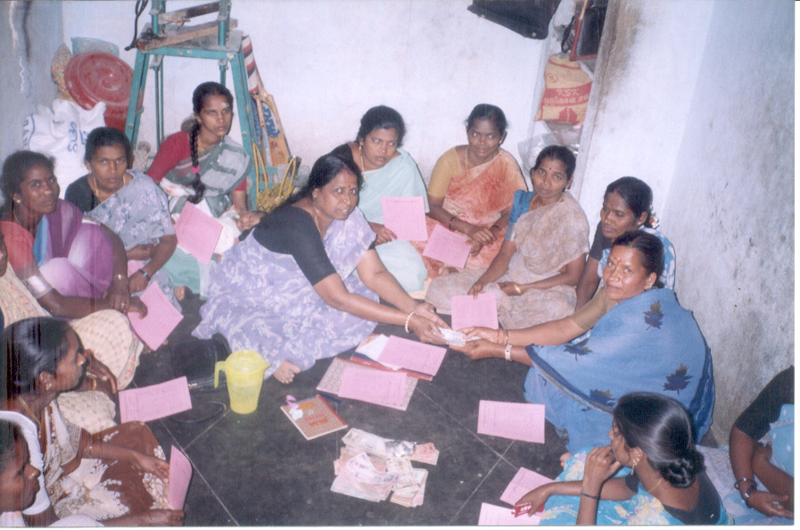
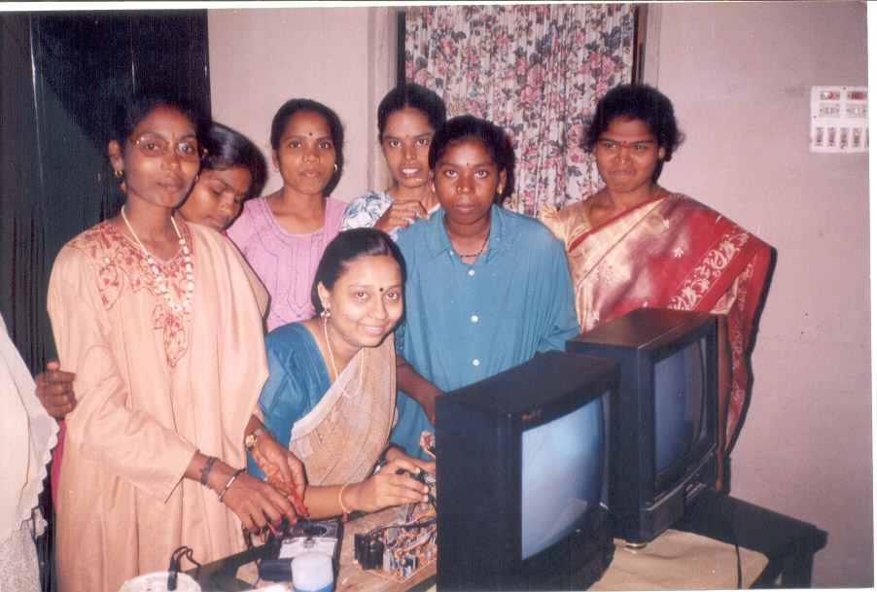
We use to give Vocational Training for rural youth girls/women such as multi-mechanism on T.V., V.C.R., V.C.D., Fridge, Tailoring and embroidering, Typewriting, Computer Course, Beautician, Agarbathi making etc.



III. AIDS/HIV Awareness, RCH Programmes, Family Planning and Population Control, Environmental and Pollution Control, Non-Formal Education, Yoga & Meditation.
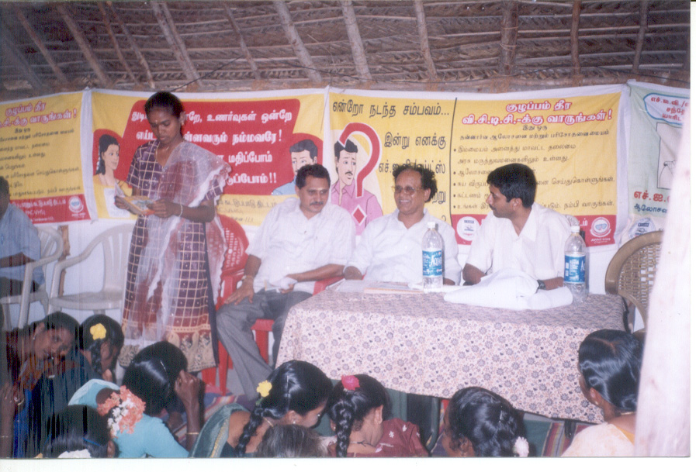
The spread of HIV all over India poses a great challenges in the area of health, Social and economic Development. The aim of our organisation is to reduce the sexual transmission of HIV/AIDS in Pondicherry. With the Finance Assistance of Pondicherry AIDS Control Society and APAC – Chennai we are doing these project successfully.


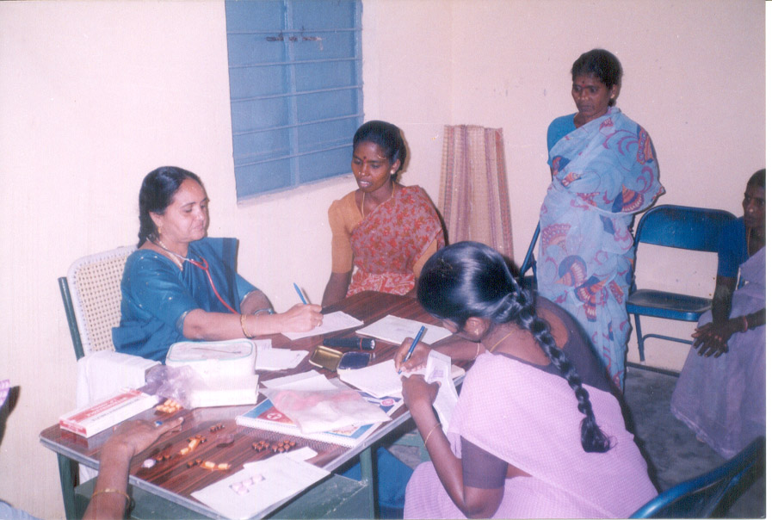
We are doing the RCH Programme for the rural girls/women form the age group 14 to 45 years in 20 villages with the Finance Assistance of GIRH&FWT Gandhigram for the three-year. 15640 girls/women and benefited by the programme we also conduct medical camp for Rural women is every month.

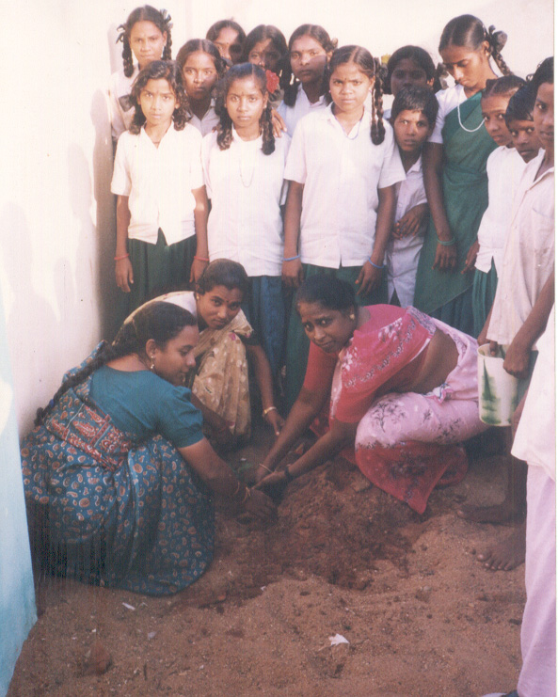

We give much importance for Environmental and pollution control. This year we planted 500 Trees in our Rural Villages. Our Main Aim is “To Keep the City Clean and Green”.

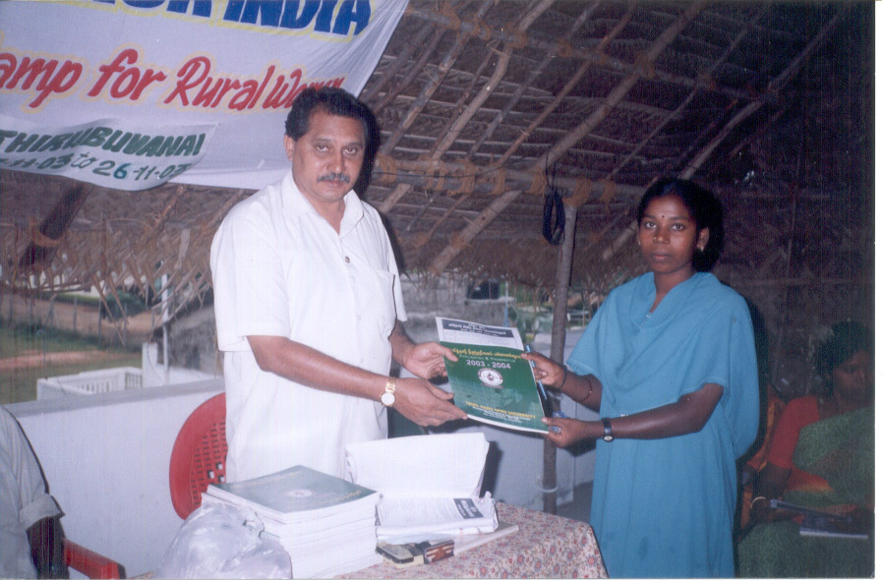
Environmental and Pollution Control.

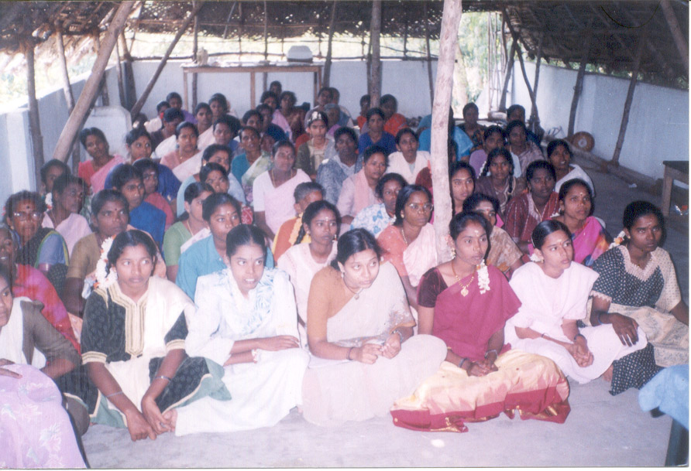
We provide non-formal Education to the Rural Women / Child Labour, Street Children, through SHGs member. We give guidance to the youth to continue their studies through Distance Education. We have Study Centre of Tamil Nadu Open University at out Office Permission.
By regular Practice of yoga and meditation, mind gains silence, body gains deep rest, which results in relief from stress and strain, Normalinisim of nerves systems. Better Co-ordination of body and mind. Better health and improve personal and behavioral changes and so we provide training to Boys and Girls.
IV. Home for the Aged people, orphan children, Child Labour, Street children and distributed women, Hosing Projects for the poor, Total Sanitation for Rural.
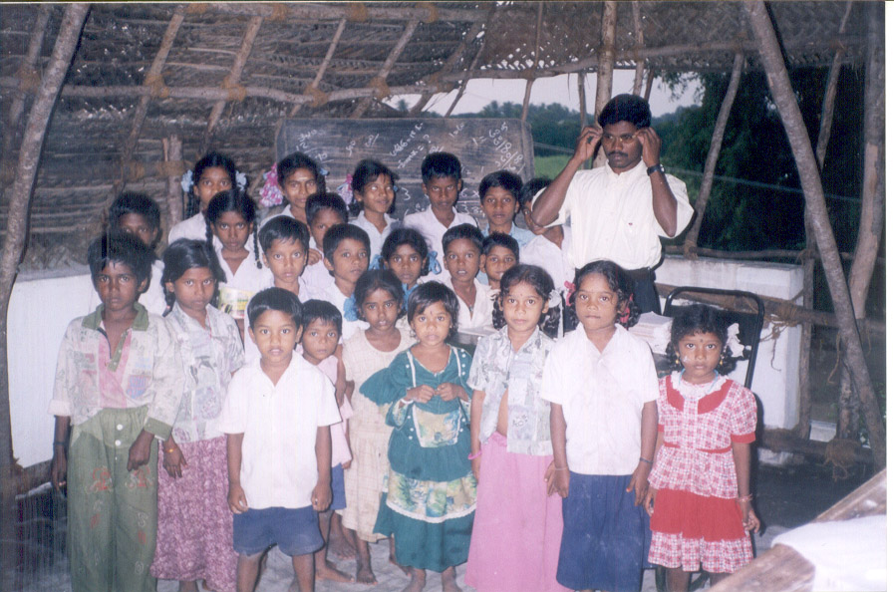
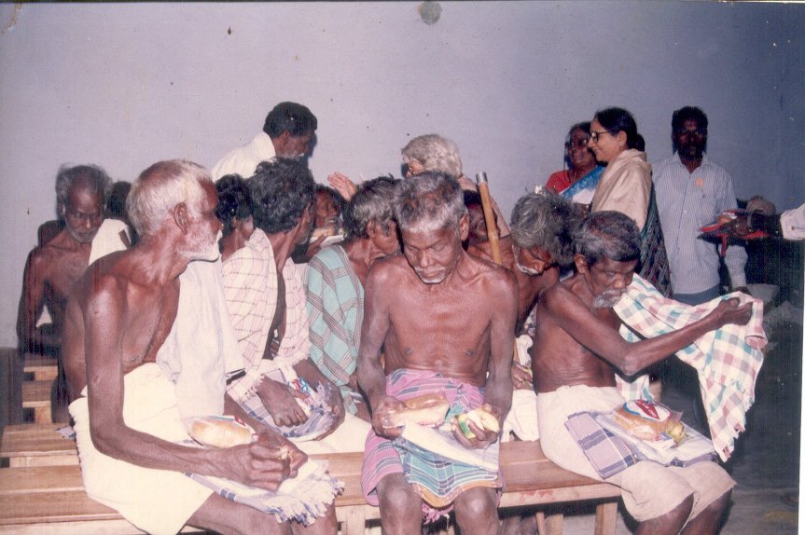
We have home for the Aged people, orphan children, Child Labour, Street children and distributed women.
We provide neutrinos food medicine, dresses to.

We provide formal education and non-formal education to the children.

We give Vocational training to them in order to stand in them own legs to because respectable citizens of INDIA.
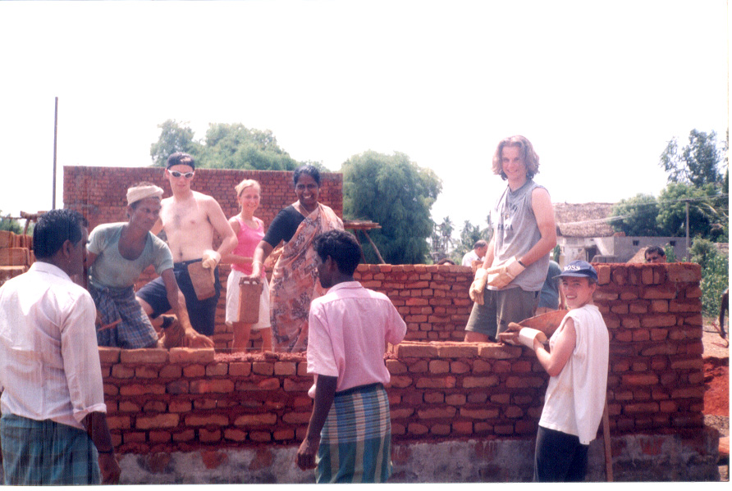

We have constructed the houses for the poorest of the poor in the villages with the Finance Assistance of Belgium and CAPART, Hydrabad.

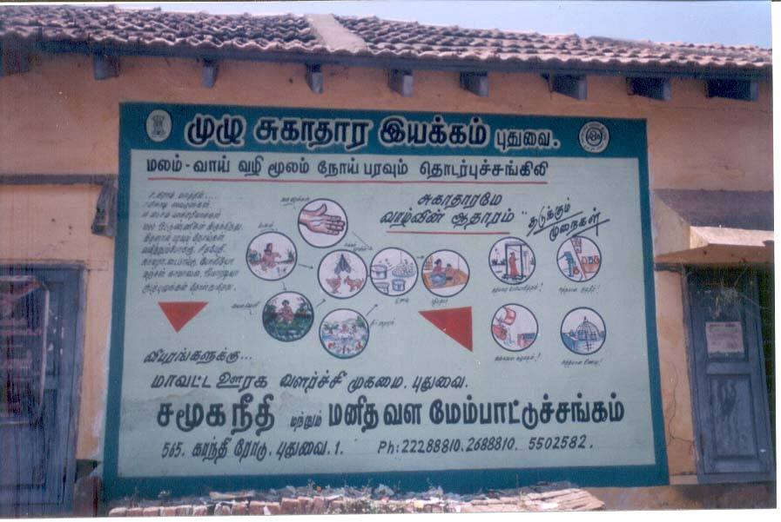
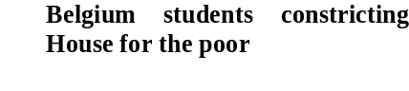

We construct Low Cost Toilet at the rate of Rs.1550/- to rural poor is the villages with the Finance Assistance of DRDA, Pondicherry.

(v)Agricultural Development, Dairy Development

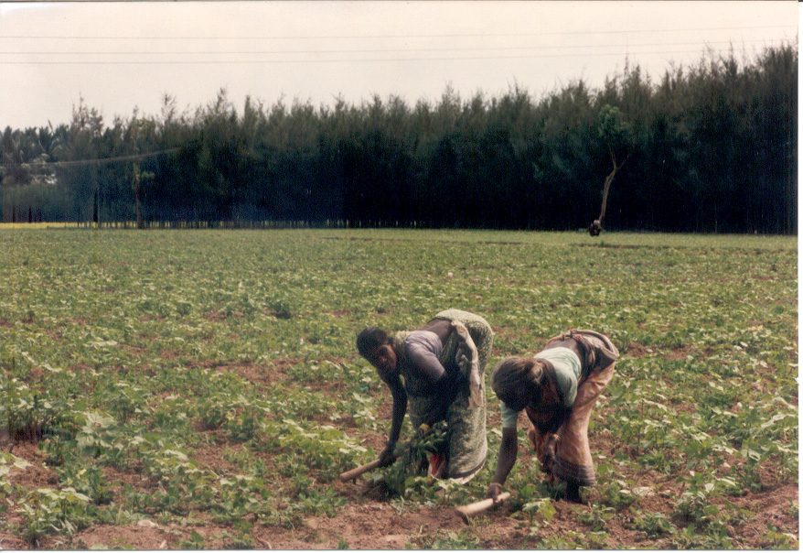
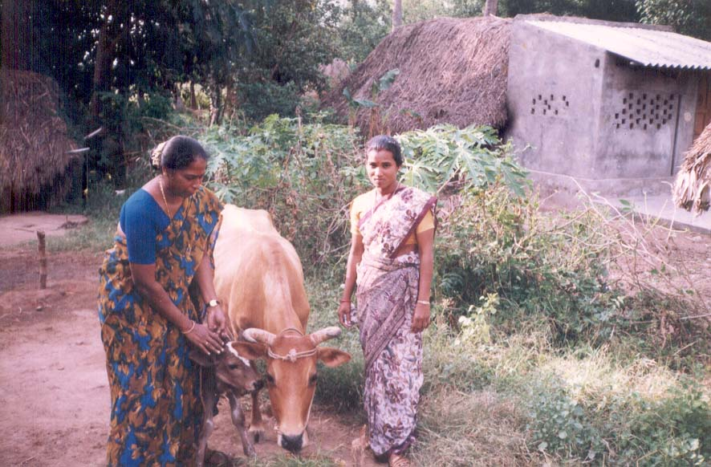
We provide training to the small and marginalized Farmers, through Agriculture Department of Pondicherry. So for we gave modern Agricultural training to 742 Farmer in our Rural Villages. We provide training to the women, on Dairy, Poultry, Sheepory, Duckary, through Animal Husbandry, Department, Government of Pondicherry. So for we gave Animal Husbandry training to 1540 women of our SHGs members

VI. Socio – Economic Research and Training, NGO Networking
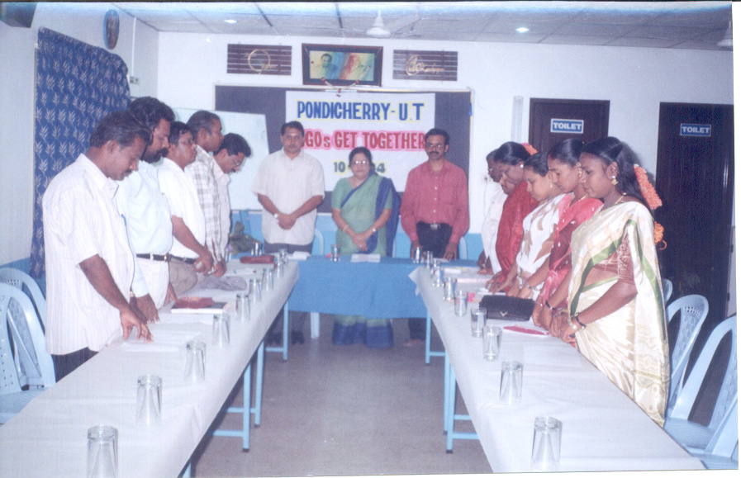
- Training Programmes
- Sharing of Experience
- Dissemination of information
- Monitoring and Evaluation
- Project Formulation & Guidance
- Fund Raising

( IV) Justification of the project:

Our organization is doing HIV/AIDS Awareness for individual workers, Self Help Group (women) Religion Leader, Political Leader, Industrial union Leader, youth club members for the past 5 years.
We are doing voluntarily Counseling and Testing centre for HIV/AIDS. Out of the experiences, We have found 30 persons, affected by HIV/AIDS. Due to HIV/AIDS, their people and their children are suffering for the daily bread. Because of the above circumstances, we provide care and support for the HIV/AIDS affected people and their children for the past five years.

( V ) Viabilities of the project:

- Our organization is already doing care and support for HIV/AIDS affected people and their children for the past four years.
- Our organization doing AIDS Awareness Programme among industrial workers in
Thirubuvanai Industrial Estate Since 2004.
- Our organization having VCTC – centre since 2004 and having full infrastructure.
- Our organization has conducted AIDS Awareness programme for Trade union Leaders in Thirubuvanai Industrial Estate.
- Our organization has trained staff in HIV/AIDS field.
- Our organization having full infrastructure.

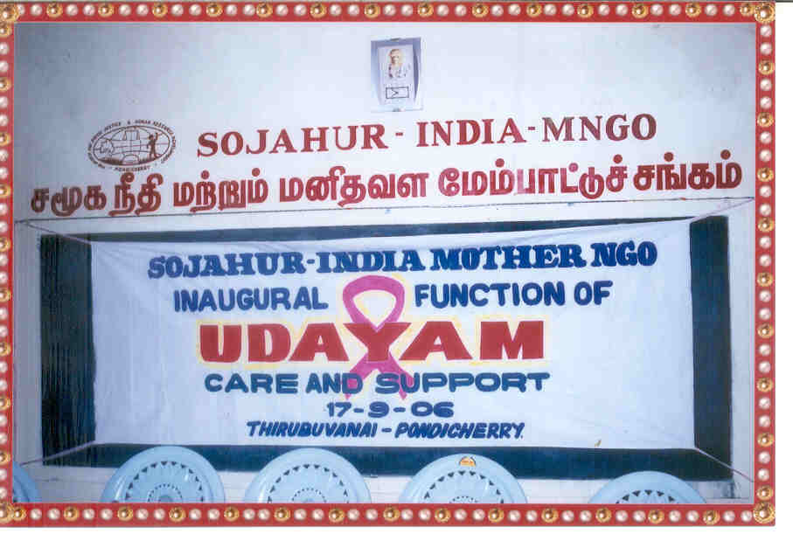

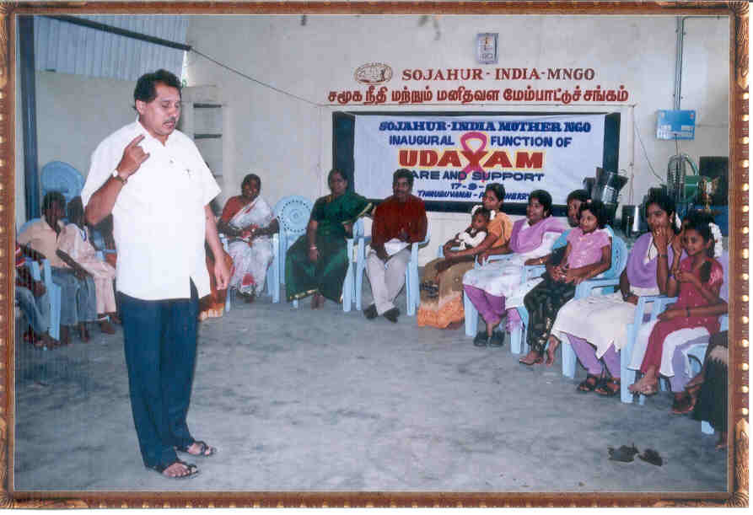
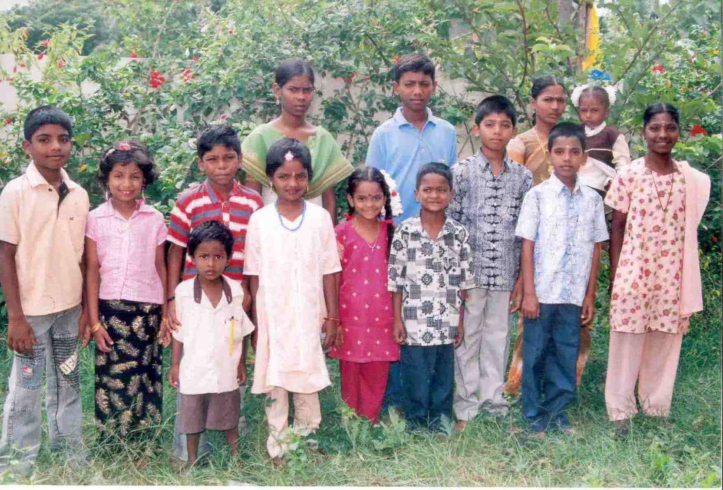

Care and Support for HIV / AIDS Affected Parents and their children

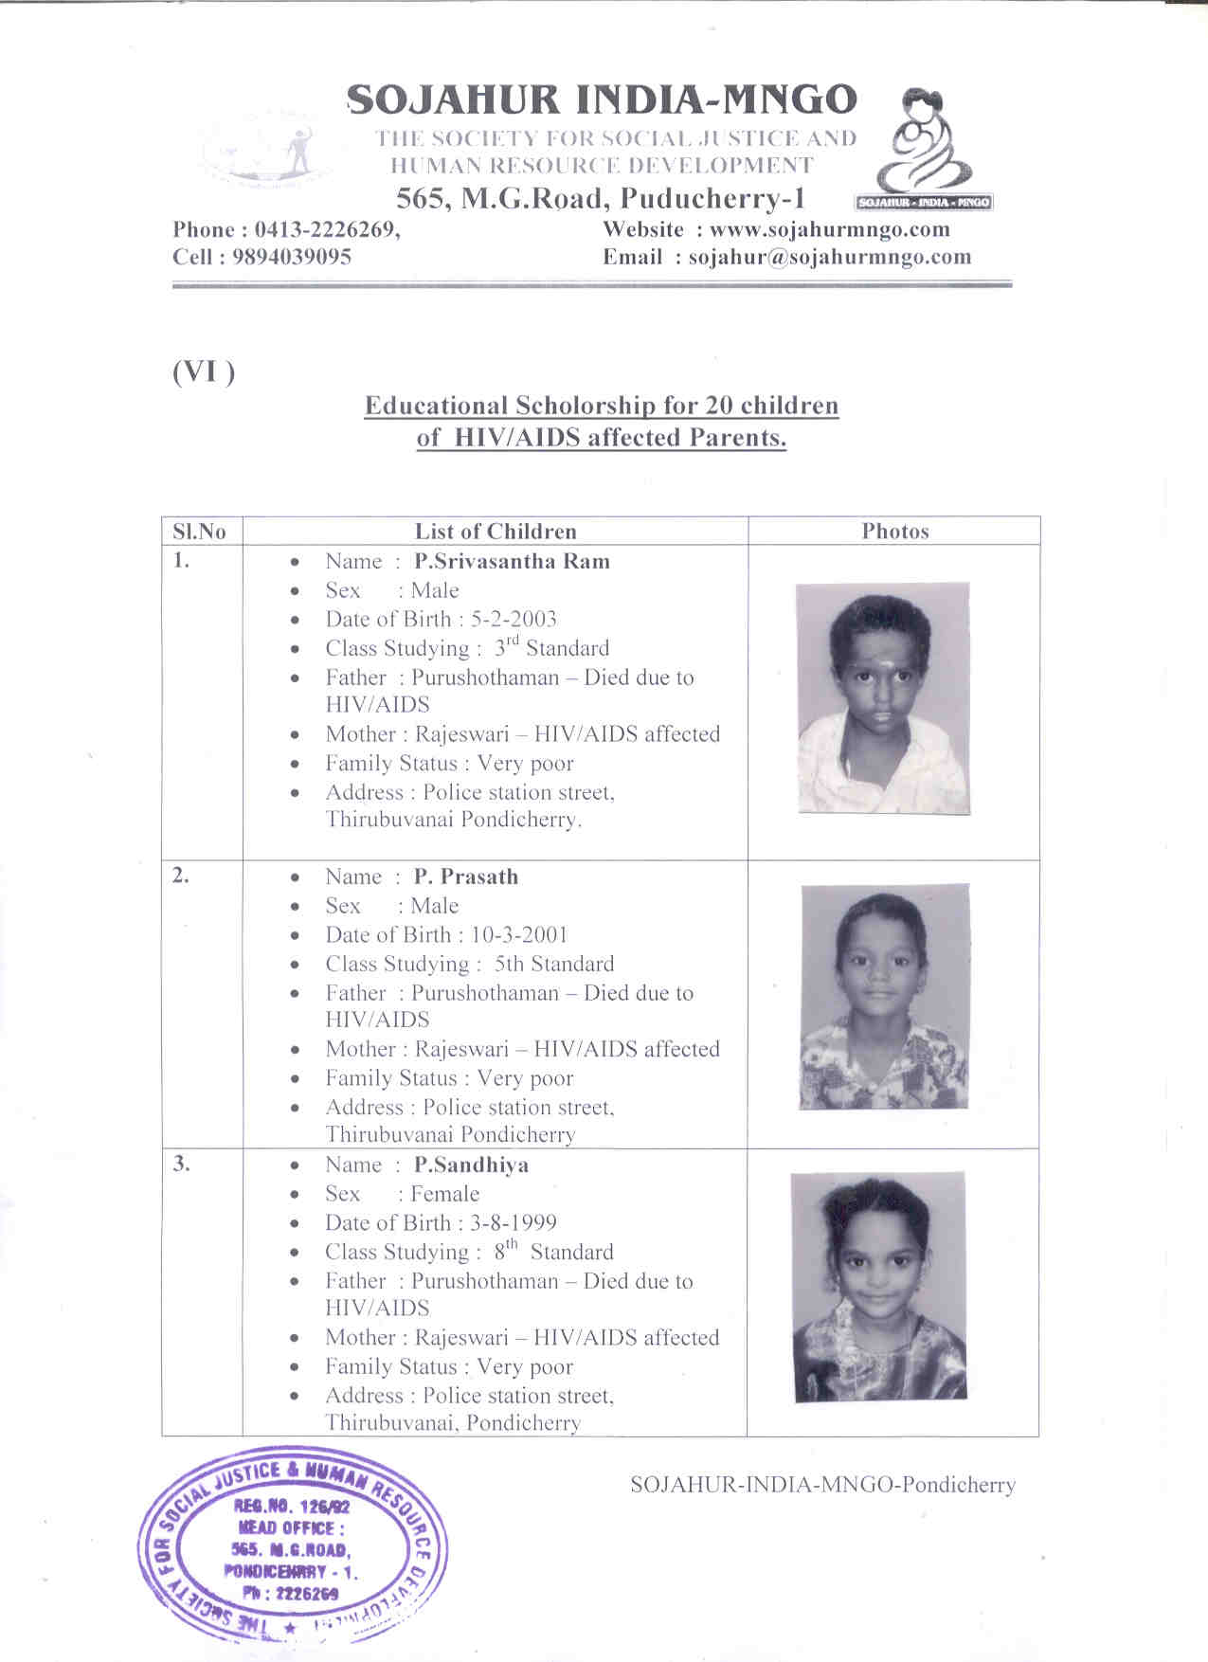

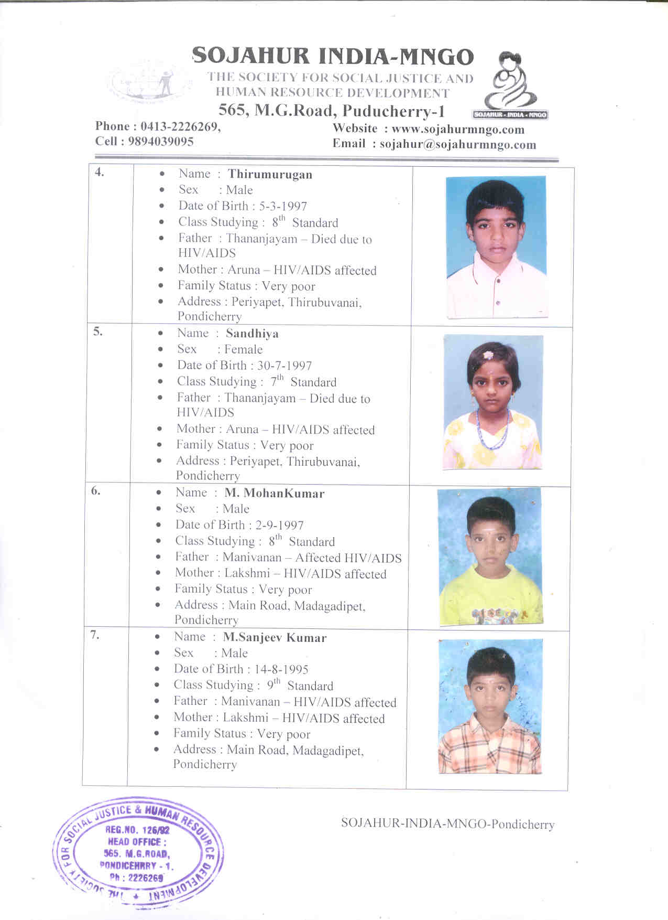

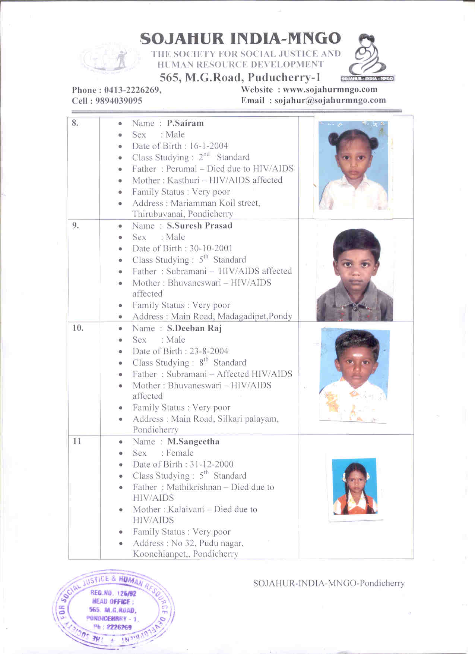

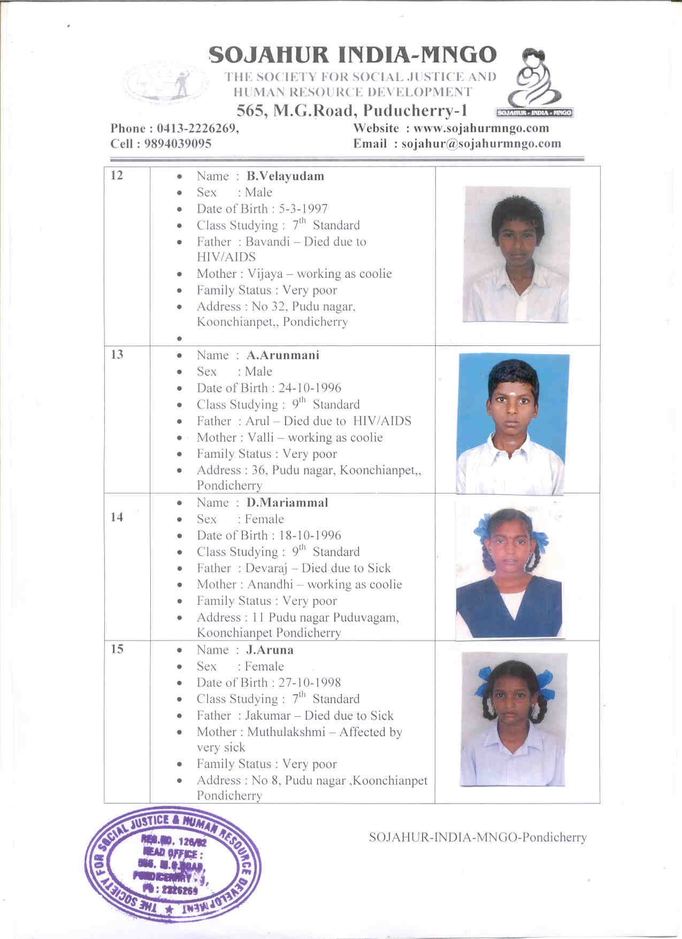

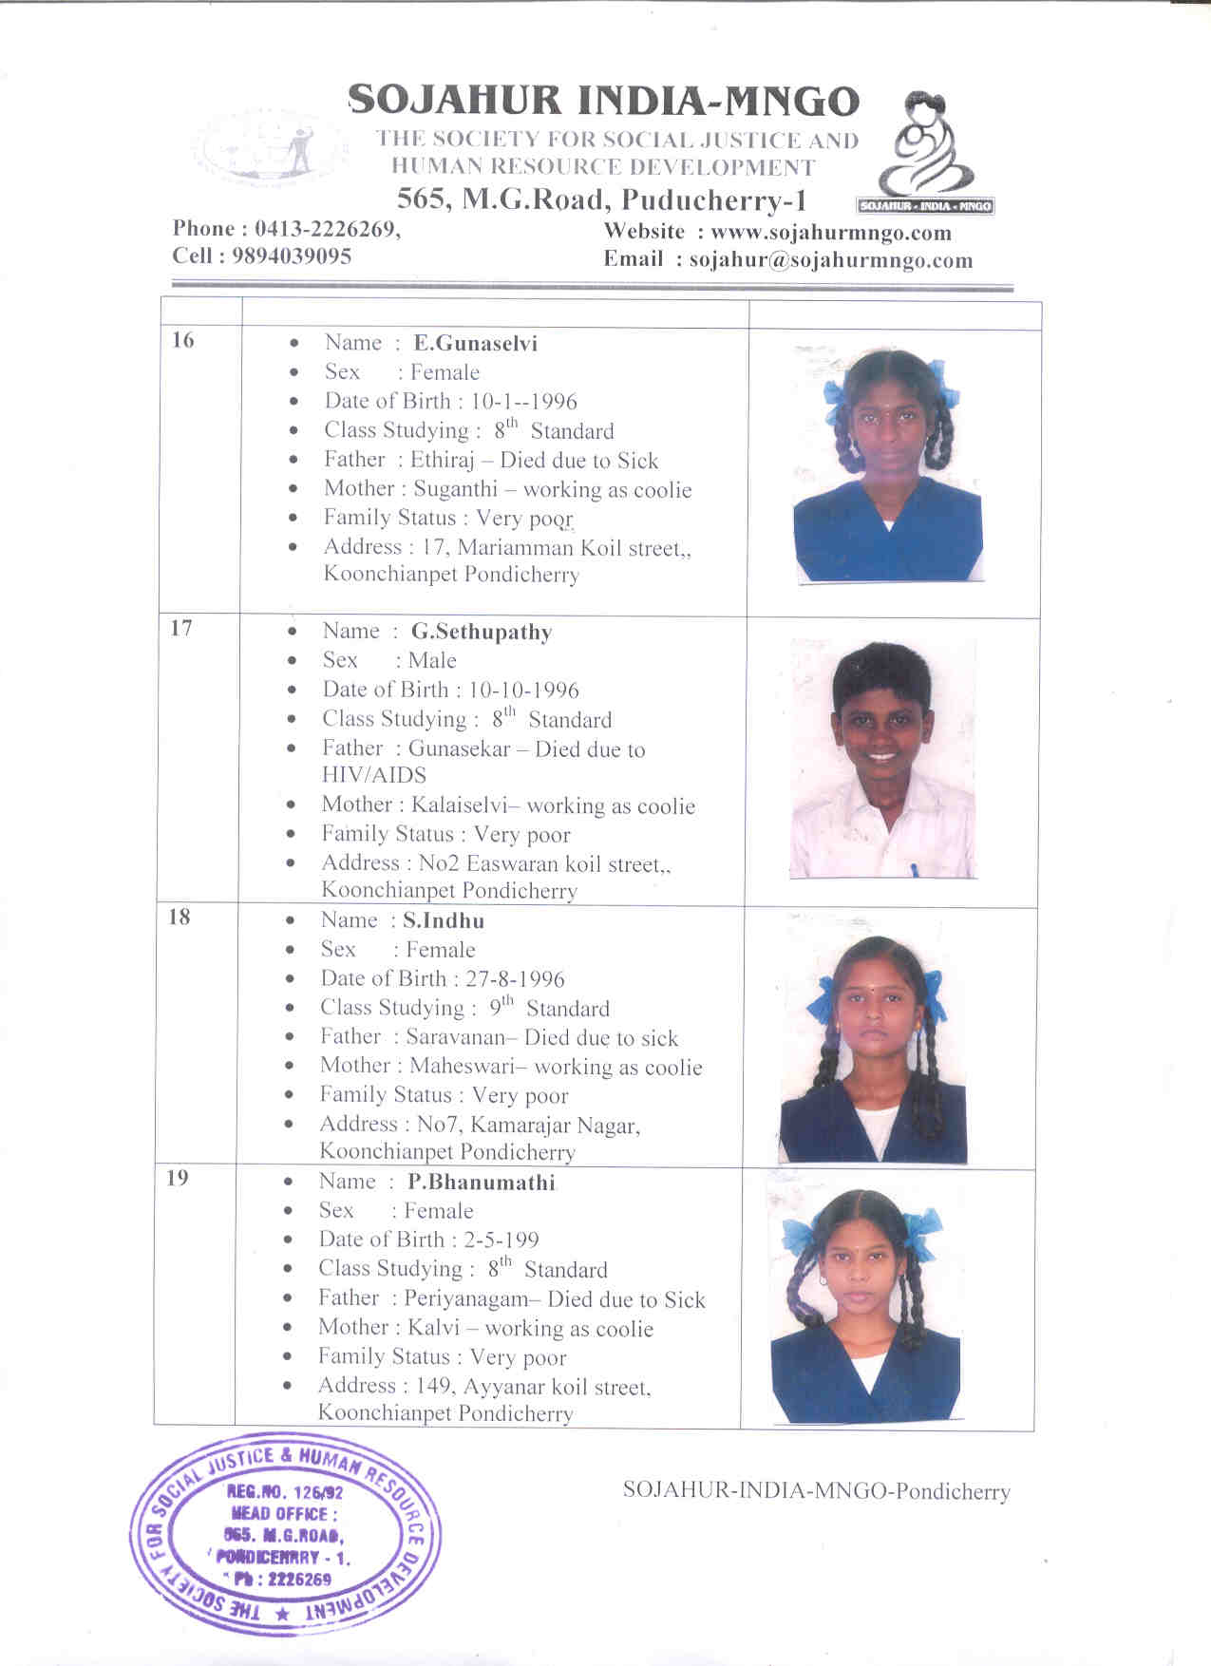

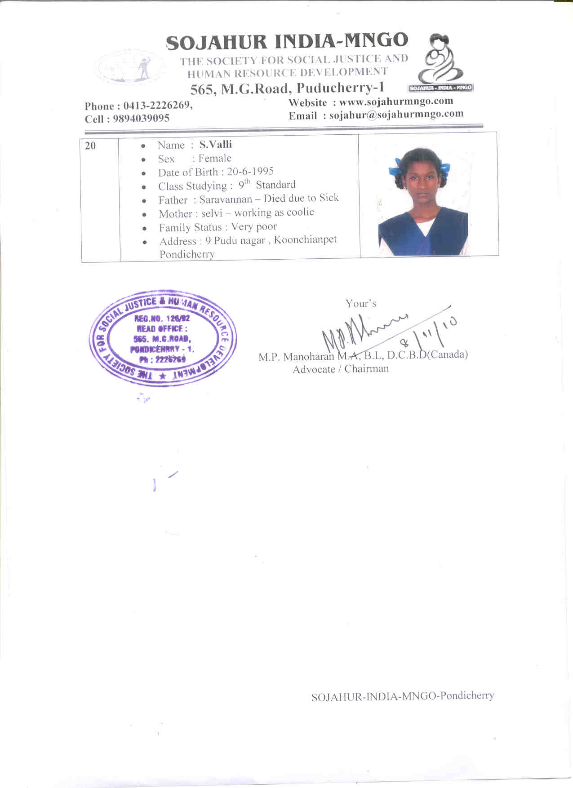

( VII ) Budget:

Educational Scholarship for 20 children of HIV/AIDS
affected parents for one year.

I 1. School Fees, Book materials, Stationary
(Rs 300 x 20 Children x 12 months ) = Rs 72,000

II 1. Dress materials Two sets per year
( Rs 1000 x 20 Children ) = Rs 20,000

III 1.Medical Expenses per year
( Rs 50 x 20 Children x 12 months = Rs 12,000

- 1. Food Provision per year
( Rs 300 x 20 children x 12 months) = Rs 72,000
……………………

Total Rs 1,76,000
……………………
44 Rupees = 1 US Dollar
Rs 1,76,000 = 4000 US Dollar

Expenses for one child per year Rs 8800 = $ 200
Expenses for one child per month Rs 735 = $ 17
Aid Requested = $4000

Note:

a, Administration cost per year
( Rs 2000 x 12 months ) = Rs 24,000

b, Staff Salary Rs 3000 x 12 months = Rs 36,000
…………..
Total Rs 60,000
…………..

1. Rs 24,000 + 36,000 = Rs 60,000 ( $1365 )
is the contribution of the organization

( VIII )Request :

We request from your esteemed Institution, a sum of Rs 1,76,000 ( One Lakh Seventy Six Thousand ) only for the project on Educational Scholarship for 20 children per year, of HIV/AIDS affected parents Rs 1,76,000 = 4000 US Dollars.

( IX ) Conclusion :

In our Project area, We have found 30 person were affected by HIV/AIDS. Due to HIV/AIDS, they are not able to go for work and also, they are suffering for their daily bread. Due to poverty their children also suffering and also not able to go for school. Hence we are providing care and support for HIV/AIDS affected people and their children for the past five years. Due to finance constraint we are not able to do much for these HIV/AIDS affected people and their Children.
Hence we request you that the project on “ Educational Scholarship for the children of HIV/AIDS affected parents”is just and necessary in our project area and so kindly consider this project favorably for the welfare of the poor children.

Thanking you,

Yours,

M.P Manoharan M.A, B.L, DCBD ( Canada)
Advocate / Chairman
Sojahur – India – MNGO- Pondicherry

