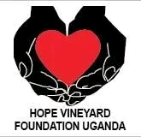HVF-UG/01/ HOPE VINEYARD FOUNDATION-UGANDA

Title of the project  ACCELERATING PROGRESS TO END TEENAGE PREGNANCY AND CHILD MARRIAGE IN UGANDA. | Project number  HVF-UG/01

Name of the organisation
HOPE VINEYARD FOUNDATION-UGANDA(FORMERLY HOPE RESTORATION CENTRE-UGANDA)

Name and position of the person responsible for the project
OKETHURU COSMAS (PROJECT OFFICER)
ACAN JOLLY(PROGRAM MANAGER)
OTINGCWINYU GODFRED (EXECUTIVE DIRECTOR)

Address
Afuda Parish, Jangokoro Sub county, 14miles West of Paidha Town Council, along Paidha-Padea Road, off Pakadha Trading Centre-Zombo District, Northern Uganda
Telephone  +256(0)759724570  +256(0)778722302 | Fax
E-mail  goddyaloysius@gmail.com  hoperescentre.hrc.org@gmail.com | Website:https://hoperestcentuganda.simdif.com

Project duration: Planned dates  September 2021-December 2022 | Project duration: Actual dates  September2021-December 2022

Financial support approved by the Vision Bearer grant in Cash ( Ugx)  Ugx 1,125,000 ($300)  $1=3750Ugx | Received instalments of grant: date and amount (in local currency)  1^{st/}Sep/2021-28th/March/2022  24th/Apr/2022-30/Dec/2022  1,125,000($300)
Project expenses covered by the Vision Bearer(Executive Director) grant  (in local currency)  Ugx 1,125,000 | Project expenses covered by your self-financing share (in local currency)  Ugx 1,125,000

Date and place  1^{st/}Sep/2021-30th/March/2022 24th/Apr/2022-30/Dec/2022 | Signature  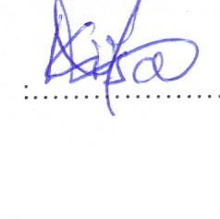
NAME AND POSITION IN BLOCK LETTERS
OKETHURU COSMAS (PROJECT OFFICER)

- EXECUTIVE SUMMARY

With Funding and support from The Vision Bearer of Hope Vineyard Foundation Uganda (formerly Hope Restoration Centre-Uganda), volunteers, HVF-UG received grants worth $300 to implement a 1 year project entitled “Accelerating Progress towards Ending Teenage pregnancy and Child Marriage in Uganda”. The project is implemented in 04 sub-counties of Jangokoro, Athuma and Abanga and current Padea Town Council in Zombo district, due to limited funds, through the use of Ecosystem approach.
Various outcome areas were Achieved; - Outcome 1: Increased government commitment(local leaders)towards renewal and implementation of the National Strategy to End Child Marriage and Teenage Pregnancy and Sexuality Education Framework at both national and sub-national level. Outcome 3: Key champions including, Youths, traditional and religious leaders in Uganda are publicly supporting alternatives to End child marriage, and teenage pregnancy, challenging traditional gender norms, other harmful practices, playing key roles in shaping public opinion.
For every project to be implemented, succeed and be sustained within the intervention area, its key to build networks as well as work closely with the District local Government and other existing structures at Sub-County, Parish and other local level structures.
Based on the above background, HVF-UG organized numerous community sessions and now we seek to start participating in organizing District and Regional level policy meeting in Zombo District and west Nile Region if resources will be available. The purpose of the meetings were to; ascertain and bridge the community knowledge gaps concerning the undertaken project to at least 6 sub counties of Jangokoro,Abanga,Athuma,Paidha,Nyapea and Padea town council, and to engage the local leaders at the sub county levels ,whereby at least a total of 15 members were involved for a good quality results through implementation of all activities and these included The Parish chiefs(01),Community Development Officers(01chairperson LC3(2), Local Journalist(01),Representative from police on the Gender desk(01),Traditional leader(01) and Religious leader(01). To strengthen on the existing structures towards the National strategy to ECM and Teenage pregnancy and sexuality Education, HVF-UG worked with 15 champions composed of 07 youth champions and 08 other champions. The Key champions including traditional and religious leaders holding the most percentage(75%) in Zombo district which are also publicly supporting alternatives to End child marriage, challenging traditional gender norms and harmful cultural practices, playing a key role in shaping public opinion helped by other influential people holding 25% . Its imperative that the District Budget Advocacy Committee is also to be identified, this will help to monitor and track the activities of the district budget that aims at Preventing or reducing child marriage and teenage pregnancy.

2.0 Youth planned activities

PLANNED ACTITIVITIES | STATUS | REMARKS
Outcome 1: Increased government commitment towards renewal and implementation of the National Strategy to End Child Marriage and Teenage Pregnancy and Sexuality Education Framework at both grassroot and sub-county levels.  Activity1:1Sub-county level policy meetings at Jangokoro Subcounty to follow up on the implementation of strategy and sexuality frame work ,champions to make public statements and advocate for change.  Activity1:1(i).meeting of Subcounty Budget advocacy committee on ECM.  Outcome 2: key champions including traditional and religious leaders in uganda are publicly supporting alternatives to end child,challengeing traditional gender norms and playing a key role in shaping public opinions.  Activity 2:1 meeting the champion at the from the six sub counties at Jangokoro sub county (from traditional and religious leaders) to lead on advocacy and act as enablers of advocacy initiatives, lead press conferences and workshops on ECM. | Implemented  1. Conducted a meeting with sub county leaders.  IMPLEENTED  IMPLEMENTED | 6 meetings were to be held targeting in 6 sub counties and 01 centralised policy meeting. But only 01 centralised policy meeting was conducted aiming at following on the implementation of the strategy and sexuality frame work towards ECM  Key issues were raised in the meeting and include;  - Multi-disciplinary approach, There is need to continuously emphasizing the long-term effects of child marriage and teenage pregnancy, This is through understanding the different perpetrators of child marriage and other forms of violence against children i.e. child to child marriage should be discouraged through educating and sensitizing the public and also engaging more youth in advocacy. And the Old people the law should apply.  - Urgent need to advocate for the uptake and embracement of Sexual Reproductive Health Rights by the adolescent girls without stigmatizing them (users )  - Increased documentation and reporting of cases of child marriage and teenage pregnancy and other forms of violence and abuse to the probation office, child and family protection office, The CID office is to be emphasized.  Budget advocacy committee was to comprise of 12 people, 2 from Jangokoro sub county, 2 from Abanga, 2 from Athuma,2 from Paidha,2 from Nyapea and 2 from Padea Town council respectively and at least 12 Local Councils (LC1) were randomly invited,2 per the village from each of the 6 sub counties for a grass root meeting. But only 8 members turned up.  KEY ISSUES  - The committee were encouraged to keep on tracking and monitoring the activities aimed at helping to fight Child marriage following the District budget.  - The use of case monitoring tool was also emphasised so that cases of child marriage are tracked and recorded.  - There’s an extreme need for involving the district budget committee and other districts officials.  Champions composed of 03 religious leaders, 07 youth champions and 7 social Network connections (SNS) community members were engaged in advocacy.  Key issues.  - Champion move house to house to educate and sensitize the effects of child marriage.  - During prayers they also inform the congregation to always protect young girls from being exchanged with cows, or money for marriage purposes since this affect the wellbeing and the future of a girl child.  - Champions also give words of encouragement (psychotherapy) to the Survivors of child marriage, Sexual violence and other forms of violence.  - Engagement of some religious leaders on radio programs with time can help increased sensitization and awareness to the public.

3.0 ACHIEVEMENTS.
- Increased number of champions inclusive of youth champions, this has drastically increased awareness towards End Child Marriage, Teenage Pregnancy and other violence against children
- Increased capacity building for HVF-UG volunteers, this has improved on the quality of work and enhanced deeper understanding on the concept of child marriage, teenage pregnancy and abuse towards children, most especially to girl child.
CHALLENGES

- Political environment, this has increased expectations to some of the community people in terms of money.
- Long distances to attend meetings, some of the participants come from distant places where getting means of transport is hard and Transport Refund to them is a challenge.
- Lack of gadgets like Laptops, Smartphones, Camera for digital data mining, collection and storage.
- Limited access to the resources and funds hindering our efforts of providing extensive services to the service-demanding poor socio-economic and marginalized population.

5.0 LESSONS LEARNT
- There is need for continuously creating awareness since child marriage and teenage pregnancy is normalized by some of the communities.
- There’s need to purchase a digital Camera for photography, Laptops and Smartphone for accurate photographs, Data mining,collection,storage and transmission
- The locals give their children in marriage due to poverty (Very poor socio-economic status).
- Increased levels of ignorance have also increased child marriage.
- There has been a significant increase in Parental negligence in child guidance, Safeguarding and protection especially during the covid19 lockdown.
- Child neglect by parents, this makes it harder for a child to access the basic needs hence resorting to child marriage.
Category | Issue Name | Problem/Success | Impact | Recommendation
Project design and scope management | Involvement of youth champions hence Increasing the number of champions | This attracts people to give much attention to the youths and also amplify their voices in the community since they are the most victims of child marriage, sexual violence and other forms of violence | This will enable the youths to actively engage themselves in advocating for their fellow youths/girls. | There is need to fully engage the youths in advocacy works making sure there are at least 5 youths representatives per parish
Project design and scope management |  | Limited access to adequate resources and funding restricts us from handling and making follow up on cases of child marriage, teenage pregnancy and other form of violence. | This makes it hard to reach to all the sub counties within the districts. | There is need to increase our financial capacity and budget to cover the whole district. This will enable efficiency and effectiveness through involvement of both the youth champions, the relevant officers, Parents, policy makers, security agents, Clan leaders, Religious leaders and other stakeholders who are all pivotal in fighting child marriage, teenage pregnancy and other form of violence and abuse against children in our communities.

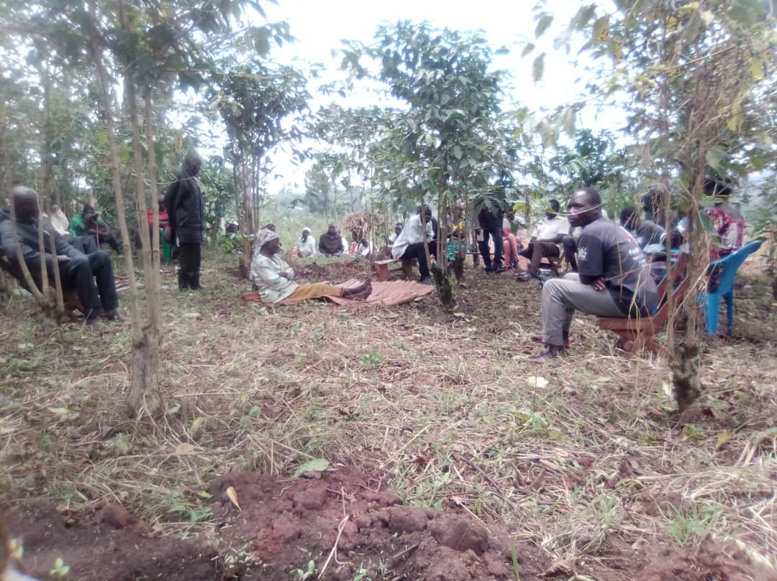Meeting the Local councils, Community Development Officers, Parish Chiefs, Cultural, religious leaders and local journalist on Teenage pregnancy, Child marriage and GenderBased Violence in Yada Parish, Jangokoro sub county December/2022
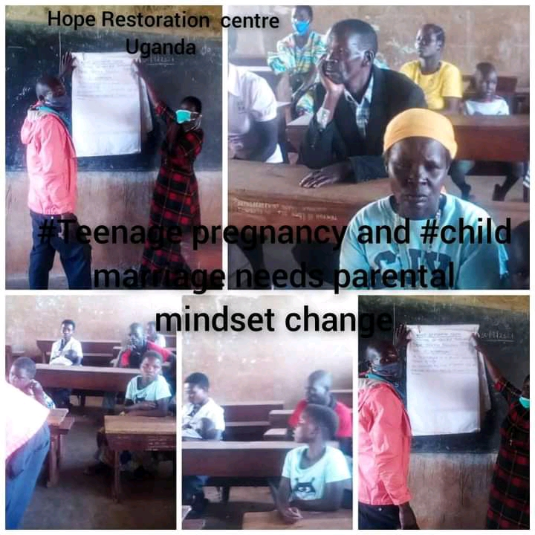Advocacy on teenage pregnancy at Alala Primary School in Jangokoro sub county 13th/Oct/2021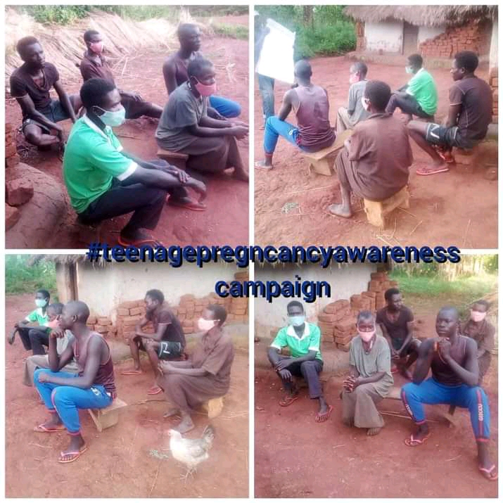Teenage pregnancy and Child marriage awareness (Dialogue) In Nguthe Village 4th/Nov/2021
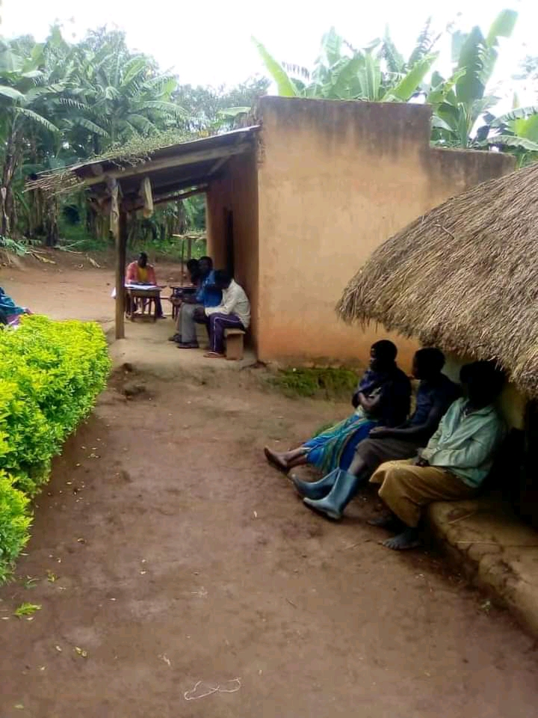
Meeting Local councils and team in Konga Trading Centre on Teenage Pregnancy and child marriage (Jangokoro Sub County)
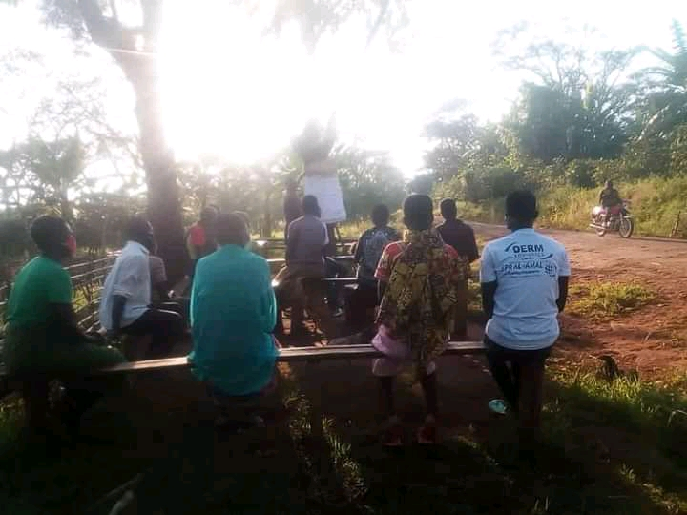
Community Dialogue on Child Marriage and teenage Pregnancy in Afuda Parish (Jangokoro Sub County)

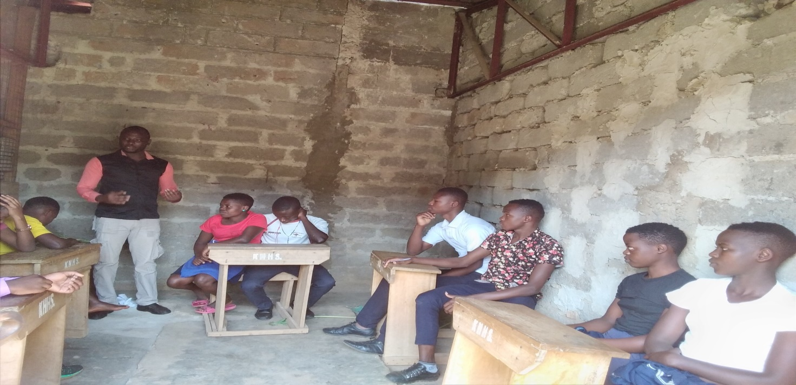
Training of Youth Champions from the 6 sub counties convening at Konga Primary School in Jangokoro Sub County.

