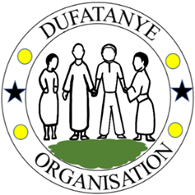
DUFATANYE ORGANIZATION
Nyanza District, Southern Province, Rwanda
P.O Box 27 Nyanza
Mobile: +250 788 513 288
Website: www.dufatanye.org
Email: dufatanyeass@yahoo.co.uk

EMPOWERING WOMEN WITH ECO-FRIENDLY SANITARY PADS” PROJECT REPORT

REPORT (JANUARY – MARCH 2026)

1. Summary
Access to safe and affordable menstrual hygiene products remains a critical challenge for many adolescent girls in rural Rwanda. This reporting period highlights continued progress by Dufatanye Organization in addressing this gap through the production and distribution of reusable sanitary pads, alongside community education and youth engagement.
Through integrated activities combining local production, capacity building, and awareness, the project is improving girls’ health, dignity, and school attendance while promoting sustainable, community-driven solutions.

2. Production and distribution of reusable sanitary pads

During this reporting period, the project strengthened its production capacity by focusing on local fiber processing and pad assembly. Locally sourced materials, including banana fibers, were processed into absorbent cotton through blending, cutting, and cooking techniques.
- 530 reusable pads were produced and distributed to schoolgirls and women in Nyanza and Nyaruguru Districts.
These efforts ensured a steady supply of materials and continuity in production, reinforcing the project’s sustainability through local resource utilization.

3. Complementary activities
During the reporting period, the project conducted a series of hygiene dialogue sessions aimed at promoting menstrual health and Sexual and Reproductive Health (SRH) awareness among young people. A total of 150 youth participants, including 90 girls and 60 boys, actively took part in these interactive sessions.
The dialogues provided a safe and open space for participants to discuss topics often considered sensitive, including menstrual hygiene practices, body changes, and reproductive health. Through guided discussions, practical demonstrations, and question-and-answer sessions, girls gained essential knowledge and confidence to manage menstruation safely and with dignity. At the same time, boys were meaningfully engaged to better understand menstruation, helping to reduce stigma and foster supportive attitudes within their schools and communities.
These sessions not only improved knowledge but also encouraged positive behavioral change, strengthened peer support, and contributed to creating a more informed and inclusive environment for adolescent health and wellbeing.

4. Impact

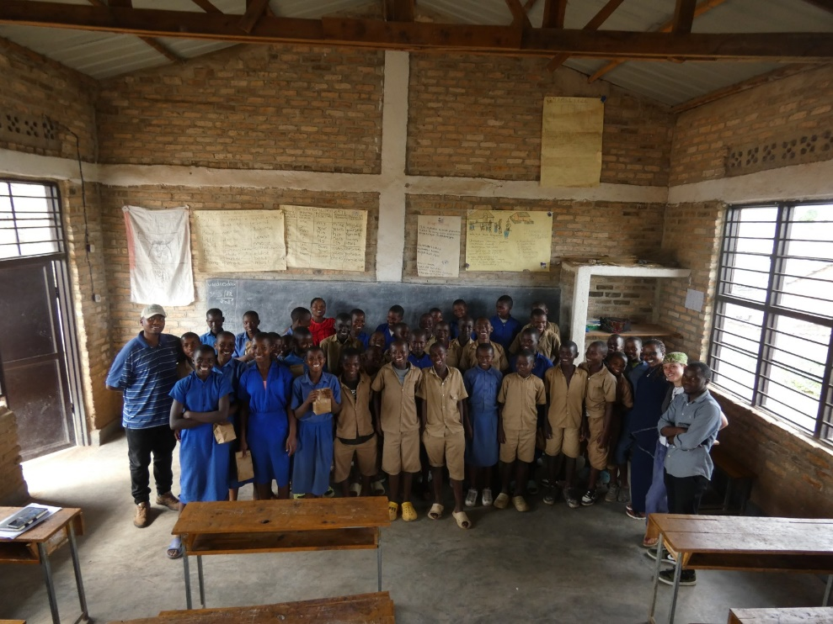
Adolescent girls and boys being trained on SRHR
The project continues to generate meaningful change in the lives of adolescent girls and their communities:
- Girls are better equipped to manage menstruation safely and confidently
- School absenteeism linked to menstruation is decreasing
- Community attitudes toward menstrual health are improving
- Local production is enhancing sustainability and economic empowerment
A previous beneficiary highlighted that access to reusable pads enabled her to attend school consistently and participate confidently in class, demonstrating the direct link between menstrual health support and educational outcomes.

5. Next steps
To build on the progress achieved, the project will focus on:
- Increasing production capacity to reach more beneficiaries
- Completing pending pad assembly processes
- Expanding outreach to additional schools and communities
- Strengthening training for local producers and youth groups
- Enhancing sustainability through continued use of local materials.

