
DUFATANYE ORGANIZATION
Nyanza District, Southern Province, Rwanda
P.O Box 27 Nyanza
Mobile: +250 788 513 288
Website: www.dufatanye.org
Email: dufatanyeass@yahoo.co.uk

EMPOWERING WOMEN WITH ECO-FRIENDLY SANITARY PADS” PROJECT REPORT

REPORT (AUGUST – DECEMBER 2025)

1. Summary
The “Empowering women with eco-friendly sanitary pads” project continued to empower young women and girls through the production and distribution of reusable sanitary pads and related hygiene education. Despite equipment challenges, the team maintained steady progress, reaching hundreds of beneficiaries and strengthening community engagement.

2. Distribution achievements
- 480 reusable pads were produced and distributed to schoolgirls and women.
- 192 pads were distributed to 48 girls at Mubuga secondary school and Icyerekezo primary school.
- 112 pads were distributed to 28 non schooling girls in Mubuga cell in Nyanza District.
- 76 pads were distributed to 19 girls and women at in Nyamagana B village in Kavumu cell.

3. Complementary activities
- Hygiene dialogues: 74 youth participants (48 girls, 26 boys) were engaged in menstrual health and SRH awareness.
- Youth empowerment: 65 youth were reached in open dialogues on sexual reproductive health.
- Technical innovation: Dufatanye staff were trained in banana fiber processing for sustainable pad materials.

4. Impact story

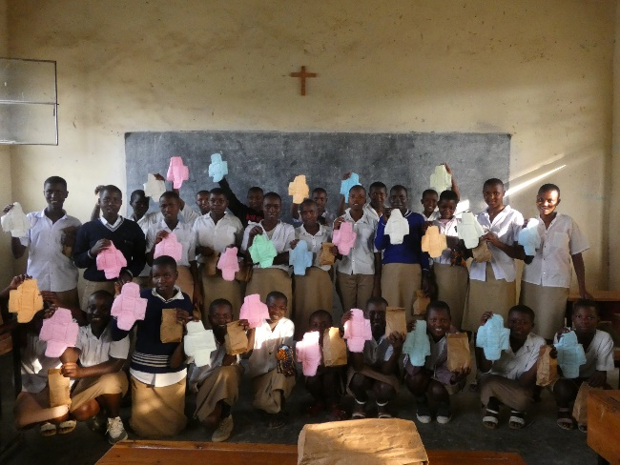
“At Mubuga secondary school, 15-year-old girls received their first sets of reusable pads during a distribution event. They shared that before; they often missed classes during their periods. With the new pads and the hygiene dialogue session, they now attend school confidently every day. Their teachers noticed some of them improved participation, and they dream of becoming teachers and other strong people themselves to inspire other girls.”

5. Next Steps
- Sustainability: Continued monthly production with a target of over 500 reusable pads per month.
- Expansion: More outreach sessions planned, aiming for at least 10 in 2026.
- Appreciation: Your support ensures that girls like those from Mubuga secondary school can pursue their education without interruption.

