Mary’s Recovery Journey
We are grateful to share an encouraging update about Mary, who recently returned to Uganda after successfully undergoing a kidney transplant in India. The journey has not been easy, but by God’s grace and through the generous support of well-wishers, the surgery was successful.
Mary and her donor—her brother—have both been steadily recovering since returning home. We have been visiting them multiple times to monitor their progress and ensure they are coping well during this delicate recovery period. It is heartwarming to see the improvement in Mary’s health day by day.
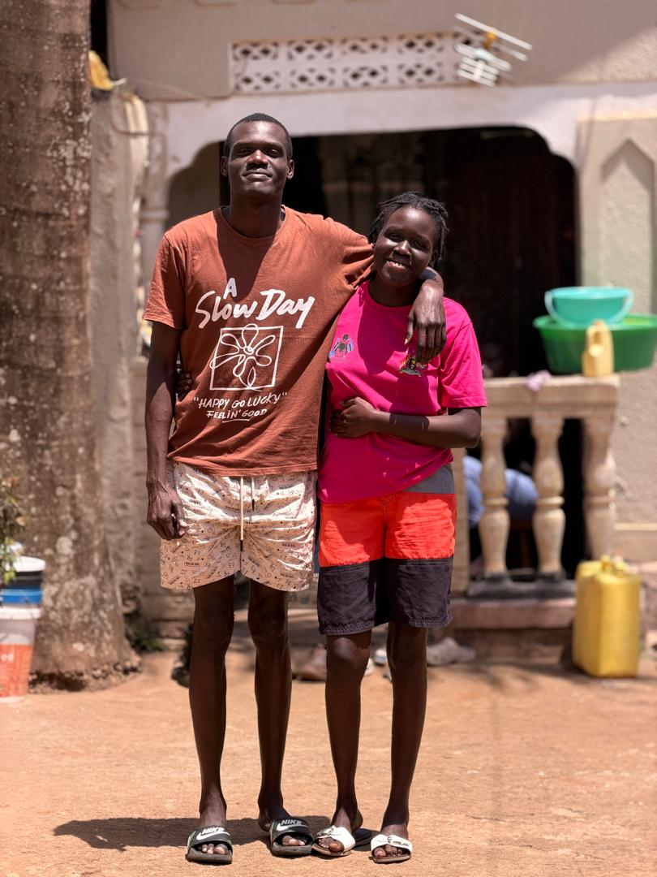
The donor has regained enough strength to return to his workplace, which is a positive sign of recovery. Meanwhile, Mary remains at home as she continues with her prescribed medication and follows strict medical guidance to support her healing process.
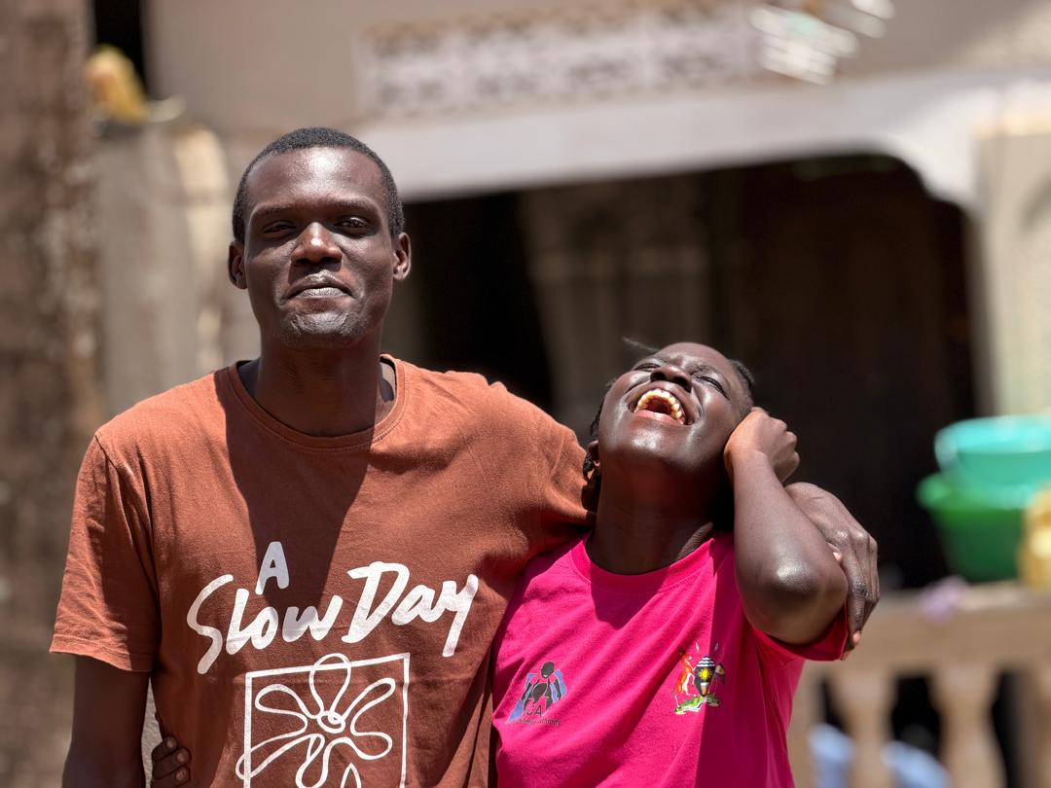

However, one of the current challenges they are facing is access to the nutritious foods recommended by the doctors. A balanced and specialized diet is essential at this stage to strengthen Mary’s immune system and protect the transplanted kidney. We are doing our best to identify and provide the specific foods prescribed, but this remains an area where additional support is greatly needed.
We extend our heartfelt appreciation to everyone who has contributed toward Mary’s treatment and recovery. Your generosity has given her a second chance at life. As she continues healing, your ongoing prayers, encouragement, and support mean more than words can express.
Together, we are restoring hope and transforming lives.
Thank you so much.

