**Ukrán Remény Egyesület / Ukrainian Hope Association**

**Report’2024**

According to a UNHCR Central Europe report, since February 24, 2022 many thousands of Ukrainian refugees have found safety in Hungary under diverse types of residence, including Temporary Protection status. The newly arrived Ukrainian citizens are facing many urgent needs, including language barriers, schooling hardships, accommodation problems, lack of finance to maintain reasonable living standards, socialization and adaptation problems which are especially relevant for schoolchildren, psychological issues related to dramatic life experiences, etc.

Parents need to obey the law demanding that all children aged until 16 must attend Hungarian schools; at the same time, many Ukrainian schoolchildren continue to study online at their respective Ukrainian schools, which often results in physical and psychological overloads and stresses. Under the existing circumstances, on one hand, the natural desire to socialize with coevals clashes with the inability to freely communicate; on the other hand, Ukrainian parents want to find an opportunity for their children to establish and maintain contacts with their Ukrainian peers living in Hungary.

Our supplementary educational project known as *Ukrainian Space* was established in March 2022 as a pop-up project by a group of Ukrainians fleeing the war, and was officially registered by the Hungarian Government as a nonprofit association in October 2022. It got off the ground to address the need for immediate and concrete humanitarian help.

Currently, the *Ukrainian Space Day Centre* is located in a two-roomed apartment in Budapest. *Ukrainian Space* is largely managed and staffed by Ukrainian nationals (with the status of a protected person in Hungary, or residing there as spouses of Hungarian nationals).

**Aims and Objectives**

The core activities of *Ukrainian Space* were defined by the Ukrainian refugees it was set up to support. This aim was for an active educational centre, the main focus of which is classroom lessons, educational support and extracurricular projects for school age children and their families.

**Our Mission**

Our mission is to provide cognitive, cultural, moral, spiritual and emotional support for Ukrainian children aged 5 to 14 and their families to ensure their safe integration, seamless adaptation and harmonious coexistence with the Hungarian community.

To achieve this mission, the Association supplements the children’s education in the schools they already attend: Hungarian public schools (offline) and Ukrainian schools (online).

We also organise summer daily camps for Ukrainian children, and get them involved in cultural activities aimed at cherishing Ukrainian language and traditions and becoming aware of Hungarian customs.

**Foundation and Management Structure**

The *Ukrainian Hope Association* was registered in October 2022 in Budapest, Hungary by a team of Ukrainian and Hungarian school teachers and academics who had been working with Ukrainian families living in Budapest on the volunteer basis since the early spring of 2022.

The *Ukrainian Hope Association* operates a bank account and employs a bookkeeper who maintains full records and tax declarations according to Hungarian Law.

**Main Objectives**

1. Integration support to Ukrainian schoolchildren currently residing in Hungary in form of afternoon educational and entertainment courses, psychological services and language courses.
2. Safe and friendly Ukrainian-language community centre for refugees’ children.
3. Coordinative centre to help children integrate into Hungarian educational environment.
4. Formation of creative, cultured, self-confident individualities, able to face challenges and successfully resolve them.

**Project Deliverables in 2024 (after receiving the GlobalGiving support and benefiting from it)**

*June – August*

In the summer months, we ran 3 sessions of the Summer Day Camp – five weekdays in June, July and August, respectively (in 2022–2023, it was assisted by a group of US volunteers). Whenever possible, we organised outdoor activities like trips to museums, exhibitions and other amenities, which not only have educational value but provide opportunities for Ukrainian families to meet and cohere.

We provided the children with 2 meals a day (breakfasts and lunches; the latter were provided thanks to our agreement with the Budapest City Hall).

Altogether, we had about 55 children attending our Summer Camps.

*September – December*

Our supplementary educational activities were carried out in the form of afternoon classroom lessons on weekdays and Saturdays in the following subjects: Preparation to Elementary Schools (2 groups: Ukrainian and bilingual Ukrainian-Hungarian); Hungarian language (2 groups for adults: Beginners and Elementary; 1 children’s group); English language (3 children’s groups classified age-wise and by the level of language command); Arts; IP & Programming; Science; History.

Our educational focus broadened to provide support for children as they integrated into the Hungarian educational system and wider society. Currently, we provide afternoon educational support on weekdays and Saturdays for cca. 40 Ukrainian refugee families residing in Budapest.

On a regular basis, by ourselves or jointly with other charity and volunteer organizations we organised such extracurricular sessions, like: Yoga, Robotics, Drawing, Puppet Theatre, etc.

*Masterclasses*

We also held the following masterclasses for children and their families: Making Advent Wreaths, and Decorating Christmas Gingerbreads (2 masterclasses – one for Ukrainian families; one for a local Seniors’ Home).

*Puppet Performances*

We had 2 Christmas puppet performances: 1 was delivered by Hungarian volunteers; 1 (traditional Ukrainian Nativity scene) was prepared and staged by our children for the Seniors’ Home and for Ukrainian families.

*Children’s Library*

At the end of 2023 Ukrainian Space received cca. 400 Ukrainian language children’s books from the Ukrainian embassy in Budapest and acts as a library for the broader Ukrainian community.

*Snacks*

Ukrainian Space provides snacks for the children, served during the intervals between the lessons.

*Advent Calendar*

Together with our students, the staff and guest teachers of the *Ukrainian Hope Association* developed, designed, illustrated and printed 300 copies of the Advent Calendar in Ukrainian. During the Advent period (from 1 until 24 December, 2024), every day the stories of the Calendar were supplemented with illustrations / fairy tales / Christmas carols recited / sung by our teachers and students, which were posted on our FB page here:

<https://www.facebook.com/groups/740405323634710>

We also operate a closed Viber group for parents of the children attending our project, where we place our weekly timetables, announcements, get feedbacks, etc.

*Christmas Party*

We held a Christmas party for our students and their parents. All our children received Christmas presents. The concert programme included the performance of a Ukrainian string ensemble from Budapest, and the Nativity puppet theatrical shown by our students.

*Additional Services*

Personal interpreting for Ukrainians at governmental offices (Tax Authority, Ministry of Internal Affairs, Immigration Authority, banks, etc.)

Interviewing cca. 25 Ukrainian households (outsourced by UNHCR).

**Staff**

At present, the Association provides employment for 4 staff teachers, 2 temporary teachers of English (all employed on part-time basis), and 4 guest teachers (paid on an hourly basis). All our teachers are Ukrainian nationals currently living in Hungary.

We also work on contractual terms with an accountant company.

The administration work is performed on voluntary basis.

**Premises**

The Association hires a two-room apartment where all our activities are carried out.

**Plans for 2025**

Subject to the availability of finances, the *Ukrainian Hope Association* plans to proceed with all its educational activities in 2025.

Besides, we plan to publish a trilingual (Ukrainian – Hungarian – English) book titled *The Beauty That Unites Us. The Trees*, with the texts written by our teachers and illustrated by our students (the first suchlike book, dedicated to flowering plants growing in Hungary and Ukraine, was successfully released in 2023).

We also want to expand our activities and launch a series of meetings/gatherings for Ukrainian families living in Budapest on psychological support, history and traditions of Hungary, business examples of Ukrainians living in Hungary, etc.

Please contact us if you need further information on our activities. You may also follow our activities on our FB page: <https://www.facebook.com/groups/740405323634710>

**Photos Featuring Our Activities in 2024**

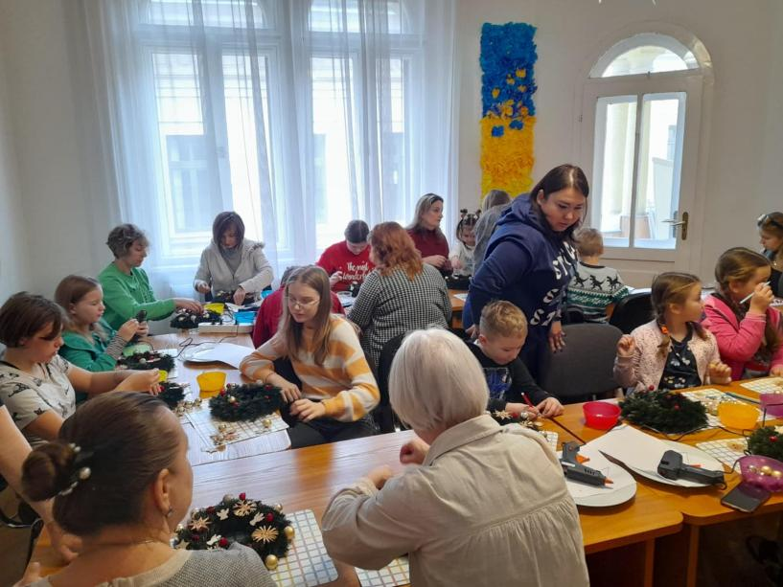

*Wreath Making Masterclass*

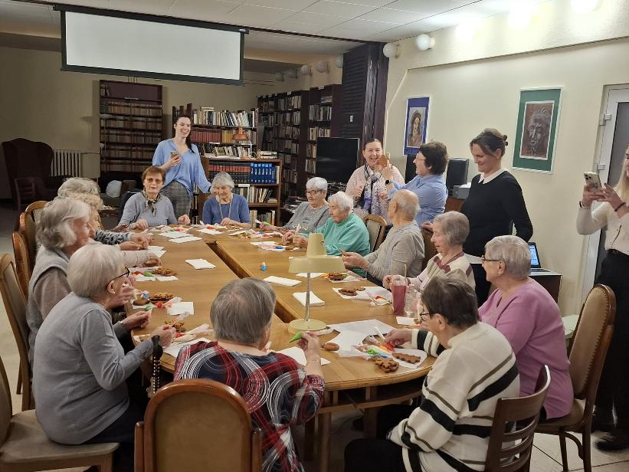

*Christmas Gingerbread decoration at Seniors’ Home*

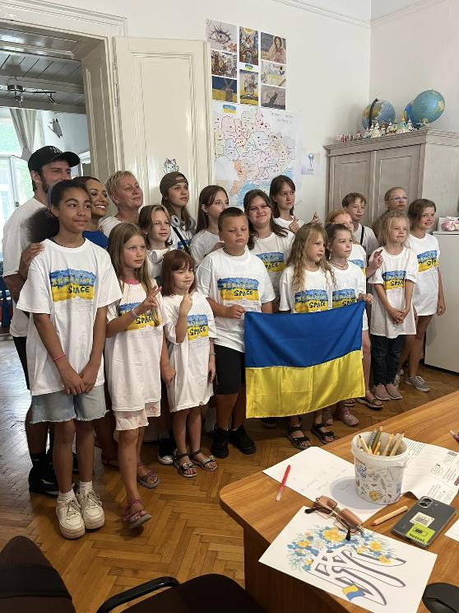

*Kat Graham, an American film star and UNHCR envoy, meets Ukrainian Space children at the Summer Day Camp*

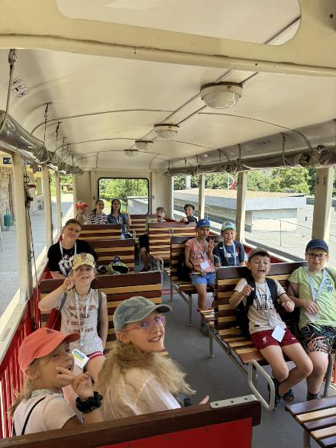

*Children’s Railway in Budapest. Ukrainian Space’s Summer Day Camp, August 2024*

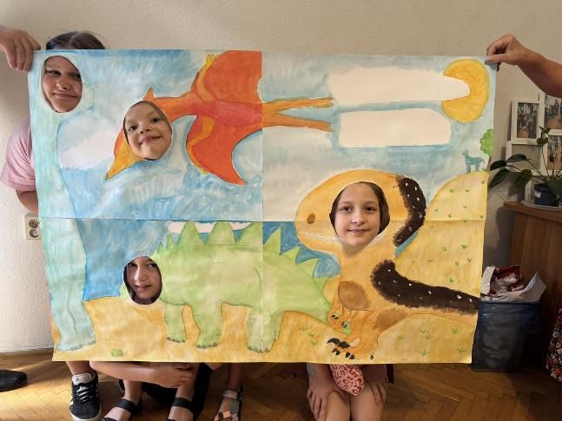

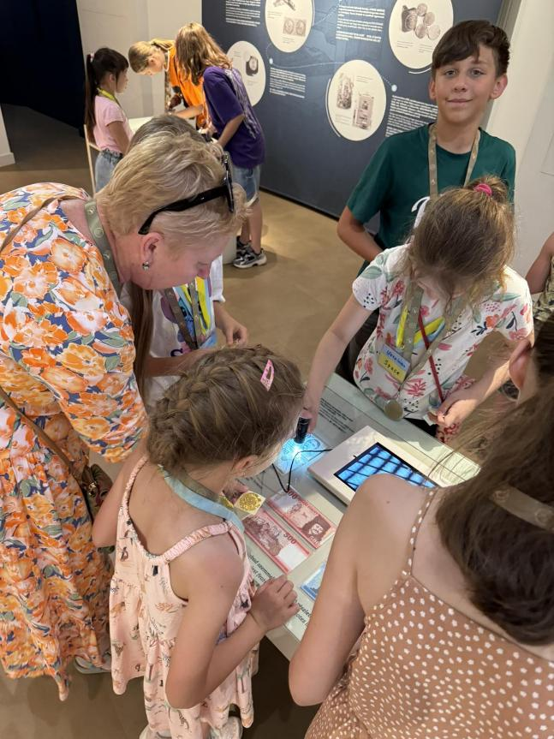

*At our Summer Day Camp 2024. Money Museum in Budapest*

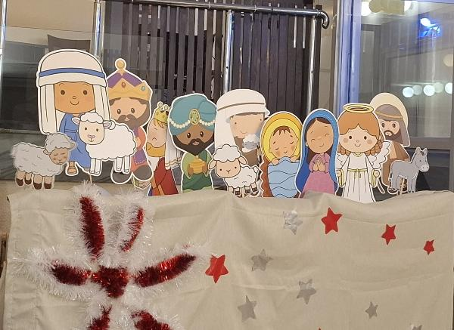

*Our puppets for the Nativity scene*

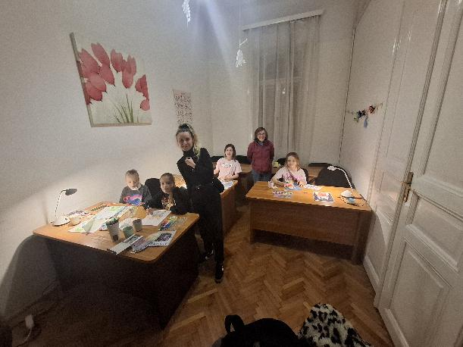

*A Drawing lesson*

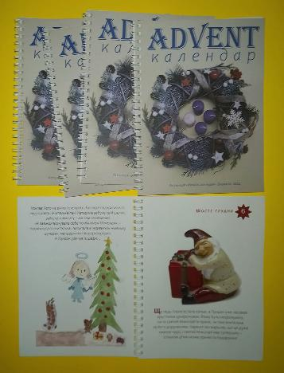

*Our Advent Calendar (300 copies, distributed among the Ukrainian schools, Ukrainian libraries, the Ukrainian scout organisation, the City Hall, and several minority self-governments in Budapest)*