Progress Report for Global Giving

Introduction:

2006 was a year of growth and strength within the movement. Domestic workers got a name and an image and a bit of more justice. The empowerment of domestic workers showed in itself their messages, solidarity and concern for all.
We are grateful to the commitment of the national and regional teams, the involvement and leadership of domestic workers and all who in one way or other trusted our approach and supported us.
2006 was a year that joins memories of the Movement as powerful and creative.
- Jeanne Devos -

We present to you the update of activities, which have enabled dignity and respect to our women domestic workers and children in domestic work in the form of:
Examples of activities we have been able to organize and to finance with the support of many helpers:

I.CHILD DOMESTIC WORKERS

a)__ CAMPAIGN AGAINST CHILD LABOUR was organized on 12th June 2007.

Working for the eradication of Child Labour: “Children are exploited”.

Inspite of the ban on child labour and ban on child domestic work the problem still persists. A Rally was planned for children, 100 children participated.
Future plans:
- to visit areas which do persist in Child Labour – and where many dropout children live.
- continue process with rallies to be held on
29th June 2007, 22 July 2007. 5 Aug 2007. 15Aug 2007.
School enrollment will be done simultaneously.
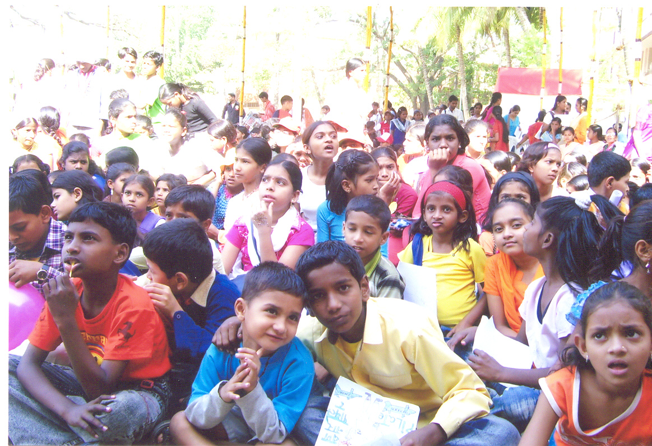

b) __________To inculcate A Day of Hope for Children…15th February 2007 …INTERNATIONAL DAY OF HOPE FOR CHILDREN

The “GOLEM” – Project:
Thanks to all our helpers, we were able to organize a project, which is starting from the childrens’ point of view:
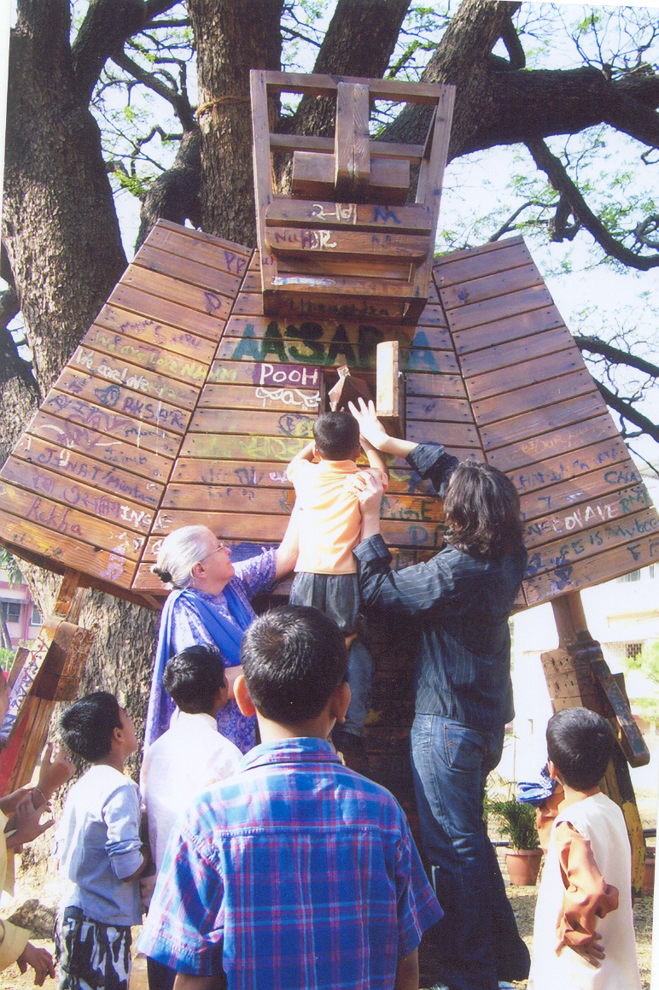
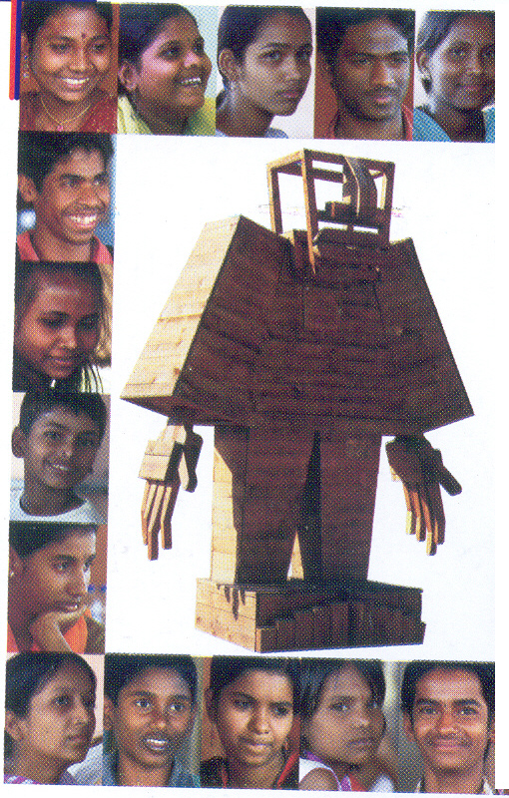

Golem, is a wooden giant of about 4 metres high and 2,5 metres broad,
Koen Vanmechelen for the first time built this few years ago. It is a symbol of the helper or saviour for those children all over the world, who are in need of help, hope and courage:
200 children from Mumbai and Thane celebrated this day at St. Paul’s School grounds in Mumbai. To give children in domestic work, children dropped out from school, children working in construction sites, children living on the streets, children with disabilties and many other an opportunity to realize their dreams about their feelings, desires and thoughts, they painted pictures, formed sculptures, wrote poems,etc. they put them in the chest of the GOLEM. This encourages children to think about themselves and to work towards the fulfilment of their dreams. The myth of ”Golems” all over the world is, that they wake up at night and examine the dreams and possibly make them come true.
Chief guest, Asst. labour Comissioner, Mr V.S. Deshpande inaugurated the day by emphasizing on the need to educate and encourage the children to go to school and to sensitize the public through awareness campaign.

We met 8-year-old Laxmi, who used to work along with her parents at a building construction site in Mumbai. She shared, “Aaj main bahoot khush hoon, aaj mujhe mere jaise bahoot saare bachon se milne ka moka mila” (today I am very happy, today I got the opportunity meet many other children like me). Laxmi and may other children are now able to go to school. This has been possible due to the efforts of various organisations that believe in the importance of education and work not only with parents but also with the government and employers.

ACHIEVEMENTS OF 2006
Total no. of rallies organized | 54
Total number of participants | 35750
Number of children worked with in whole project area | 35000
Children enrolled in mainstream education | 360
Children enrolled for vocational training | 1124
Children enrolled for non formal education | 864
Total number of children rescued from crises situation | 176
Number of children rehabilitated or repatriated | 67
Children placed in crisis intervention centres | 95

II. WOMEN DOMESTIC WORKERS:

a)_________________Self-helping groups (SHGs):

Consequently our groups are expanding everywhere in the country. New groups for children and women are initiated where we have staff and the possibilities.

2006
Total number of SHGs formed | 6132
SHGs formed in source areas | 2792
SHGs formed in destination areas | 1340

…we believe only by involving the primary stakeholders – domestic workers – we can achieve such high goals as the following:

GOVERNMENT RECOGNIZES DOMESTIC WORK
Tamil Nadu, 19th January 2007, the Tamil Nadu Worker’s Movement reached a high goal this year: The government agreed on forming a separate welfare board for domestic workers when the new legislature was convened in January. This is really a great boost to the Domestic Worker’s Movement especially to the group in Tamil Nadu but sure also for the whole movement and domestic workers in general! We really hope, that we can reach more of these highest goals which is only possible with strong will and support of the public! Thank to all the people who are interested and listen to us!
By now the law has just passed! 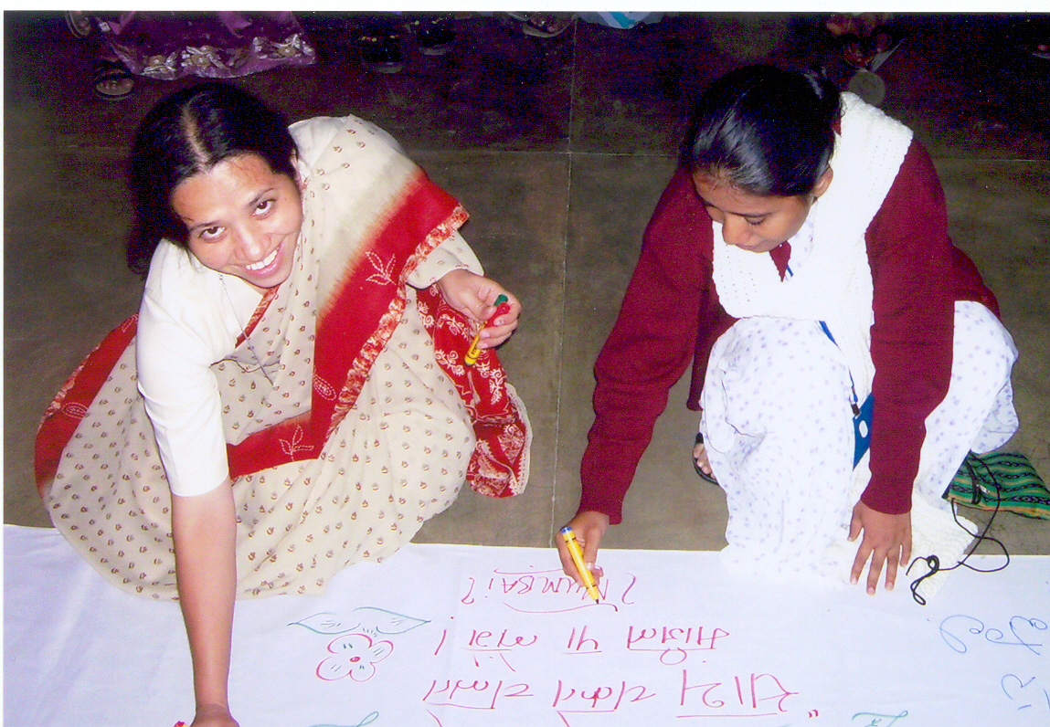
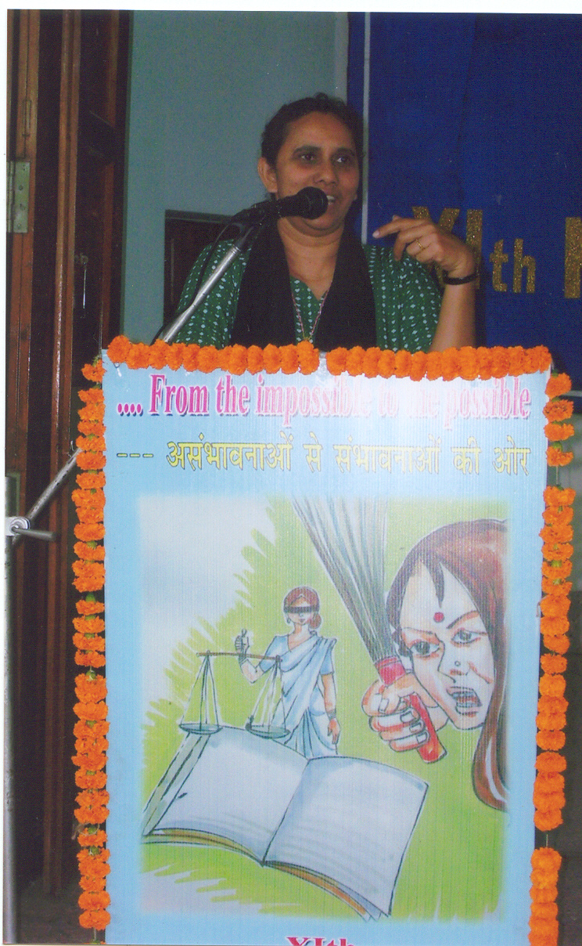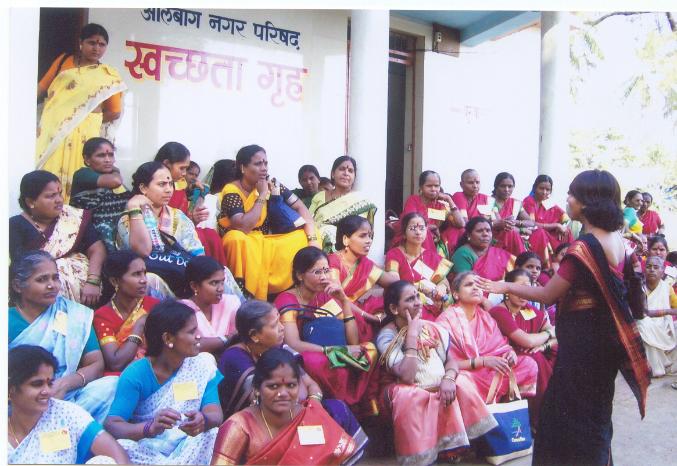

III. Anti – Trafficking and Media Campaign
- Spreading awareness about the issue in both the source and destination areas through street plays, Path Yatra (Protest Walk) and information leaflets
- Village vigilant committees are formed that keep track of their own people who may be potential victims but also of traffickers.
Our aim is to identify traffickers and rescue victims even before they have left the state.

IV. Conclusion

The work that we do is an ongoing process. The impact of an intervention may or may not be felt immediately. The fact that the ban on child domestic work in India came in 2006 does not mean that it was an immediate result of our programmes/interventions. It is a result of a process that started 21 yeas ago. A process that has involved empowering, stregthening, awareness and advocacy through various means.

