Support Girl’s Digital Education in Rural Nigeria Project Report.
Introduction:
To ensure that “No One Is Left Behind”, Environmental and Rural Mediation Centre (ENVIRUMEDIC) has taken the crusade on digital literacy to rural Primary Schools level in Nigeria’s public schools to “Catch Them Young” on Digital Literacy skills.
Aim and Objectives:
This intervention is aimed at catching the younger generation especially children in primary schools in rural public schools with the mindset of Data Science, Machine Learning and Artificial Intelligence; Sensitizing them about the proposed National Computer Based Test in Secondary School Examinations and enhance their skills with computer knowledge as they are growing.
Interventions:
From the month of January – April, 2025, the Team has visited 13 rural community schools to sensitize them on digital literacy. This is the era of Artificial Intelligence and the rural communities need to be carried along. The communities visited include: Ossissa, Obikwele and Abuator in Ndokwa East LGA; Emonu, Eboh and Ugono in Ughelli North LGA; Arhavwarien, Esaba, Otutuama, Ophorigbala, Okwemor, Egbo-Ideh and Otegbo in Ughelli South LGA of Delta State, Nigeria.
A total number of 1042 pupils were reached with (1000 girls) and (42 boys) were sensitized on Data Science, Machine Learning and Artificial Intelligence, 1042 note books shared.
Children sensitized and mindset changed towards embracing Artificial Intelligence, parents and teachers also sensitized to further push for digital literacy inclusion and community members are sensitized to support digital literacy program in their various communities.
Challenges:
ENVIRUMEDIC digital literacy project has not started generating supports so going to this rural communities requires transportation cost. The project requires computer tablets to show as model but non is available yet.
Solutions:
The project requires funds and other supports like computers to drive the process. This project is supported by ActionAid Nigeria Local Rights Programme.
Conclusion:
The project brought happiness, joy and acceptance in the various communities visited. Especially that the Nigerian Government wants to implement the national CBT examinations on WAEC, NECO and other examinations. This is a project to really “Catch Them Young” and “Leave No One Behind’
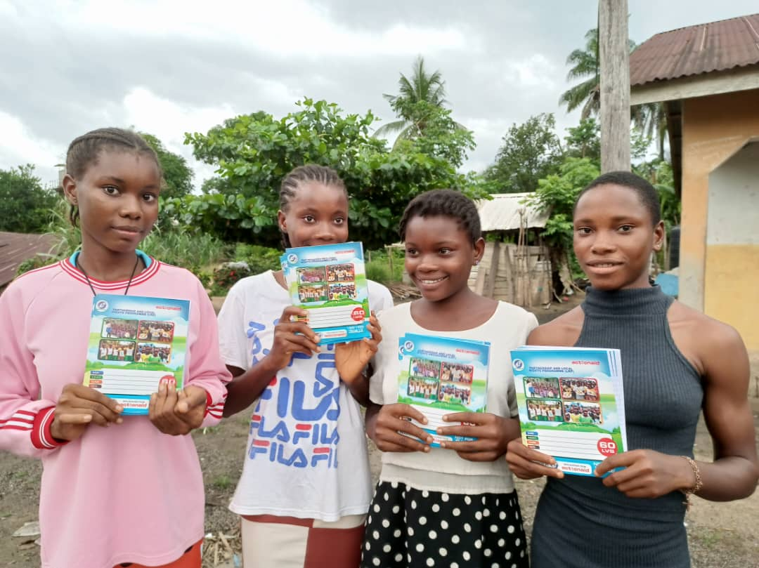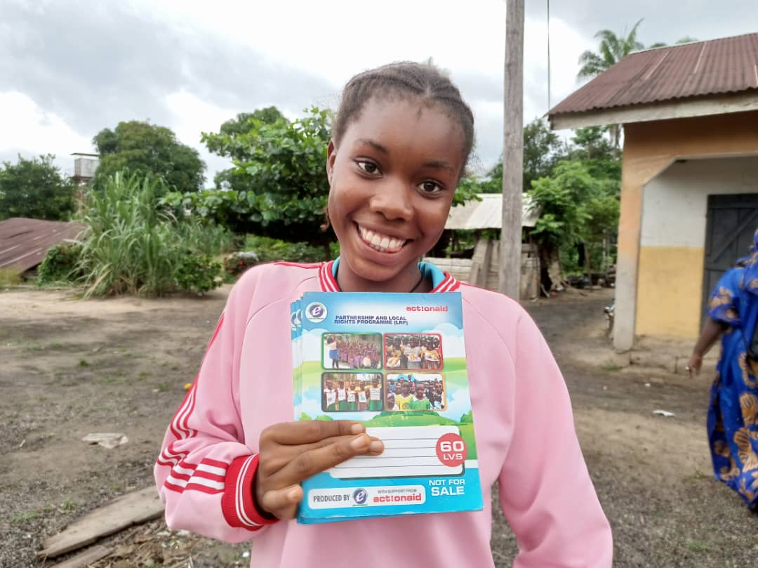
Abuator Communities Children on Digital Literacy/AI Sensitization.

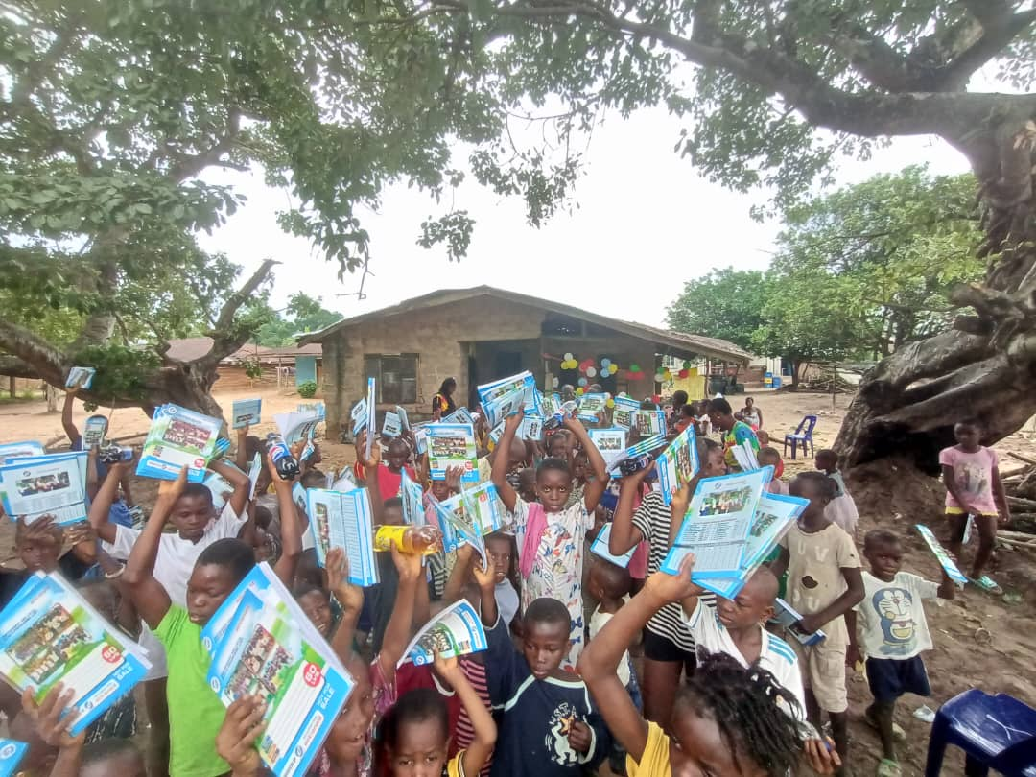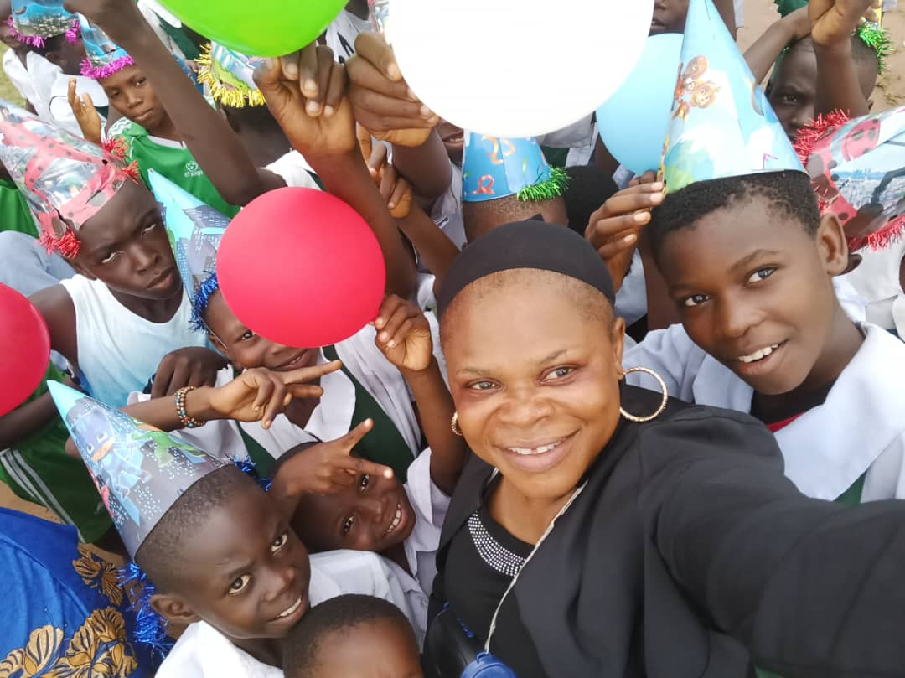
Obikwele Community Pupils/Children on Digital Literacy/AI Sensitization.

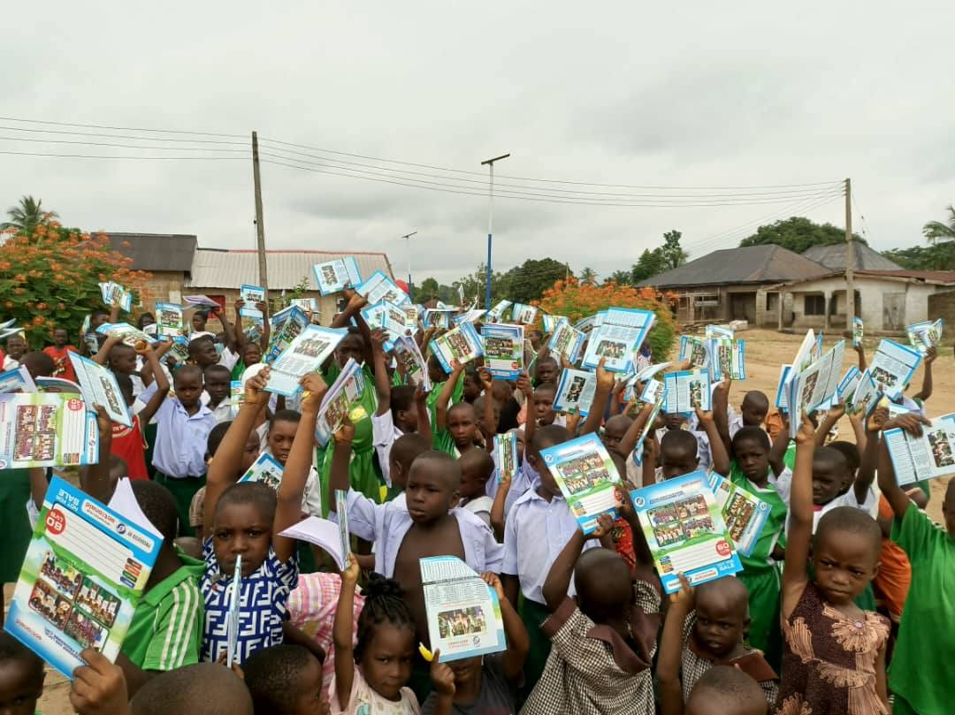
Osissa Community Pupils/Children on Digital Literacy/AI Sensitization.

