Nayabasti WASH Project

Project Overview:
From 26-28 September 2024, Nepal experienced severe flooding and landslides due to continuous heavy rainfall, predominantly affecting the Bagmati, Koshi, and Madhesh provinces. The disaster resulted in the destruction of vital infrastructure, particularly impacting water supply, sanitation, and hygiene (WASH) facilities. The Nayabasti WASH (Water, Sanitation, and Hygiene) project (Bethanchok Rural municipality ward no .2 Kavrepalanchok District) was completed with the goal of providing safe and reliable drinking water to the households in Nayabasti by Nepal Water for Health. The project was a significant step forward in improving the health and well-being of the community by establishing water infrastructure that included an intake system, tapstands, and other essential structures for water distribution.
However, the heavy rainfall and devastating floods in September 2024 have caused catastrophic damage to the project. The intake system, which was the lifeline for the water supply, was completely swept away by the floodwaters. The tapstands, which were installed to provide clean water to households, have been severely damaged, rendering them non-functional. Additionally, other key structures that were built to support water distribution have also been destroyed.
Impact on the Community:
As a result of the flood’s destruction, 73 households having 602 population in Nayabasti are now left without access to safe drinking water. Prior to the disaster, the community had been relying on the newly established infrastructure for clean water, which significantly reduced the risks of waterborne diseases and improved overall hygiene and sanitation. However, with the collapse of the WASH project’s infrastructure, the people of Nayabasti are once again facing the dire consequences of contaminated water sources and unsafe hygiene practices.
Currently, the residents of Nayabasti are forced to rely on temporary pipe connection for drinking, cooking, and other essential domestic needs. This alternative source may be contaminated, putting the health of the entire community at risk, especially vulnerable groups such as children, the elderly, and pregnant women.
Without immediate intervention, the community faces the ongoing threat of waterborne diseases, including cholera, dysentery, and typhoid. The destruction of the WASH infrastructure also jeopardizes the community's ability to maintain basic sanitation, making it more difficult to practice proper hygiene and preventing the spread of diseases.
The Need for Support:
The restoration of safe drinking water in Nayabasti is critical to the survival and health of its people. Rebuilding the water infrastructure (Pipe line, Intake, slow sand filter, Horizontal roughing filter and community tapstand) is an urgent priority. This includes the repair or reconstruction of the intake system, installation of new tapstands, and restoration of other key water distribution structures. Additionally, we must ensure that the community has access to clean and safe water sources in the long term.
With the help of compassionate donors like you, we can ensure that the people of Nayabasti are not left without their most basic human right: access to safe, clean water. Your donation will directly support the reconstruction efforts needed to restore the WASH infrastructure and provide the community with the resources they need to stay healthy and thrive.
How You Can Help:
It will cost around US $ 15,000 to restore the water infrastructures in this project.
We are calling on individuals, organizations, and communities to join us in raising the funds necessary to rebuild the Nayabasti WASH project. Your support will go toward:
- Reconstruction and Repairing Water Distribution Infrastructure: Restoring the intake, vital tapstands and other structures that make clean water accessible to every household.
- Community Engagement and Education: Ensuring that the community is involved in the rebuilding process and educated about water conservation, hygiene practices, and maintaining the new infrastructure.
By contributing to the restoration of the Nayabasti WASH project, you will directly improve the lives of 73 households and help prevent further suffering caused by contaminated water. Together, we can rebuild not just infrastructure, but hope and resilience for the people of Nayabasti.
Donate Now and be a part of the solution. Your generosity will ensure that the residents of Nayabasti once again have access to safe, clean water – a foundation for better health, hygiene, and a brighter future.

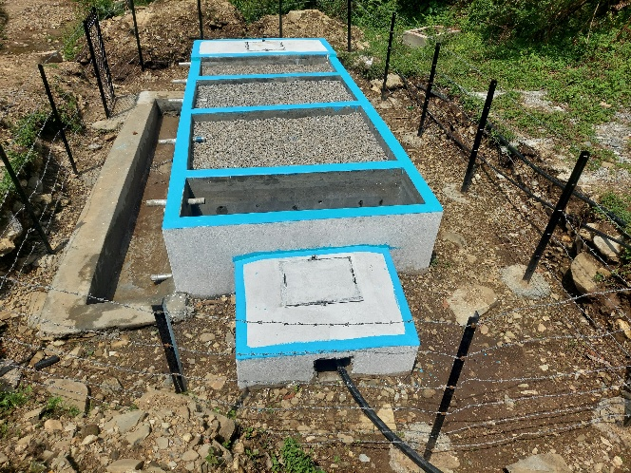  Slow sand filter (Before the flood) | 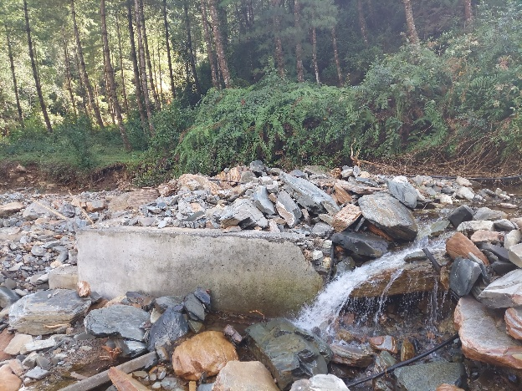  Intake (After the flood)
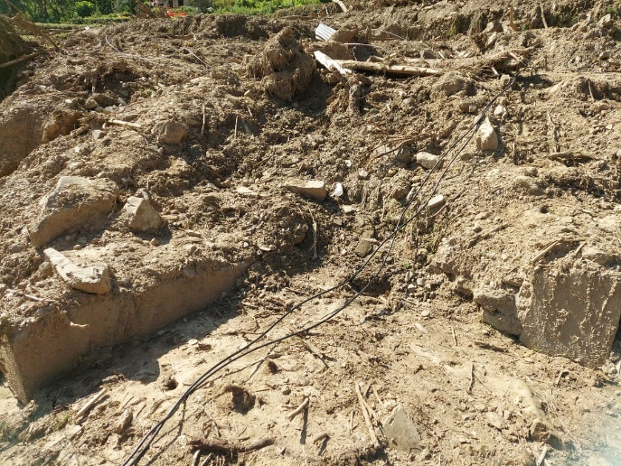  Destroyed Pipe line area | 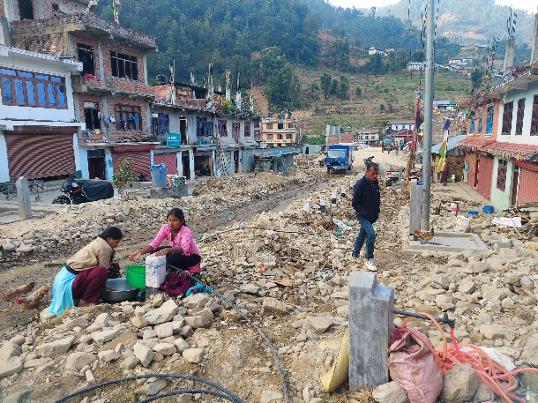  tapstands

