**BIG ACTIONS REQUIRE BIG COMMITMENT**

"Do not be discouraged when things do not go as you had planned, because what is not possible today, will be possible tomorrow; but remember, Big Vision requires Big Dream, Big Dream requires Big Actions and Big Actions require Big Commitment, knowing that there is wonderful joy ahead. Commitment requires courage and patience; Patience and courage never fail and are shown by the End".

YES IT CAN BE DONE AND IT WILL BE DONE

Imuhira Iwacu Village

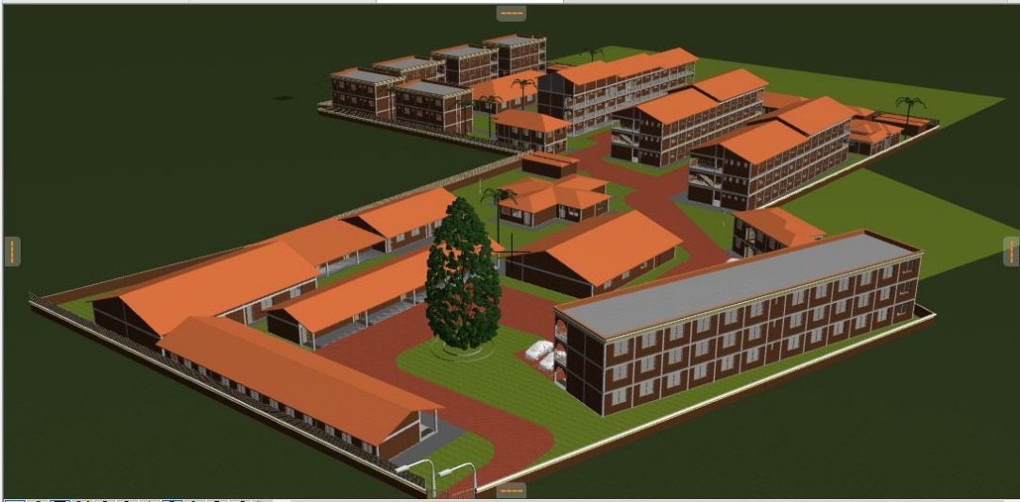

Imuhira Iwacu Village will be made up of the orphanage, school, Community Building, Health Center and Iwacu Ruhagarika Hill University. Imuhira Iwacu Village is still under construction.

Providing shelter, education and caring for the orphans, street children and children from needy families is a major priority for us now and beyond.

The orphanage will accommodate 160 children, and the school will be able to teach around 800 children each year and Iwacu Ruhagarika Hill University will be attended by over 1000 students from different parts of the continent of Africa. Children attending the school will come from the orphanage, locations surrounding Imuhira Iwacu Village and beyond. The Imuhira Iwacu Village will create employment opportunities for over 200 people.

Providing orphaned children with housing, education and life skills will save the lives of thousands of orphans and street children who live today in horrible situations, without hope for the future.

Imuhira Iwacu Village will be a meeting place for children, young people, and adults. It will provide for more than just their education. It will offer a place for conferences, workshops, trainings, weddings and fun. Over 35,750 people will benefit from Imuhira Iwacu Village, each year.

The Imuhira Iwacu Village will reduce the number of suffering children in the street and reintegrate them in a new life, new family, new society and give them an opportunity to have shelter and education. The Imuhira Iwacu Village will be a NEW HOPE FOR THE NEW GENERATION. New hope for today and tomorrow’s generations.

In Burundi, the 14 years of civil war and continuing HIV-AIDS epidemic left behind more than 823,000 orphans, over 20,000 of whom are currently living on the streets; intensifying a cycle of poverty, violence and hopelessness, in the country where life expectancy is 39 years and where around 50% of the population are illiterate. The number of orphans of war and AIDS in Burundi is estimated to be 11% of the Burundian population and are everywhere in the country. Clearly and totally, this project will contribute to the accomplishment of the objectives, as described above.

We continue to raise funds that will enable us to complete the construction of Imuhira Iwacu Village (primary and secondary school, orphanage, community building, health center and Ruhagarika Hill University) which is still under construction.

Our Plan is to see Imuhira Iwacu Village becomes self sufficient, after 6 years from the date it will be completed. During the first year of its activity operations, the Imuhira Iwacu Village will need full support (100%); then 85% of the running costs for the second year, 65% for the third year, 45% for the fourth year, 30% for the fourth years, 20% for the fifth year, 10% for the sixth year and then from there, the Imuhira Iwacu Village will become self sufficient.

To make this to happen, we have 3 plans which will enable the Imuhira Iwacu Village to continue to run the costs on its own, by establishing the following projects: A small soap making factory, Poshmill for both cassava and maize, farming and other projects that would enable Imuhira Iwacu Village to become self sufficient. In addition, we will be collecting some school fees from the students who will be enrolled in our school for those who have parents who will be able to pay the school fees.

The Management of Imuhira Iwacu Village will be centered on its objectives, tasks and plan for which it is committed to accomplish:

* Recruit a well educated and experienced person to serve as the Manager of Imuhira Iwacu Village, able to offer an assurance of integrity, probity and attachment to human values.
* Establish Rules and Regulations as a guidance and procedure of the Imuhira Iwacu Village which will serve as a guidance to the management team and workers
* Establish a steering Committee of Imuhira Iwacu Village to assist and advise the Manager to oversee the development and implementation of Imuhira Iwacu Village according to its objectives and tasks to be accomplished
* Recruit mother caretakers and teachers and provide a good training, guidance and orientation which will contribute to facilitate their work with Imuhira Iwacu Village
* To encourage the manager and workers to work as a team focusing and remaining committed to their duties without deviation
* If there arises any problems, arrangements will be made as quickly as possible to identify the problems so that they can be corrected and allow the activities continue in a positive environment
* Staff meeting will be held regularly to discuss different issues related to the improvement and progress of Imuhira Iwacu Village
* All major tasks, resources, equipment and costs will always be properly identified and determined in time and a list of existing resources will be established and take note of those still needing to be sourced, according to our priority
* Generating projects will be undertaken and established to enable Imuhira Iwacu Village to become self-sufficient, such as a small soap making factory, Poshmill for both cassava and maize, farming and other projects, as well. In addition, we will be collecting some school fees from the students who will be enrolled in our school for those who have parents able to pay the school fees.

**IWACU RUHAGARIKA HILL UNIVERSITY**

**NEW HOPE FOR TODAY'S and TOMORROW’S GENERATIONS in AFRICA**

file:///C:/Users/Prosper%20NDABISHURIYE/Documents/Imuhira%20Iwacu%20Village%20%20plan.jpg

I am taking this opportunity to inform you about a dream and plan that I have to build and establish an University in Cibitoke, at Ruhagarika in Burundi. This University will be called “Iwacu Ruhagarika Hill University". It will be a regional University.

The Iwacu Ruhagarika Hill University will be part of Imuhira Iwacu Village. Imuhira Iwacu Village will bring NEW HOPE FOR TODAY'S and TOMORROW’S GENERATIONS in Africa.

I would like to invite you, dear friends, to be part of the planning and organizing body.

Please join us in this and be part of this Big Vision to help make a difference in Africa.

Yes, we will get there! Together we will make this BIG Dream become a reality. Yes, Big Vision requires Big Dreams, Big Dreams require Big Actions and Big Actions require a Big Commitment. Commitment requires Courage and Patience; Patience and Courage never fail and are shown by the END.

Please join us in this and be part of this Big Vision to help make a difference in Africa.

Prosper Ndabishuriye

Ambassador for Peace_General Coordinator and Founder/JRMD

