HOPE IN ACTION: GULU OUTREACH.
Background
Northern Uganda, particularly Gulu, continues to face the long-term consequences of more than two decades of armed conflict, notably the Lord’s Resistance Army insurgency. The conflict led to widespread displacement, loss of livelihoods, family separation, and severe disruption of social services. Thousands of children were directly affected many were orphaned, abducted, or grew up in harsh conditions.
Although peace has since been restored, the effects of the conflict remain deeply rooted. Many families continue to struggle with unresolved trauma, and limited access to quality education, healthcare, and psychosocial support. These challenges disproportionately affect children, especially girls, who face additional barriers such as poor menstrual hygiene management, limited awareness of their rights, and increased vulnerability to exploitation and early school dropout.
In response to these persistent challenges and support from Global Giving, Joy for Children Uganda has been implementing targeted interventions aimed at restoring hope and improving the wellbeing of vulnerable children in conflict affected areas. As part of this effort, JFCU conducted a school a 2 days outreach at a primary school in Gulu to address key issues affecting learners, particularly menstrual hygiene, mental health, and access to education.
Objectives of the Activity
- To Promote menstrual hygiene management among girls through provision of essential menstrual hygiene materials to support school attendance and dignity.
- To Increase awareness of mental health among learners.
- Sensitize pupils on their right to education.
Activities Accomplished
Distribution of Menstrual Hygiene Materials
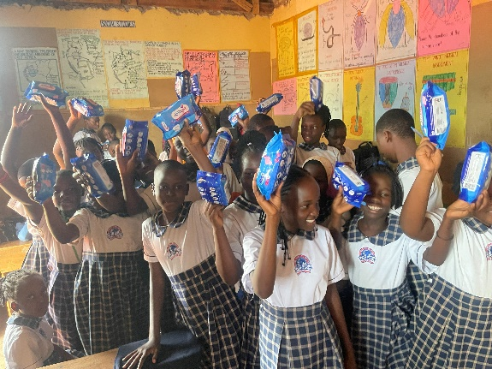
Our staff engaged pupils from Primary Four to Primary Seven in a series of interactive and supportive activities. One of the key components of the outreach was the distribution of menstrual hygiene materials, where each girl was provided with reusable sanitary pads and bags. This intervention aimed to promote proper menstrual hygiene management, restore dignity, and reduce school absenteeism caused by limited access to these essential materials.
girls holding reusable sanitary pads distributed by joy for children Uganda.
In addition, the team with support from the school senior woman and school nurse managed to created a safe and supportive space to listen to the girls’ voices as they openly shared their experiences and challenges related to menstruation. These discussions helped to break myths, misconceptions, and stigma surrounding menstrual health. Through open dialogue and guidance, the girls were empowered with accurate information, increased confidence, and a better understanding of how to manage their menstrual health with dignity.
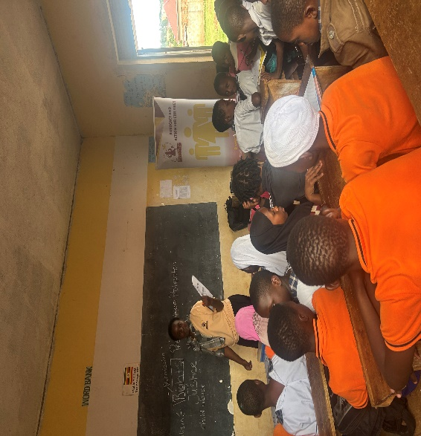
In addition to material support, the team facilitated an interactive mental health awareness session designed to help pupils understand their emotions, cope with stress, and build confidence in expressing themselves. The session created a safe and open environment where learners were encouraged to share their thoughts, experiences, and challenges with their parents and teachers.
one of our staff in class delivering a session on children’s rights.
A learning session was also conducted on Day 2 focusing on children’s rights. An exciting part of this activity was that children were already somewhat familiar with the topic, as children’s rights are included within their school curriculum. This provided a strong foundation for deeper engagement and discussion. The session explored four key thematic areas: violence, rights, justice, and protection. Pupils were guided to understand what it means for their rights to be violated, how and where to seek help, what rights look like in their daily lives, and how justice and protection can be accessed within their communities.
The discussion also addressed sensitive but critical issues such as sexual violence and child trafficking, handled in an age-appropriate and informative manner. Teachers were encouraged to continue reinforcing comprehensive sexuality education and menstrual health awareness to ensure learners receive accurate and supportive information. The session further aimed to raise awareness about Children’s rights and the available justice and protection systems, while promoting understanding of gender-based violence and violence against children
The activity was highly participatory, providing a safe platform for both girls and boys to express their views and experiences. Girls were encouraged to share emotional and psychological challenges, contributing to awareness and healing, while boys were engaged to share their perceptions regarding children’s access to justice. Through these discussions, several grievances were identified, including concerns about how some parents undermine or dismiss children’s rights.
These engagements further revealed that these pupils are bright and have strong potential, with many likely to benefit from education sponsorship programs.
Lessons Learned
- There is a significant gap in menstrual hygiene knowledge and access to materials, especially among young girls.
- Mental health remains an under-addressed issue in primary schools, yet children are eager to talk when given a safe platform.
- Schools lack sufficient support systems for psychosocial wellbeing.
- Community-based interventions are highly effective when they combine material support with awareness and education.
Future Plans
- Support vulnerable children with clothing and essential items to improve dignity and wellbeing.
- Introduce regular counselling sessions, child-friendly spaces, and mental health clubs in schools.
- Pay school fees and provide scholastic materials such as books, uniforms, and school supplies.
- Through livelihood programs, including vocational training and sustainable farming, to strengthen household resilience.
- Scale up interventions to reach more schools and children across Northern Uganda.
Appreciation Note
To our donors on global giving and partners whose support makes such impactful initiatives possible. Because of you, we were able to reach children in Gulu with menstrual hygiene materials and carry out all these engagements. We look forward to continued support and collaboration in improving the lives of vulnerable children and building a brighter future for communities in Northern Uganda.
Photos.
