Protection of a Water Source and Construction of Water Collection Points in njombe mjini ward, Njombe Town
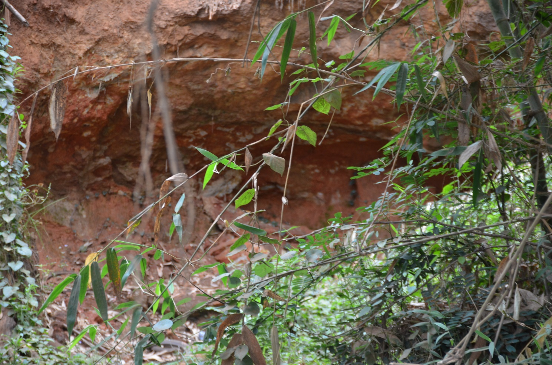

PROJECT FORMULATION

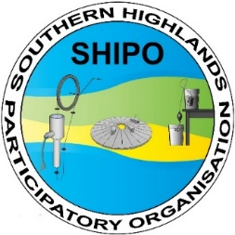

- Area's context and geo-location

The Njombe region, located in the Southern Highlands of Tanzania, was separated from the Iringa region in 2012. It comprises four districts: Njombe, Makete, Ludewa, and Wanging'ombe. The region borders Ruvuma to the south, Lake Malawi to the west, and Mbeya, Iringa, and Morogoro regions to the north, northeast, and east, respectively.
Njombe region has an area of 21,347 km². The population in 2018 was 803,299 (381,410 male and 421,889 female).
The project is going to be implemented in Njombe Mjini ward and Mjimwema Ward in Njombe town Council, the main town in the region, with a population of 85,747. Its location is detailed in Figure 1 and Table 1.
Figure 1: Location of the project area in Njombe town, Njombe region, Tanzania.

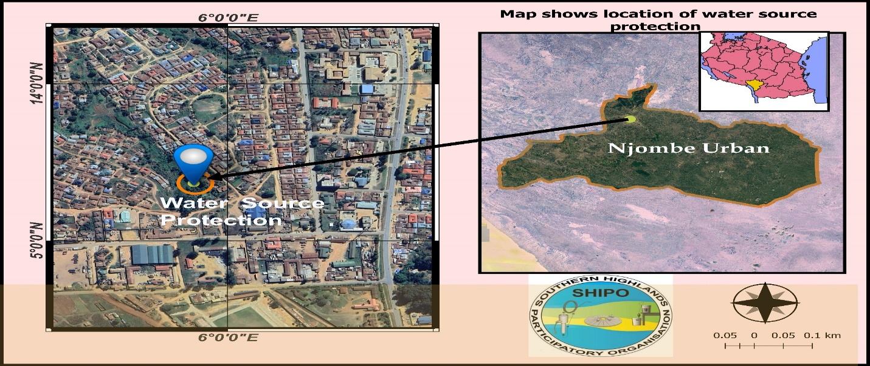

Table 1: Details of the location of the project area.
Region | Council | Ward | Street | Latitude | Longitude | Elevation
Njombe | Njombe Town | Njombe Mjini | Mgendela | -9.332714052136236 | 34.770030906486596 | 9°19'57.9"S 34°46'12.2"E
Njombe | Njombe Town | Mjimwema | Joshoni (B) | -9.348691677736808 | 34.77630699513358 | 9°20'56.1"S 34°46'34.7"E

- Project description

  - Background
The Njombe Water and Sanitation Agency (NJUWASA) is responsible for supplying water within Njombe town. However, the water network is often unreliable, with frequent cuts and breaks. Despite being within the town’s jurisdiction, areas like Mgendela, Joshini (B) in Njombe Town ward, and Mjimwema Ward frequently experience a lack of piped water, particularly during the dry season from June to December. This shortage affects households, businesses, and educational institutions in the area.
As a result, many residents are forced to fetch water using buckets from an open spring nearby. Several ponds have been dug to retain the spring water, making it easier for locals to access. However, the area is also used for dumping solid waste, and livestock such as cows and goats are often seen grazing, alongside some cultivation activities. These factors significantly increase the risk of water contamination, rendering it unsafe for household use.
  - Objective
The main objective of the project is to improve the access to clean water of the neighbours of Mgendela and Joshini (B) in Njombe Town ward and Mjimwema Ward in Njombe town, by:
- protecting the spring area through covering of the intake and ponds and fencing the area;
- constructing three water points connected to the intake.

- Beneficiaries, profile

The beneficiaries of the project are those who draw water from the spring area when tap water is not available. More than 6200 people shall benefit from the project. The return of water from the stored source can cause an increase in water in the Ruhuji river to benefit from it.
- Impact and sources of verification
The ultimate goal of the project is to enhance the living standards of the communities in Mgendela street (Njombe Town ward) and Joshoni (B) street (Mjimwema ward) by improving access to clean, safe water. With better water availability at the spring, the risk of health issues will decrease, while fetching water will become quicker, safer, and more manageable, especially for women and children.
To assess the project’s success, two key indicators will be tracked over five years: the operational status of the water systems (whether they are functional or not) and the effectiveness of the street-level water management committees. These indicators will be monitored through regular site visits and meetings with Local Government Authorities (LGAs) and community members.

- Timeline of the project

The project is expected to start at the beginning of 2025 and last for 6 Months, as shown in Table 2.
Table 2: Timeline of the project implementation.

- Budget

At Mgendela, the total project cost of the project is 28,349.60 euros; 16,080 euros to be contributed by the donor and 9,650 euros to be contributed by SHIPO and 2,620 by community from Mgendela at Njombe Mjini ward and the district. The budget is presented in Table 3 for more clarity. The exchange rate used is 2500 TZS/Euro.
Table3: Budget for the protection of a water source and the construction of water collection points in Mgendela street, Njombe Town ward, Njombe town.

At Joshoni (B), the total project cost of the project is 24,209.60 euros; 13,200 euros to be contributed by the donor and 8,390 euros to be contributed by SHIPO and 2,620 by community from Joshoni (B) at Mjimwema Ward and the njombe Town Council. The budget is presented in Table 4 for more clarity. The exchange rate used is 2500 TZS/Euro.
Table4: Budget for the protection of a water source and the construction of water collection points in Joshoni (B) street, Mjimwema ward, Njombe town. As table below shows.

- Project sustainability and risks

One of the risks during project implementation is the degree of community cooperation. Since the area is close to the city center, some neighbors may be away from the project area during the day. Public events, such as an upcoming national census or visits by national government officials to an area can also affect community engagement. In order to ensure the proper participation of the community, introductory meetings will be organized by the Council and the community and a contract will be signed by all parties, explaining the responsibilities of each party and the agreed time of the activities. The community will contribute at least 5% of the total budget; his exact contribution will be decided during introductory meetings but will probably involve labor and food for the masons.
In order to improve the sustainability of the project, a committee at the local level will be formed and trained in Operation and Maintenance of the infrastructure. Once the project is handed over to the community, this committee will be responsible for ensuring that the infrastructure works and is well maintained.
In addition, NJUWASA will also be involved from the first introductory meetings. An expert from NJUWASA will monitor, together with SHIPO experts and M&E staff, the work during the implementation and at the end of the project.
Within 3 months after the completion of the project, SHIPO will monitor the performance of the committee and the infrastructure and take the necessary measures to ensure their proper functioning. After that, SHIPO will monitor every year during the 5 years the infrastructure and performance of the committee and report to the donors.
SHIPO´s experience in spring protection projects (Water Conservation component within Mbozi Farmers´ Livelihood project funded by Heifer International) and the Joshoni water conservation in Njombe funded by AUARA. As well water hygiene and sanitation project funded by Connect International learned a lot regarding community contribution.

- Graphic material

Project implementation area

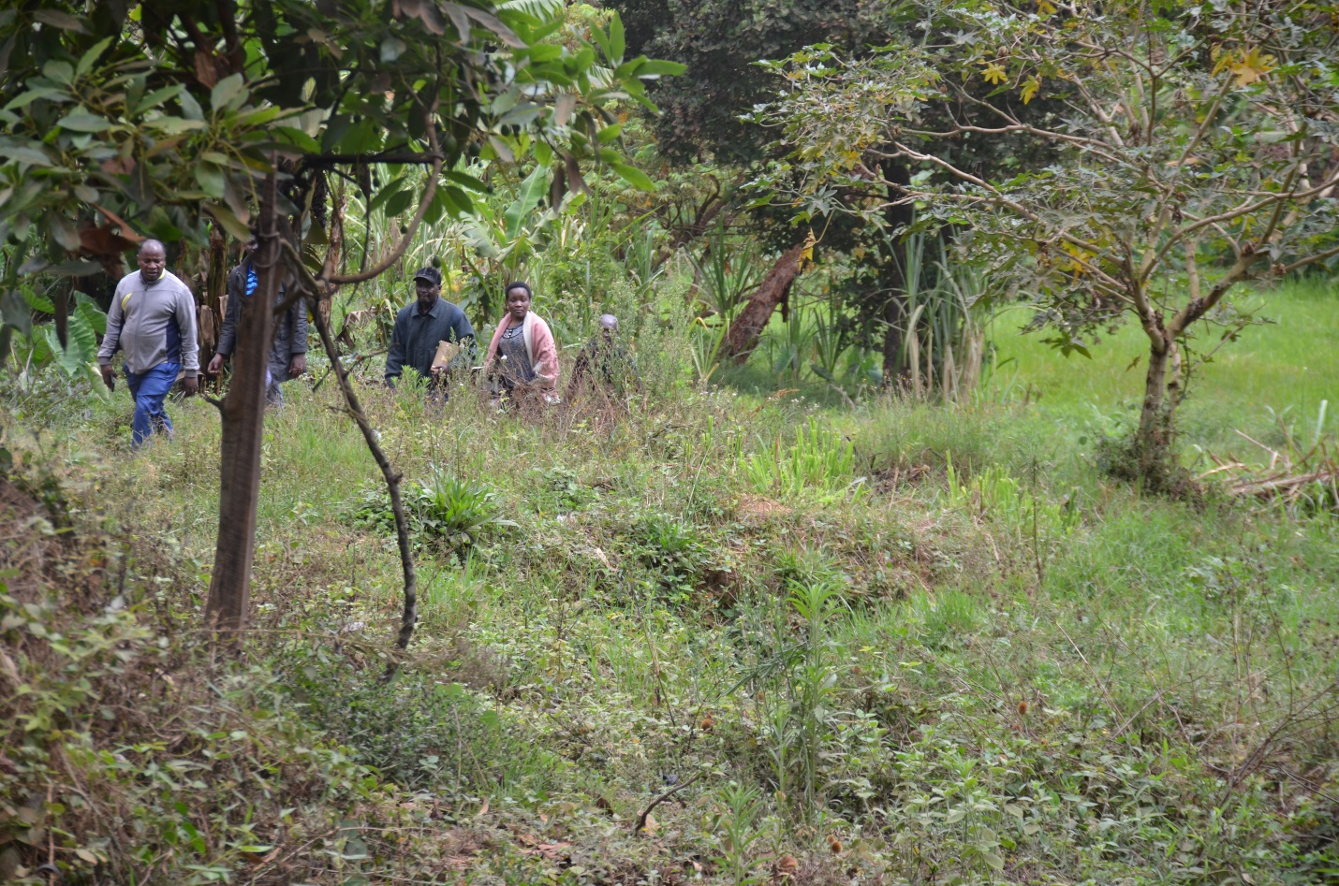
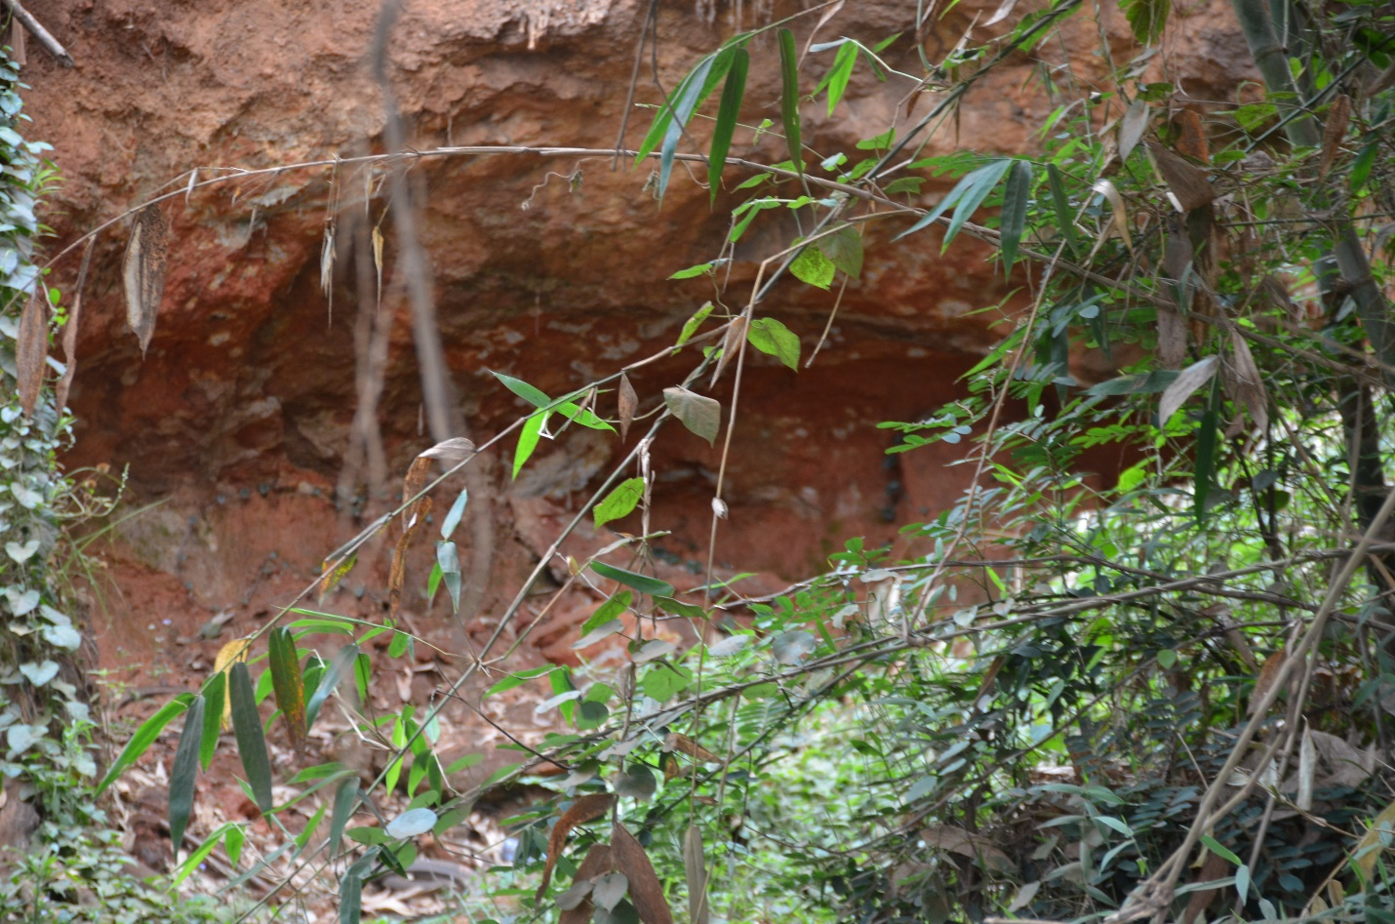
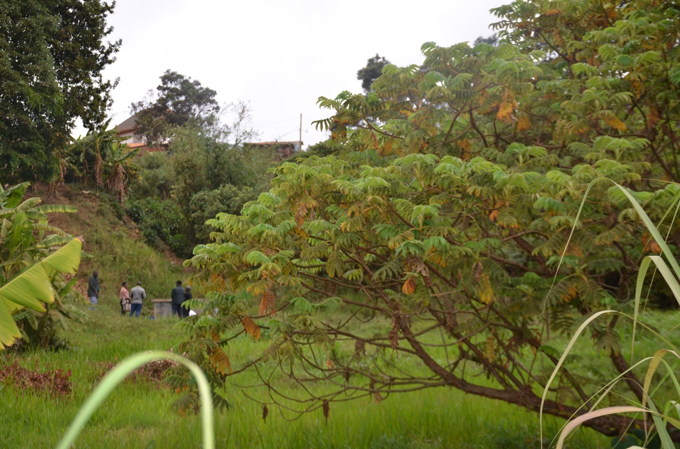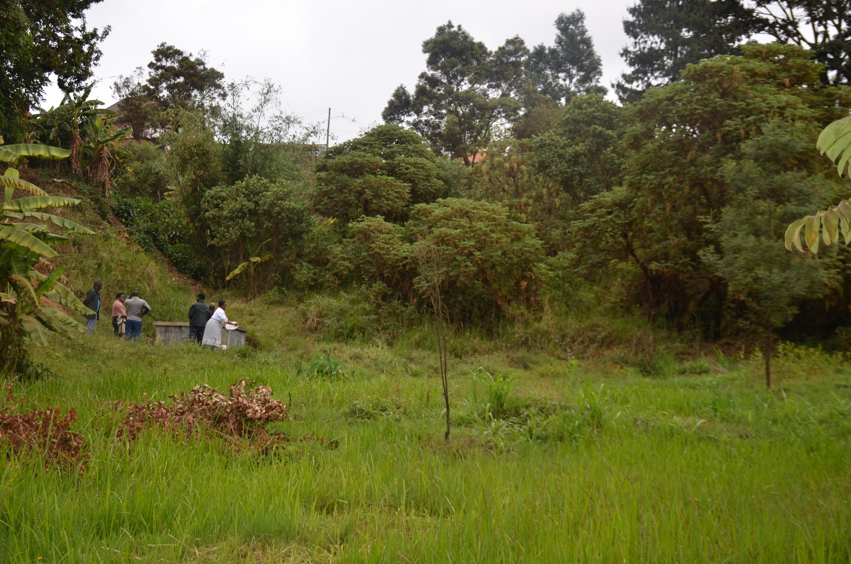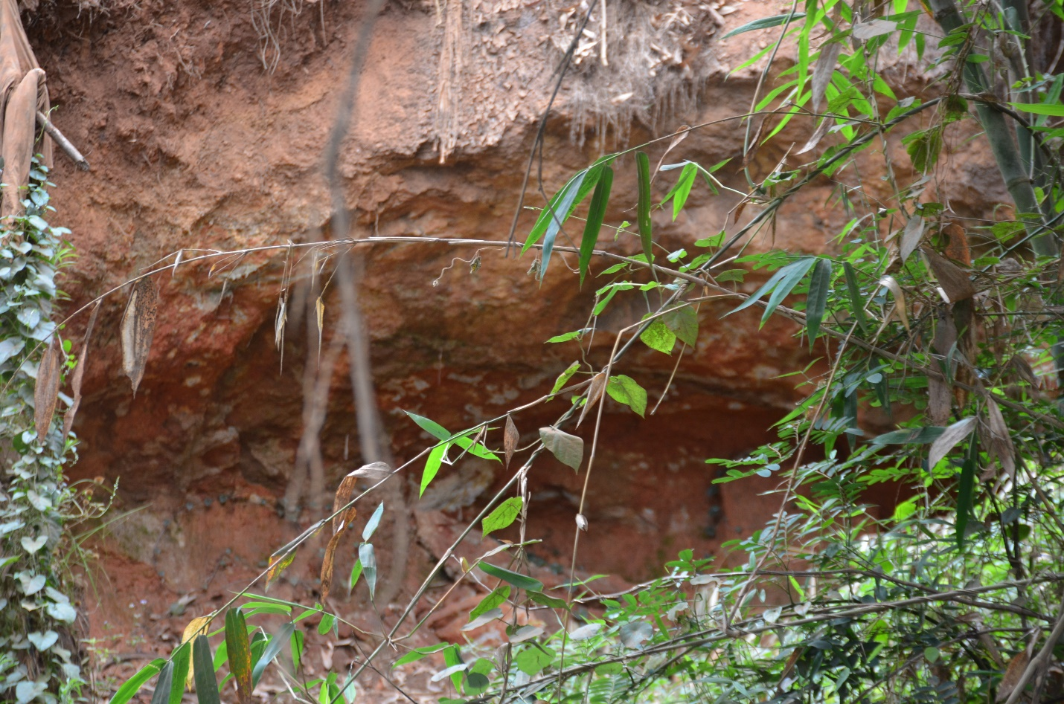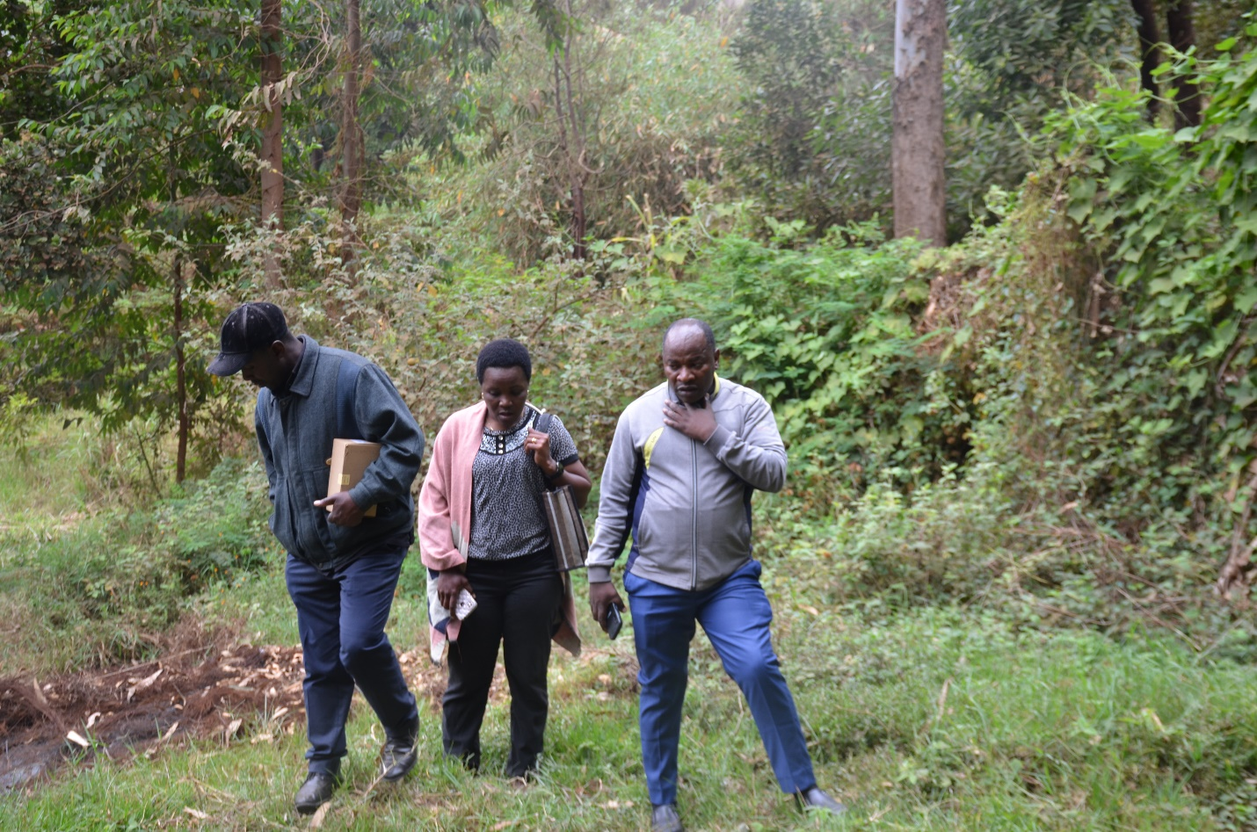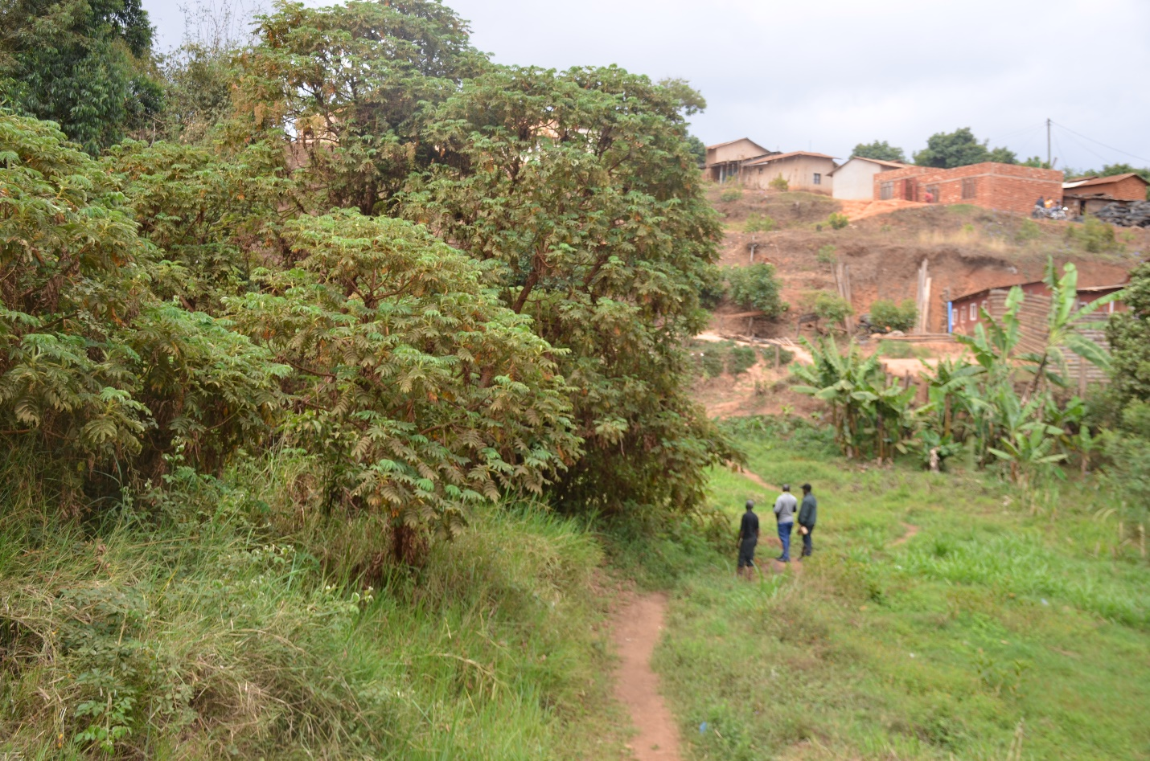

Figure 2: Students carrying the water back to the school.

Retrieved from President’s Office Regional Administration and Local Government, Njombe Region: http://www.njombe.go.tz/ [Last accessed: 16th July 2020]
Retrieved from President’s Office Regional Administration and Local Government, Njombe District Council: http://njombedc.go.tz/ [Last accessed: 16th July 2020]

