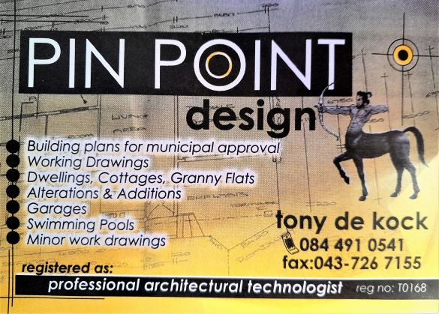

1st August 2022
Quotation for Plans and Building of Safe House for Greensleeves Children’s Trust
Draw plans and construct building as follows:

- Building size : 20m x 10m
- Total SQ Meters; 200 Total cost : 850,000 ZAR or $42500
- This will include the following :
    - Labour
    - Block work up to roof height
    - Roofing
    - Plaster and Painting
    - Aluminum windows and sliding door
    - Tiling for floor
    - Labour for Tiling
    - Veranda
- Total cost for building of a Safe House for up to 30 children, with bathrooms, Lounge area and small Kitchen area
I await your further instruction to commence construction.
TONY DE KOCK
081 512 6314

