Profile of Geladas

**GELADA**

The gelada (Theropithecus gelada) is a species of [Old World monkey](https://animalia.bio/lists/old%20world%20monkeys) found only in the [Ethiopian Highlands](https://animalia.bio/ethiopian-highlands). Like its close relatives the baboons (genus Papio), it is largely [terrestrial](https://animalia.bio/terrestrial), spending much of its time foraging in [grasslands](https://animalia.bio/grassland). They are the last surviving member of a grass-grazing primate group, members of which were abundant and widespread in the past.

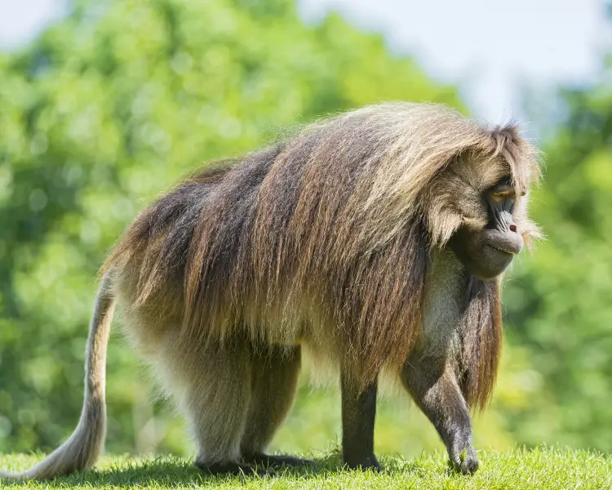

Geladas have buff to dark brown fur, a dark face, and pale eyelids. Adult males are characterized by longer back hair and a distinctive bright red patch of skin on their chests, shaped like an hourglass. Females also have a bare patch of skin, though less prominent, which brightens during estrus and features a "necklace" of fluid-filled blisters. Males typically weigh around 18.5 kg (41 lb), while females average 11 kg (24 lb). Their head-body length ranges from 50 to 75 cm (20 to 30 in), with tails measuring between 30 to 50 cm (12 to 20 in).

The gelada exhibits a complex multilevel social structure. Its basic groupings include reproductive units and male units, with bands consisting of multiple reproductive and male units. Communities can comprise one to four bands, and females within reproductive units are often closely related. Males typically leave their natal groups to establish their own units, where females can choose to support or oppose the new male. In units with multiple males, only one male mates with the females.

Geladas have a diverse range of vocalizations, which are thought to be nearly as complex as human communication. Their population has declined from approximately 440,000 in the 1970s to around 200,000 by 2008. The International Union for Conservation of Nature (IUCN) currently lists the gelada as Least Concern.

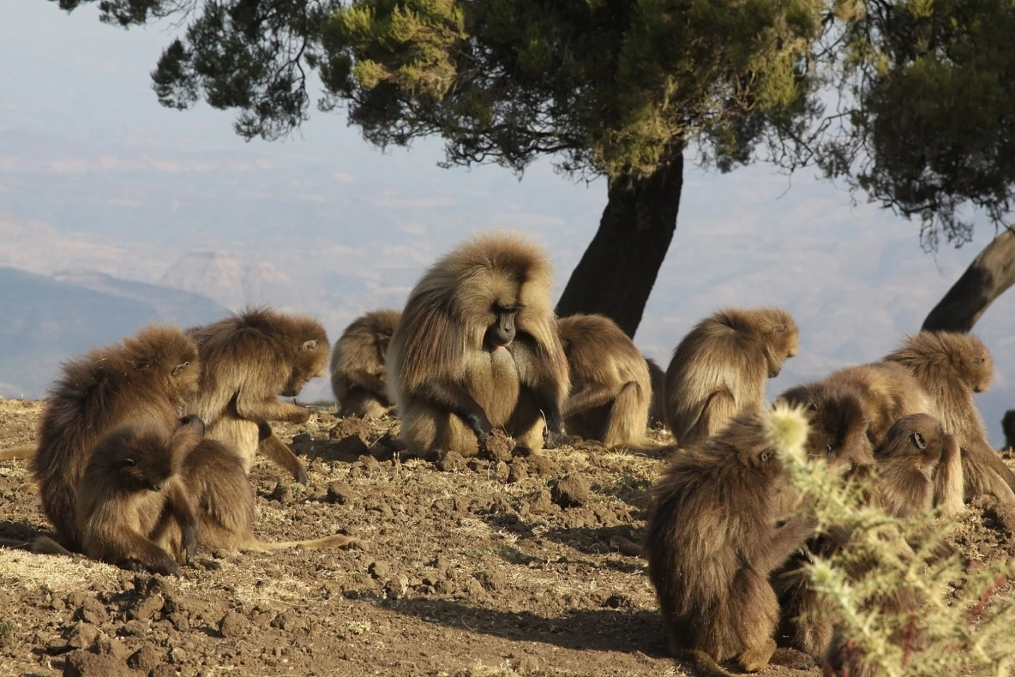

Appearance

The gelada is large and robust, and it is covered with buff to dark-brown, coarse hair and has a dark face with pale eyelids. Its arms and feet are nearly black. Its short tail ends in a tuft of hair. Adult males have a long, heavy cape of hair on their backs. The gelada has a hairless face with a short muzzle that looks more similar to a chimpanzee's than a baboon's. It can also be physically distinguished from a baboon by the bright patch of skin on its chest. This patch is hourglass-shaped. On males, it is bright red and surrounded by white hair; on females, it is far less pronounced, but when in estrus, the female's patch brightens, and a "necklace" of fluid-filled blisters forms on the patch. This is thought to be analogous to the swollen buttocks common to most baboons experiencing estrus. In addition, females have knobs of skin around their patches. The gelada has several adaptations for its terrestrial and graminivorous (grass-eating) lifestyle. It has small, sturdy fingers adapted for pulling grass and narrow, small incisors adapted for chewing it. The gelada has a unique gait, known as the shuffle gait, that it uses when feeding. It squats bipedally and moves by sliding its feet without changing its posture. Because of this gait, the gelada's rump is hidden beneath, so is unavailable for display; its bright red chest patch is visible, though.

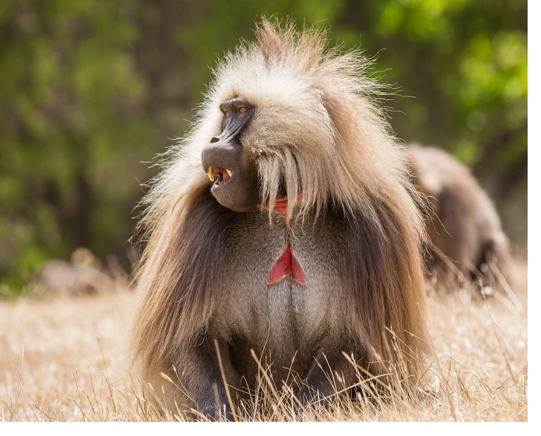

**GELADA**

**Gelada baboon, Bleeding-heart monkey, Lion baboon, Bleeding-heart monkey baboon**

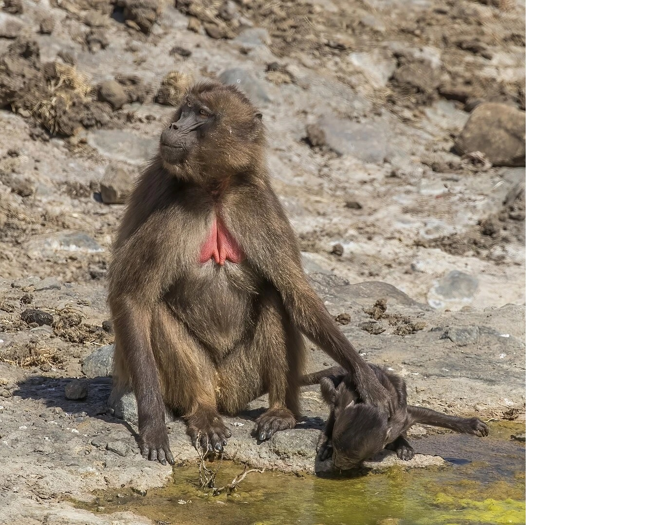

**The gelada (Theropithecus gelada, Amharic: ጭላዳ, romanized: č̣əlada), sometimes called the bleeding-heart monkey or the gelada baboon, is a species of Old World monkey found only in the Ethiopian Highlands, living at elevations of 1,800–4,400 m (5,900–14,400 ft) above sea level. It is the only living member of the genus Theropithecus, a name is derived from the Greek root words for "beast-ape". Like its close relatives the baboons (genus Papio ), it is largely t ...**

**errestrial, spending much of its time foraging in grasslands, with grass making up to 90% of their diet.It has buff to dark brown hair with a dark face and pale eyelids. Adult males have longer hair on their backs and a conspicuous bright red patch of skin on their chests shaped like an hourglass. Females also have a bare patch of skin but it is less pronounced, except during estrus when it brightens and exhibits a "necklace" of fluid-filled blisters. Males average 18.5 kg (41 lb) and females average 11 kg (24 lb) in weight. The head-body length is 50–75 cm (20–30 in) with a tail of 30–50 cm (12–20 in).The gelada has a complex multilevel social structure. Reproductive units and male units are the two basic groupings, a band comprises a mix of multiple reproductive units and male units, and a community is made of one to four bands. Within the reproductive units the females are commonly closely related. Males will move from their natal group to try to control a unit of their own and females within the unit can choose to support or oppose the new male. When more than one male is in the unit, only one can mate with the females. The gelada has a diverse repertoire of vocalizations thought to be near in complexity to that of humans.The population of geladas is thought to have dropped from 440,000 in the 1970s to 200,000 in 2008. It is listed as Least Concern by the International Union for Conservation of Nature (IUCN).**

**Discover more**

