“Breaking the Myth Market” a project of
A Future Without Poverty, Inc.

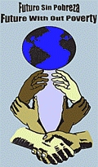
Working Vision Statement: A Future without poverty is working together with communities creating opportunities, providing resources and empowering people in a continual journey to eliminate poverty. Together we are promoting thriving communities globally with adequate opportunities for work, access to education, adequate healthcare, clean running water, nutritious food, comfortable shelter, and a hospitable environment where there exists a sense of security for everyone. A Future without Poverty is committed to working with the unique needs of each community, supporting that community as it grows in all areas of sustainability; Education, Enterprise, Environment and Empowerment and providing the tools needed for individuals and communities to decide their own destiny.
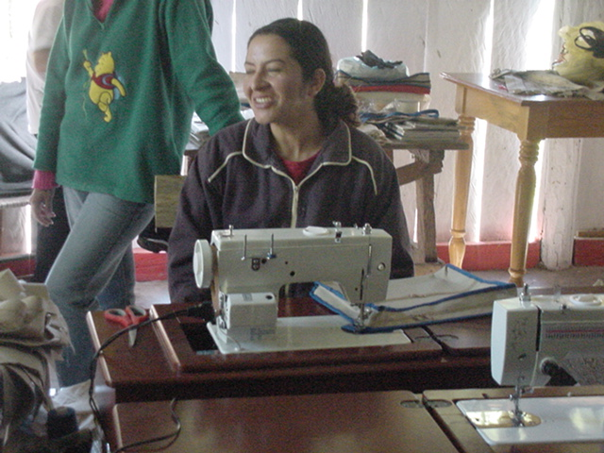
Flora De Compo – Women’s Cooperative A small isolated Mexican farming community in the mountains south of Guadalajara is comprised of 12 families. FWOP helped the community start a women’s cooperative that is creating jobs in the community.

Summary This project will create on online “Breaking the Myth Market” a global online market place that is devoted to creating jobs for those in poverty. The only solution to reducing poverty is to create jobs. A personal assessment of a person’s skills and talents is the first step to helping the person find suitable employment. In communities around the globe including the United States there is a lack of good paying jobs to lift a person out of poverty. A person can with a few dollars invested properly capitalize a small business if they can sell their product or service at a fair an equitable rate. Participants are empowered through business training and the knowledge if they work hard and produce goods products and services that they have a buyer for their goods.

What is the issue, problem, or challenge?

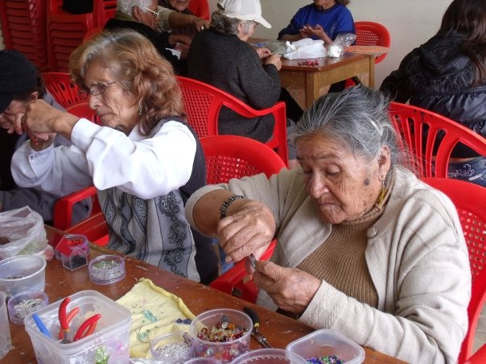
The myth of no effect, that an individual can not make a difference is being broken every day by FWOP donors and volunteers. Poverty can be found in every country and can be a life sentence of hunger, thirst, illness, illiteracy and premature death. Most handouts are only short term band aids to the problem and create a dependency on others for ones daily needs. The only real solution to eliminating poverty is to create jobs that pay a livable wage based on the local economic conditions. Individuals that are very creative and hardworking are only asking for a chance to earn enough money to feed, cloth and house their families. In many cases they make items that can create income for them if they can find a viable market that pays a reasonable price for their goods and services. A Future Without Poverty is creating an online “Breaking The Myth Market” for these items, this market helps individuals set up a business and provides a consistent source of income for their families. This is a photo of women in Peru that are making jewelry to help support the senior center that provides food, medicine and a meeting place for seniors in their community.

How will this project solve this problem?
This project will create on online “Breaking the Myth Market” that will provide a global outlet for goods and services that are created by individuals that are in poverty and have made a commitment and signed an agreement to create their own business. As part of the agreement FWOP provides a start up loan to the individual and in return they agree to supply a certain amount of goods or services. FWOP agrees to purchase a set amount of goods and or services for a period of one year. This provides a guaranteed income to the individual and encourages them to become self reliant. This project creates jobs, builds business knowledge, self respect and most importantly provides an opportunity for a future without poverty.

This is an example of a product made by individuals in Yucatan, Mexico. Each card sold provides over a days wages to the maker based on the local economic conditions. This individual is able to make 5 cards a day and could break the cycle of poverty for her family if she can sell the cards. FWOP will contract with her to buy 25 cards a month for the next 12 months.
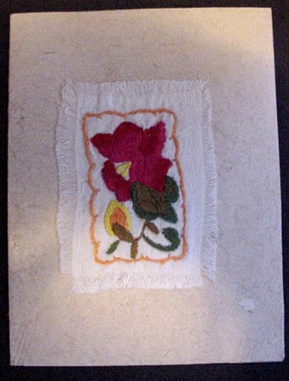
Hand crafted one of a kind card
Item description:
Size: Approximately 5" X 6.75" or 13 cm X 17 cm
(when folded)
Materials: hand made paper embroidery on hand made
cloth hand stitched to the paper
Origin: State of Yucatan, Mexico
This card was hand crafted by the Maya women in the
village of Yaxunah in the state of Yucatan, Mexico. The
paper called "hu'un" is made using the same process the
ancient Maya used to form the paper in their books, the
codices. The process of flattening with found ancient
Maya beater stones causes the unique striations on one
side of the paper.
Price: $5.00 Inventory number: Card 0001

Potential Long Term Impact

The “Breaking the Myth Market” will provide jobs to hundreds of individuals and will successfully break the cycle of poverty in their lives and create a future without poverty for them. Each dollar invested in this program will create hundreds of dollars in potential sales. For example: A donor makes a donation of $100 to FWOP we use the hundred dollars to buy 25 cards from the merchant. We sell the 25 cards for $125. We keep $25 to cover our costs and purchase another 25 cards from the merchant. This cycle is repeated 12 times a year and the individual makes $1,200 and FWOP makes $300 all from the donor’s original $100 donation. In this case each dollar the donor gave us was multiplied by 15X the first year and provided an income to one family that is equal to the median local income for those that have jobs in the community.

Project Message

A Future Without Poverty “Breaking the Myth Market” is creating jobs which is the only long term and permanent solution to reducing poverty. If a person is willing to work and can produce a unique item or service we can help them reach the dream of a future without poverty.

Funding

Funding goal: $ 50,000
For more details please go to http://www.fwop.org

Future With Out Poverty, Inc. 8733 Old Dumfries Road Catlett, VA 20119

501 (c) 3 non-profit Organization all donations tax deductible to the extent allowed by IRS

