A working sample of some items we plan to have available

Hand crafted one of a kind card

Item description:

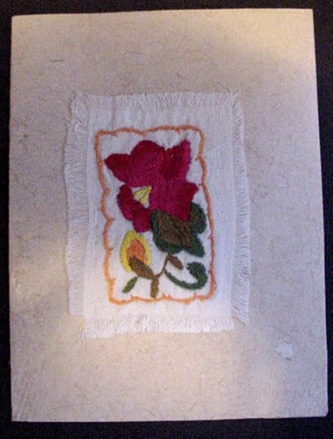
Size: Approximately 5” X 6.75” or 13 cm X 17 cm (when folded)

Materials: hand made paper embroidery on hand made cloth hand stitched to the paper

Origin: State of Yucatan, Mexico

This card was hand crafted by the Maya women in the village of Yaxunah in the state of Yucatan, Mexico. The paper called “hu’un” is made using the same process the ancient Maya used to form the paper in their books, the codices. The process of flattening with found ancient Maya beater stones causes the unique striations on one side of the paper.

Price: $5.00 Inventory number: Card 0001

Hand crafted one of a kind card

Item description:

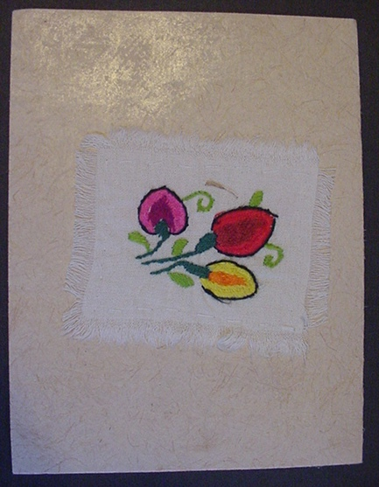
Size: Approximately 5” X 6.75” or 13 cm X 17 cm (when folded)

Materials: hand made paper embroidery on hand made cloth hand stitched to the paper

Origin: State of Yucatan, Mexico

This card was hand crafted by the Maya women in the village of Yaxunah in the state of Yucatan, Mexico. The paper called “hu’un” is made using the same process the ancient Maya used to form the paper in their books, the codices. The process of flattening with found ancient Maya beater stones causes the unique striations on one side of the paper.

Price: $5.00 Inventory number: Card 0002

Hand painted one of a kind card
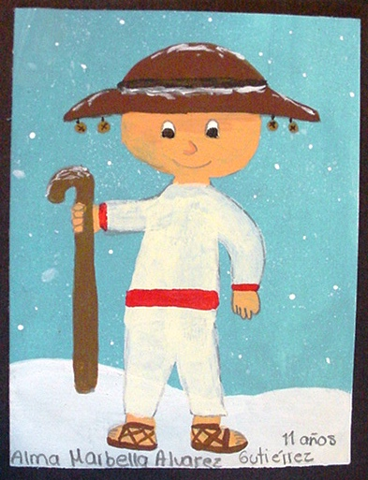
Item description:

Size: Approximately 5” X 6.5” or 12.5 cm X 16 cm (when folded)

Materials: water colors on card stock

Origin: Ajijic, Jalisco Mexico

This card was hand painted by Alma Malbella Alvarez Gutiellez an eleven year old orphan. Your purchase of this card provides some spending money for this child and helps the orphanage to take care of her and her friends.

Price: $5.00 Inventory number: Card 0003

Hand painted one of a kind card

Item description:

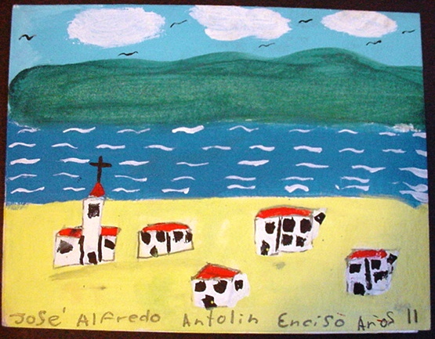
Size: Approximately 5” X 6.5” or 12.5 cm X 16 cm (when folded)

Materials: water colors on card stock

Origin: Ajijic, Jalisco Mexico

This card was hand painted by Jose Alfredo Antolin Enciso an eleven year old orphan. Your purchase of this card provides some spending money for this child and helps the orphanage to take care of him and his friends.

Price: $5.00 Inventory number: Card 0004

