ACTIONSO GROUP FOR DEVELOPMENT « GRAD « Asbl
4, Avenue Luano , Joli Parc, Commune of Ngaliema , Kinshasa, Bukavu : Av.KINDU N°38/C Ibanda
Baraka center, AEBAZ I district, FIZI territory, South Kivu DR CONGO
Email: gradasbl2008@gmail.com/Tel . +2343829902102, 990997599 www.gradasbl.org

SOUTH KIVU PROVINCIAL CORDINATION

ADVOCACY NOTE N° 002/CP/GRAD/2025 OF HUMANITARIAN SOLIDARITY IN FAVOUR OF THE DISPLACED VICTIMS OF THE WAR IN GOMA
Subject: Appeal for urgent humanitarian assistance for victims of armed conflicts in
Goma/North Kivu/Democratic Republic of Congo.

To the Idealist team and partners.

Introduction

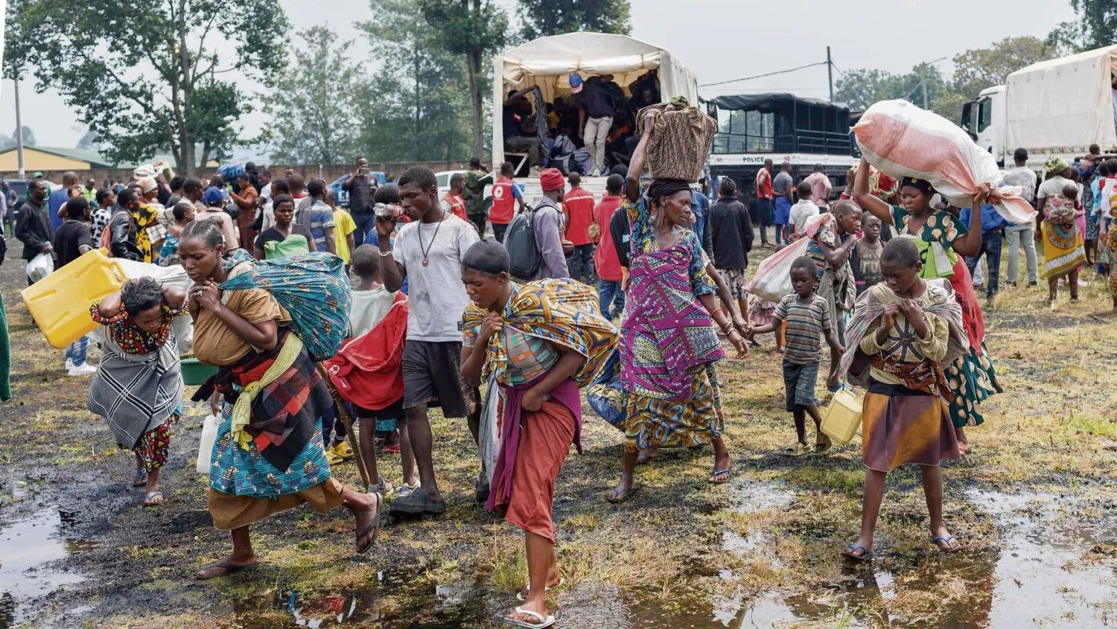
Photo : Displaced people from Goma in the east of the Democratic Republic of Congo, January 27, 2025

The Democratic Republic of Congo "DRC", its eastern part, in the Provinces of North and South Kivu and its surroundings have been experiencing clashes for several months between the regular army and the M23 rebel movement which has caused enormous human and material losses, massive displacement of populations in localities in the neighboring Province of South Kivu, exposing thousands of people to extremely precarious living conditions.
Faced with this alarming situation, we, the undersigned, Groupe d'Actions pour le Développement "GRAD", a non-profit association, advocate for increased and coordinated humanitarian assistance for internally displaced persons who are victims of these conflicts.

Background and Justification
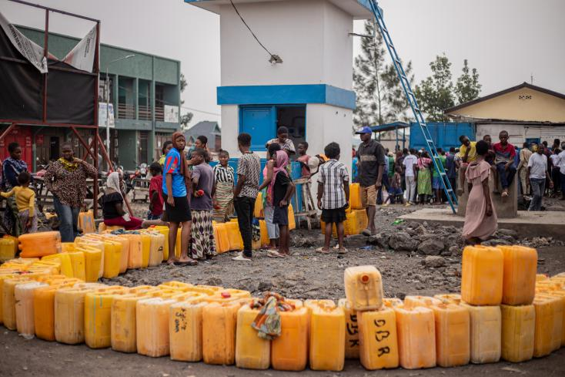
Photo : Water shortage in the city after four days of power cuts and electricity and REGIDESO
Since midday on 28 January, there has been a relative lull in Goma, where the M23 appears to have taken control of a large part of the city of Goma, following intense fighting with the Congolese army. Looting of businesses, offices and warehouses of humanitarian organisations has been reported, while heavy weapons fire and explosions have been heard in various locations in the city since 27 January.
Humanitarian sources report several incidents of violations of International Humanitarian Law (IHL), including sexual assaults perpetrated by armed elements. Many lifeless bodies, more than 700 bodies litter the streets of the city of Goma. Although it is difficult to establish a precise toll of the number of civilians killed, the human losses could be significant.
In Goma, essential services have been severely disrupted. Water and electricity have been cut off, and transportation has been virtually non-existent since midday on 26 January. Internet access has also been interrupted since 1pm on 27 January, complicating humanitarian coordination operations.
On 26 January, at least 12 people lost their lives and about ten others were injured as a result of shelling at the Rusayo 1 and 2 sites in Nyiragongo territory. Several water, hygiene and sanitation facilities, as well as shelters, were also destroyed. As a direct result, more than half of the populations of the Kanyaruchinya , Bushagara , Rusayo 1 and Rusayo 2 IDP sites left these areas. Some headed to Goma or other nearby localities, others found refuge with host communities, in schools and other collective infrastructures and others in localities in the neighbouring province of South Kivu ( Kalehe and Idjwi territories ).
Due to the fighting, humanitarian activities are severely limited. Only health and water, hygiene and sanitation interventions continue.
Since 22 January, schools in Goma and Nyiragongo have been closed due to the ongoing clashes. Health facilities are saturated and are organising to care for the seriously injured, despite power and water cuts. Medical evacuation is becoming a challenge in a context of persistent violence, with ambulances being targeted. An ambulance driver was shot on 28 January. On the same date, the International Committee of the Red Cross (ICRC) recorded 256 wounded at Ndosho hospital (City of Goma), while Médecins sans Frontière recorded more than 61 wounded at Kyeshero hospital (City of Goma). Goma airport has been closed since 26 January, leading to the suspension of air traffic, including humanitarian cargo and rotations of humanitarian personnel. Most of the roads linking the city of Goma to the rest of the country are also cut off.
In South Kivu Minova – Kalehe : On 26 January, clashes continued between the Congolese army and the M23 in several localities around Minova and forced the displaced population to leave the reception sites to return to their villages of origin or to find refuge with host families.
Cases of human rights violations have been reported, with several people subjected to forced labour. Local sources also report the forced recruitment of youth by armed groups.
At a humanitarian coordination meeting held on 27 January in Bukavu, humanitarian actors estimated that at least 19,500 households, or more than 117,000 people, were newly welcomed in the Kalehe health zone in Kalehe territory, including children, women, and other vulnerable people, between 20 and 27 January. Also, more than 22,800 displaced people arrived on Idjwi Island by river between 18 and 26 June. These people fled Minova during this period and settled in schools, churches, and with host families.
In South Kivu Access routes to Minova have been blocked since January 18, 2025, particularly on the Minova-Bunyakiri , Kalehe-Idjwi , and Minova - Kalehe -Bukavu axes, due to insecurity on the various front lines. Added to this is the measure taken by the Governor of South Kivu on January 29, 2025, prohibiting all navigation on Lake Kivu, then a route connecting Bukavu to Goma, Bukavu- Kalehe ( Minova and other villages in the Territory).
The Development Action Group, being a humanitarian organization, whose beneficiaries are orphaned women and children, is ready to intervene in this area as soon as the security situation allows. This is why we are asking the the Idealist team and partners to mobilize the necessary funds to support these displaced and destitute populations in order to guarantee them hope of still living.
The Development Action Group "GRAD" is always ready to come to the aid of vulnerable populations, we hope that this advocacy note will attract particular attention to any organization or person with a charitable and philanthropic spirit, we urge you to act diligently to meet the urgent humanitarian needs of the victims of these conflicts, their survival and dignity depending on the solidarity and commitment of everyone.
And finally, we recommend that substantial financial resources of $1, $2, $10, $100, $1000... be mobilized in order to respond to:
- Strengthening humanitarian aid in the distribution of food and non-food items
- Increased protection of displaced populations, particularly women and children, against violence and sexual abuse;
- Psychosocial and educational support for displaced persons to promote their resilience and reintegration into local communities
- We urge the relevant authorities, humanitarian organizations and the international community to act diligently to address the urgent needs of the victims of the conflicts in Goma. Their survival and dignity depend on solidarity

Done in Bukavu, February 3, 2025
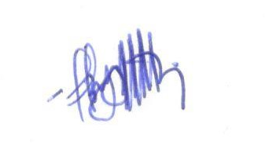

Adrien M'MASSA BYA'OMBE
Coordinator

