 Tell Our Story

Project Title: Weaving a Future: Girls' Empowerment through Sewing

Summary: What will this project do?

Al Mehran Research and Development Foundation (AMRDF) has provided life skills training to 140 girls and women in the field of sewing and stitching who could not attend formal schooling due to some irrepressible conditions. By acquiring this skills women can gain financial stability, independence, and empowerment thereby improving their overall wellbeing. There is need for sewing machines and related threats and twines stuff for starting the business. Your donations will help us provide them machines and related stuff to start their business.

Recommended 500 character maximum
Funding Amount/Goal: How much money do you hope to raise (in USD)? 5000

Challenge  What is the problem or need?  In Pakistan, many girls face significant barriers to accessing higher education, leading to high dropout rates and dependencies this may include financial constraints, gender inequality, lack of access, poverty, and cultural barriers. These challenges hinder girls' educational progress, perpetuating gender disparities and limiting their future opportunities thereby pushing them to live below the poverty line. Resultantly, affecting their reproductive health and face many other challenges.  Recommended 500 character maximum | Solution  How will this project solve the problem?  Provision of sewing and stitching training will earn a steady income for such girls and women through freelance work or employment, support their families and gain financial stability, gain confidence and independence, break free from gender barriers and societal expectations, develop a marketable skill, in high demand in Pakistan's textile industry, potentially start their own businesses, becoming entrepreneurs and role models.  Recommended 500 character maximum | Long-Term Impact  How will this make a lasting impact in your community?  Ultimately, the project will result in enhancing their productivity and efficiency, increase their earnings and financial stability, expand their customer base and market reach, encourage entrepreneurship and innovation, build confidence and self-reliance, create a sense of ownership and accountability, help them become role models, inspiring others to pursue similar opportunities.  Recommended 500 character maximum

Donation Options: How can you illustrate the impact of a person’s donation? For the purpose of this exercise, we recommend outlining three donation options under $100.

Amount | Description
$ 71 | Sewing Machines
$ 35 | threats, cloths, twines etc
$ 30 | Table for sewing machine
Photo Gallery
Choose four images that show the impact of your work and draft clear captions. Choose high-resolution photos that are positive and empowering and show the community you serve with respect and dignity. Before sharing a photo, ask yourself this question: Would I want to be portrayed this way? Does this image instill hope? Upload photos to worksheet however makes the most sense - photos don’t have to fit perfectly in box!
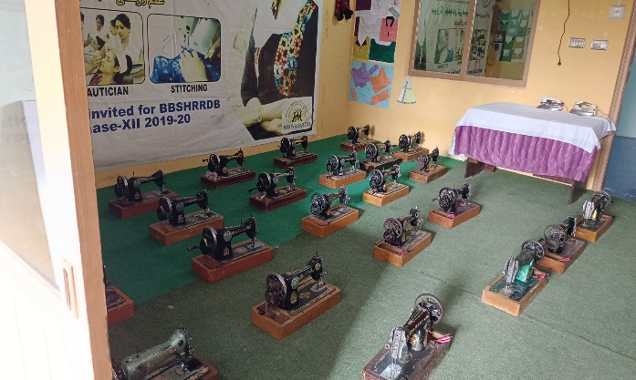  PHOTO | 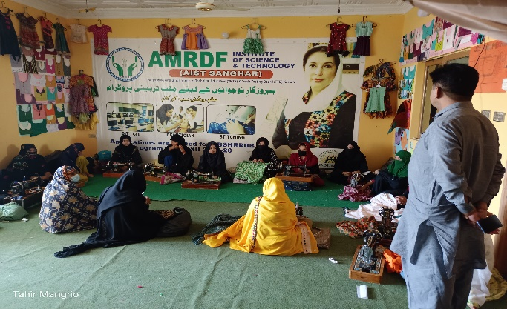  PHOTO
Sewing machines availability for training purpose to the girls/female learners | Learners are taking sewing and stitching classes
PHOTO  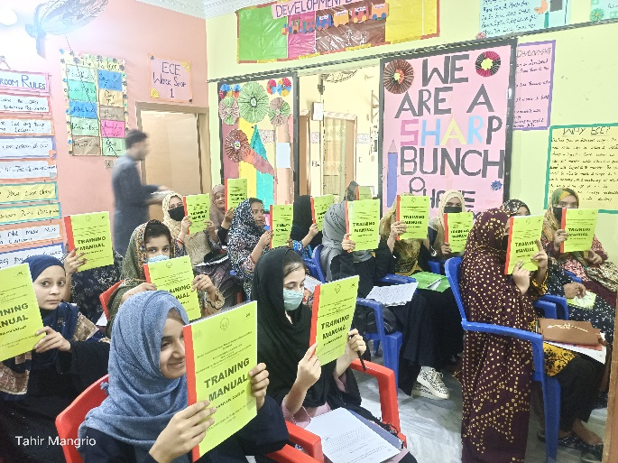 | 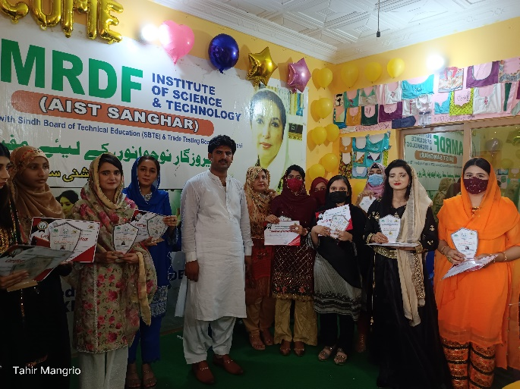  PHOTO
Leaners attending the training on sewing/stitching | Certificates distributed to successful leaners

