
AUSTIN SICKLECELL SUPPORT ORGANISATION (AUSSO)
MASINDI- UGANDA
Email:ausso.cbo@yahoo.com
TEL: +256709372393
____________________________________________________
WHO WE ARE:
AUSTIN SICKLECELL SUPPORT ORGANISATION(AUSSO) is a Community Based Organisation (C.B.O), which was formed by a group of a few born again community individuals that serve at St.Mathew’s cathedral Masindi in Bulyasojo Village, Central Division, Masindi Municipality in the year 2021, Ms.Nabukeera Annet Kagoro being the vision bearer.
It was founded on a basis of an inspiration story about a child by the names of Austin Lameck Laloyo who is a victim of the sickle cell anemia disease whose life was rescued and transformed through the kind contribution of an International friend from the USA. Through him, Austin was able to access the best doctors and medication at the National Referral Hospital in Mulago-Uganda. Today Austin is so healthy and no one can tell from his physical appearance that he is a Sickler.
We exist to help the vulnerable sicklecell anemic children be able to access medical facilities, medical attention and enough information about the disease in order to overcome the hardships involving around the disease.
We look towards changing vulnerable sicklecell anemic children’s lives in the same way through different individuals and organisations holistically.
We are registered as a Community Based Organisation since November 2021 under Masindi Municipal Council, Masindi District in Uganda with 2021/2081 being our registration number.
OUR MISSION:
To create awareness, empower vulnerable sickle cell anemic children, inspire families and communities to rise and mitigate the causes and effects of sickle cell anemia for a positive living.
OUR VISION:
Sensitized informed children, families and communities for a tomorrow sickle cell free environment.
OBJECTIVES:
- To contribute to the fight against the prevalence of the sickle cell causes and effects in Masindi District initially and Uganda at large in the foreseeable future.
- To provide social, moral, spiritual, medical and educational assistance or rehabilitation to vulnerable children affected by the sickle cell.
- To improve the health and nutritional status of the sickle cell children.
- To encourage the fear of God among all the children irrespective of everyone’s religion.
- To build the esteem of the vulnerable sickle cell anemic children.
- To sensitize the community about the disease.
- To encourage voluntary testing of sickle cell.
- To carry out any activity as may be incidental and conducive to the attainment of the above objectives.
WHAT WE DO:
- Health screening, counseling and guidance: This is being done by the medical personnel at the initial day of taking the beneficiary to hospital and other routine days of their hospital visits as well the counseling department of our local church alongside the Hospital counsellors.
- Treatment support: This is done on a monthly basis by providing them with medications like Fansida, Pen V, Folic Acid, Hydroxyurea capsules and pay for emergency medical bills as well when funds allow.
- Nutritional support: We provide these children with nutritional supplements that are within our financial reach which help in the strengthening and building of their immunity on a monthly basis
- Transport to hospital: This is provided at every hospital visit since the beneficiaries stay long distances from the health facility and they can’t afford the transport fares.
- Financial empowerment: This is done occasionally when funds allow by giving caregivers some funds that can help them to start up an income generating activity.
- Improving standards of living: Its done only when funds allow us to do so in different ways like providing household items.

However, we wish to do the following activities with the children as well if funds allow:
- Raising sensitization campaigns amongst the community and other neighboring communities.
- Community voluntary counselling and testing.
- Bible studies for the children aimed at introducing them to a personal relationship with God.
- Outdoor and indoor games and sports.
- Hand work.
- Livelihood support for the beneficiary’s family through income generating activities which will lead to a saving scheme for a better future of the children and sustainable healthy lives since we cannot support them for their entire life time.
- Education support for the children.
- Raise funds to build a sickle cell clinic/hospital in our area since the country only has one central one which can’t be accessed by everyone.
- Have our own home/offices as an organisation

Below are some of the field photos of the children we reach out to:
- MURUNGI NICKSON (AUSSO/2081/001)
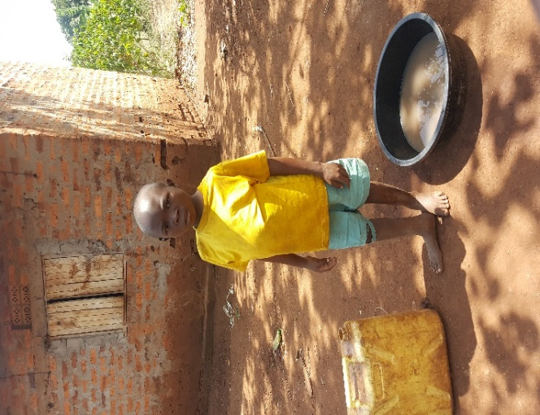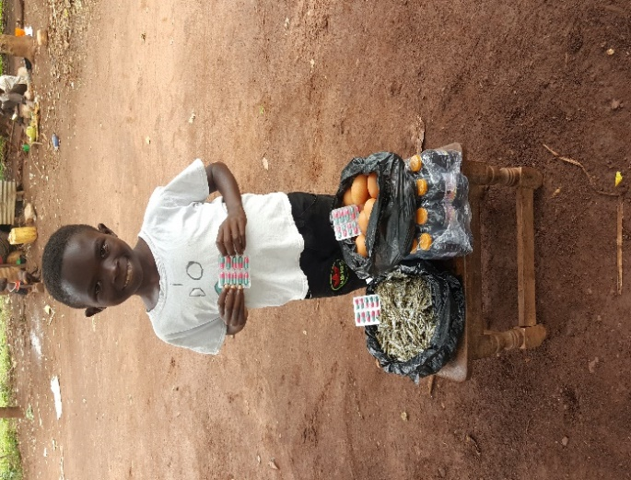
Before After
He was our very first child to be brought on board. The only medication his family knew was Folic Acid of which it wasn’t being given to him on a daily basis as well so we took him to the hospital for screening and he was introduced to other medications like hydroxyurea capsules and some nutritional supplements. Since then his hemoglobin level increased and he has never been transfused again. His grandmother says he no longer falls sick like he used to on a weekly basis and he attends school every day yet he had dropped out of school because of over falling sick. The grandmother says she never imagined Murungi ever living a normal life like he is today and he smiles like never before because all the time was sorrow for him. She is so grateful to God for the work we are doing.
2.MUTEGEKI DUNCAN WARREN (AUSSO/2081/002)
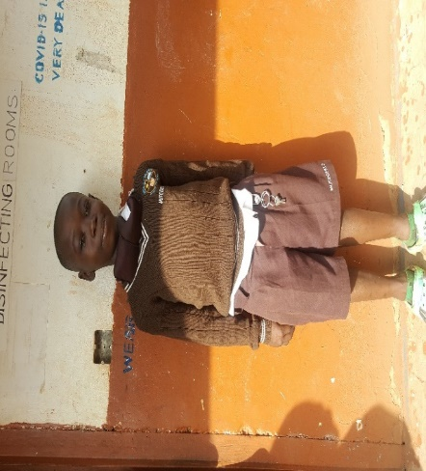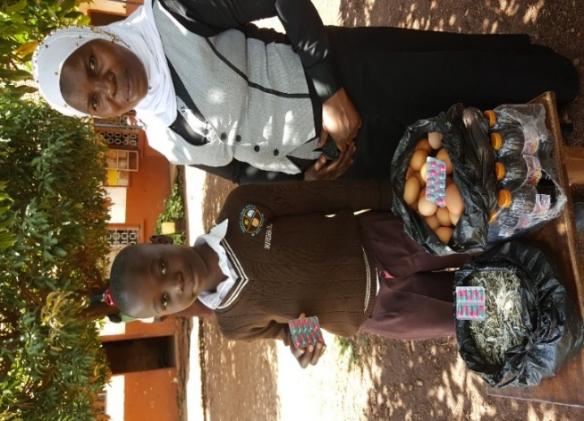
Before after
He was our second child on board. He is going to completed his Primary education year 2022 and now in Secondary school. Duncan used to experience joint pains and headaches and every month would be admitted to hospital for some good days but since he started using hydroxyurea capsules he has only been admitted twice in 2years. His mother thanks God for the transformation in his life. The nutritional supplements have been of great importance to him as well because he hasn’t been transfused too again. He now lives a normal life with the daily medication. He told his mother of recent that he feels fat now. In the photo with him is the teacher who helps us to remind them to take their medication while at school.

- AHUURA MAHAD MUHAMMAD(AUSSO/2081/003)

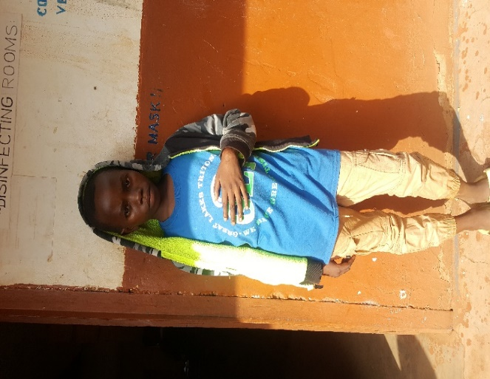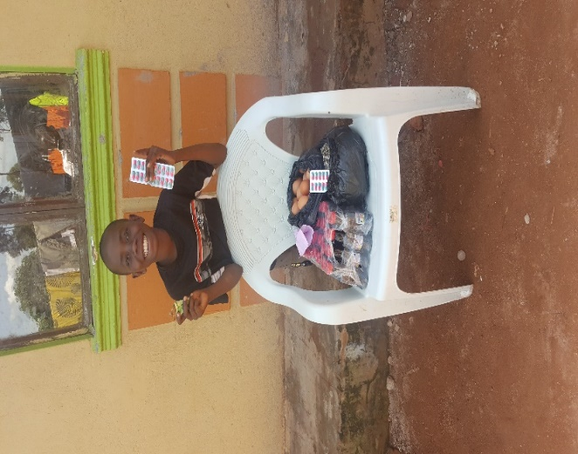

Before After
Mahad came on board at the same time with Duncan. We found him with a paralyzed hand that had come as a result of a crisis he had experienced. His mother said they had heard about hydroxyurea capsules but they weren’t using it because it was expensive and they couldn’t afford it. Before starting hydroxyurea Mahad always experienced strong headaches, joint pains and would fall sick often but after starting hydroxyurea his health has greatly improved and his hand is back to normal. Recently he went to Mulago National Referral hospital and the doctors commended the good care that was being rendered to him because they found him healthier. Mahad too will be completed his Primary Education and joined. We thank God for the good health he has given to him.
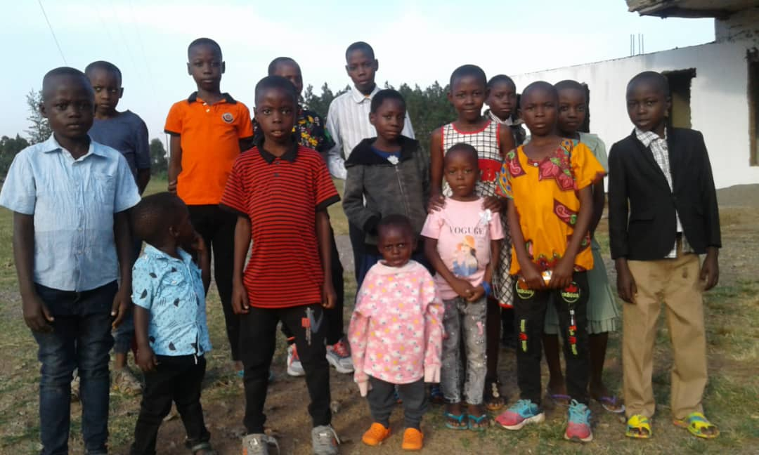
These fifteen children in a group photo after a meeting with their caregivers
HOW WE RAISE FUNDS:
This is done locally by contacting our local community both individuals and Organisations. Initially we were given an opportunity in our local church to speak about our organization and we raised a little amount which gave us a starting point. Today it’s more of individual donors that we depend on because organisations want to fund Organisations with a big number of already impacted beneficiaries yet we are still at the start up level.
Some different individuals committed themselves to be donating to us monthly and others donate when they have. It is a challenge because even those that committed to monthly donations sometimes fail where in such a case I have to table it up with my husband and we use some of our family savings.
I as well tried an online fundraiser with M-CHANGA and it didn’t yield that much for we got only two donations though I was thankful to God for it for it pushed us for a month.
Most of the organisations I have written to haven’t responded or have given a sorry so it’s generally more of individual donations dependency. Our highest donor gives us UGX100,000= USD30 and our lowest donor gives us UGX1,000=USD 0.3
WHAT WE NEED:
Currently
We have 50 registered children but due to financial constraints we only take care of 20children and this has happened since February 2022. Below is a summarized expenditure.
- Each child is budgeted for 200,000ugx(USD$59) monthly as broken down below
ITEM | AMOUNT(UGX) | USD($1=3400UGX)
MEDICAL BILLS | 140,000 | 41
NUTRITIONAL SUPPLEMENTS | 50,000 | 15
TRANSPORT TO HOSPITAL | 10,000 | 3
TOTAL | 200,000 | 59

- Operational costs monthly:
ITEM | AMOUNT(UGX) | USD($1=3400UGX)
OFFICE RENT | 200,000 | 59
STATIONERY, OFFICE MAINTANENCE AND OTHER CHARGES | 200,000 | 59
AIRTIME | 20,000 | 6
TRANSPORT ASSOCIATED | 80,000 | 24
TOTAL | 500,000 | 148

NB: However most of the operational costs have always been met in kind by some individuals because our monthly financial support couldn’t handle them.
If we are to support the other 30children too, we need $1770 monthly and $148 for operational costs.
We need to increase on the number of the beneficiaries because the number of suffering vulnerable sicklecell anemic children in the area is overwhelming.
We need an office from which we can carry on our operations.

BANK DETAILS:
ACCOUNT NAME: AUSTIN SICKLECELL SUPPORT ORGANISATION (AUSSO)
ACCOUNT NUMBER: 1028202019168
BANK BRANCH: MASINDI
BANK NAME: EQUITY BANK
SWIFT CODE: EQBLUGKA
WESTERN UNION: NABUKEERA ANNET
WHATSAPP NUMBER: +256709372393
MOBILE MONEY NUMBERS: +256787295579, +256709372393(NABUKEERA ANNET)

COMPILED BY:
NABUKEERA ANNET KAGORO
CHIEF EXECUTIVE OFFICER
AUSTIN SICKLECELL SUPPORT ORGANISATION (AUSSO)
Email:annnabu@ymail.com

