 Tell Our Story

Project Title: Empowering Pedals; One Girl, One Cycle

Summary: What will this project do?

Al Mehran Research and Development Foundation (AMRDF) is providing free and quality education to the children belonging to poor families in its 10 schools where 1200 girls students are getting free and quality education but due to long distance to the schools, most of the girls have to walk miles to reach school which cause long absenteeism and dropout which ultimately result in early marriages. Your donation to the empowering pedals will help provide cycles and bags to the girls for redressing their issue.

Recommended 500 character maximum
Funding Amount/Goal: How much money do you hope to raise (in USD)?
5000

Challenge  What is the problem or need?  Girls in District Sanghar face more challenges in accessing quality education. Most population lives in the rural settings, where girls face significant transportation barriers and lack of safe and reliable transportation options forces them to walk long distances, often in harsh weather conditions, making them vulnerable to safety risks and fatigue. This leads to high absenteeism and dropout rates, hindering their educational and socio-economic empowerment.  Recommended 500 character maximum | Solution  How will this project solve the problem?  Providing one cycle to one girl who travels long distances to reach school can significantly reduce absenteeism and dropout rates. This simple intervention can transform her daily commute, saving time and energy, and ensuring she reaches school safely and consistently. By bridging the distance barrier, we can empower girls to pursue their education, unlock their potential, and break the cycle of poverty. Let's pedal towards a brighter future, one cycle at a time.  Recommended 500 character maximum | Long-Term Impact  How will this make a lasting impact in your community?  Empowering girls with cycles creates a ripple effect, transforming their lives, families, and communities. Education unlocks their potential, leading to better healthcare, economic independence, and informed decision-making. As they become change-makers, they'll break gender stereotypes, challenge social norms, and inspire future generations. This small act of providing cycles sparks a chain reaction, contributing to a more equitable, prosperous, and enlightened society.  Recommended 500 character maximum

Donation Options: How can you illustrate the impact of a person’s donation? For the purpose of this exercise, we recommend outlining three donation options under $100.

Amount | Description
$ 90 | Speed Bicycle 26 inch Alloy Rim Adjustable Seat for girls students coming from long distance
$ 20 | School bag, uniform and shoes for poor and needy students who are regular and deserving
$ 30 | snacks from students for 3 days
Photo Gallery
Choose four images that show the impact of your work and draft clear captions. Choose high-resolution photos that are positive and empowering and show the community you serve with respect and dignity. Before sharing a photo, ask yourself this question: Would I want to be portrayed this way? Does this image instill hope? Upload photos to worksheet however makes the most sense - photos don’t have to fit perfectly in box!
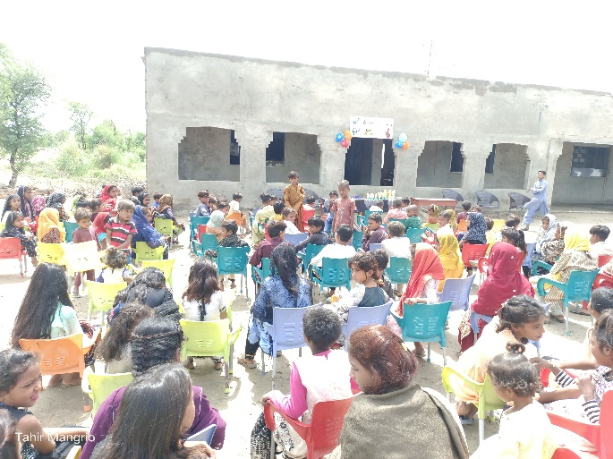  PHOTO | 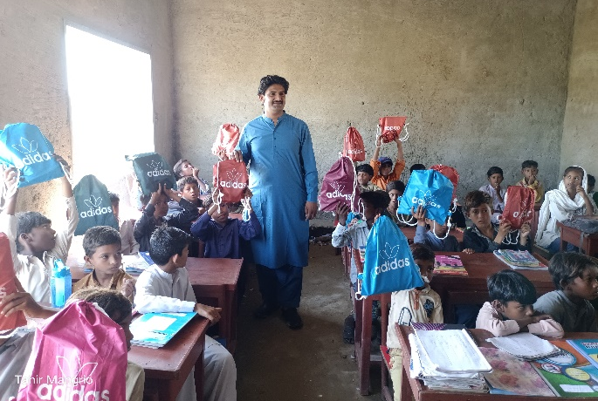  PHOTO
Students attending result declaration ceremony | Bags are distributed to students
PHOTO  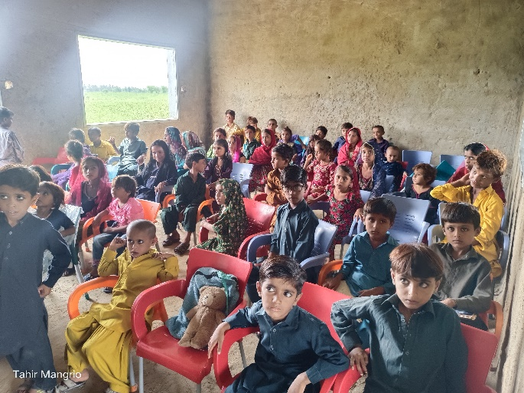 | PHOTO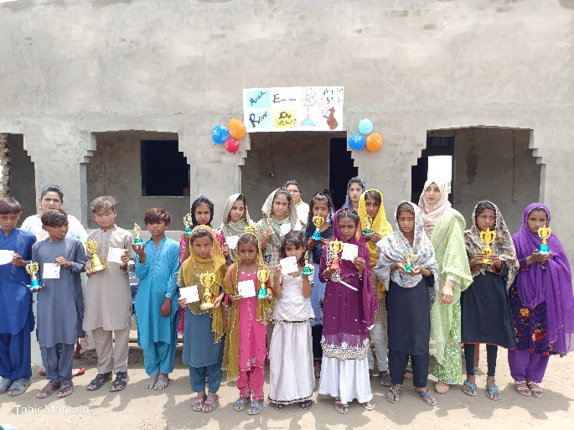
Students are taking classes | High achievers are awarded

