Te 0742345665 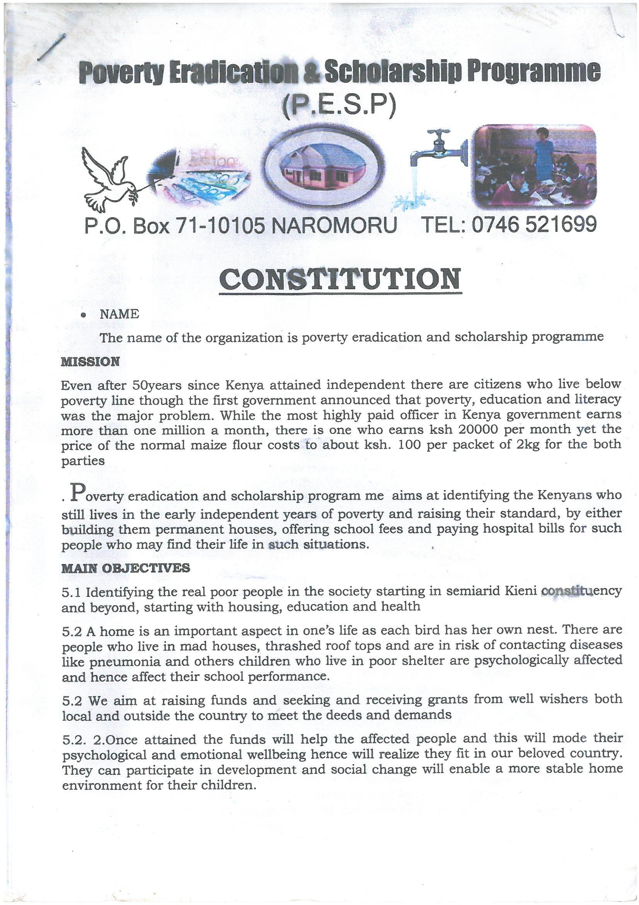
Email: povertyeradication.scholarship@gmail.
J H edana primary shool uniform fundraising badgert
ITEM | DESCRIPTION | AMOUNT
1 | GRANT
2 | LOCAL INCOME DONATIONS
3 | INTERNATIONAL DONATIONS | 8334 USD
4 | BANK INTEREST | 0
 | TOTAL INCOME | 8334
 | EXPENDITURE
ITEM | DESCRIPTION | AMOUNT
1 | SALARIES | 20000.3
2 | RENT
3 | MAINTENANCE | 0
4 | EQUIPMENT AND SUPPLIES
5 | MEDIA AND COMMUNICATION
6 | OFFICE EXPENSES
7 | PROJECT COSTS | 50000 USD
8 | PROJECT RELATED COSTS
9 | TRAVEL | 10333.0
10 | MISC EXPENSES | 3000.3
11 | COMMUNITY RELATED EXPENSES
 | TOTAL EXPENSES | 8334
 | INCOME/EXPENSE

