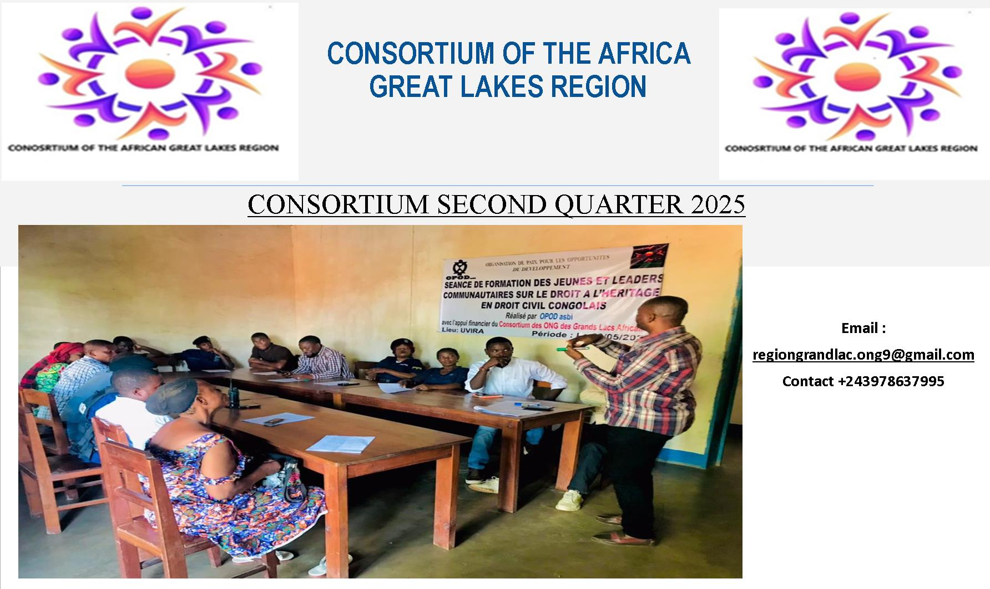

Who we are
The African Great Lakes Consortium is made up of eleven local non-profit organizations working in solidarity to support vulnerable victims of armed conflict and natural disasters. These organizations have taken the initiative to collaborate to contribute to the socio-economic recovery and self-care of vulnerable groups, including orphaned children, women survivors of sexual violence, widows, the disabled, refugees, war-displaced persons, and flood victims.
Our mission is to contribute to the reconstruction of the broken hearts and lives of victims of armed conflicts in the African Great Lakes region by giving them hope to become themselves, capable of working to take care of themselves far from armed conflicts and violence.
Our vision is to live in a peaceful and prosperous Africa.
Our goal is to work in solidarity to support the vulnerable in the African Great Lakes Region (Burundi and DR Congo ) .
NGO platform under No. JUST.112/DP-SKV/CA/8145/20.
The Consortium's areas of intervention are: Peace and Conflict Resolution, Education, Health and Nutrition, Trauma Healing, Youth Promotion, Protection and Food Security.
Location of activities: African Great Lakes Region (DR Congo and Burundi)
Period: 4 months ( May, June, July and august 2025).
Table of contents:
- Current projects
- Security situation in the African Great Lakes Region
- Finance
- Recommendation

- Activities
Project to support education for vulnerable people
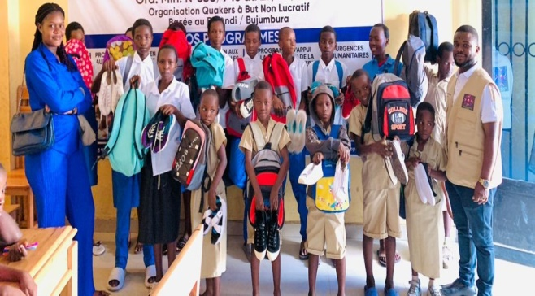
124 children from primary and secondary received school tools for the 2025-2026 school years. Their results will be published in the third quarter report.
Support for the administration of NGOs
We supported our field teams with internet connection and supervision costs.
- Security situation in the Great African Lake region :
Much of the eastern Democratic Republic of Congo is occupied by the M23 rebels. This is causing psychosis in Bukavu and Goma because young people are forced to join the rebel army. More than 30,000 refugees in Burundi, thousands of internally displaced people, in Uvira (only in one month, a peak never before reached) to count more than 126 cases of sexual violence and gender-based violence (GBV), committed by armed men, armed groups and thugs (prisoners) released from the Mulunge central prison in Uvira. Another report, investigated from February to May 2025, affecting Fizi , Uvira and Baraka, by women's organizations reports 1,100 cases of serious human rights violations documented. Very noticeable tensions between local communities, mistrust between political parties, fear and traumatic insecurity. In the high and middle plateaus of Fizi, Uvira and Mwenga territories, peace is volatile, insecurity is persistent following daily fighting between local armed groups WAZALENDO supported by the FARDC against the TWIGANEO and ANDROID groups close to M23 sow terror and displacement of populations to foreign countries and neighboring villages; committing summary assassinations, arbitrary arrests and causing thousands of populations to abandon their fields, livestock. Children are forced to cut studies to escape the atrocities, without food and medical care, many suffer from malnutrition and others die of hunger due to lack of food and appropriate health care.

Finance:
Source of funds: GlobalGiving and other donations

Total donations : 516,55USD
Spent:
Projects 95%
Administration and logistics 5%
- Recommendations
Share this report with like-minded international organizations that may be interested in partnering with the Consortium.
Share the report with potential donors who might be attracted by our activities and support us.
Anyone who expresses an interest in supporting us, making a donation or financing one of our projects can contact us at the following addresses : http//www.copgla.org /

Make a donation : http://goto.gg/67043

