Restoration and Conservation of Bunyala Forest
Report by Action for Child Development Trust
Photos for tree planting activities
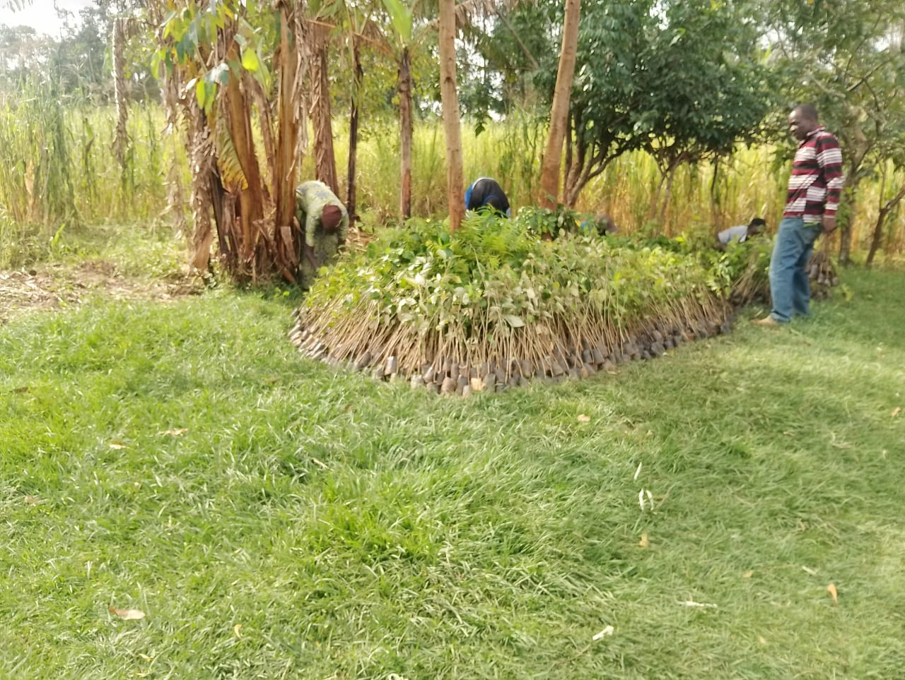
Tree seedlings in readiness for planting.
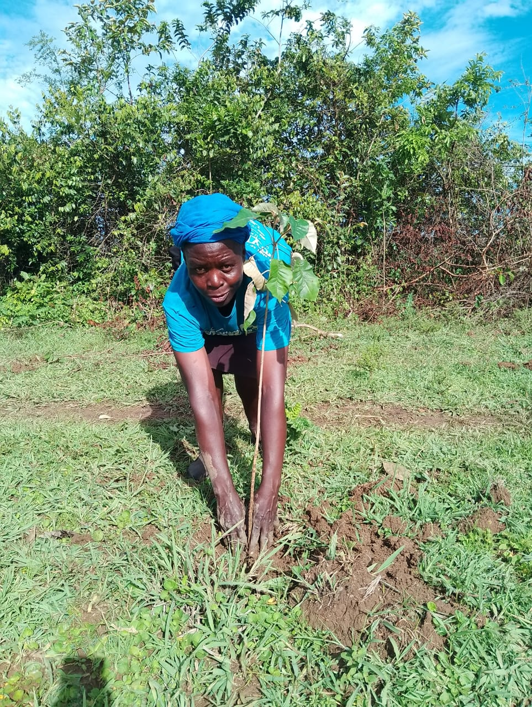
Lady planting a tree in the forest

Offloading seedlings from a truck from purchase point
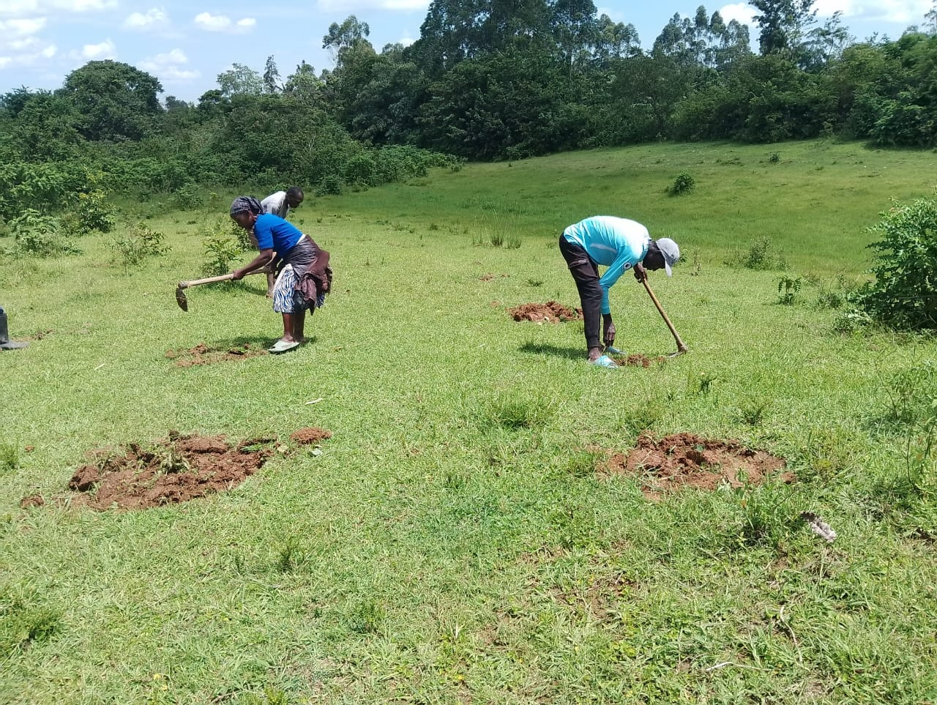
Tree planting ongoing

