**Unfunded Priority Request**

**Public Affairs Section - U.S. Embassy Tegucigalpa**

**Project Name -- Building a Better Future – One Pair of Hands at a Time**

**Project Objective**

Give students job qualifying, hands-on experience in designing and building functioning robots and other useful objects using state-of-the-art equipment. These include Computer Aided Design (CAD), 3D printers, and basic machine tools. In Honduras, like most Latin countries, education consists of teachers writing lessons on the board with students copying and memorizing them for the test*.* Children at best read about engineering and science versus do it. Most students leave school with little real world knowledge or skills and are then a poor fit for meaningful jobs. This project will increase the practical and creative skills of over 700 students*.*

**Project Summary**

Beginning in 2017 and evolving since, Shoulder to Shoulder developed a program to enhance student retention and build employment skills based on hands-on exposure with Science Technology, Engineering and Mathematics (STEM). This proposal builds a more robust STEM support system and scales our proven programs to reach more students.

We introduced robotics: <https://hondurasrobot.org/the-first-robot-el-primer-robot/> into our Bilingual School in Camasca. In addition to delivering a superior education, this also serves as our learning lab for educational technology. That same year, StS created the Honduran National Team that participated in the First Global Challenge travelling to Washington DC: <https://hondurasrobot.org/what-really-happened-at-that-robotics-competition-youve-heard-so-much-about/> & <https://hondurasrobot.org/absolute-folly/>. The team later traveled to Mexico City, Dubai, and most recently Geneva. The team did as well as 15th out of 160+ countries before we concluded our funds were better spent delivering to more students locally rather than the expense of foreign travel for only a few.

**STEM Center** - In 2019, (StS) initiated a joint project with the local Mayors Association (AMFI) to create a regional STEM Center for its seven municipalities.   An agency of the Honduran government constructed the building, World Vision constructed bathrooms, and StS provided the technical equipment and expertise.  See [STEM Center dedication day – -CREE- (hondurasrobot.org)](https://hondurasrobot.org/2494-2/). The US Embassy in Honduras sent a nice video.

**STEM Program Elements** – The Center is the anchor of our program that consists of the following elements:

* *Lego Building Bricks* – See Budget Narrative Section 7a. This program is aimed at getting young children from early grades interested in building with their hands, creating objects using their imagination and small action figures. Having this kind of hands on building experience together with small figures to promote story telling has been shown to help children learn to read. [LEGO Launches StoryStarter For Improved Literacy (teachthought.com)](https://www.teachthought.com/literacy/lego-launches-storystarter-for-improved-literacy/" \l ":~:text=From enhancing reading comprehension and vocabulary to fostering,into building blocks for a lifetime of literacy.).
* *Lego Robotics* – See Budget Narrative Section 7b. This program is aimed at cycle 2 (grades 4-6) and 3 (grades 6-9). Small groups of students plus a teacher/coach use Lego Robotics kits to build a functioning robot. Students analyze the problem and develop a control program on a laptop computer using a block language. This is downloaded into the robotic controller which runs the robot for the contest. Teams from each municipality compete to see who can score the most points in an annual game. After developing and running this regional competition, StS turned over the annual competition to the Mancommunidad or local mayor’s association, AMFI. See <https://hondurasrobot.org/the-big-awaited-lego-day/>. LEGO Education provides excellent teacher support: [STEM Professional Development and Training | LEGO® Education](https://education.lego.com/en-us/professional-development/)
* *VEX Robotics* – See Budget Narrative Section 7c. This aimed at cycles 3 and 4 (grades 7-12). It is a more sophisticated robotics kit with more powerful programming support consisting of a block control language that generates Python code. This code can be augmented by students to create more complex robotic action strategies and motions. Both robotics systems provide a gateway for students into the world of coding. VEX provides excellent training and certifications: [VEX Professional Development Plus](https://pd.vex.com/). Two of our staff now hold robotics certifications. The V5 system that we provide features more sophisticated functionality including pneumatics add-ons see Section 7d and industrial training modules, see Section 7e.
* *3D Printers* – See Budget Narrative Section 7g. This technology supports “additive manufacturing” in which an object is built up in layers rather than being cut out of a larger block or sheet of material. The benefits it provides is very rapid development of almost any shape. We provide two entry level “Sketch” systems by **Makerbot.** This company has a range of equipment that target education up through college. See Budget Narrative Section 7f. Also see illustrations below of objects made in our STEM center. See also <https://www.makerbot.com/3d-printers/classroom-solution/>. This company also provides excellent teacher and curriculum support, see attachment. They also make larger, more complex university level systems that can utilize more robust materials for production parts.
* *Computer Aided Design* (CAD). See Budget Narrative Section 7h. This technology allows students and teachers to design a part on a computer screen. From our participation in First Global, we have licenses for SOLIDWORKS ([SOLIDWORKS | 3D CAD Design Software & PDM Systems](https://www.solidworks.com/)), one of the industry leaders in this kind of software. Using SOLIDWORKS or one of our other packages, the computer produces a file of instructions that are loaded into the 3D printer to make the part. CAD software can also produce instruction for CNC routers that will cut out complex shapes from wood or plastic. Similar but more powerful are CNC mills that do the same only on metals.
* *Machine tools*, See Budget Narrative Section 7i. In addition to assembling parts from kits and making the odd part using 3D printers, the students are exposed to the ability to make additional parts under adult supervision using available stock and small machine or hand tools.

**STEM Commercial Concepts and Sustainability** - In addition to learning technical skills, students are encouraged to develop commercial concepts and bring them to life. Students use the 3D printers to make custom items and sell them to people in the community. See examples below:

|  |  |  |  |
| --- | --- | --- | --- |
|  |  |  |  |

They sell these for 30-100 Lps. depending on the amount of printing time and fuel needed. They have catalog and with established pricing that recovers the cost of fuel, cost of staffing, and amortizing the life of the two 3D printers over its 3 years expected useful lifetime. So far this year, they have made and sold almost 300 items. The revenue being collected is deposited in a bank account. They will report out periodically to see if they are on track to save up enough after expenses to buy a new 3D printer when one of theirs no longer works. We are continuing to develop business concepts to introduce to the STEM Center to increase opportunities for employing additional students and introducing them to basic business finance.

**STEM Community Development** - In addition to this central resource, StS placed robotic kits of several levels in surrounding municipalities supporting local teams of about 10 students each. At year-end, there are local competitions in each municipality sponsored by the local mayor.  This is followed by a regional competition and celebration. See <https://hondurasrobot.org/reviving-the-regional-lego-robotics-competition> and [Regional Teams – -CREE- (hondurasrobot.org)](https://hondurasrobot.org/regional-teams-2/).  Last year, StS extended the program to lower-grade participants by distributing basic Lego building kits to start the hands-on process earlier.  See <https://hondurasrobot.org/building-our-future-with-legos/>. Although a success, the follow-on program for the preschoolers will be restricted to the municipality level due to the difficulties of traveling**. These celebrations are important in generating interest among the students in a future path in engineering or manufacturing versus what they now see immediately around them in subsistence farming.**

After running the program for three years, StS turned the robotics competition/celebration programs over to a local Mayors' association for sustainability.  This reduced the StS role to funding equipment and prizes and providing training to local teachers/coaches.  The mayors now rotate the location of the final competition. **Last year**, **over 370 students from seven municipalities participated in the annual robotics competition – more are expected this year.**

**Project Description**

This project proposes to *strengthen and expand* *the STEM Community and position it for sustainability.*

**Community Engagement Model** – We continue to build and strengthen the model of bridging across Education staff and mayors. The mayors are the key to discretionary funding for schools. This includes ordinary repairs, electrical installations, bathrooms, etc. They have provided large screen TVs and IT support staff for Kolibri. The mayors are organized in regional associations (Mancommunidad), some of which span across departments. See chart below. Mayor associations can provide funding mechanism beyond the scope of a single municipality. They also sponsor regional celebrations which we utilize in our STEM program (and also our Reading program.) Some granting organizations such as BMZ ([Federal Ministry for Economic Cooperation and Development (bmz.de)](https://www.bmz.de/en/)) prefer to work with Mancommunidad.

|  |  |  |  |  |
| --- | --- | --- | --- | --- |
| **Mancomminudad:** | AMFI | LENCA ERAMANI | MANUNI | MANCURISJ |
| **Department** | Municipalities | Municipalities | Municipalities | Municipalities |
| Intibuca | Camasca | Intibuca | Jesus de Ortoro | Dolores |
|  | Colomoncuaga | Las Esperanza | Masaguara | San Juan |
|  | Concepcion | San Francisco | San Isidro | San Miguelito |
|  | Magdalena |  |  | Yamaranguila |
|  | San Antonio |  |  |  |
|  | Santa Lucia |  |  |  |
|  | San Marcos |  |  |  |
| Lempira |  |  |  | Erandique |
|  |  |  |  | Santa Cruz |

**Strengthen Robotics Program** *by Formal Recruitment, Training and Resourcing, Ongoing Support, and Compensation* – In the past, our recruitment and qualification of potential robotics teachers or coaches was informal and one off. Frankly, getting and retaining enough quality coaches is the limiting factor on getting robotics exposure for children in the frontera. In fact, the last two years, we have had some equipment sitting idle without an available coach.

*Formal Recruitment* - The project will be kicked off at the beginning of the Honduran school year, February, 2025.   The kickoff meeting will be sponsored by the Intibucá Departmental Director of Education. She, along with the local mayors association (AMFI) have previously cohosted the final regional robotics competitions. The project will run through the school year ending in late September with a seven-community robotic competition and STEM demonstration similar to the ones we currently run. The Director will publicize the project among all the eligible schools and invite teachers to attend the orientation and training.

*Training and Resourcing* - We will provide formal orientation and training seminar at the STEM center for prospective teacher/coaches. This includes demonstration of various robots and equipment including the 3D printing system. The teachers will be given translations of material provided by the robotics vendors: Lego and Vex. The coaches will also be provided a laptop computer loaded with resources. These include coding support for the robots and **Phet** simulations to help students visualize physical laws unavailable in their rote memorization-oriented classroom experiences.

*Ongoing Support* - The teachers will be registered into an online support group in WhatsApp. This STEM WhatsApp group serves as a forum for teachers to share ideas and progress plus photos and short videos of their team activities and results to date.  This group also functions as a source of community excitement and peer support.  The StS Technical Resource will monitor the group and address questions that other teachers are unable to answer.  StS will distribute resource material from Lego and Vex via the STEM WhatsApp group. This WhatsApp support group is similar to the ones StS has had in place to support the Kolibri implementation for the last five years.

*Compensation* - In most US school districts, teachers who coach sports teams or supervise extracurricular activities receive additional compensation from the school district. This is not typically the case in Honduras. StS will provide a small honorarium to teachers for their extracurricular time in coaching robotic enrichment programs and providing regular monthly reports of participation.   This will incentivize additional teachers to become involved.

Assuming this is a success and generates community excitement, we will petition mayors to continue this practice to achieve sustainable community of STEM teacher/coaches.

We will ask each teacher/coach to meet with their students weekly and send a report to the WhatsApp group describing the attendance and the focused activities, accompanied by photos if available. The idea is to create a virtual community among these teachers even though they are far apart physically. Teacher/Coaches will earn a prorated portion of the proposed honorarium at the completion of each report.  This provides an ongoing motivation to teachers to keep up the appropriate level of student contact throughout the year. We will distribute the small payment via **TIGO Money** or equivalent upon receipt of each monthly report, providing motivation for the student sessions.

**Deploy more LEGO kits** – In the US, most children grow up having experience with some kind of building kit. Having this kind of hands on building experience together with small figures to promote story telling has been shown to help children learn to read. [LEGO Launches StoryStarter For Improved Literacy (teachthought.com)](https://www.teachthought.com/literacy/lego-launches-storystarter-for-improved-literacy/" \l ":~:text=From enhancing reading comprehension and vocabulary to fostering,into building blocks for a lifetime of literacy.).

Our experience to date with Legos has been very positive. The teachers and students love them. Last year we added basic building demonstrations to our Robotics competition finals. This year, we are limiting the attendance at the final event to just the robotics participants in order to manage the total numbers. Instead, we will limit the Lego building demonstration to the municipal levels. Throughout the year, teachers will utilize the kits in any way they chose and we will gather and share their experiences via blogs, creating a community of interest for the primary grades.

**Expand LEGO and VEX Robotics** – We have more communities that are requesting to join into the Robotics Program and place entries into the local competitions and celebrations.

**Expand Sustainable STEM Centers**– Our deal with the AMFI area was a shared costs. They were successful in getting a centrally located dedicated space and we provided the technical equipment. Since then, we have supported a local teacher to create and administer a STEM program that this teacher has grown to be sustainable. We would like to replicate this model in each of our other three mancommunidad, beginning with one in the coming year.

The table below summarized our program to date in black and the proposed expansions in blue.

|  |  |  |  |  |  |  |  |
| --- | --- | --- | --- | --- | --- | --- | --- |
| **Mancomminudad:** | AMFI | LENCA ERAMANI | MANUNI | MANCURISJ | Total | Total | Grand |
| **Program Element** |  |  |  |  | Existing | New | Total |
| STEM Center: | Camasca | Intibuca | Jesus de Ortoro | San Juan | 1 | 3 | 4 |
| a. LEGO Building Bricks | 32 | 20 | 20 | 20 | 52 | 40 | 92 |
| b. LEGO Robotics kit | 16 | 4 | 4 | 4 | 20 | 8 | 28 |
| c. VEX Robotics kit | 10 | 2 | 2 | 2 | 12 | 4 | 16 |
| d. Laptops @ per kit | 26 | 6 | 4 | 2 | 32 | 12 | 44 |
| e. VEX Pneumatic | 2 |  |  |  |  | 2 | 2 |
| f. VEX Workcell | 1 |  |  |  |  |  | 1 |
| g. 3D Printers | 2 | 2 | 2 | 2 | 2 | 6 | 8 |
| h. CAD System | 1 | 1 | 1 | 1 | 1 | 3 | 4 |
| i. Machine tools | Yes |  |  |  |  |  |  |

**Project Start Date**

The project can start with the availability of funding although most of the activity will occur during a school year beginning in February, 2025.

**Project End Date**

The project will run for a year and end after a year or at the end of the next school year, October, 2025.

**Expected Outputs**

The outputs are number of students participating, number of municipalities, number of robotics kits in operation, and number of coaches. Also, the number of Lego kits deployed and total number of children using them. Finally, a description of the new STEM Center.

**Expected Outcomes**

The annual competitions generate wide spread community participation and often attract media coverage – as measured by number of interviews and articles published. This helps create enhanced future visions for frontera children versus the default of subsistence farming or migration to the US. We will also track school retention of participating students versus the department at large. We will track scholarships to university and employment outcomes of participating students.

**Target Audience**

At least 700 students from 17 municipalities in the department of Intibucá, and two in the department of Lempira. This is up from 370 in 7 municipalities. These communities are populated by indigenous Lenca people who are among the poorest in Honduras. Many homes are without power or cell coverage.

**Funding Amount Requested: $49,230**

This is and expansion of our current installed and planned base of $66,640 that serves as Cost Sharing for a total project cost of $115,870.

**Justification**

Schools and communities face several contextual challenges that affect students’ ability to attend school and learn. Poverty levels in Honduras remain high; more than 60 percent of households in the country live in poverty and more than 40 percent in extreme poverty. This fact makes it very difficult for parents to send and keep their children in school. Grades 6 and 9 in particular see high levels of drop out. Parents struggle to see the value of education often not viewed as relevant to the needs of the marketplace. (*Source: USAID 72052222RFA00005*)

Rural areas like Intibucá are largely without equipment for students to learn science or express their creativity through designing and building objects. With a focus on rote memorization, learning opportunities are limited and school isn’t really very engaging. As a result, about half of rural children drop out of school by the sixth grade. This consigns them to the subsistence farming or day labor if they stay in their community. The resulting earning power is insufficient to support a family. Many choose to migrate illegally into the US leaving families behind and sometimes abandoned.

Teachers in Honduras aren’t paid much and the environment in which they work is often poorly maintained. Teachers typically do not receive additional pay for working with students beyond the school day. Many are just going through the motions. With declining enrollment driven in part by migration in search of jobs, the government is responding by decreasing teachers per school and asking teachers to double up on grades they are assigned to teach.

The resulting teacher reassignments and reduced number of new tenure openings is leading to teacher job insecurity further degrading the education available to Honduran young people.

Honduras is one of the countries sending the most irregular immigration to the US. Getting more children to stay in school longer and learn skills that will enable them to get jobs increases the chance that they will stay and help develop Honduras. This directly addressed Mission Objective 1.2: “… reduce irregular migration through increased educational and workforce opportunities….” In previous projects we have generated directional statistical support for Kolibri schools having a positive role in increasing retention (+7%). We also are seeing the prospect of working with robots and laptops computers attracting children to reenroll into school. This expanded project will increase and document this impact.

**Monitoring and Evaluation**

We will monitor the robotics program via weekly reports by teacher/coaches for which they receive a small honorarium. We will report out on the number of students and teachers participating. We will evaluate the success by tracking school retention, educational levels and scholarships won by students participating in STEM activities versus retention of the general population from the same areas.

**Project Timeline**

|  |  |  |
| --- | --- | --- |
| **Topic** | **Date** | **Description** |
| Recruit Teachers | Project Begin  School Year | Publish project description in local media sources and out the word out to school administrators |
| Teacher/Coach Training | Mid School Year (July after break) | Assemble prospective teachers in the STEM center for an orientation and training on robotics equipment, introduction to resources. |
| WhatsApp Support Groups | Mid School Year | Teachers are entered into WhatsApp support group and introduced to staff resources |
| Recruit Students | Mid School Year | Enter all students with Honduran ID so we can track their academic and retention outcomes |
| Baseline Survey | Mid School Year | Survey of teachers and students on expectations. |
| Project Monitoring | Monthly  (Jul. –Oct.) | Teachers submit report of their student session and receive small compensation |
| Monitor Teachers | Ongoing (Jul.-Nov.) | Monitor WhatsApp based support groups and address any problems not resolved by MOE staff and intervene to address process outages. Collect any software problems and refer to Learning Equality. |
| End Line Survey | Two weeks before schools ends (October) | Shoulder to Shoulder conducts teacher and student surveys about impact on student attitudes and likelihood to remain in school. |
| Preliminary Project Report | Dec.  School Year | Shoulder to Shoulder sends preliminary report to the US Embassy. |
| Final Analysis Update | April  School Year + 1 | The preliminary report will capture and analyze the student intention to remain in school but the actual registration for the 2024 school year data will only be available approximately April, 2024. We will finalize the analysis at this point. |

***Budget***

See budget form below

|  |  |  |  |
| --- | --- | --- | --- |
| ***Budget – Building a Better Future – One Pair of Hands at a Time*** | | |  |
| Item | Cost Sharing | Requested from USG | Total |
| 1. Personnel |  |  |  |
| a. Project Management @ 15% * $15,000 | $2,250 |  | $2,250 |
| b. Training and support @ 50% * $7,000 |  | $3,500 | $3,500 |
| c. Analysis and reporting | (In Kind) |  |  |
| 2. Fringe Benefits |  |  |  |
|  |  |  |  |
| 3. Travel |  |  |  |
|  |  |  |  |
| 4. Equipment |  |  |  |
|  |  |  |  |
| 5 Supplies |  |  |  |
| a. fuel @ $350 * (1+3) | $350 | $1,050 | $1,400 |
| 6. Contractual |  |  |  |
| a. Administration and Accounting |  | $1,000 | $1,000 |
| b. Honorarium for teachers $65 * ((20+12) + (4+8)) | $2,080 | $780 | $2,860 |
| 7 Other Direct Costs |  |  |  |
| a. LEGO Bricks @ $105 * (52+40) | $5,460 | $4,200 | $9,660 |
| b. Lego Kits @ $550 *(20+ 8) | $11,000 | $4,400 | $15,400 |
| c. Vex Kits @ $1,750 * (12+4) | $21,000 | $7,000 | $28,000 |
| d. Laptops @600 * (32+12) | $19,200 | $7,200 | $26,400 |
| e. VEX Pneumatics @ $350 *2 |  | $700 | $700 |
| f. VEX Workcell @ $3,500 * 1 |  | $3,500 | $3,500 |
| g. 3D Printer @ $2,300 * (1+3) | $2,300 | $6,900 | $9,200 |
| h. Cad System * (1+3) | $3,000 | $9,000 | $12,000 |
| i. Machine Tools |  |  |  |
| Total Direct Costs (lines 1-7) | $64,560 | $48,450 | $113,010 |
|  |  |  |  |
| 8. Indirect Costs |  |  |  |
|  |  |  |  |
| Total Costs | $66,640 | $49,230 | $115,870 |

**Budget Narrative: Building a Better Future – One Pair of Hands at a Time**

1. **Personnel** 
   1. Project Management – Arrange Kick off with Departmental Director. Organize training and logistics Obtain agreements with local Mayors
   2. Demonstrations, technical training, and monitoring of the WhatsApp support groups and answering questions, supporting the regional competitions.
   3. Data Analysis and project reports – writing interim and final reports.
2. **Contractual**
   1. **Administration and accounting –** payments to our accounting firm
   2. **Honorariums for Teacher/Coaches.** The Robotics Programs run for approximately 12 weeks culminating in an annual Mancommunidad level competitions. The teams meet 2-3 times per week or 4-6 hours per week. Using the full government compensation table the rate for 4 hours per week is 1318 Lps. In the US, teachers are paid for extracurricular activities but at a substantial discount to full time salaries ranging from 5% for clubs to 20% for football coaches. With this as background, we’ve determined that we will compensate teachers at the rate of 125Lps/week for 12 weeks = 1500 Lps. This is about $65 per teacher for the competition season.

**7. Other Direct Costs**

1. **LEGO Building Kits** – consisting of a box of LEGO bricks (#11030@ $70) as a construction outlet plus a set of Lego minifigures (#9443 @$35) to support storytelling. ($105 for both)

|  |  |
| --- | --- |
|  |  |

1. **LEGO Robotics** - Our current primary school level robotics program has provided over 20 LEGO EV3 Educational Robotics kits (basic plus the expansions) to support competitions among our municipalities. This model has been discontinued and replaced by the Spike system, shown below. While less expensive than its predecessor, we will need to partition the competitions since the size and capabilities are different. Cost = ($320+$140) 1.077% taxes + $55 shipping = $550

|  |  |
| --- | --- |
|  |  |

1. **VEX Robotics** - Our third and fourth cycle robotics program makes use of VEX V5 technology. We currently have 10 of these kits in place throughout the AMFI area. See [VEXcode Overview - VEX Robotics](https://www.vexrobotics.com/vexcode), <https://www.vexrobotics.com/support/get-started/research>, and <https://kb.vex.com/hc/en-us/articles/9834349433236-V5-Educators-Start-Here>. Costs = 1,575 + taxes and shipping = 1,750

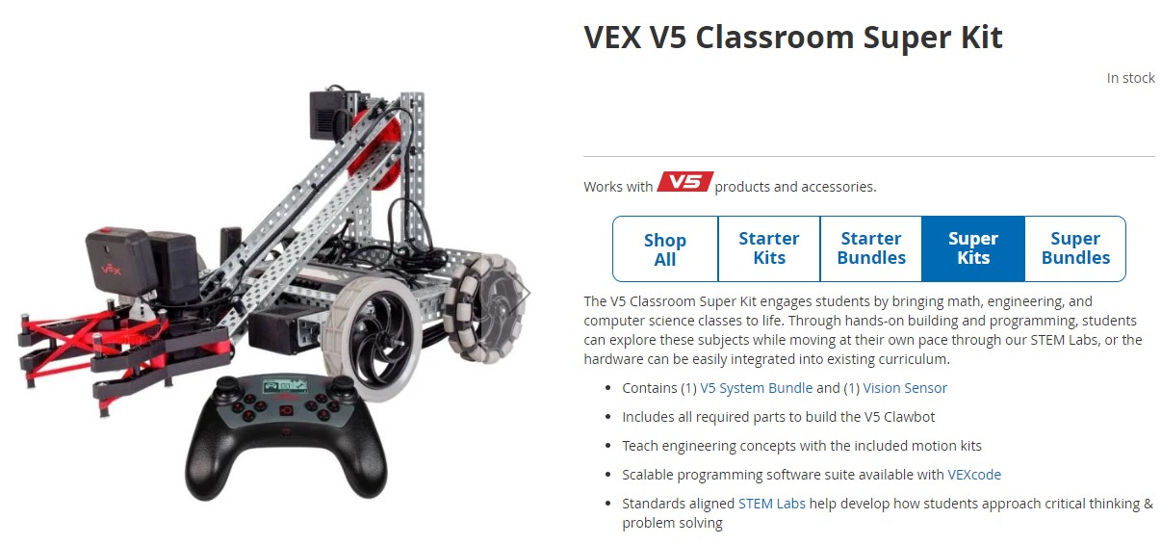

1. **Laptop** – Basic laptop i3 or equivalent, 16 Gig memory, 256 SSHD, used for programming robots, running robotic simulations, running physics simulations (Phet), and resources.

1. **Pneumatics Kit** - Vex has added additional elements to their V5 Robotics kits @ 299 plus taxes and shipping = $350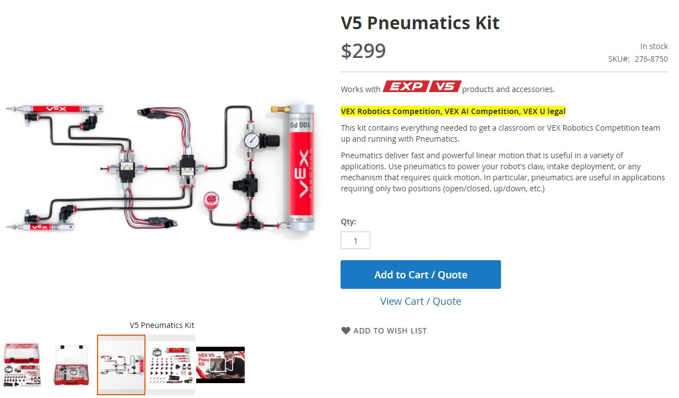
2. **VEX Workcell** - The V5 technology system has introduced a couple of additional more industrial elements to their product line shown below: #276-7900 @ $2,499, 254-8241 @$499, 276-7899 @ $103.99 plus taxes and shipping = $3,500. See [VEX V5 Workcell - VEX Robotics](https://www.vexrobotics.com/v5-workcell.html).

|  |  |
| --- | --- |
|  |  |

1. **3D Printers** - Makerbot is a 3D printing Company specifically targeting schools. See the following website for photos of their equipment and examples of its use. They have extensive educational material as well, see attachment. The equipment shown below is the equipment that we currently have installed in our AMFI Regional STEM Center in Camasca. It also includes educational material shown in the photo (and attached) plus certifications that two of our staff have achieved. See <https://www.makerbot.com/3d-printers/classroom-solution/>. $2,000 plus taxes and shipping = $2,300

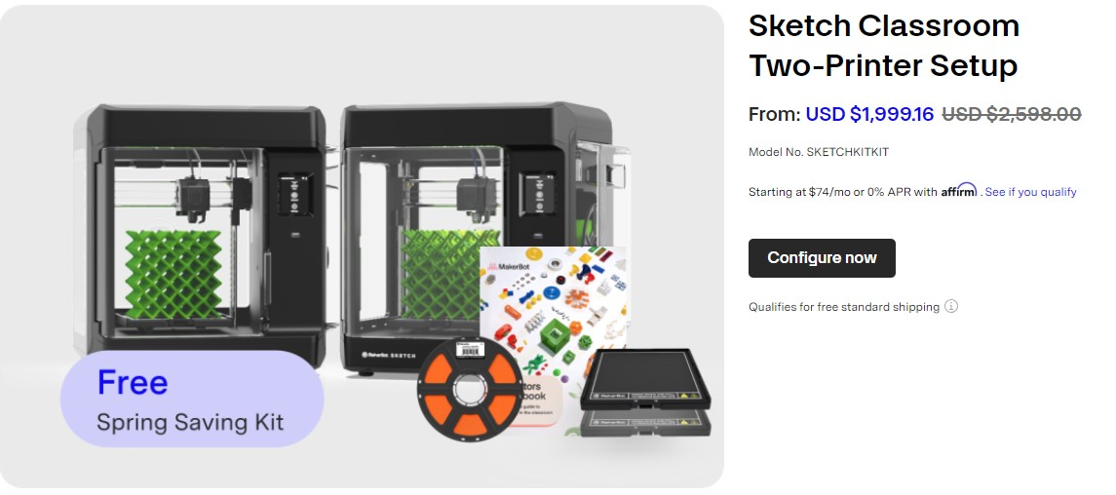

1. **Computer Aided Design (CAD) System** - This consists of software that we acquired as an educational instution, e.g. Solidworks [SOLIDWORKS | 3D CAD Design Software & PDM Systems](https://www.solidworks.com/) and a powerful computer to run it such as Dell 7780 Precision Workstation $2500-3,719, plus tax and shipping.
2. **Machine tools** – Drill presses, saws,grinders, hand tools, various faseners, etc.