Improving Livelihood of 200 Widows Affected By HIV/AIDs in Mubende

Project Progress Report

Introduction:
This report presents the achievements so far registered with support from donor through global giving; since the beginning of 2011, SORAK Development agency set out to assist 200 widows living with HIV and TB; with livelihood support. A partipatory selection exercise for indigent widows was carried out.
Ten of these have been supported with 10 improved goats and one with 10 local improved chicken. These are the enterprises selected by the beneficiaries themselves. Five months after the support, the project has started bearing results as indicated by the two case stories here below;
Edith and Olivia can afford a smile;
Edith and Olivia are young widows living with HIV/AIDs were visited in March to assess their situation see plate 1 and 2 respectively
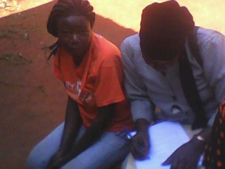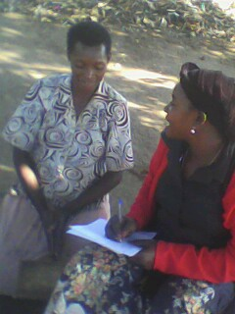
Left plate 1: Edith and right plate 1: Olivia during a beneficiary participatory selection exercise, share notes with SORAK volunteer
Edith preferred chicken rearing for egg production. She also wanted to improve her nutrition status as advised by SORAK staff during psychosocial care visits; while Olivia wanted a goat for multiplication and be able to buy a cow for milk after two years. Plates 3 and 4 presents the livelihood support giving ceremony.
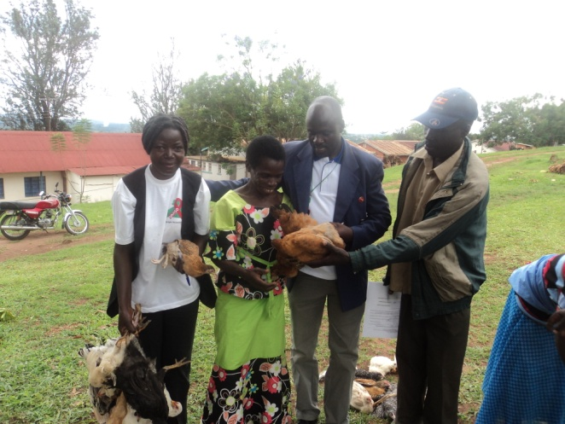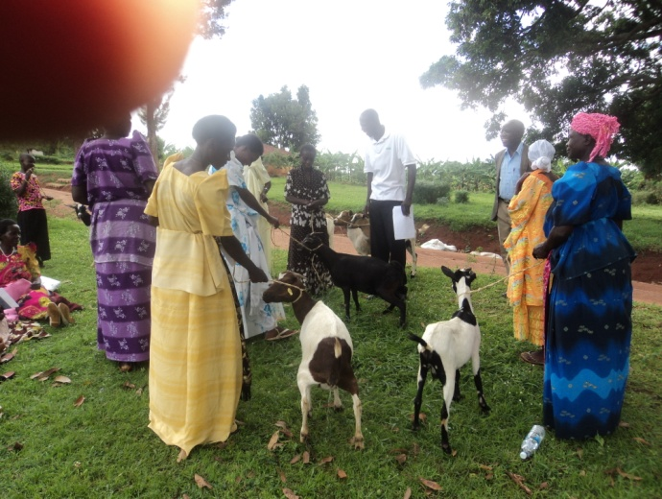
Plate 3; extreme left; Edith in a white T-shirt receives chicken, Plate 4: Olivia receives a black goat among other widows while SORAK staff and District Veterinary Doctor looks on.
Results: Five months after, Edith’s chicken is already laying eggs; she can now have eggs to boast her diety.She is all joyful and happy to SORAK Development Agency and the donors to this project. Likewise it is all praises from Olivia whose black got produced a nanny kid. During the monitoring visit Edith afforded to give some eggs to the executive Director. While at the same time the Director was happy to carry Olivia’s goat kid. See plates 5 and 6 below;
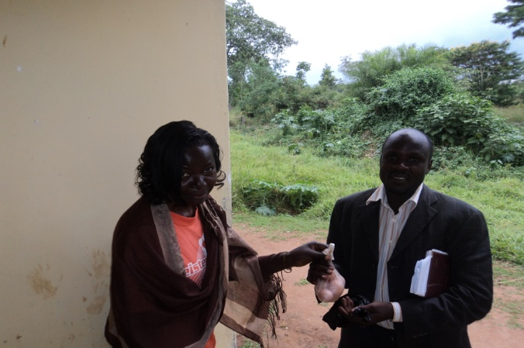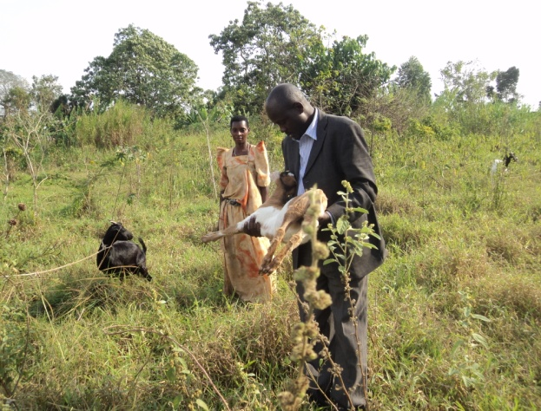
Plate 5 : After 5 months Edith shares her eggs with SORAK Development Agency Director; Plate 6 ;Olivia standing looks on as the Director carries a health Kid produced by the goat supplied by this project.
Conclusion and way forward; SORAK Development agency and the project beneficiaries are very grateful to the donors who have provided support through Global Giving. We are also thankful of Global Giving for this Noble job well done of linking those in need with those who can lender a hand to women affected by HIV and AIDs. You have created hope and joy to the once yearning hearts and those who had lost hope in life.
There is still many more widows who continue to approach us for more support of similar nature which we hope to achieve once we hit our budget..

