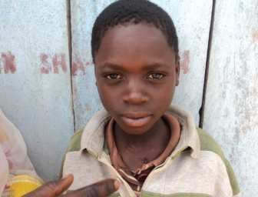Alex, 14, full orphan, HIV-positive
Alex is Fourteen year old but does not at all look it. The shy boy of stunted growth lost both parents to Aids and lives with his granny. He himself is HIV-positive – and that is not at all easy. But things have improved considerably since SORAK Development Agency with funding from Global giving came to support his Granny who were included the SORAK widow goat rearing programme. Among other things Alex and his 72 year old granny, now have a small income, which they earn from selling art crafts. They raised the materials for making the crafts after selling one of the goats kid that had come of size– a huge relief – and the child gets two meals per day since SORAK Development Agency provided support to his granny –widow affected by HIV and AIDS. This and more are some of the milestone being made by a few dollars well spent by donating to SORAK Development Agency,20$ have for instance changed life of Alex and his granny despite their HIV/AIDS situation. They are bound to live longer than they had anticipated!.Thanks to global giving and funding partners.

