When $12 Saved Jane from Death
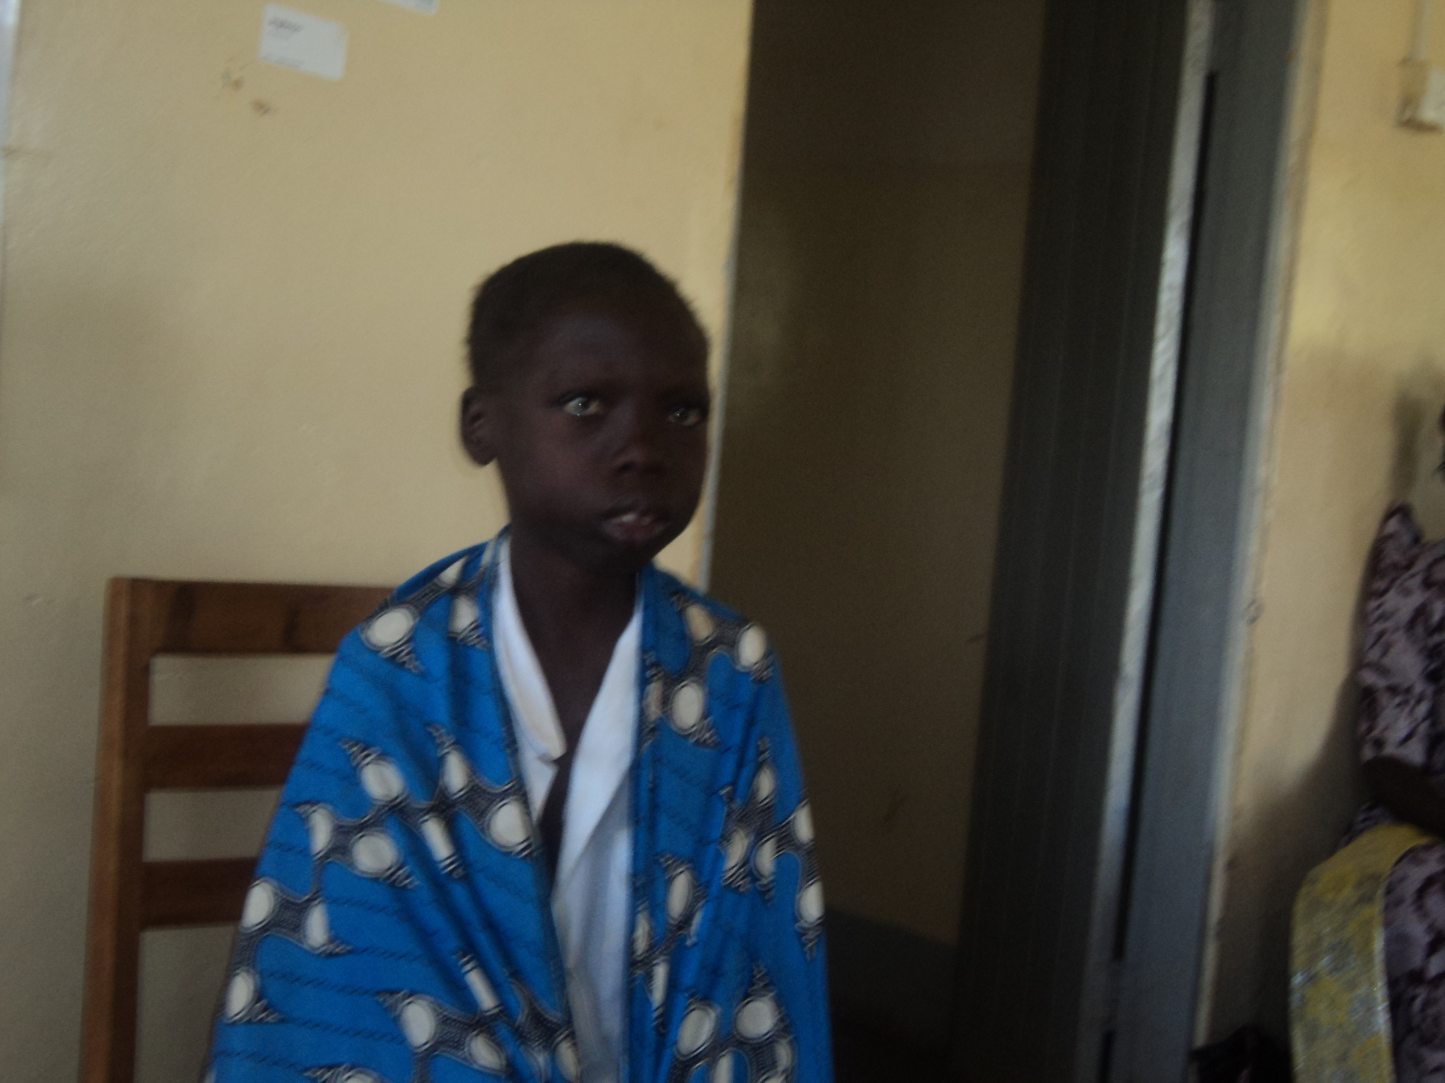 | When SORAK program staff reached out to Nabingoola HCIII, checking on the progress of her Widow membership and how they went on with HIV/AIDS treatment, the staffs’ eyes came face to face to and adolescent in set, whose health had terribly deteriorated. She had come to the health unit complaining of endless fevers, diarhoea, headache and cough.  Even before screening her for HIV/AIDS, Jane had all the signs and symptoms of HIV/AIDS. She was in a situation un heard of at least in the last 5 years when HIV/AIDS victims used to die ignorantly.  With support from SORAK counselors, Jane was tested for HIV and found positive. She had lost all her parents to HIV/AIDS before celebrating her 1st birth day.  “I don’t know if can live for another one week’’ lamented Jane to SORAK Counselor.  The health unit provided Jane with septrin hence initiating her to HIVAIDS treatment. Jane needed urgent attention to enhance her immunity
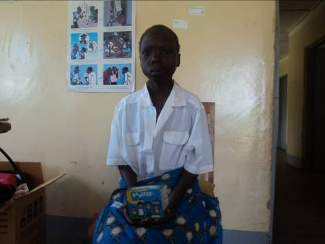 | With only $12, SORAK rushed for an immune boaster for Jane in March 2015 (see packet handled by Jane). This is however still expensive for the majority rural vulnerable and impoverished women and girls.  One month later, Jane’s health and physical appearance greatly improved. She is shading off the aging like skin, and can afford a smile .Jane now hopes to live longer and even marry!  There are many more other ‘Janes’ in our community whose lives needs to be prolonged a little longer with only a few dollars like what the $12 did for Jane. Many more girls and widows of Jane’s caliber have flocked to SORAK for that magic, immune boaster that improve CD4 counts of HIV/AIDS infected persons.  Our hope of saving and prolonging many more lost souls lies in the continued support of our past, current and the future donors.

