Project: Empowering 100 vulnerable single teenage mothers

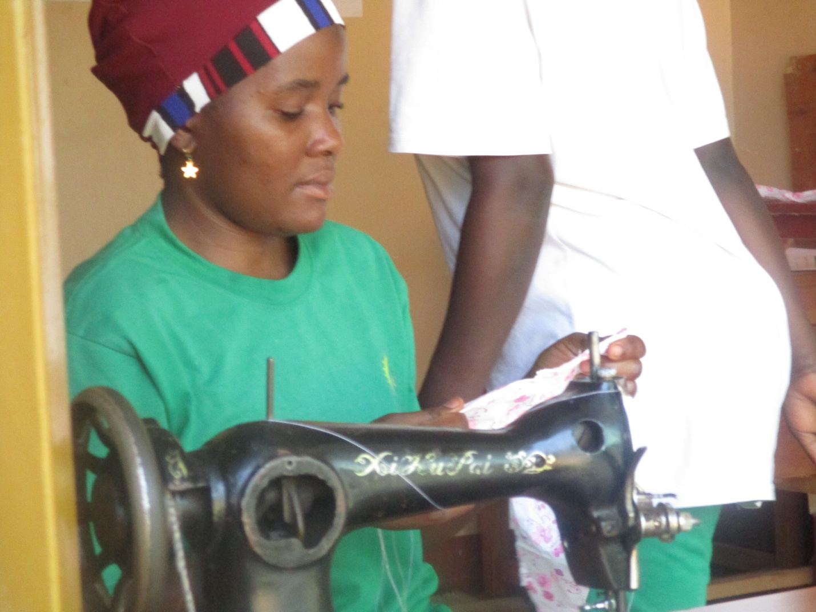

PROJECT NARRATIVE REPORT January 2025

- PROJECT SUMMARY:
This project of empowering 100 single teenage mothers is being implemented by BLF with support from Global giving empowering 100 teenage mothers access resources and opportunities for growth and development through empowering them in hands on skills specifically in hairdressing and tailoring.
So far we have registered 15 young women to receive the training from our communities with support from our religious leaders and local leaders.
This project empowers these teenage mothers be free from male dominance that undermines the girl child capability therefore forcing them in early forced marriages, through our skills program we give them more hope to feel they are also part of the society as their fellows.
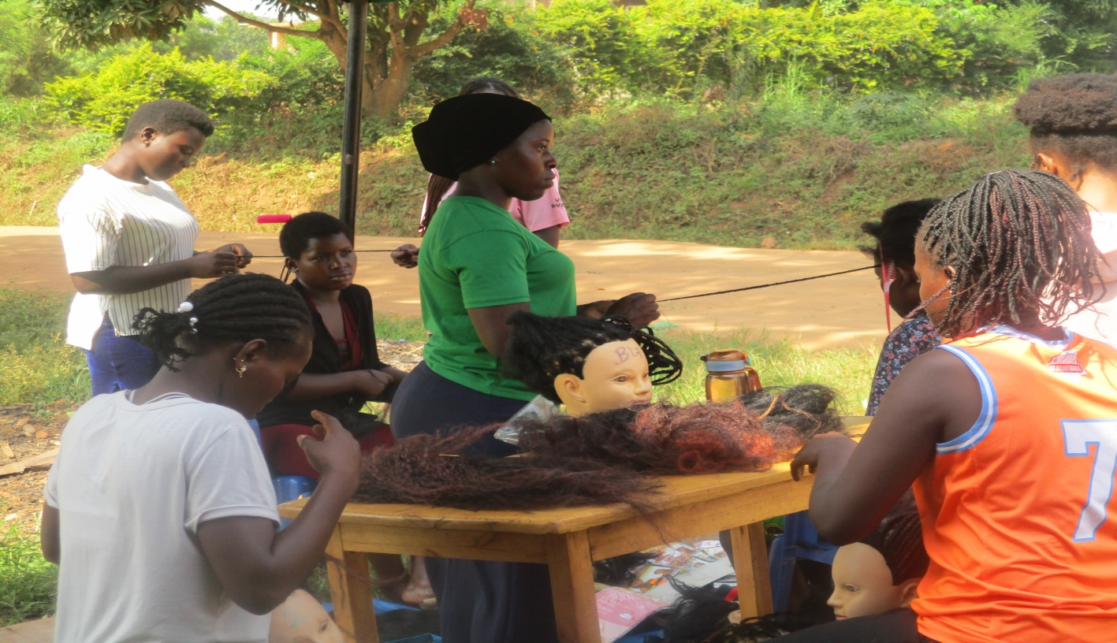

With this being the beginning of year you can help us fulfill more teenage mothers dream big and fill that they are part of the world we are living in.

