2024–2025 SCHOLARSHIP & NUTRITION PROGRAM REPORT
For Orphans in Uganda – Prepared by Hands of Empowerment Uganda

1. EXECUTIVE SUMMARY
The 2024–2025 Scholarship and Nutrition Program marked a transformative year for orphans in rural Uganda. Beneficiaries increased from 100 to 120, with enhanced community engagement and tangible improvements in health and academic performance. This report details these achievements while acknowledging persistent challenges, notably funding constraints and infrastructure issues.

2. PROGRAM OVERVIEW
Background
Children in rural Uganda continue to face significant educational and nutritional barriers. The program addresses these issues by offering comprehensive scholarships and daily nutritious meals to orphans in underserved regions.

Objectives
- To provide scholarships to 120 Orphans and Vulnerable Children (OVCs), including tuition, uniforms, and school supplies.
- To deliver daily nutritious meals across three schools.
- To deepen community involvement in education and child welfare.

3. KEY ACTIVITIES
Scholarship Distribution
- Beneficiaries: Increased from 100 to 120, with attention to gender parity.
- Support Provided: Included tuition fees, scholastic materials, and uniforms.
- Coverage: Expanded to include underserved areas of Jinja and surrounding communities.

Nutrition Support
- Meal Program: Provided daily meals including grains, vegetables, and proteins.
- School Reach: Now supports three schools (up from two in 2023–2024).
- Health Monitoring: 93% of children showed improved BMI and health metrics.
- Community Involvement: Strengthened through regular workshops and parent-teacher meetings.

4. IMPACT & OUTCOMES
Educational Achievements
- Attendance: Improved by 38%, with a dropout rate reduced to 1.5%.
- Academic Success: 72% of students recorded improved grades; seven earned academic honors.
- Three students qualified for advanced secondary scholarships.

Nutritional Improvements
- Malnutrition Cases: Decreased by 65% compared to the previous year.
- Health Benefits: Students showed better growth, energy, and classroom focus.
- Feedback: Teachers noted marked improvements in concentration and participation.

5. CHALLENGES
- Funding Shortfalls: Limited program scalability and expansion.
- Transport Issues: Poor roads continued to impede food and material delivery.
- Parental Engagement: Cultural and economic barriers reduced workshop participation.

6. FUTURE STRATEGIES
- Expansion Goals: Increase OVC beneficiaries to 150 in 2025–2026.
- Infrastructure: Improve delivery logistics through partnerships with local transport providers.
- Sustainability Measures: Launch local income-generating projects to support operations.
- Engagement: Introduce community liaisons to boost parental involvement.

7. VISUAL HIGHLIGHTS
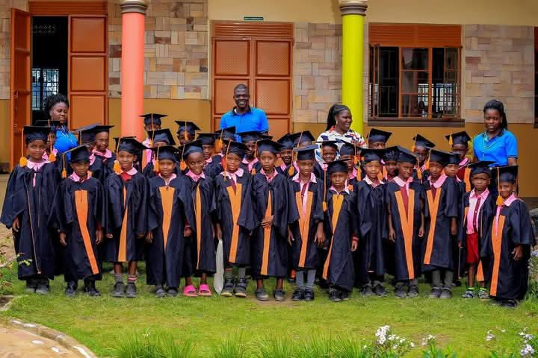
- Fig 1: Scholarship recipients, teachers, and parents at the 2025 graduation event.
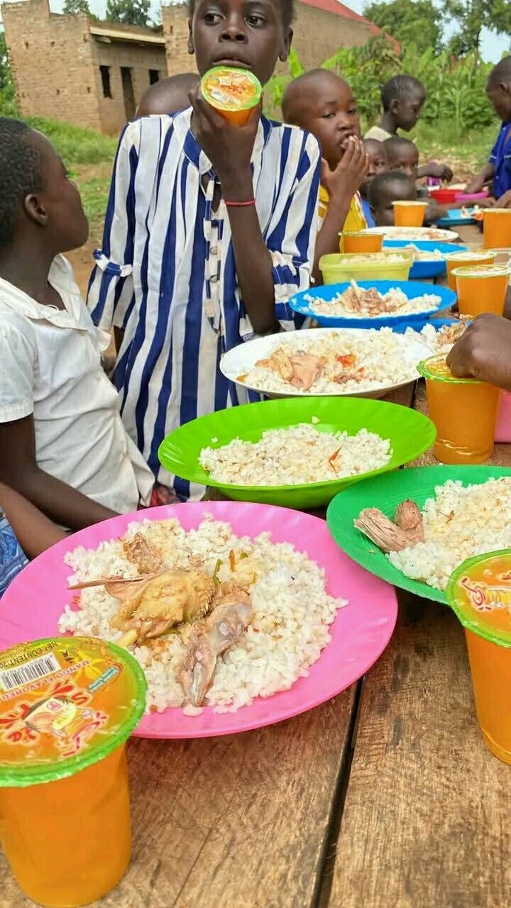
- Fig 2: Students enjoying balanced meals during school lunch.
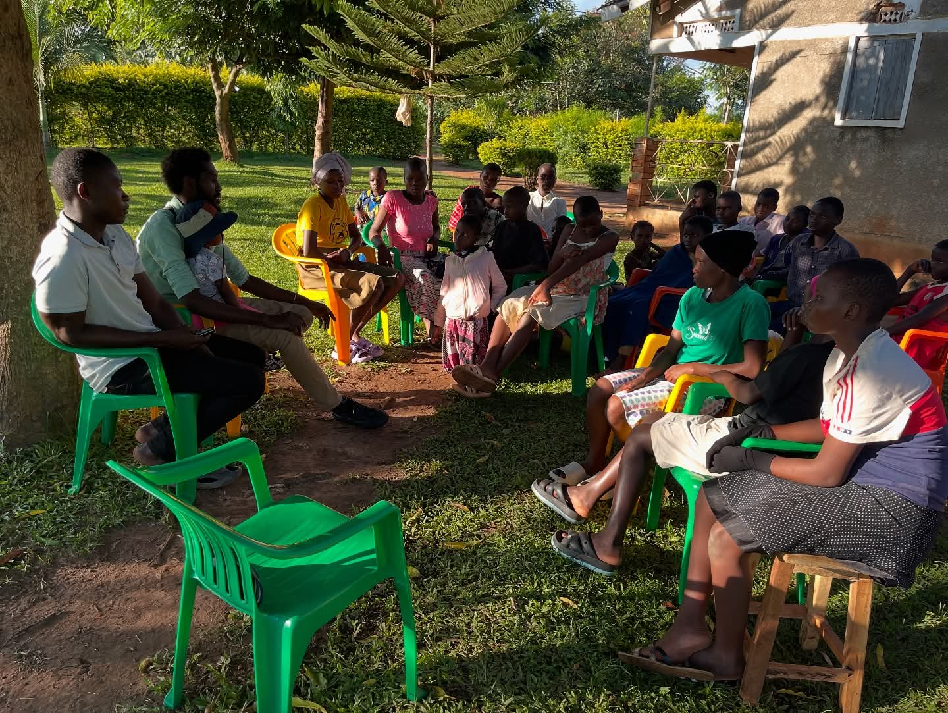

- Fig 3: Health officers conducting wellness checks with visible child improvement.
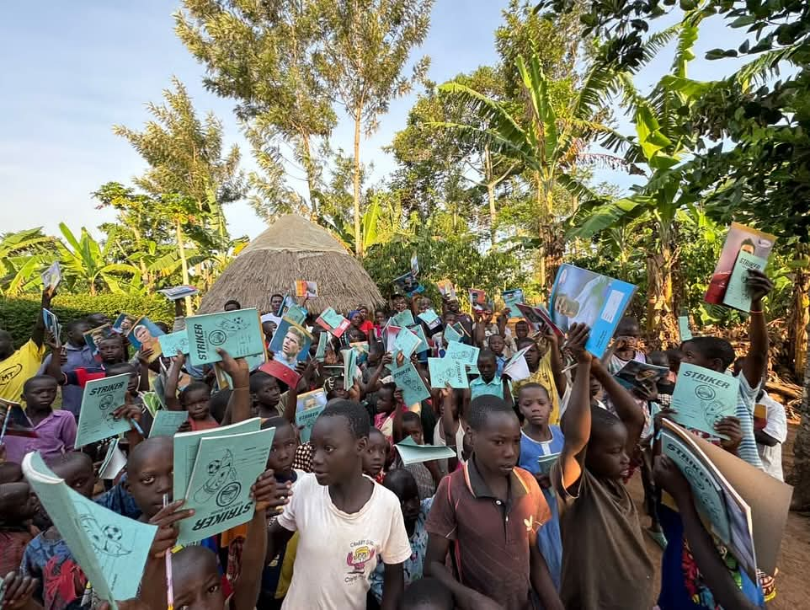
- Fig 4: Excited students displaying new scholastic materials.

CONCLUSION
The 2024–2025 program successfully enhanced educational access and child health for vulnerable populations in rural Uganda. Hands of Empowerment Uganda remains committed to expanding and deepening its impact. Continued collaboration with donors and stakeholders is vital to achieving these goals.

Prepared by:
Gizaza Davis
Director, Hands of Empowerment Uganda
Email: handsofempowermentu@gmail.com
Tel: +256781401868 / +256783520269

