GlobalGiving Project Report
Project: Climate based innovations for disaster mitigations (#66670) | Reporting period: September 2026
Title or Subject of Report
Somali Women Lead Climate Innovation, Sept 2026
Project Report
Thanks to you, a community in Somalia gathered under an acacia tree this September to talk about the climate that is changing around them, and three out of every four people who came were women. One mother of six who joined the focus group discussion walks further every dry season to find water and cooks over charcoal that is stripping the last trees from the land around her village. When the discussion turned to solutions, she was the first to ask how her group could learn to make fuel briquettes and energy-saving stoves, so that they could stop cutting trees and start earning.
Your gifts made that conversation happen, and they are funding what comes out of it. Participants mapped where the soil is washing away and where the next drought or flood will hit hardest, then agreed on a practical plan: briquette and cookstove production run by women's groups; indigenous acacia, sisal and Moringa seedlings to hold the soil; drought-tolerant sorghum, millet, cowpea and cassava that need less water than local seed; and goats, sheep and beekeeping so that no family depends on a single source of income. Elders from different clans agreed to sit together on a water and land management committee so that scarce resources are shared, not fought over. In all, the project reaches 500 survivors of climate disasters: displaced families, returnees, host communities, persons with disabilities and minority clans, with women and girls in the majority.
We want to be open with you about where we stand. The full project budget is $41,000, and $40,796 of it is still to be raised, so your monthly gifts are what keep the sensitization sessions, field demonstrations and seedling work alive. Every $50 puts drought-resistant seed and seedlings in a farmer's hands; every $200 helps a women's group start briquette and cookstove production. If you can give again, make your gift monthly, or share this report with one friend, you are helping this community move from surviving climate shocks to preparing for them. In our next report we look forward to showing you the first seedlings in the ground and the first briquettes made by the women's groups. Thank you for standing with them.
Author Name
Fred Wisdom Khaemba
Author Title
Program and Donor-Partnership Advisor

Photos to upload
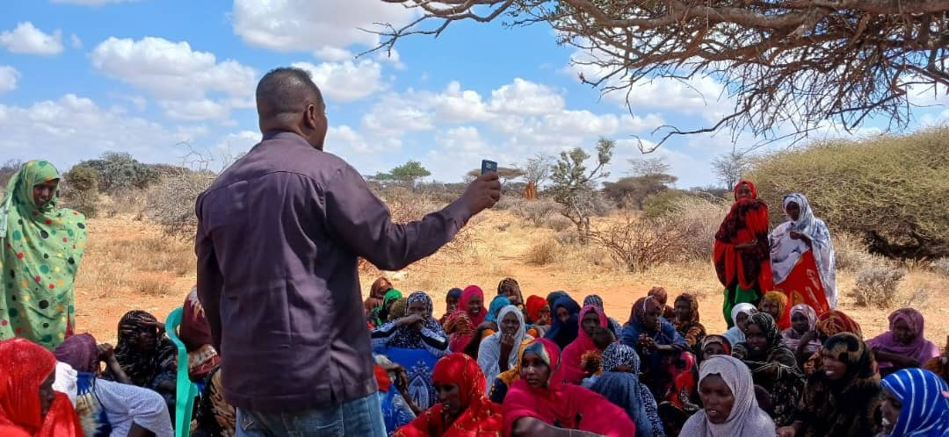
APCO_Photo1_Focus Group Discussion, Women make up three out of four participants at the community focus group discussion on climate change and environmental innovation, September 2026.
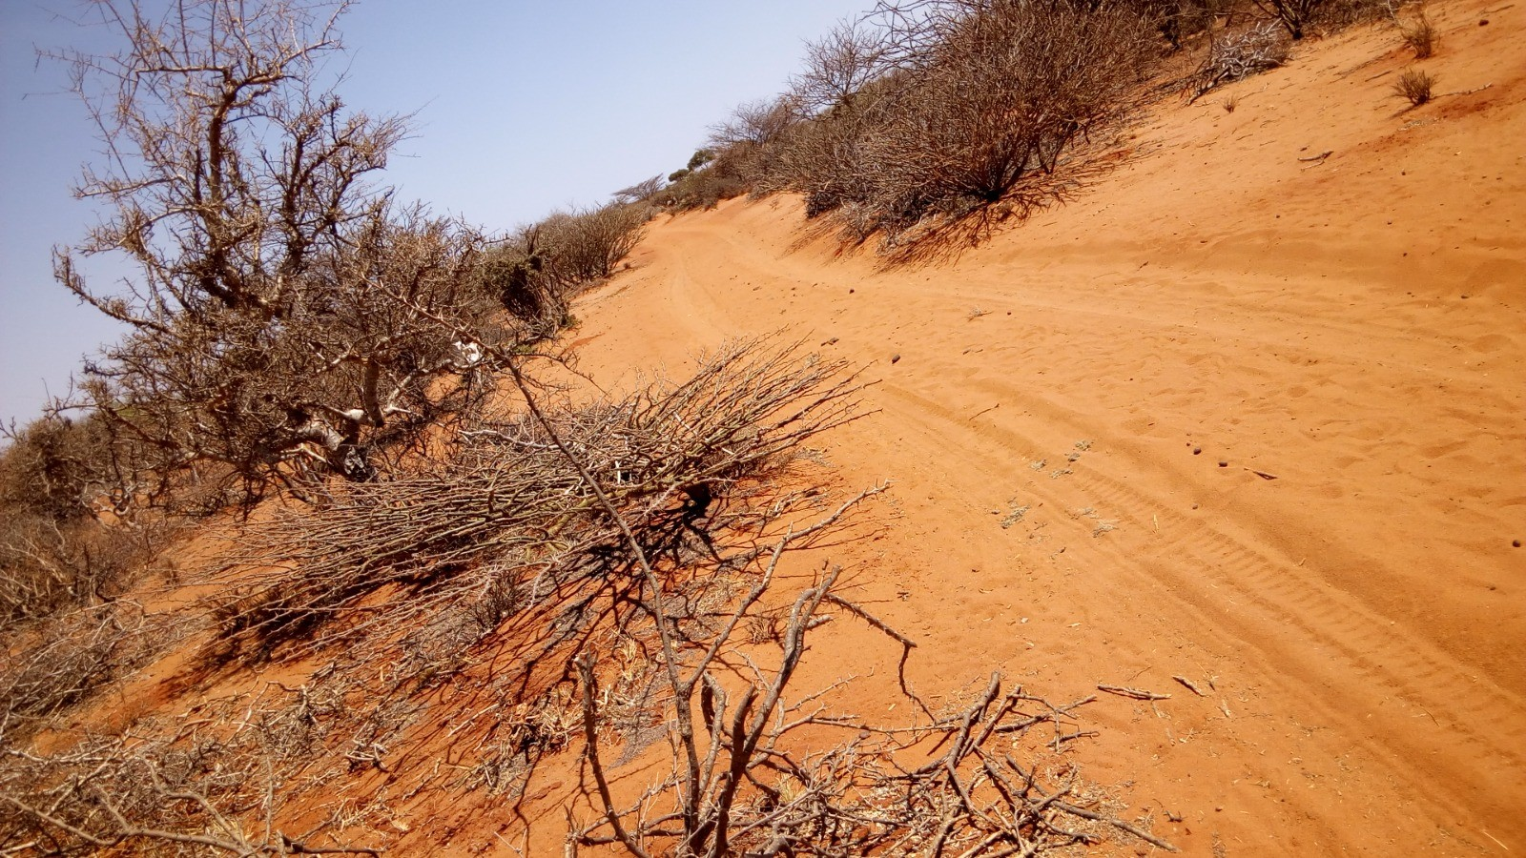
APCO_Photo2_Degraded Land, Deforestation and soil erosion on the project site: the land the community's afforestation and briquette work is meant to restore.

