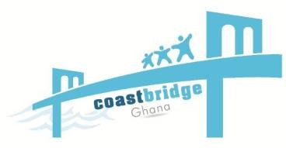
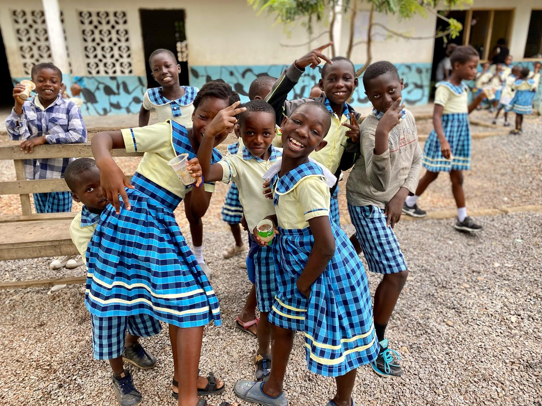

ANNUAL REPORT 2023

Ghana no: CG194812015. +233248986334
coastbrideghana@gmail.com www.coastbridgeghana.org



We aim to alleviate poverty and mechanize a sustainable development in the rural fishing communities through education, health and economic empowerment project
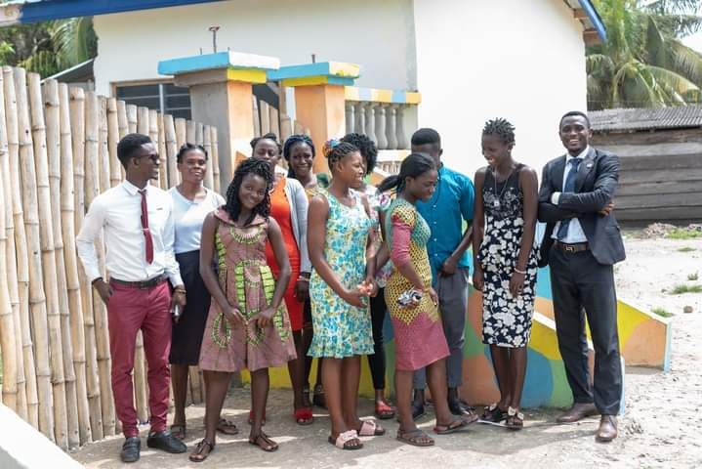

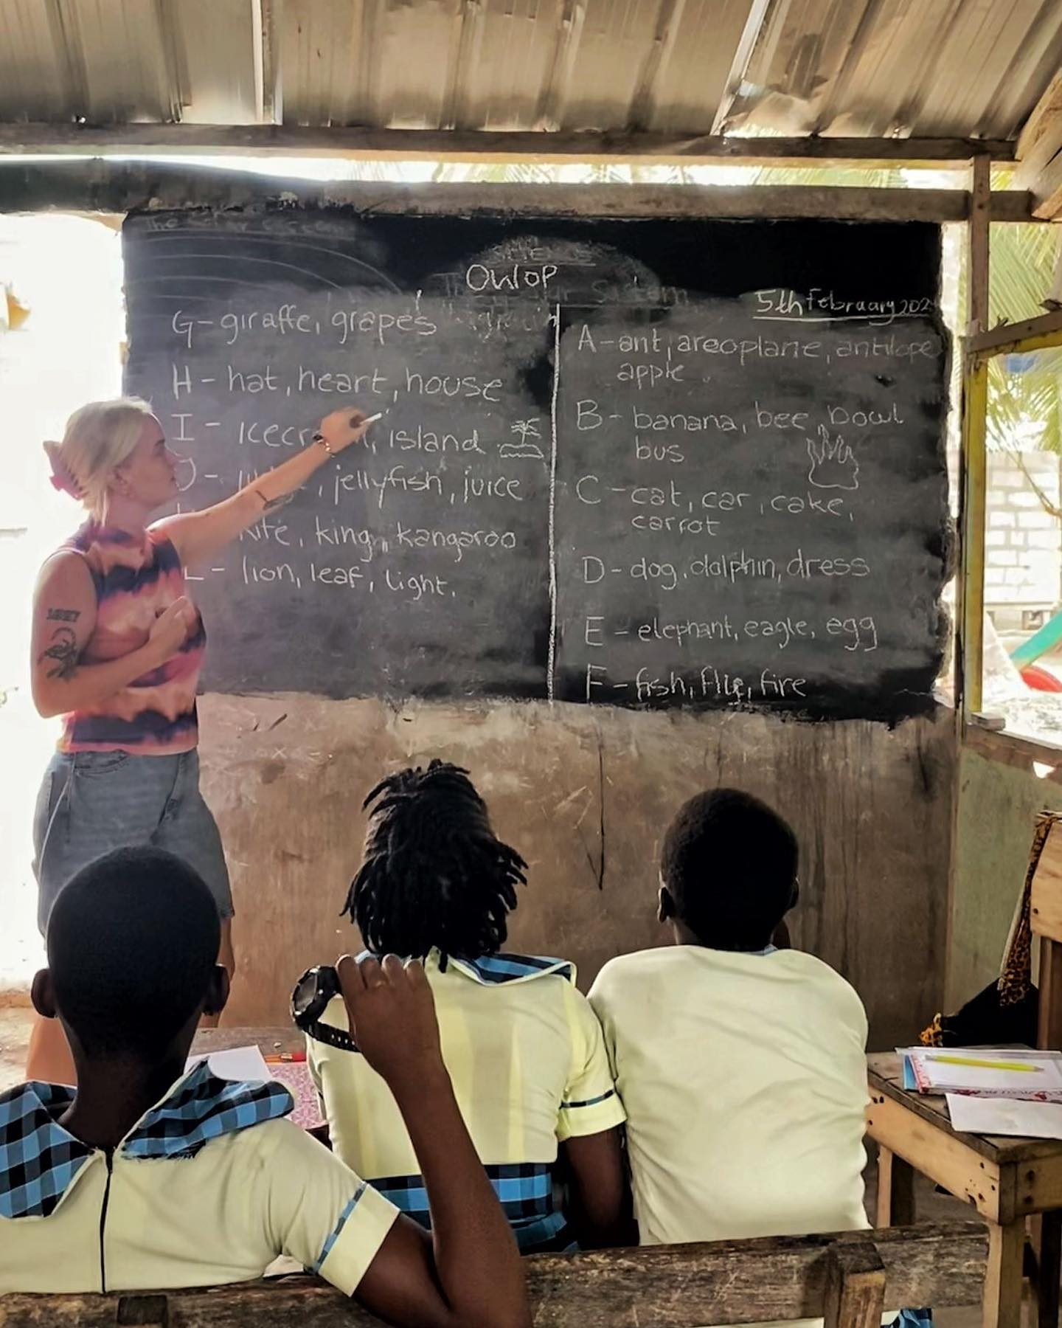



CONTENT

About Coast Bridge-Ghana

- Executive Summary

- What we do

Our achievements

- Education

- Health

- Economic Empowerment

Our team, supporters and partners
Financial overview Future plans

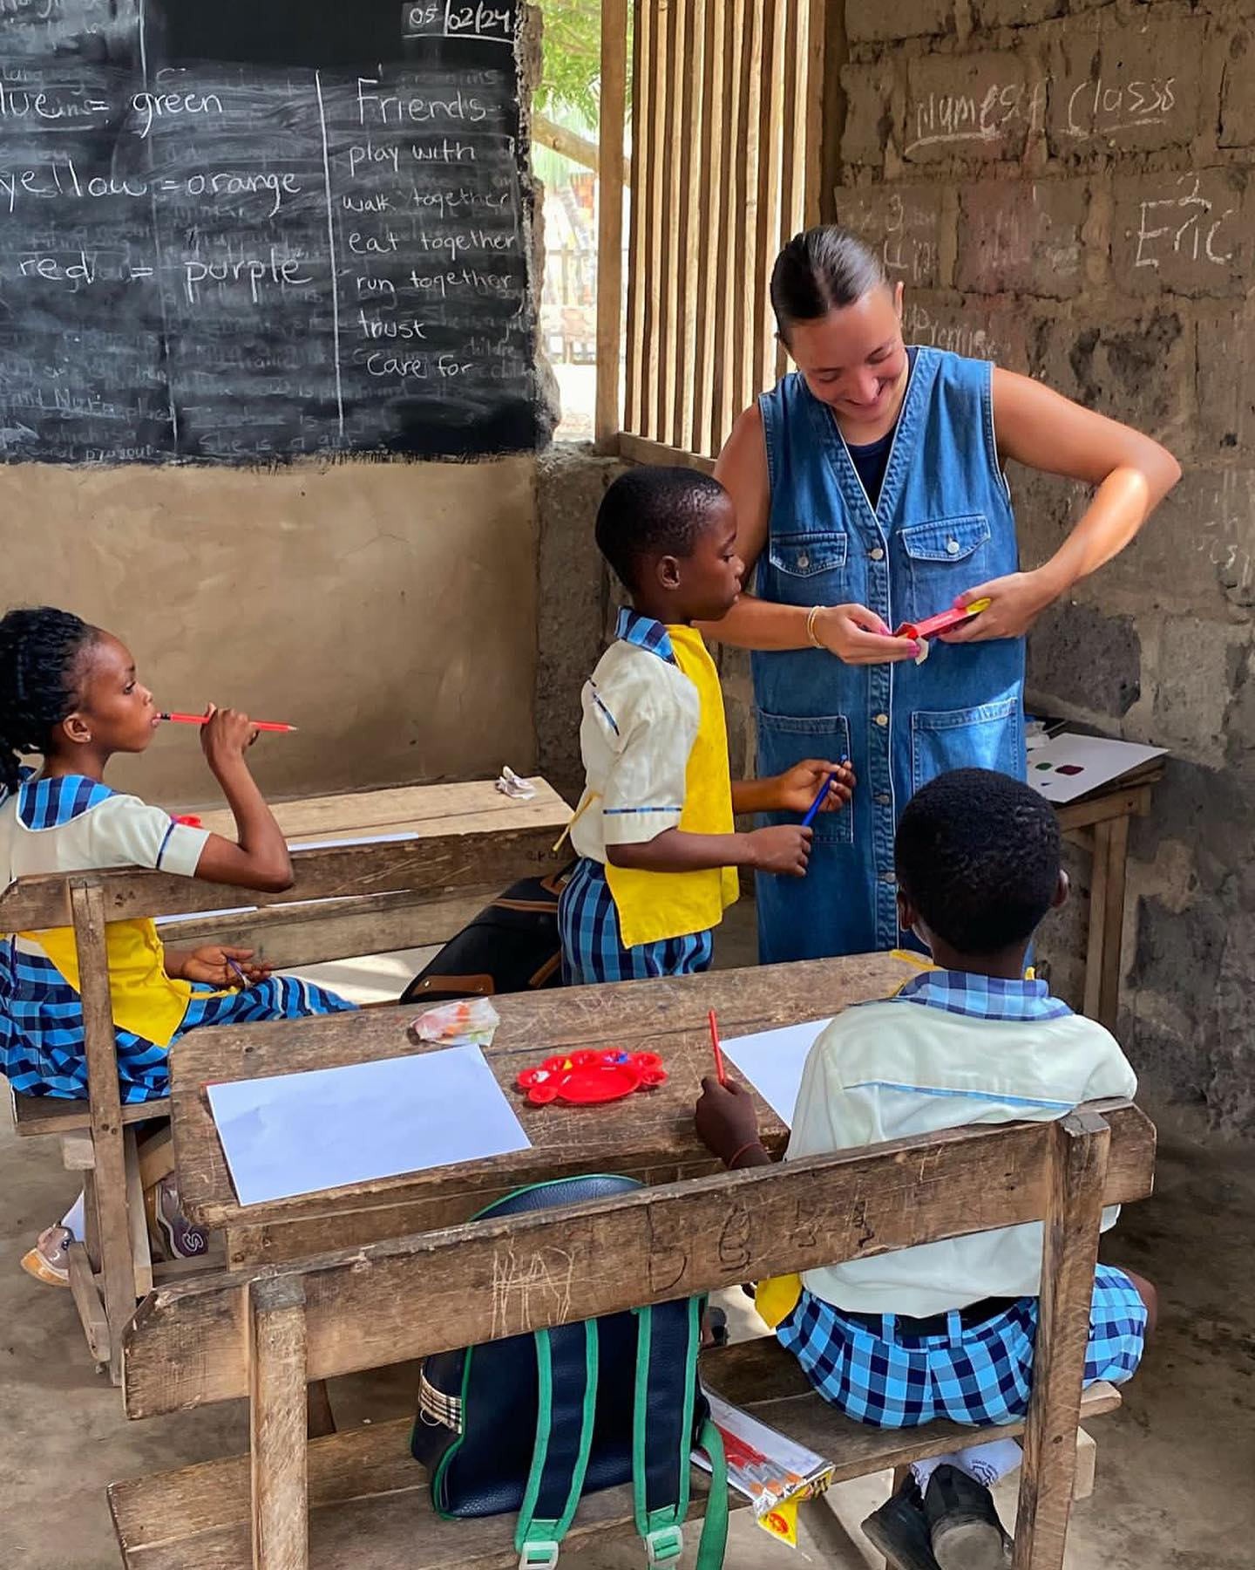
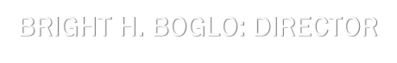
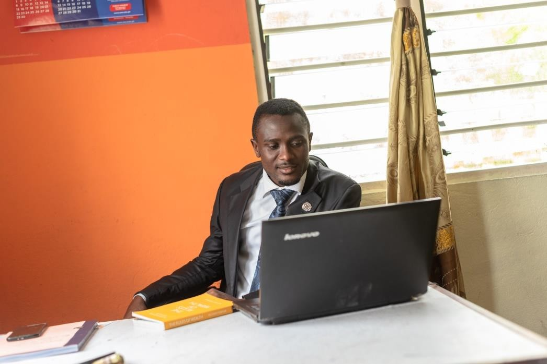
under construction, an office, a washroom, a place to cook and a compound to play for the children. A total of nine (11) teachers, a cook, cleaner, two (2) administrative stuffs and a full functioning board of directors.
BRIGHT H. BOGLO: DIRECTOR
I believe education is the only known way of making a greater change, this is especially the case in our part of the world where such opportunities are few and the information about them limited. Many things have change since when I was a child in the

Since 2015 when we started our development project form a very humble beginning, our impact has been unbelievable. We ended 2023 with a great school closing durbar amidst a little Christmas party for our student, their parents and our staff in our school compound.
In 2015 we had no building; we started teaching the children from the community under coconut trees with just one board and a teacher.
Today, in our school, Coast Bridge-Academy we have eight (12) classrooms with tables and chairs, four (4) more classrooms
village, when we thought the known world is our immediate community but education over the years have broaden my understanding of things. Education therefore grants the individual the very opportunity to be enlightened and to have knowledge about those few available opportunities.
After successfully managing to start a formal school in 2018 with only seven (7) children in three (3) uncompleted classrooms, today after a year we are over hundred (100) children in our school compound.

Our future aim is to provide more classrooms and upgrade all our classrooms to a standardized classrooms furnished with computers and modern teaching and learning equipment in other to improve on the quality of education we can offer to the children we support.
We also have plans to create can income generating activities for the parent of the children to economically empower them so that they can better care for their children and themselves. We do also have plans to create incoming generating project internally to support our activities. The health and wellbeing of the children and the entire community is a top priority to us and we will continue to engage in public health awareness campaigns in the community.
In an increasingly challenging effort to finding sponsors, and patterns for our work, we are determined to continue our work believing to obtain new sponsors and supporters and we look forward to what 2024 has to bring.

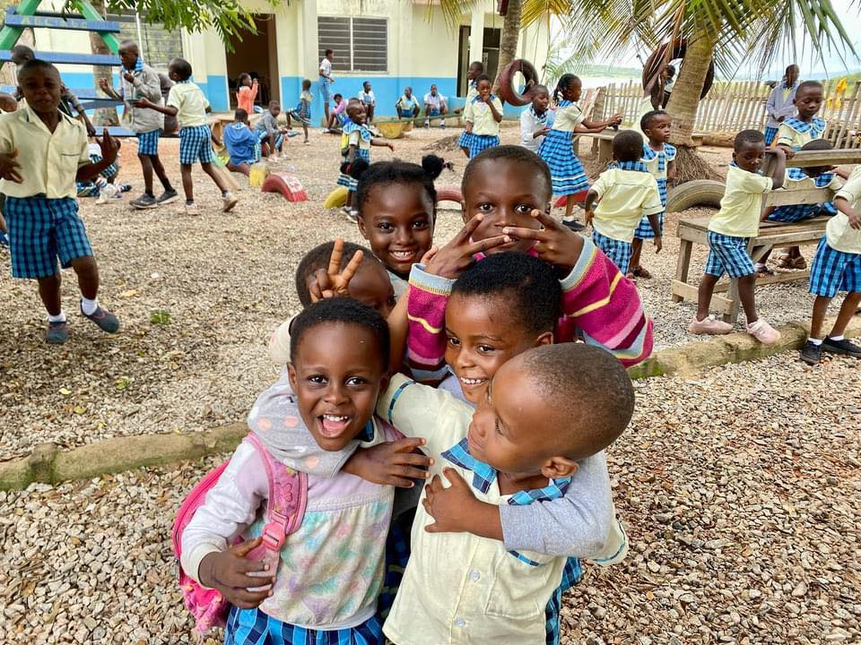
I say thank you to all of you our supporters, you have continued to trust us and have supported us. As an organization, we are at a stage where your friendship and support is most needed; this is the stage we need to work to retain our staff in order to ensure program consistency and to grow into being a self-sustaining organization.
Sincerely yours, Bright H. Boglo.

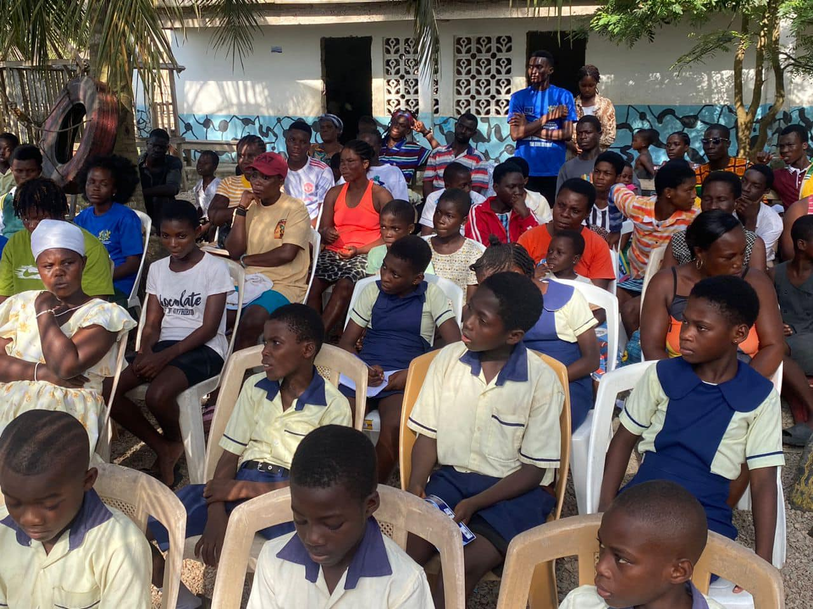

WHAT WE DO
Coast-bridge-Ghana is a registered non-governmental organization (N.G.O) based In Akosua Village, Winneba – Ghana. Our vision is to alleviate poverty and mechanize a sustainable development in the lives of vulnerable children and
families living in rural fishing communities in Ghana through education, health and economic empowerment projects.
Our work is mainly focused on children and families in rural fishing villages where educational providers are often unable or unwilling, to provide services tailored to these communities where the impact of child labor may also reduce school enrolment and attendance.
Where behaviors and lack of knowledge about basic health related issues could lead to wide spread of diseases and sickness and where there is economic hardship and the survival of the woman is solely dependent on the man. In these areas, there is a widespread of poverty due to lack of education and extremely poor hygiene levels.

OUR ACHIEVEMENTS:
2023 is a wonderful year filled with may good memories we will cherish forever. The year also came with sure hard parting moment which was very difficult.
In 2023, most of our work was focused on our new school, building new classrooms to accommodate the increase number of student, making arrangement for tables and chairs, teaching and learning material, getting new teachers, meetings with parents etc.
We continued our work on improving the lives of those in the rural fishing community. Because of our school many children were able to Start School, the total enrollment which was only seven (7) when we started the school has shot up to over hundred (100) by the end of 2023.
Amidst all the education projects we were also able to roll out a comprehensive research into some of the major cause of teenage pregnancy in the village which was depriving the young girls opportunity to go to school or learn a vocation. Under our health
project with two volunteers form North Western University in the U.S.A. We also built new classrooms
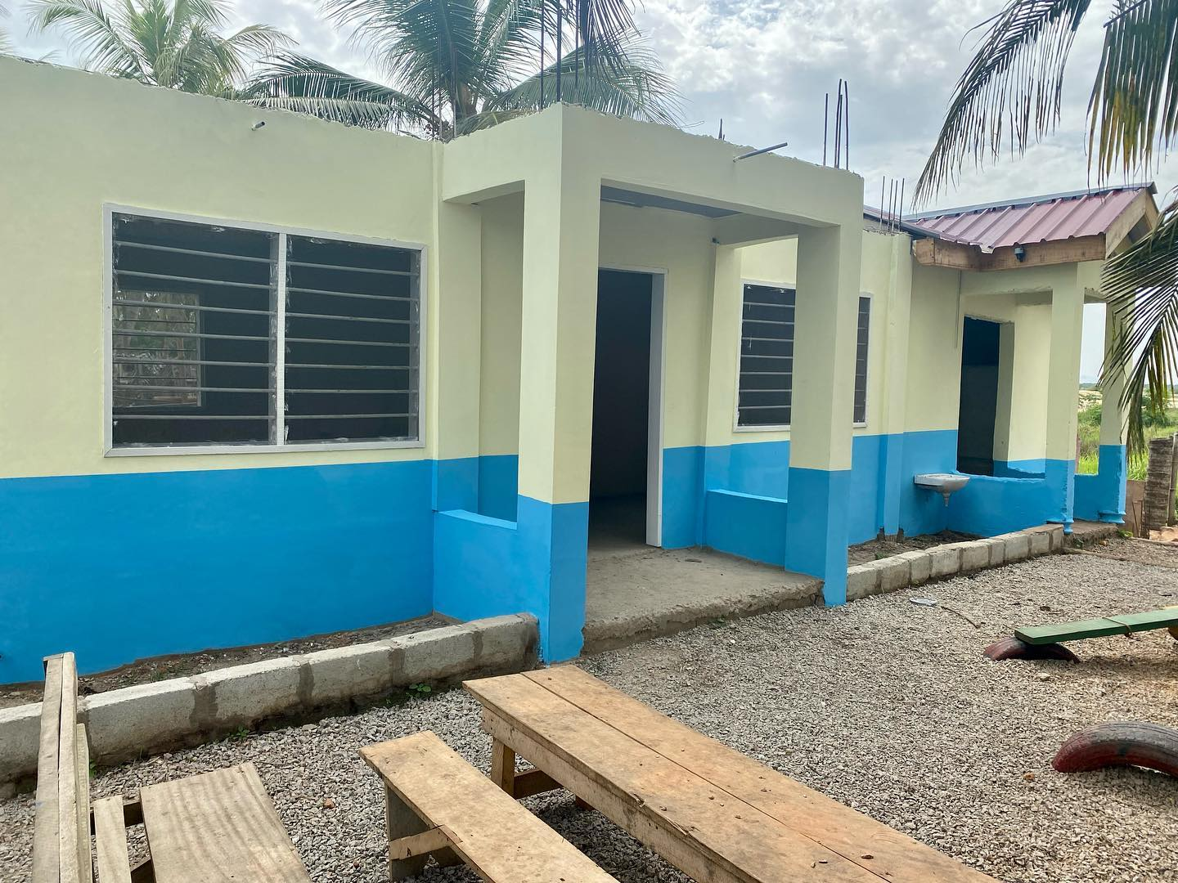
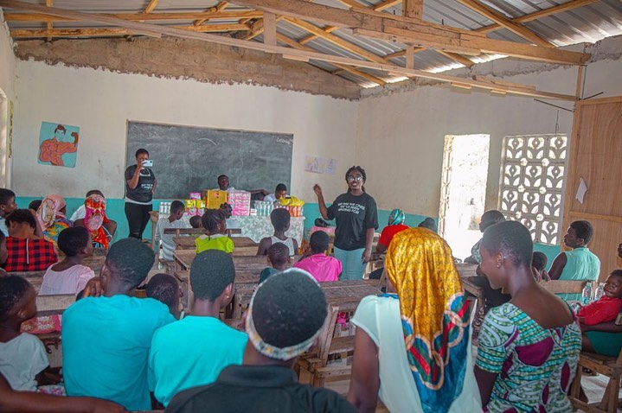

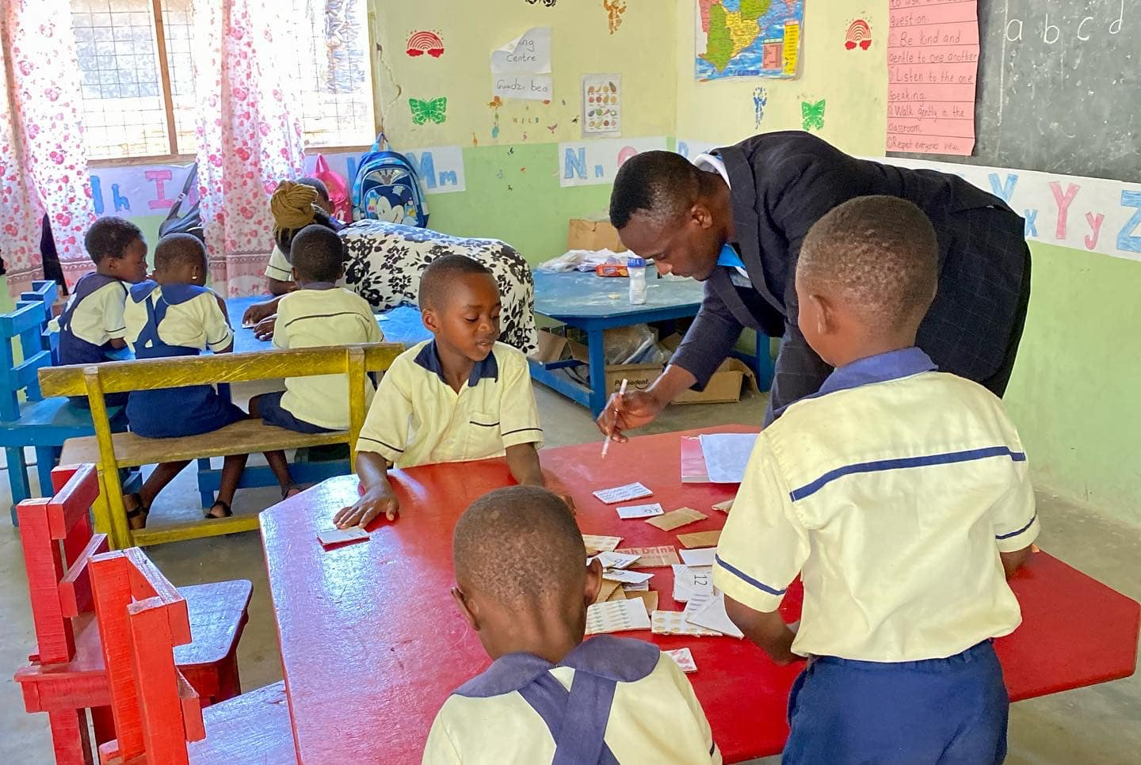

PROJECTS HIGHLIGHTS - EDUCATION
In 2023, our education project has continued to expand in size. By the end of the year, we had a total of 105 children from the age of two (2) to thirteen (17) enrolled in our school. Our school, Coast Bridge - Academy also expended its classrooms, two (2) rooms for nursery, I and 2 kids, two (2) rooms for kg 1 & 2 kids, one room each for class 1,2,3 and 4 student. While four (4) more classrooms were also constructed to continue our Junior High School and extra classroom to meet future expansion needs. These expansions also means, the need for more tables and chairs, teaching and teaming materials and more facilitators,
our teaching staff also increased to nine (11) a cook, a cleaner and two (2) administrative staffs.
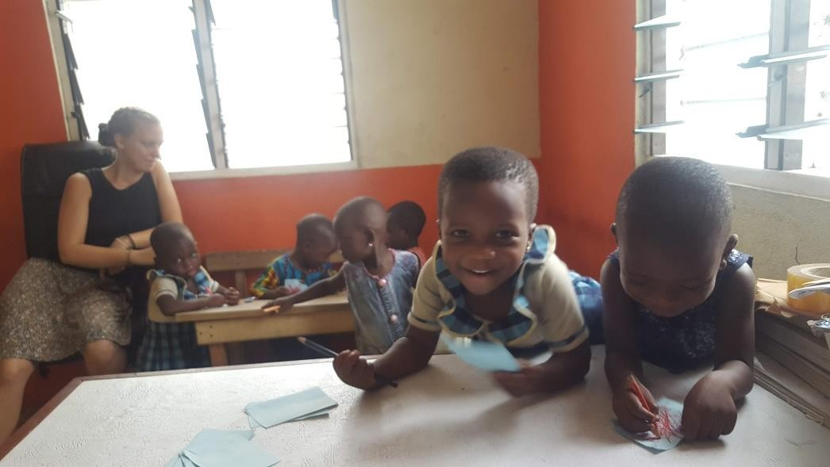

She also made arrangement for her visiting friend Mette Nielsen to come along with her to Ghana two (2) bags of playing toys for the school children. Abena, as she was popularly called by the children also invited four (4) other friends Jessica, Timon, Natasha and Malene who comes around in the afternoons to help the children to read.
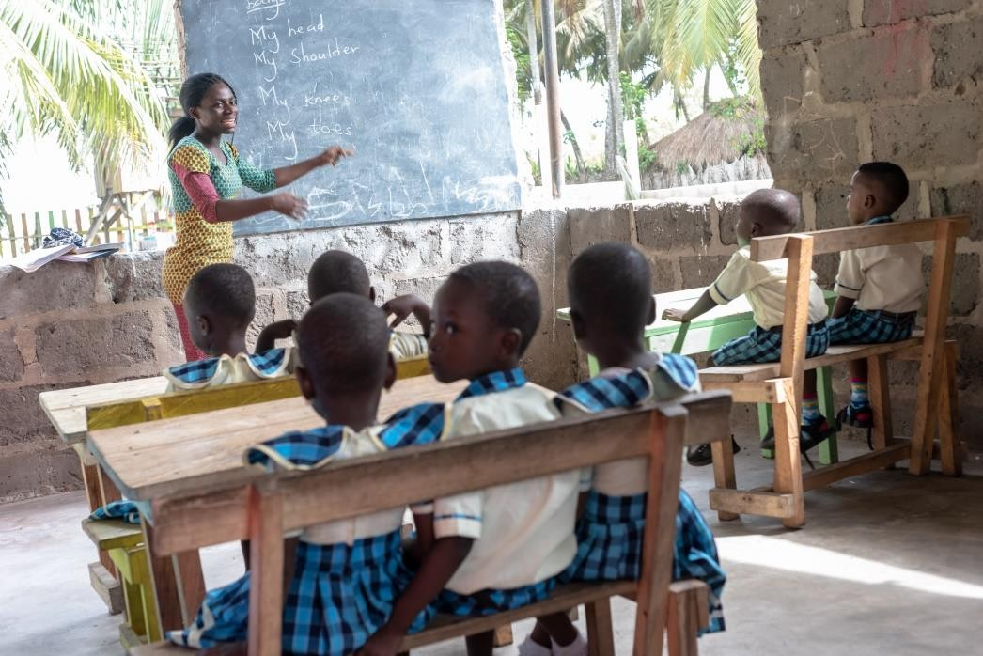
Around the same time, we continued to teaching the children in our afternoon classes even though not as regular as we used to do because of the pressure of the new formal school. Leyna a marine biologist, from the state who was working with the wildlife
department also contributed immensely to teaching in our afternoon classes for the children.
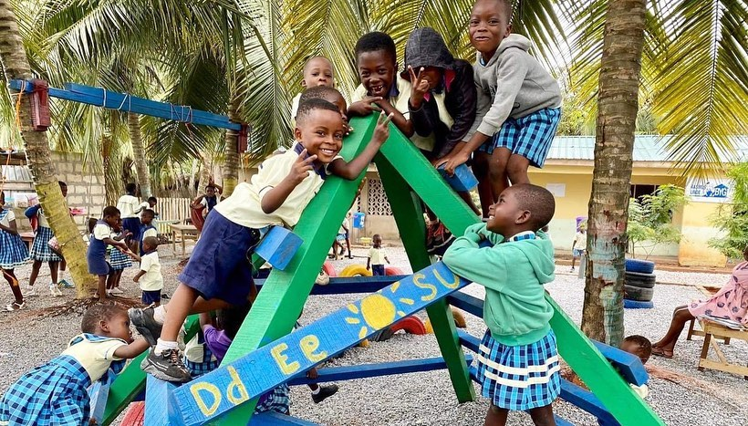
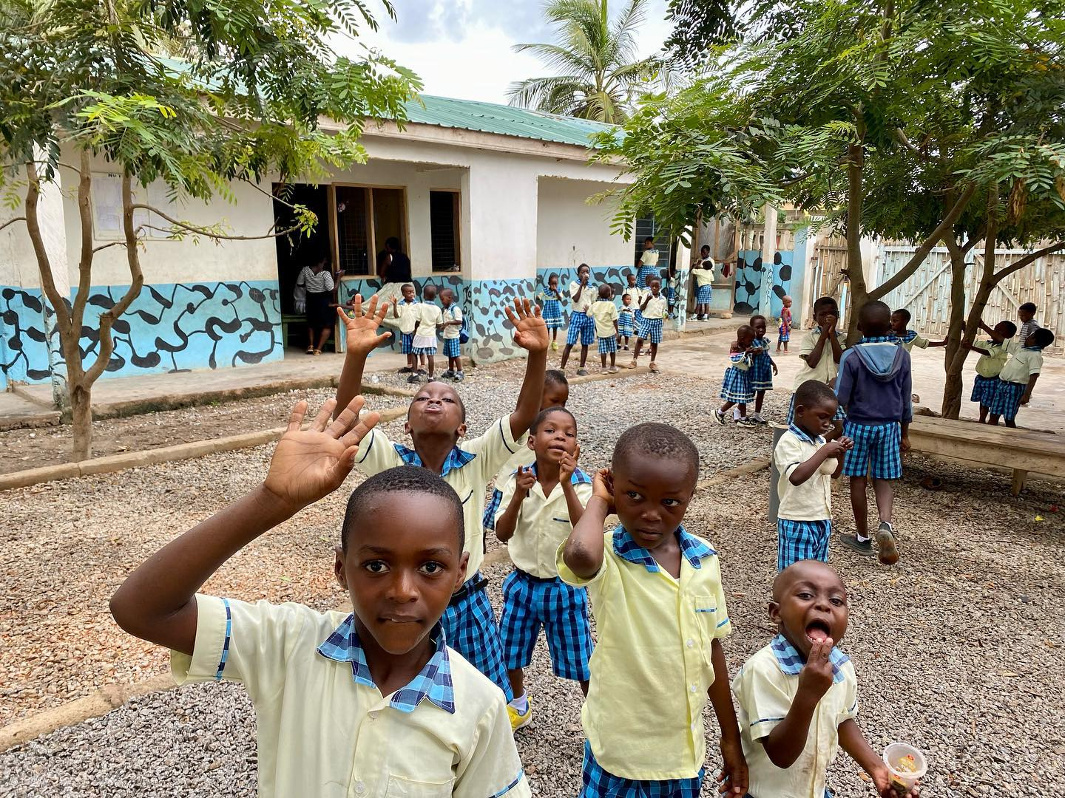

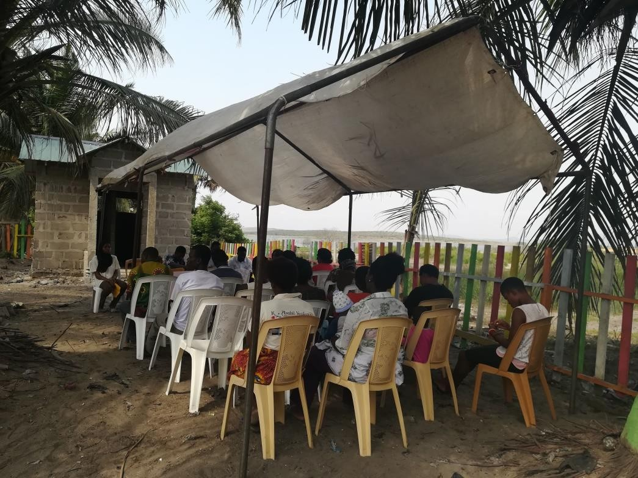

PROJECT HIGHLIGHTS-HEALTH
In 2019 we continued to work with our community based youth health club in partnership with project ten, an Israeli N.G.O in Ghana. Meetings and lesson where being held on Thursdays afternoons between 4pm to 6pin every week for the youth, this meeting and lessons where being planned and coordinated by the youth leaders, two (2) of our stuffs, two (2) volunteer from project ten and two (2) nurses from the Winneba municipal hospital. Health education and awareness continues to remain one of
the biggest challenges of the rural fishing communities. These meetings and lessons focused on public health issues and awareness on preventable diseases, these youth intend go to their various homes to practice and educate their families on what they have learnt.
Common topics that are being discuses include malaria prevention, Diarrheas, burns, hygiene and sanitation among others. Also our health program this year sponsored the national health insurance registration for some people in the community as well as funding the cost of a major surgery on a complicated near death Hernia case for a man in the village.
In July 2019 we had two (2) intern student Ariella & Nadege from North Western University, Evanston, U.S.A and Doha, Qatar, who further strengthened the activities of the youth club and did extensive researches on major cause of teenage pregnancy in the village which was one of our major challenges which eventually led to preparation of hand book on the activities of the youth health club.

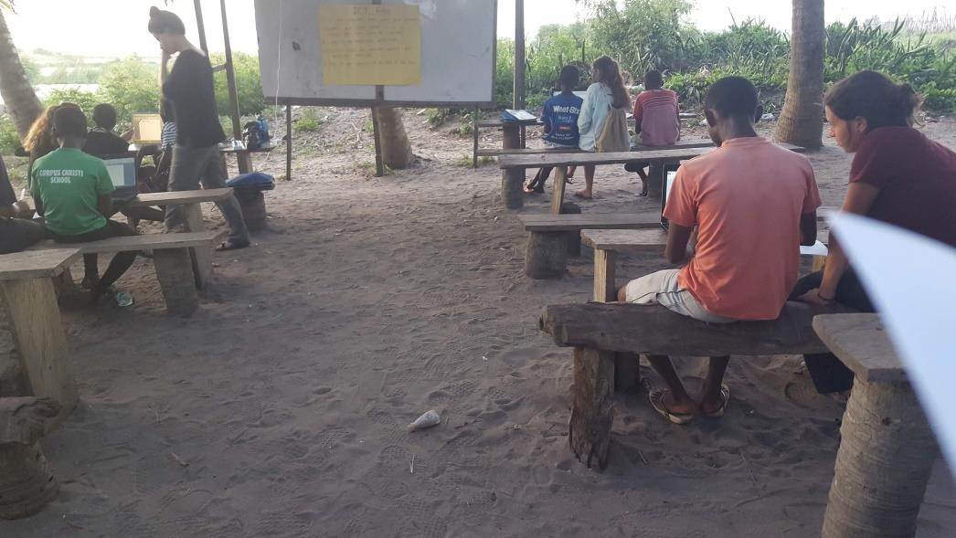
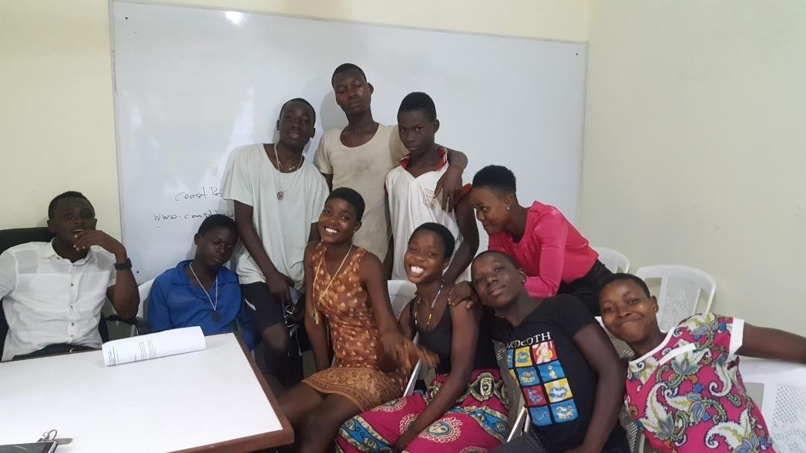
We also continued our community sensitization activities from house to house and open forum on Tuesday evenings for the entire community. General community clean up exercise, awards and durbars where organize once in a while for the entire village to further strengthen our health awareness campaigns.

PROJECT HIGHLIGHT-ECONOMIC EMPOWERMENT
Planning is still underway for effective and sustainable economic empowerment project to support the livelihood of people in the community, as an organization, we are aware that, the financial status of parents will determine to a large extent their ability to send and support their wards education. In 2019 no specific economic empowerment project where carried out, however, the starting of our community school Coast Bridge Academy, brought about a lot of economic reliefs to some of the community members. For instance, laborers for the construction and grounds work where hired from the community giving then means to earn to support their families. Also five (5) of our staffs are from the local community who are on monthly salaries. Again, parent who otherwise would have paid for transportation and taken their children far to school and pay tuition are saving these money by bringing their children to our school for free except paying a small contribution towards the development of the school building which is just a stone throw from their homes.

PROJECT HIGHLIGHT-OTHER ACTIVITIES
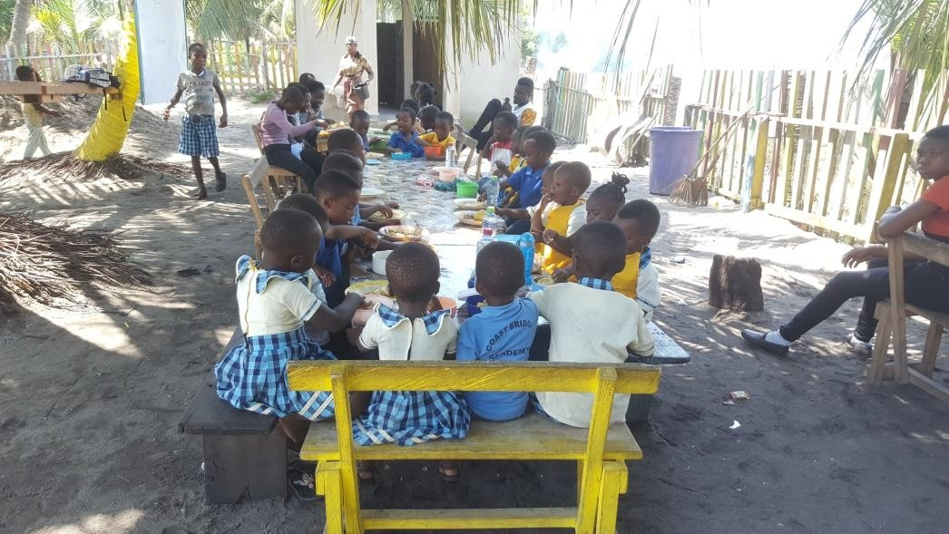
In 2019, our washroom was made available for use even though it was not fully furnished. This was such a great relief at a time when the sanitation and hygiene of our school was under great threat. this year, we were also able to make a temporal kitchen, hire a cook to start giving cooked food in the school to the children which was a major concern for the parents of our children, this saved the parent a lot of effort trying to prepare or find food for their children in the morning every day, the children loved it to eat together with each other.
Traditional drumming and dancing has come a long way in our project. The children love to showcase their rich culture and the coordinator of our drumming and dancing group Mr. Clement Akwandoh who also doubled as the head of the school has managed to keep this amazing group growing.
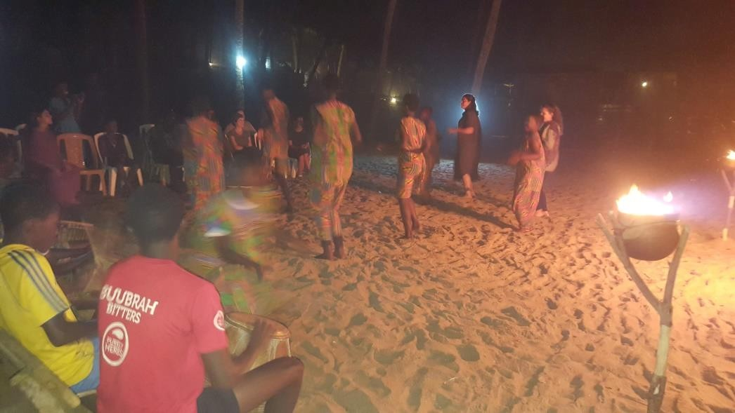
What use is of children’s activities without sport? Our two (2) sport themselves playing and winning matches against others from far. Swimming lessons were also introduced in our school since the whole village is surrounded by the Huge Atlantic Ocean and the Moni-Lagoon.

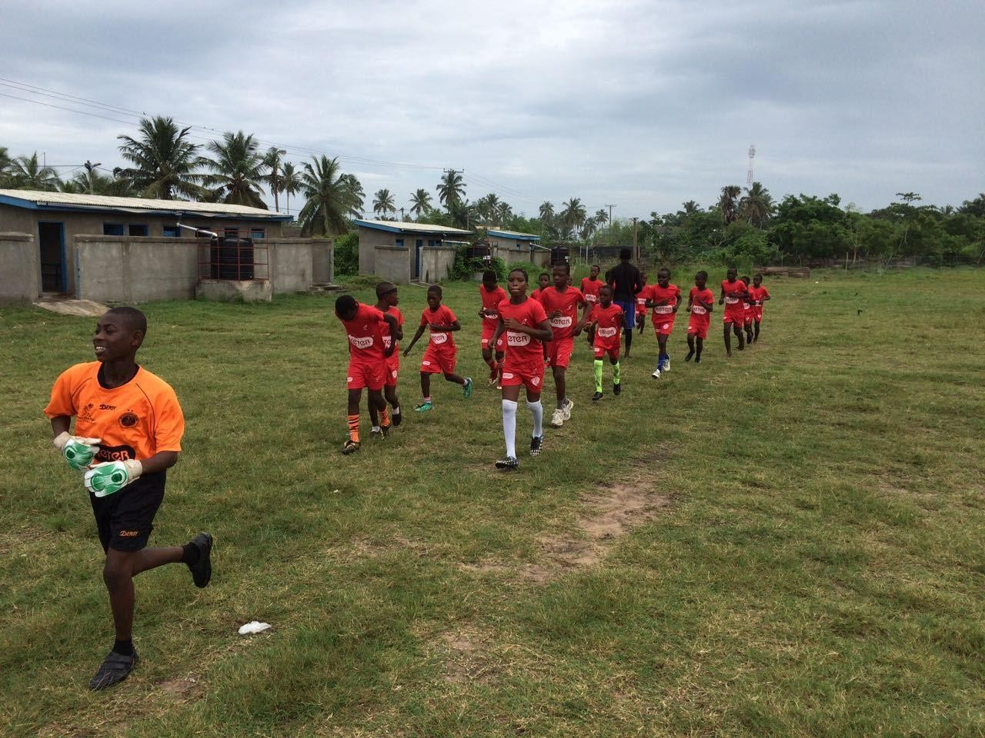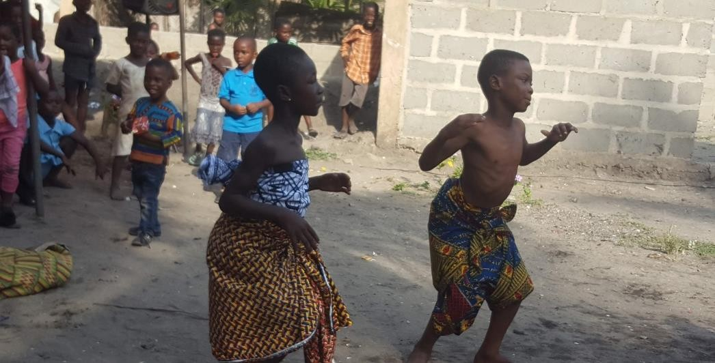
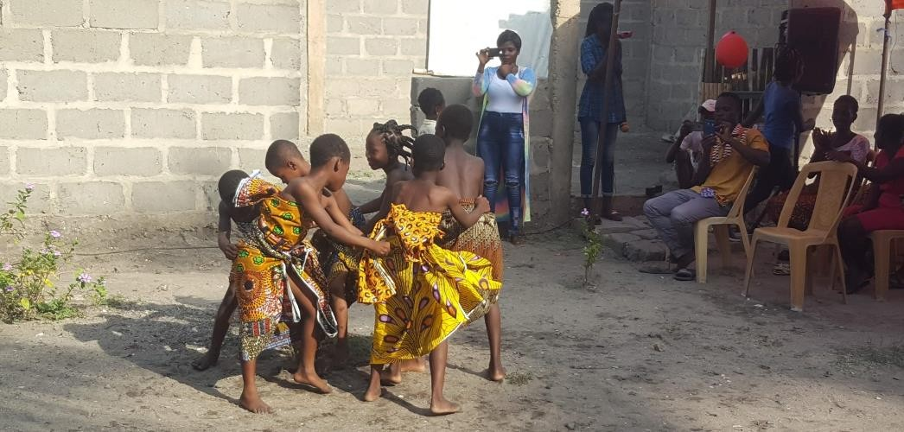
In the year 2019, we did continue our support in a small way for three (3) students to peruse high school education.
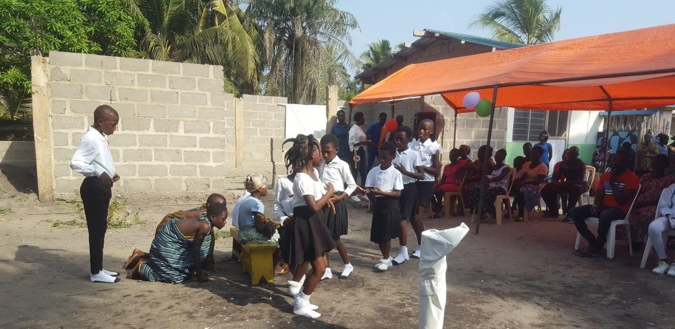
It is also in this same year that we were able to get water supply to our school compound which was very much needed for, cooking, building and for the washroom.
We closed the year with amazing closing ceremony performances form our students which was a great delight for the parent to watch.

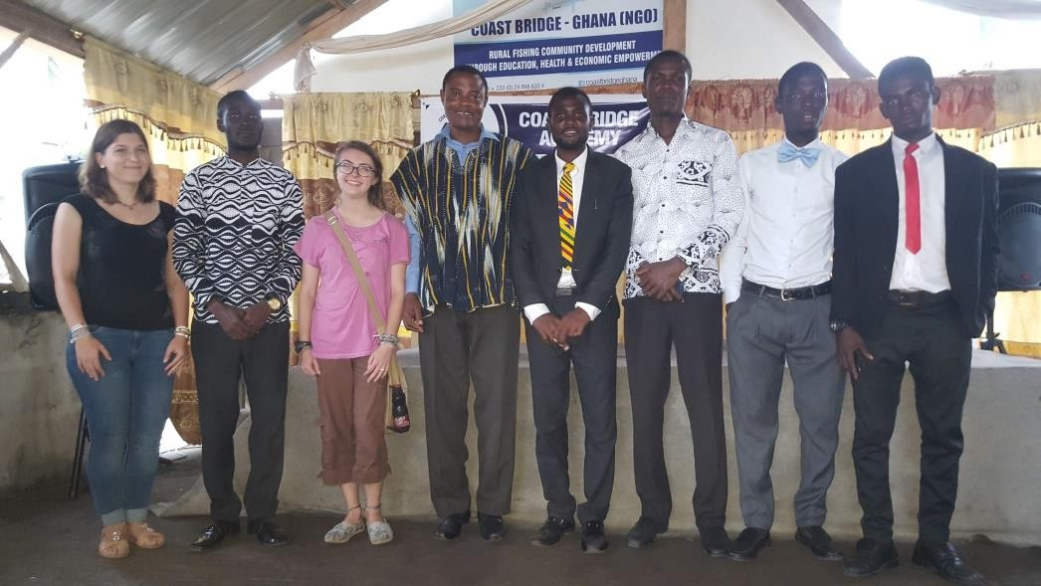

OUR TEAM SUPPORTERS AND PARTNERS:
In 2019, we had the privilege of working with and being supported by a number of amazing individuals and organizations, we would like to thank all of them for their unfailing support. Our thanks also extend to Melissa Niedzielsk, Teresa Pritchard Cole, Linda Bibas, Frank Moris and the New Life Ministries, Malene Linde Larsen, Jessica Alice, Mette Larsen, Nis Ove Jornae, our friends and supporters in Ghana, U.S.A, Denmark and Germany who continues to sponsor or make donations to our school and other projects. This is the bedrock of our organization and we are grateful to our many supporters in
Akosua Village and Winneba. Our work will not be possible without you.
Finally we wish to thank our amazing board of directors, Melissa, Malene, Eric, Linda and Bright, our stuff, our teachers and volunteers for their hard work and dedication to coast-bride over the last year.
Thank you.

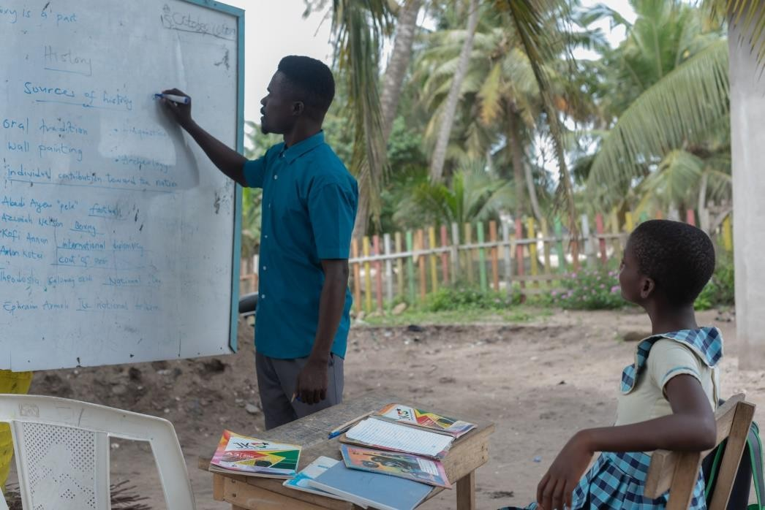

3. Utilities | 850.00
4. Communication, printing & publication | 1526
5. Building, renovation and maintenance | 10,291
6. Equipment, fixtures and fittings | 631
7. Scholarship & other expenses | 870

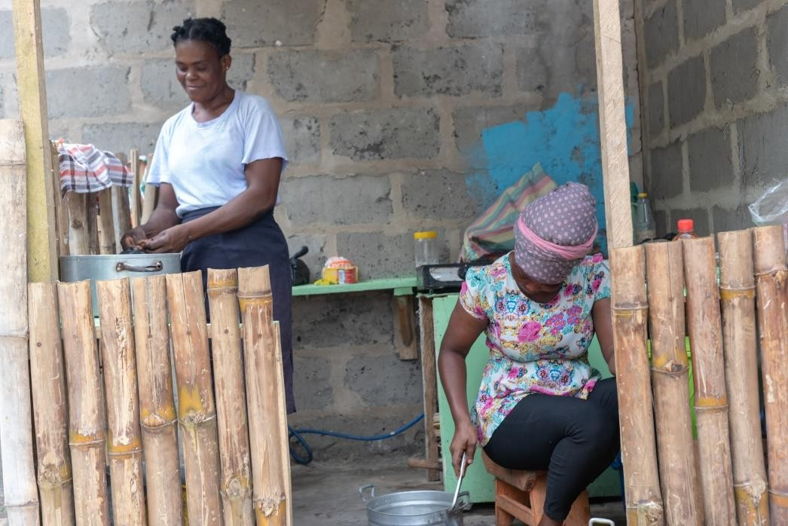
FINANCIAL OVERVIEW

The sources of finance for the organization are founder funded, Friends and family, individuals and organization. As a non-profit, non- governmental organization we rely on the generosity of others to continue our work. Most of the funds for the project are directly used on the project and on the community we work in.
Shown below is a summary overview of our finances for 2019. Summary overview by expenditure GHs
- Salaries and allowances 16619.70
- Administrative expense 3127.86

TOTAL EXPENDITURE 33915.56

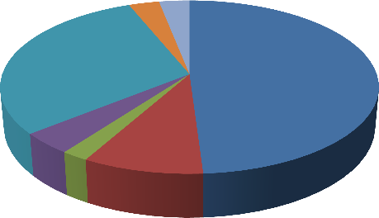
EXPENDITURE
Salaries and allowances
0.03 0.03
Administrative expense
0.3
0.49
Utilities
0.09
0.04
0.02
Communication, printing
& publication
Building, renovation and maintenance

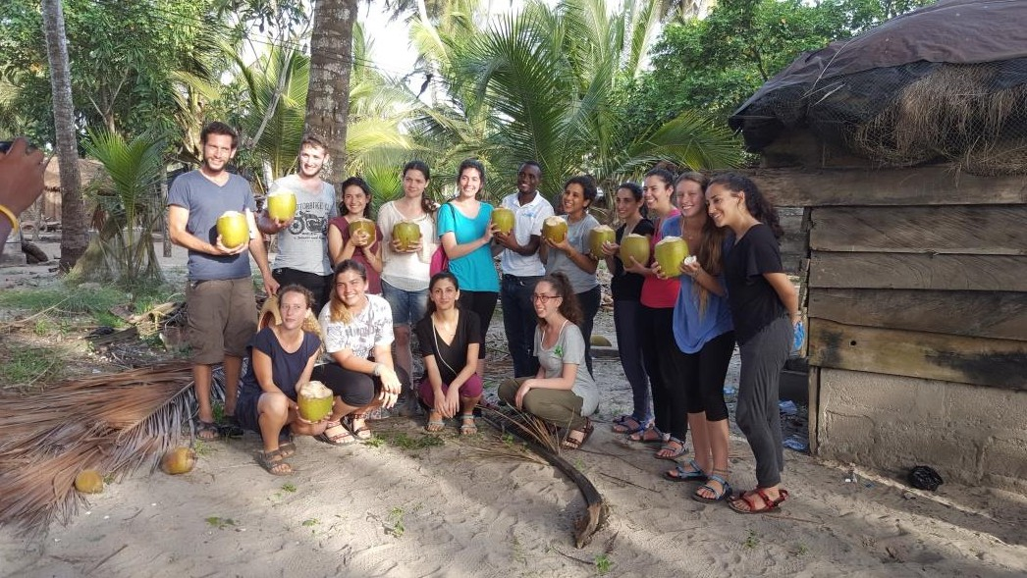
FUTURE PLANS

As we have grown as an organization, so have our reach and our impact on the fishing village of Akosua. The organization has been working only in and with Akosua fishing village and will remain as such to maintain the personal community involvement for the time been.
Now that our school is stabilizing, we have our sight set on further growth in other aspect of our operations thus; Health and Economic empowerment of our community as well as focusing on sustainable project to raise income internally to support our activities.
We also have plans to introduce livelihood empowerment project to support women in our community economically, plans to increase our public awareness campaigns on preventive health issues. We also intend to continue with the development of our school building and other structures that will allow us to introduce new programs to further support the Akosua fishing community.
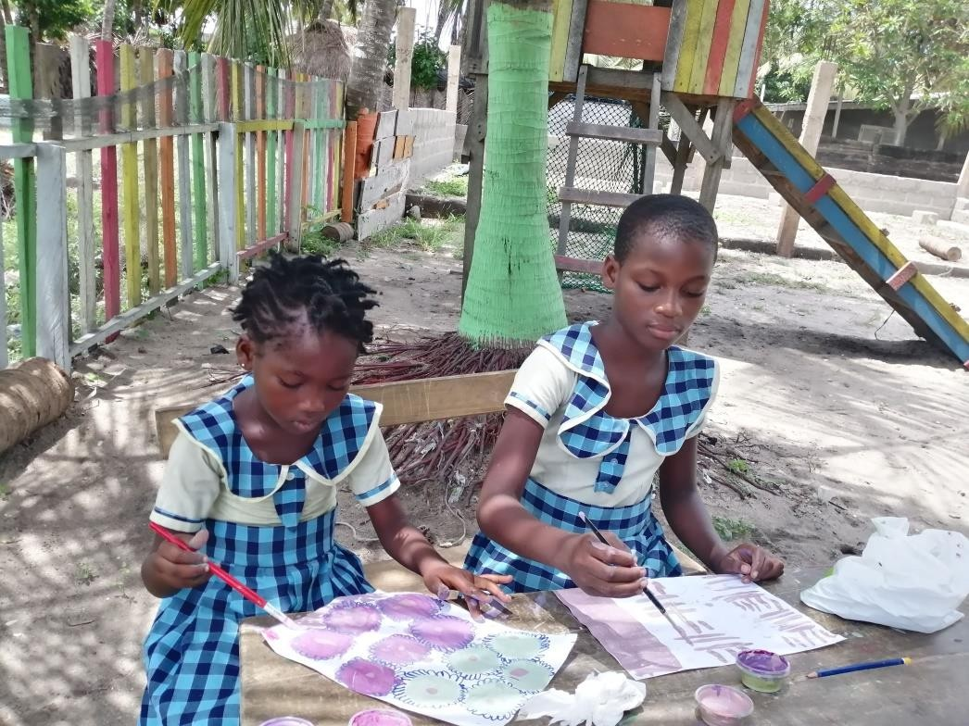
As we are planning many exciting activities and developing new ideas for 2020, we hope you will join us on the journey towards achieving them.

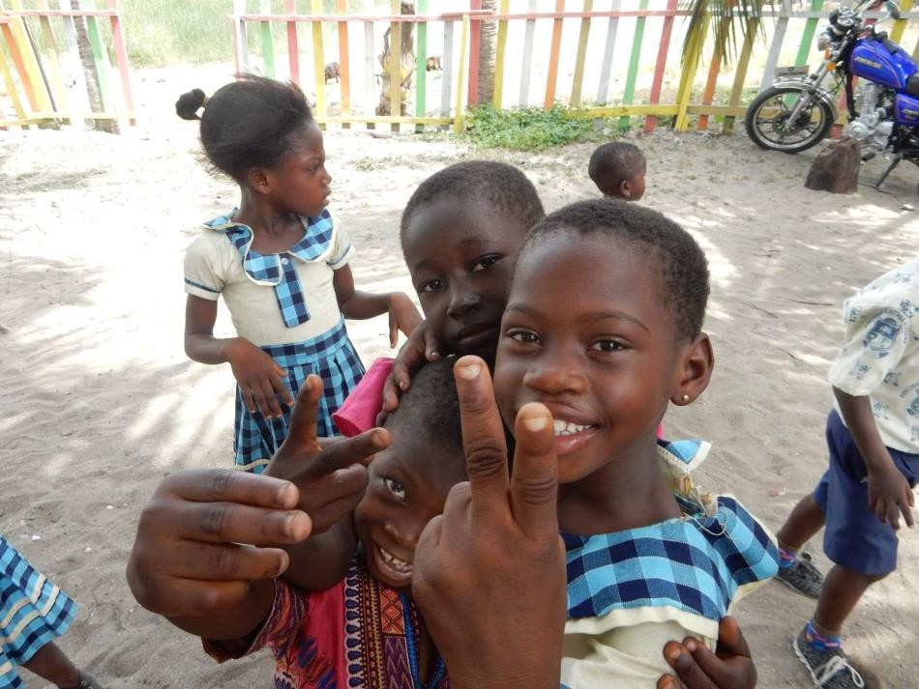
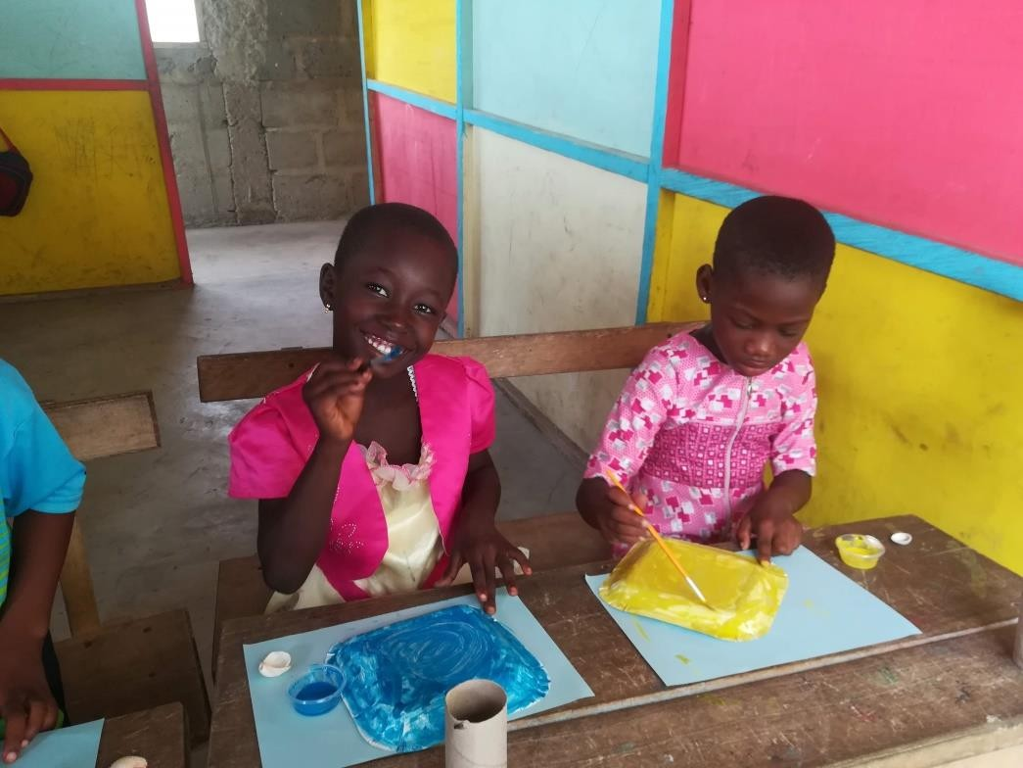



CONTACT IMFORMATION
Office location
Coast Bridge - Ghana
Akosua fishing village, near the Moni lagoon, Winneba, Ghana.

Mailing Address Coast Bridge – Ghana Post office box 489 Winneba. Ghana
Mobile: +233248986334

Emails: coastbridgeghana@gmail.com
boglo943@gmail.com
Website: www.coastbridgeghana.org

Facebook:
https://web.facebook.com/coastbridgeghana
/
Instagram:
https://www.instagram.com/coastbridgeacademy
/?hl=en

