Representation on National and International Platforms
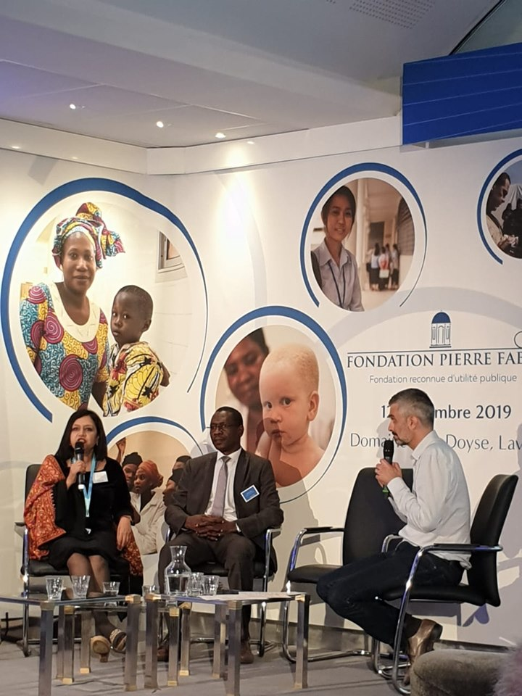
- Our President Dr Shelly Batra was invited to Lavaur in France as a speaker during a star studded glittering event on the occasion of the 20th Anniversary celebrations of the Pierre Fabre Foundation. The event was graced by Ministers, Nobel Prize winners and dignitaries from across the globe.
https://www.fondationpierrefabre.org/en/access-to-quality-healthcare/fondation-pierre-fabre-celebrated-20-years-of-commitment/

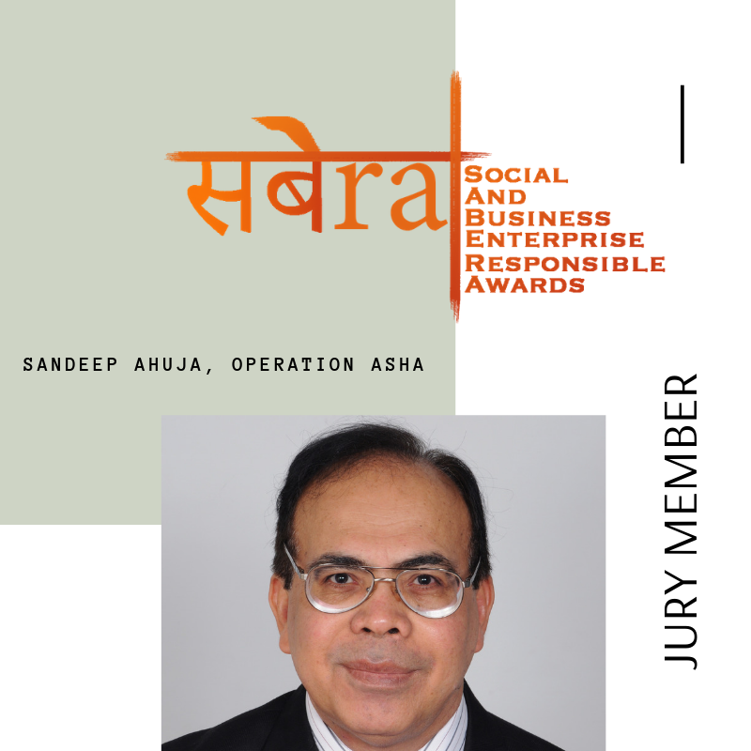
- Our CEO and co- founder Mr Sandeep Ahuja was nominated as a Jury member at the SABERA Award 2019 in which he’ll be recognized for the tremendous work his team has been executing in the way of treating over 1 lakh patients of TB to date through their state of the art tracking of patient updates and medicine administration in the most marginalized communities. Operation ASHA was also one of the winners last year in the Health & well-being category.
http://simplysuparnaa.com/sabera-2019/

- Operation ASHA's cost effective and life-saving work got published in a UK based financial magazine "This is Money".
https://www.thisismoney.co.uk/wires/afp/article-7549011/India-frontline-fight-against-tuberculosis.html

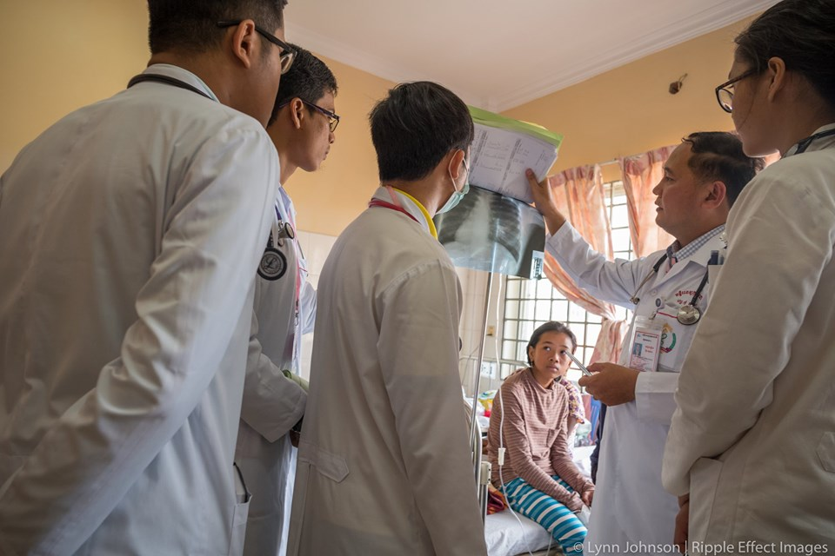
- The Ripple Effect Images, Cambodia wrote about Operation ASHA’s work of delivering the health services to last mile.

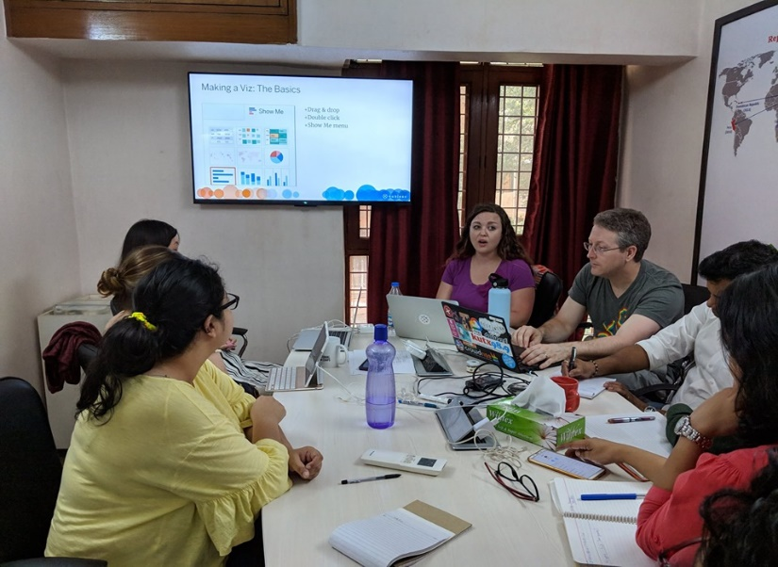
- Tableau Foundation supports Operation ASHA for using data analytics in order to significantly increase detection of TB patients. Tableau sent over two of its best employees – Micheal Becke and Lauren Beck, all the way from USA to work in our Delhi office for 3 whole weeks. Together with OpASHA’s Director Technology and the in-house technology team they brainstormed and worked on an app on Tableau mobile to be used by health workers while doing active case finding in the field. They also managed to find time to train OpASHA employees in the use of Tableau and gave multiple presentations in office to that effect. It was wonderful having them over and we look forward to a long and continued relationship with Tableau.

