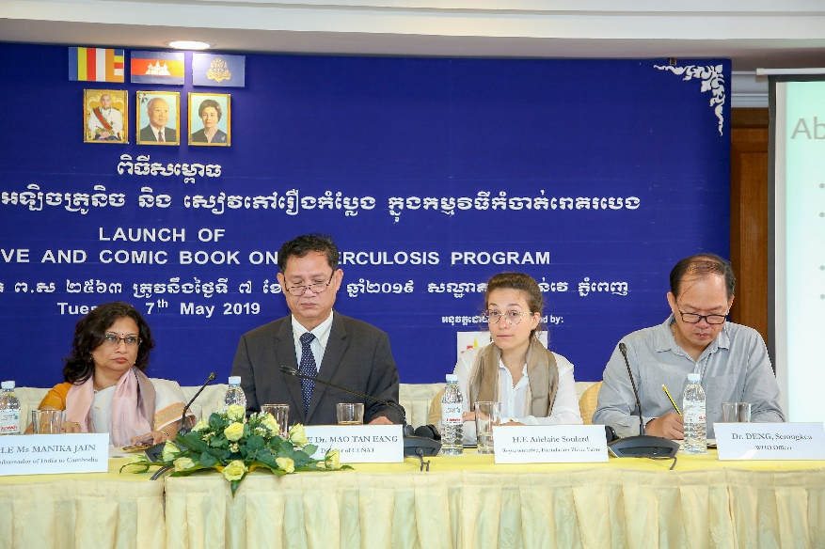
Launch of the comic book in Cambodia in presence of Dr. Eang and the Indian Ambassador to Cambodia

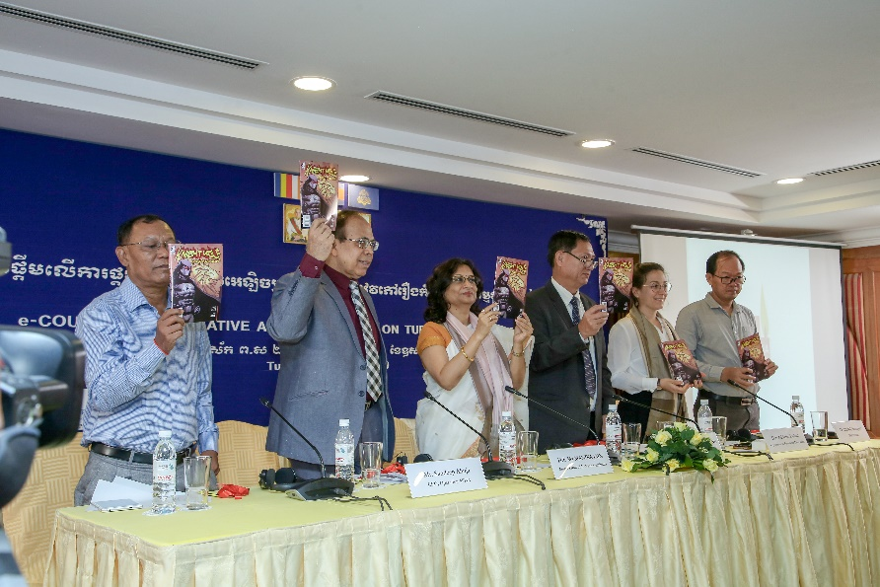
Mr. Sandeep Ahuja, CEO of OpASHA with other dignitaries at the launch of the comic book

