Saving Future Lives

Summary
The numbers of stray animals in Colombia are alarming. In 2023, three million (3,000,000) animals were reported wandering on the street. Of these, most - there are no exact figures - are unsterilized. On the other hand, a female canine in five years and her offspring can give five thousand (5,000) puppies and a female feline and her offspring in five years can give up to twenty-eight thousand eight hundred and twelve (28,812) pups.

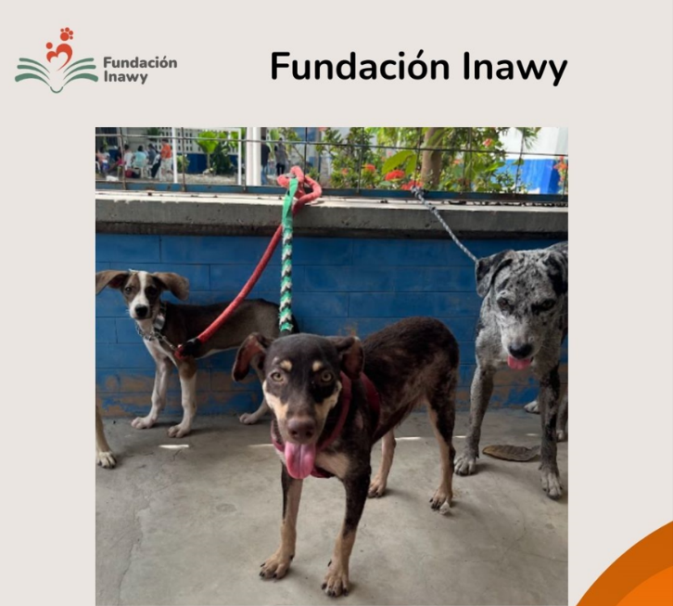

The Saving Future Lives Project reduces the numbers of overpopulation and therefore abandonment and abuse of stray dogs and cats in the communities of Bogotá Soacha (Cundinamarca), Cartagena (Bolívar) and Ciénaga (Magdalena), through mass sterilization days in these communities.

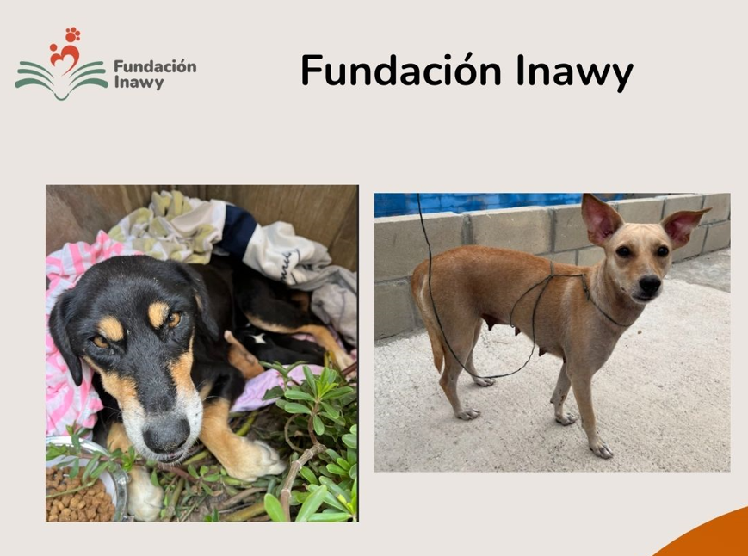
Challenge
In Bogotá alone, there are sixty-six thousand (66,000) stray animals, in Cundinamarca twelve thousand four hundred and thirty (12,430) and similar figures in the departments of Bolívar and Magdalena. Health authorities in Bogotá report that there are approximately 903,573 dogs, of which almost ninety thousand (90,000) live on the streets. Working in the communities and showing the animals wandering the streets, with diseases, malnourished, with signs of abuse and often finding females with litters is quite difficult. Therefore, working to sterilize this group of animals contributes to the reduction of the problem.
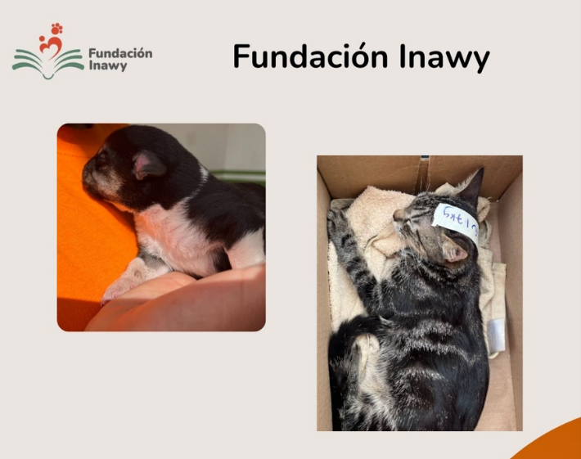

Solution
Develop five thousand (5000) sterilizations per year in the communities where stray animals are found, which will contribute to the reduction of the overpopulation of dogs and cats significantly. And the figures of abandonment and abuse will also be reduced.

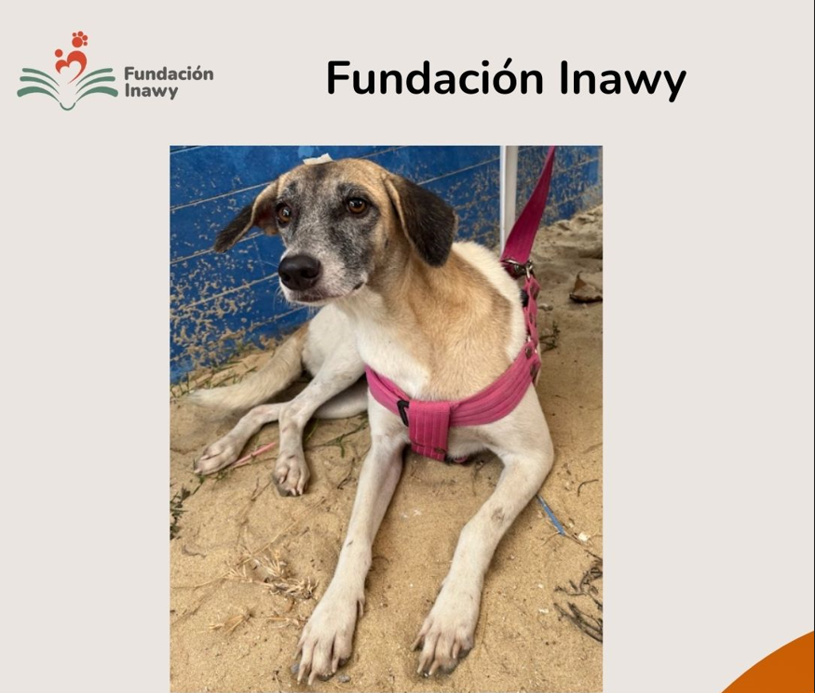
Long-term impact

The reduction in the overpopulation of dogs and cats and the decrease in the numbers of abandonment and abuse is the greatest impact on communities. However, there are other benefits that are the reduction of infectious diseases since they are no longer in a herd behind a female in heat, reduction of breast and prostate cancer and reduction of bite wounds since aggressiveness is reduced and finally increase in life expectancy.

https://www.infobae.com/colombia/2023/01/31/hay-3-millones-de-perros-y-gatos-abandonados-en-colombia-este-es-el-plan-que-propone-la-senadora-andrea-padilla-para-cambiar-esta-realidad/
https://concejodebogota.gov.co/mas-de-100-mil-perros-deambulan-por-las-calles-de-bogota/concejo/2017-01-03/143353.php#:~:text=Las%20autoridades%20de%20Salud%20estiman,han%20permitido%20consolidar%20cifras%20definitivas.

