REPORT 4/5/2025
Project Background.
New Mercy Nursery school is a non-for-profit community-based Organization registered with Kole district Local Government. It envisions promoting education system, good healthcare and uplifting economic growth and opportunities amongst Adolescent youth and young girls and Orphans and vulnerable children in Kole district so that they can live a transformative and inclusive life with limited barriers on basic needs, self-reliance and education.
Northern Uganda experienced two decades of Lord’s Resistance Army from (1986 to 2006) which culminated in a drastic economic setback, many development sectors were crippled; education, Health and economic sectors were most affected. Many lives were lost, properties looted and many people were displaced leading to camps and internal displacement settlement. The communities are in the post-trauma and rehabilitation phase and healings. Many Government interventions have been initiated to uplift education like establishment of more schools to promote the education system but the intervention does not consider the needs of the common child who has no parent (Orphans and vulnerable children), it is highly urbanized living the rural community in absurdity with no basic supports, studies materials to enhance their education.
Kole district is one of the affected communities; the district is located in the northern part of Uganda and has recorded the lowest school enrolment in 2023 by 30% of the eligible children aged 3-7 who are supposed to be enrolled for pre-primary and primary school and the highest school dropout of 46.8% in 2022. This low enrolment is due to the inability of the caregiver to provide food for the children while at school, buy school uniform and pay small amounts of money meant for school development and as well an increased numbers of orphans and vulnerable children and few pre-primary schools in the district.
New Mercy Nursery school was vetted by Global Giving in 2024 to mobilize funds and resources to provides meal for the children, provides books and pens, provides playing materials, Studies material, Furniture, School uniforms and classroom construction for the identified orphan and vulnerable children, provision of psychosocial support, food and seconds hand clothes to the orphans and vulnerable children.
Report on Activities.
No much resource was mobilized as of today thought the fundraising is still running however; we are glad for the support rendered to us by the committed team of Global Giving. The guidance, directions and coaching exhibited by the team in unquestionable and can’t go unnoticed. However, with the support received, below are the highlights of the few activities implemented.
Activity 1. Conducted Board meeting.
Aware of the pertinent of the meeting, New mercy organized a board meeting and it was conducted successful and the following resolution were agreed
- To acquires more school desks
- To conduct community outreach and sensitize the guidance on the role and responsibilities as a stakeholders
- Chief executive officer to source for funding for the construction of class room blocks from any well-wishers, foundation or grants
. (See pictures 1)
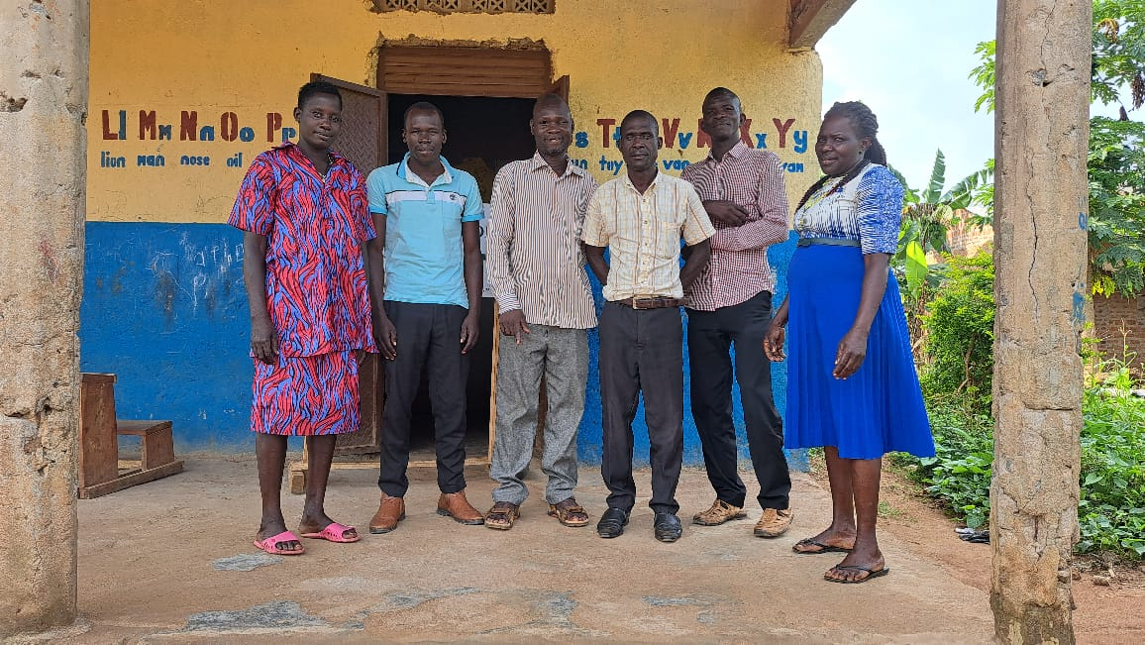
Board meeting

Activity Two. Provision of free Uniforms.
The Organization is committed to it continuous support of providing school uniforms to ensure uniformity at school and in the community. This activity encourages children to attend school regularly. This cannot be done at once to all the enrolled beneficiaries due to limited resources. Therefore there are still many orphans and vulnerable children without school uniforms that need to be supported. (Kramer et all 2002b). “The impact of distributing school uniforms” (See picture 2 below).

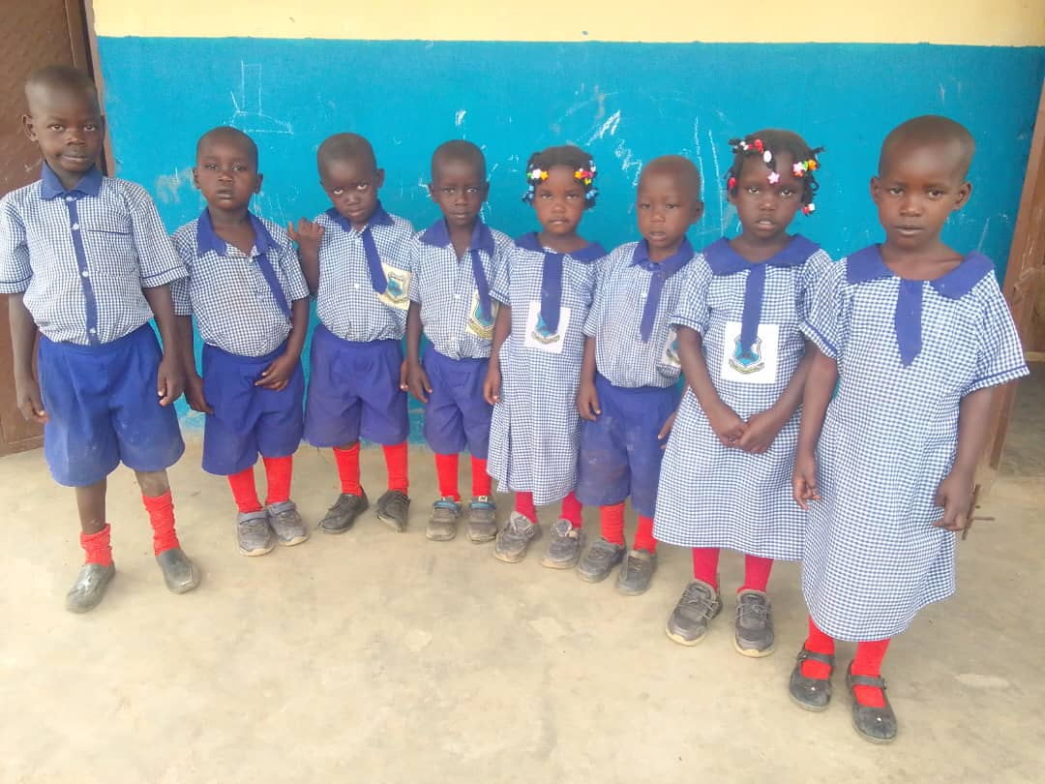
Orphans and vulnerable children giver free school uniform.

Activity 3. Playing materials
Playing materials are crucial at nursery school as they facilitate various aspects of child development, including cognitive, social, emotional, and physical skills. Through play, children learn, explore, and express themselves, fostering creativity, imagination, and problem-solving abilities. They also develop important social skills like cooperation, communication, and empathy. (UNICEF 2013). The organization has acquired one playing material and looking forwards to add more
(See picture 3)
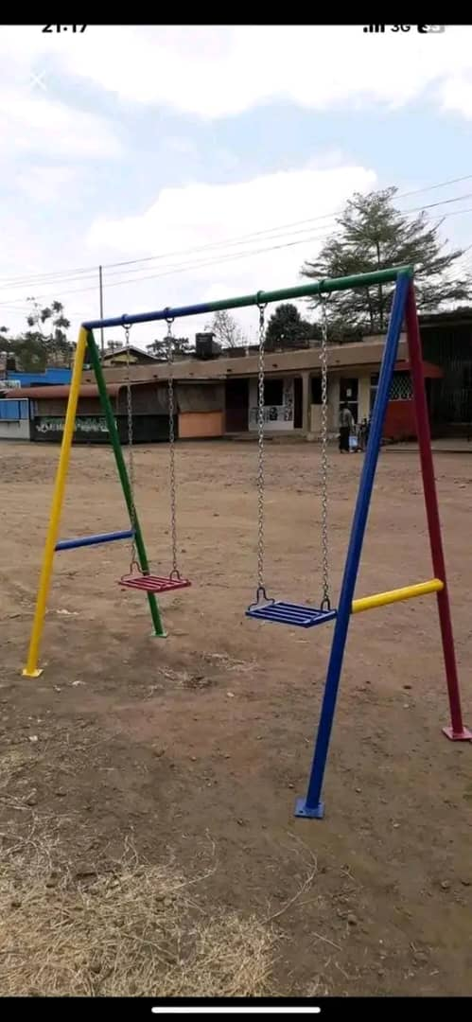

Pending Activities.
Due to insufficient funds, the following activities are yet to be engineered since they are lacking;
- Furniture (desks for children, tables and chairs) to be bought.
- More Playing materials to be installed at the school.
- More reading materials like storybooks, graph books, rulers, crayon, color pencils to be bought.
- Classrooms blocks to be construction.
- Purchase of land for the construction of classroom blocks
- Continuous provision of free school meals
- Provision of school uniforms to all the orphans and vulnerable children
- Purchase of balls
Recommendation.
- We are still vouching for funding for the above aforementioned activities since they are very pivotal for effective learning of the orphans and vulnerable children.
- We are requesting for sponsorship. I would be important if some children get sponsors.
- We are requesting any well-wisher, foundations or donors to support us with any of the above items.
- We are requesting individuals, groups, companies, foundations, organization to donate as little as they can and share out donate page link below
Thanks
Jimmy Okello

Executive Director, New Mercy Nursery school
newmercynursaryschool@gmail.com
Whatapp (256) 774-049-495
Mobile (256) 774-049-495
www.newmercyecd.org
Donation page: http://goto.gg/66512

