The Long Journey Home: Malaika’s Story

When Malaika* was just a little girl, the stable world she knew began to fracture. After her mother left her at her tender age, she leaned heavily on her father and siblings in their rural home. But when the COVID-19 pandemic hit, hardship deepened: her father was incarcerated, and the family was pulled apart. Relocated to live with an extended relative in a distant district, Malaika’s world grew increasingly quiet. Though briefly enrolled in school, she was soon withdrawn from the classroom and expected to spend her days doing heavy domestic labor.
At an age when she should have been learning to read and write alongside her peers, her education came to an abrupt halt at the age of 13 years.
She became a burden to her relative whose family kept growing and she was now referred to as an ‘extra mouth to feed’. Under the guise of a "better opportunity" to support her family, Malaika was placed on a cross-border bus bound for Nairobi, Kenya. She was handed a single bus ticket with a phone number on the back. Her instructions were terrifyingly simple: upon arrival in a foreign city, she was to find a "good Samaritan," hand them the number, and wait for an unknown employer to pick her up.

A promised wage of a mere KES 6,000 (about $45 USD) a month would be sent directly back home. In exchange, she was expected to give up the next three years of her youth working in an unfamiliar household in a foreign country.
Malaika was just a child, traveling completely alone across international borders into the hands of a trafficking network.

Malaika’s story took a pivotal turn upon arrival in the foreign city. Recognizing her extreme vulnerability, vigilant authorities intercepted her. She was safely rescued and placed under protection at the Police Station before being officially referred to HAART Kenya through child welfare officers.
When Malaika arrived at our shelter, she was carrying the invisible scars of profound trauma and systemic neglect. During her stay it was revealed that her years away from school had left her literacy skills far behind other children her age. Because of her family's early separation, she didn't know how to reach her siblings or extended family. The only person she could name was the relative who had trafficked her.
Yet, beneath the fear and confusion, Malaika held onto a powerful shred of hope. In her pocket, she kept a phone number she believed belonged to her father. She had heard a rumor shortly before being trafficked that he had finally been released from prison. More than anything in the world, she just wanted to go home to him.

At HAART she was able to receive:
- A Safe Haven: She was provided a secure bed, nutritious meals, and clothing in our specialized shelter.
- Medical Care: Medical screenings revealed she was suffering from untreated infections. She immediately began receiving targeted medical treatment and regular checkups.
- Restoring the Mind: Our counseling team initiated intensive psychosocial support to help her process the trauma of her migration journey and build emotional resilience.

Healing is a process, but the ultimate goal for a child survivor is a safe, loving family environment. While Malaika received therapy and care at our shelter, our team went to work collaborating across agencies to trace her family, verify her father’s safety, and pave a secure path back home.
We are overjoyed to share that Malaika has been successfully repatriated back home.
The child who was placed on a lonely, dangerous bus to be exploited is now back in a familiar environment, reunited with the family she longed for. HAART Kenya, alongside local partner networks, will continue to monitor her integration and advocate for her return to the classroom where she belongs.

You Make This Possible
Malaika’s safe return home was not an accident. It was the direct result of coordinated protection systems. Your donations to GlobalGiving can provide the immediate shelter, medical care, and legal coordination required to pull children out of exploitation and hand them back their childhoods.
Thank you for standing with HAART Kenya, and thank you for being part of Malaika’s journey from isolation back into her father's arms.

Want to help us protect the next child?
Tragically, trafficking networks target hundreds of vulnerable youth across East Africa every month. Your ongoing support ensures our shelter doors stay open and our rescue teams remain ready.

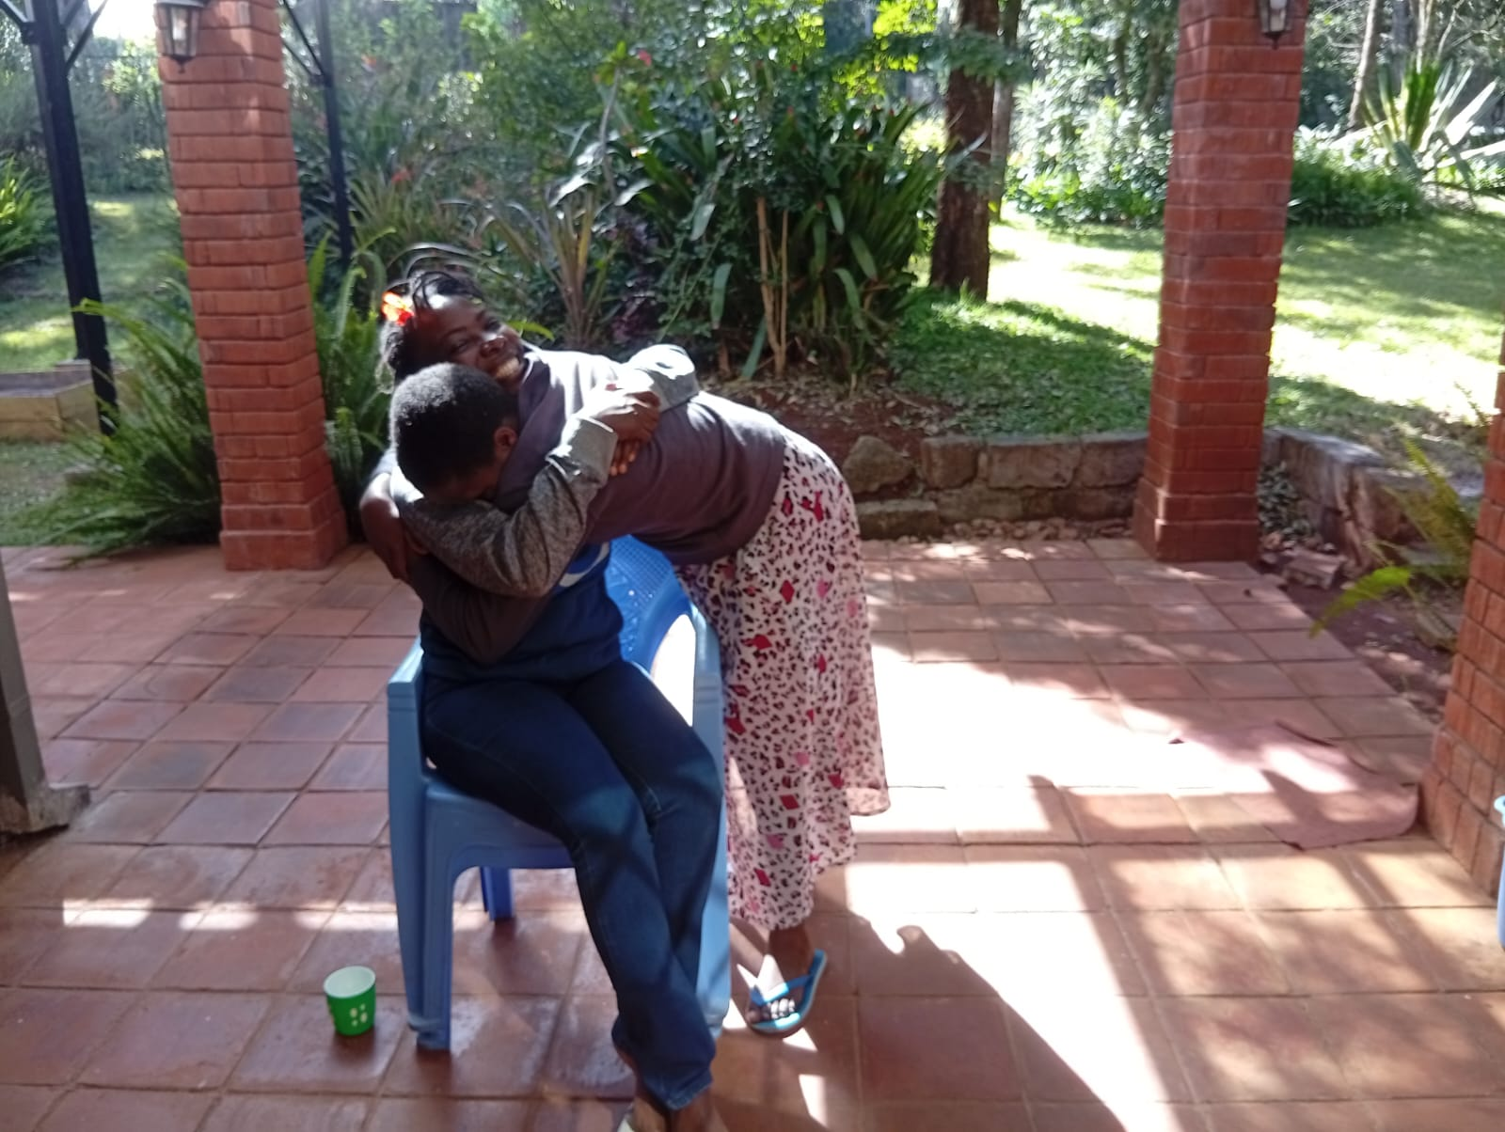An emotional goodbye from a survivor preparing to travel back home after being in the safe house.
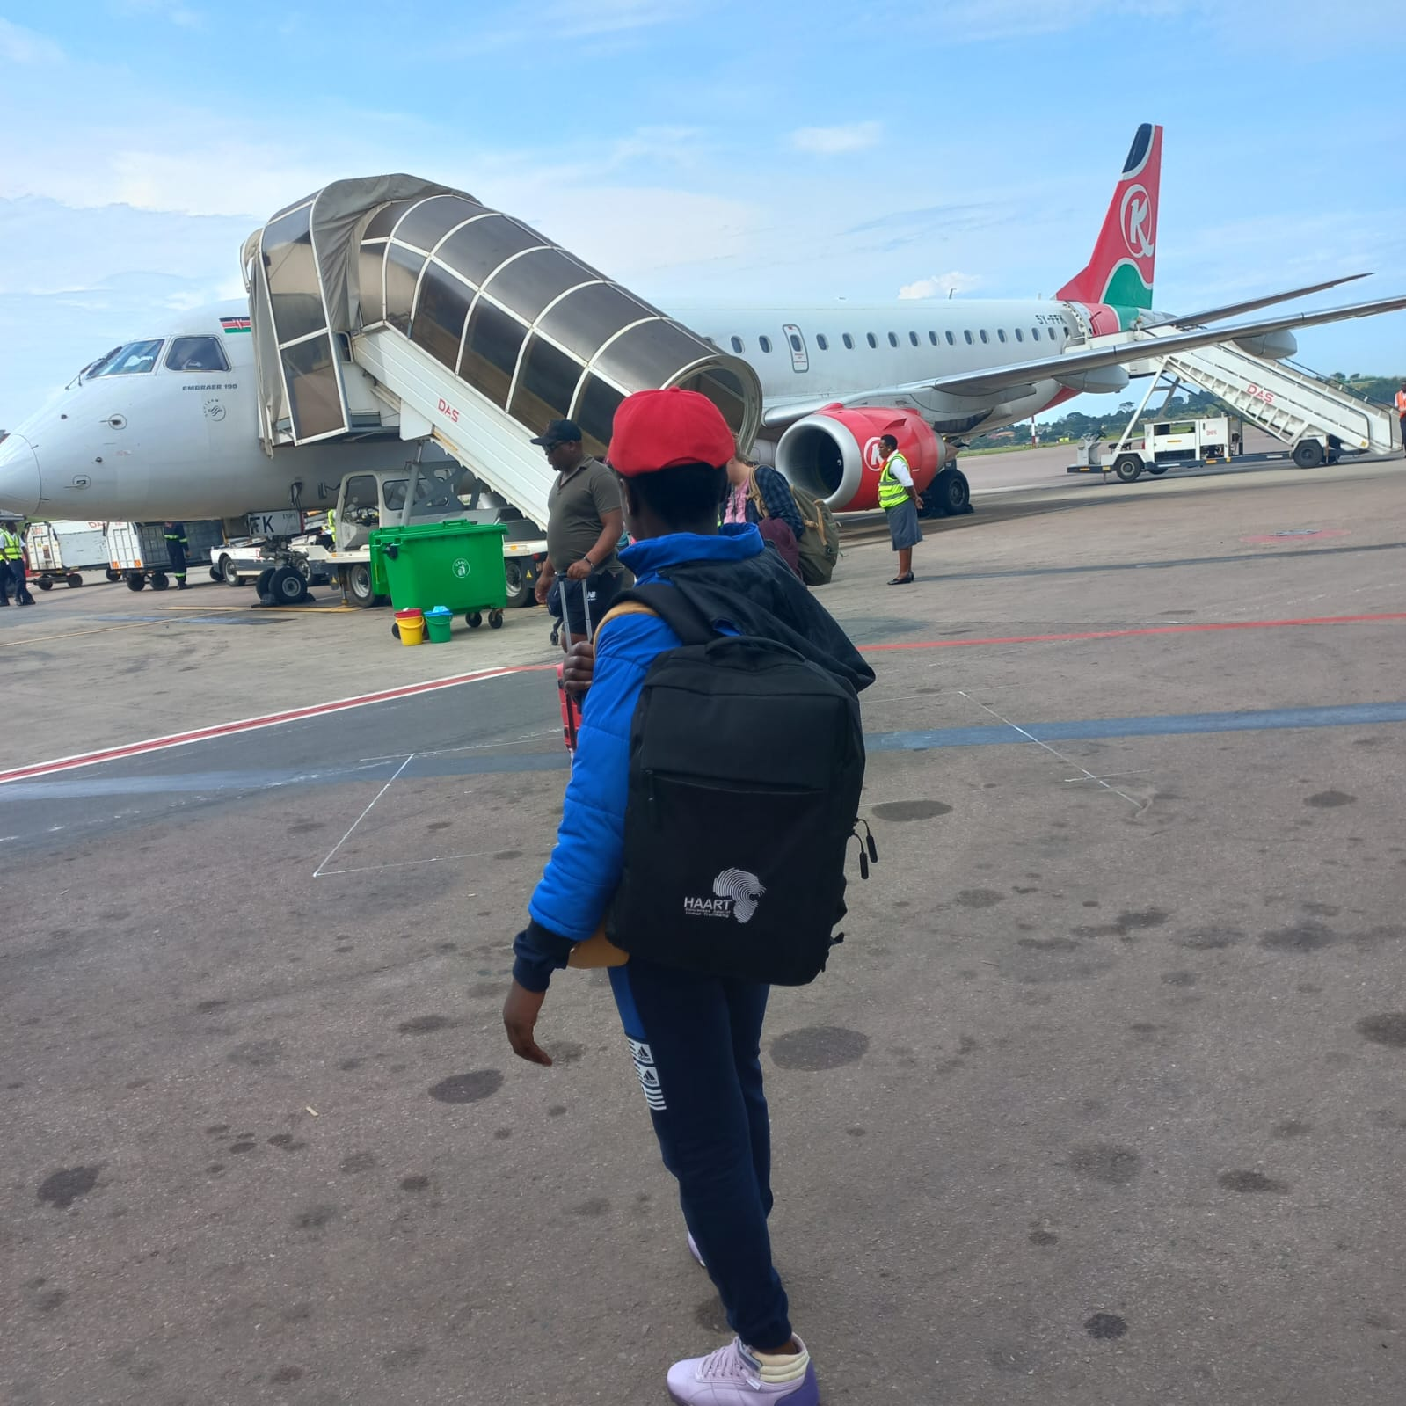All set to board and head back home, a picture of a minor being accompanied to return home.

