Cholera in Haiti: Another Disease of Poverty in a Traumatized Land
UPDATE: See Joia Mukherjee featured on the October 22 CBS Evening News.
By Joia Mukherjee, Chief Medical Officer PIH
An outbreak of cholera has been documented in the area surrounding the lower Artibonite region of Haiti by the staff of PIH’s sister organization Zanmi Lasante (ZL,) working with the Haitian Ministry of Health and other partners. As of Friday morning October 22, 2010; there have been more than 2000 cases of acute watery diarrhea and 160 deaths reported at the facilities in St. Marc, Petite Rivière d’Artibonite, Verrettes, Mirebalais and Lascahobas.
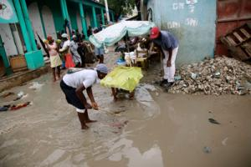
Flooding and unsanitary conditions makes an environment vulnerable to waterborne diseases like cholera.
Photo courtesy of David Darg,
Operation Blessing International.
What is Cholera?
Cholera is an acute diarrheal illness that is spread by drinking water containing the organism Vibrio cholera. Symptoms typically develop between one and five days after drinking water contaminated by the human feces of persons infected with the cholera bacteria. Only about 10 percent of those who drink water contaminated by the cholera bacteria will fall ill; however, the infection can be fatal particularly among young children, the elderly, the malnourished and persons with decreased immune function. Those ill with cholera develop profuse, watery, high volume diarrhea that is rapidly dehydrating. Without adequate replacement of volume lost, patients may go into shock and die of dehydration. The mainstay of treatment for cholera is fluid and salt replacement—generally by oral rehydration solution—a standard combination of salt, sugar and water. Intravenous fluids may be needed if the patient is unable to drink due to vomiting or a depressed level of consciousness. Antibiotics are used to decrease the volume of diarrhea and the excretion of bacteria in the stool—both can help decrease transmission.
Cholera is a disease of poverty—and was one of the earliest documented public health problems. Cholera epidemics are caused by a lack of access to safe, clean water. Typically, the world’s poorest people obtain drinking water from a river or stream; in the absence of pit latrines or public sewage systems, the same river is used for defecation allowing human waste to mix with the water used for drinking. While boiling water will kill the cholera bacteria, the fuel to boil water costs money and as wood-based charcoal is the main source of cooking fuel in Haiti use of charcoal is also related to the continued deforestation of the country. Cholera can also be transmitted if a person eats food contaminated with the cholera bacterium.
Cholera in Haiti:
While Haiti has not had a documented case of cholera since the 1960s, the conditions in the lower Artibonite placed the region at high-risk for epidemics of cholera and other water-borne diseases even before the earthquake of January 12, 2010. In 2008, Partners In Health working with partners at the Robert Kennedy Center for Human Rights released a report of the denial of water security as a basic right in Haiti. In 2000, a set of loans from the Inter American Development Bank to the government of Haiti for water, sanitation and health were blocked for political reasons. The city of St. Marc (population 220,000) and region of the lower Artibonite (population 600,000) were among the areas slated for upgrading of the public water supply. This project was delayed more than a decade and has not yet been completed. We believe secure and free access to clean water is a basic human right that should be delivered through the public sector and that the international community’s failure to assist the government of Haiti in developing a safe water supply has been violation of this basic right. Additionally, in Gonaives the capital of the Artibonite has been destroyed in two waves of floods and mudslides, after tropical storm Jeanne in 2004 and after the series of hurricanes in 2008, made possible because of the environmental devastation of the region. The destruction contaminated the water supply and left the infrastructure (including the health infrastructure) of the upper Artibonite in ruins, forcing people to seek residence and medical care in St. Marc. The St. Marc region itself experienced significant flooding in 2008, displacing thousands of people. Lastly, the earthquake of January 12, 2010 resulted in the displacement of 1.7 million Haitians. While reliable statistics are not available currently, the last estimate, as of March of 2010 was that 300,000 addition Haitians had fled Port au Prince to the Artibonite. As there are no “camps” in the region, these displaced persons are “home hosted”—joining poor relatives in already overcrowded conditions, without water security or adequate sanitation. The dispersal of displaced people makes it difficult to provide centralized services.
What can be done?
Thousands of people are being given basic education, soap and oral rehydration salts in their communities by community health workers and those already ill are being referred to Zanmi Lasante/Ministry of Health facilities in the Artibonite and Central departments. Programs of community mobilization and mass messaging are being conducted by Zanmi Lasante staff and local leaders. There is a sense from our team in the field that the outreach is working and patients are arriving at medical facilities at earlier, less severe stages of the disease. Ill patients are being treated in facilities—most notably l’Hôpital Saint Nicolas, where the ZL team is working in partnership with Médecins sans Frontières (MSF) Spain, and at Petite Rivière d’Artibonite (PRA) in partnership with MSF-Belgium. In St. Marc, MSF - Spain is setting up systems to separate cholera cases from non-cholera cases and to organize waste management and infection control. On the national level, the leadership of Partners In Health and Zanmi Lasante with other partners working in the camps are helping to design the contingency plan for Port au Prince.
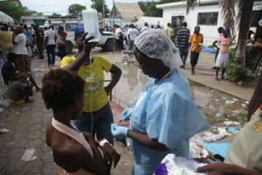
Treating patients in the courtyard at l'Hopital Saint Nicholas.
Photo courtesy of David Darg,
Operation Blessing International.
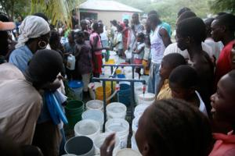
Providing clean water in the Artibonite.
Photo courtesy of David Darg,
Operation Blessing International.
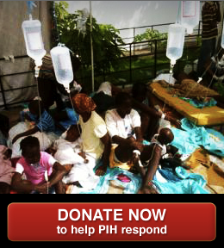

Yet the key to stopping the cholera epidemic in Haiti is to provide water security for the people of the Artibonite urgently and in the long term. To meet the urgent need for water security, Partners In Health/Zanmi Lasante is again partnering with numerous organizations in addition to MSF such as Operation Blessing, who were instrumental in providing water installations in the camps in Port au Prince as well as in the Central Department after the earthquake; with the Centers for Disease Control and the World Health Organization who are coordinating the investigation to determine the sources of the outbreak; and with the water and sanitation/hygiene cluster within the UN system to obtain water trucks and water bladders for distribution.
For the future of Haiti, we will continue to be engaged in community-based water projects as we have been for decades in the Central Department. However, community based water projects and latrines will never be sufficient to assure the right to clean water—the government of Haiti must be enabled by international partners to assure this right. To that end, we will also continue to advocate for money pledged for the reconstruction of Haiti be used to strengthen the public infrastructure of the country, including prioritizing the development of a reliable and safe public water supply to provide real water security as a basic right for the people of Haiti.

