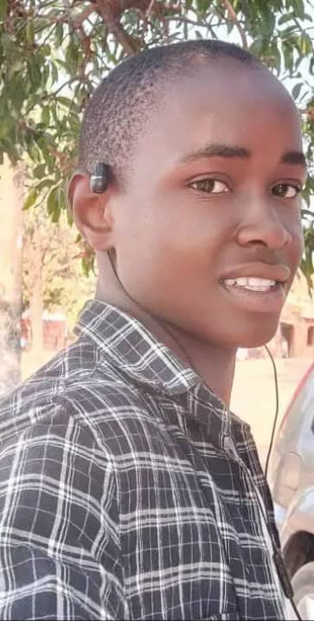
Kelvin dream to be engineer, he comes from a humble background. Your support keeps his dream alive. Thank you for being a part of his dream. Without your donation, Kelvin could have drooped if you were not there.
“I am grateful to everyone for support that is making me to persist in school and perform better. I sincerely thank NACC and the education program for the fees, role modelling, mentorship and coaching, without which, I would not have been here today” said Kelvin who dreams to become a Mechanic Engineer.
There are many genius and hard-working needy students in high schools who need your kind heart to fulfil their dreams. We ask you to join us in supporting these students.

