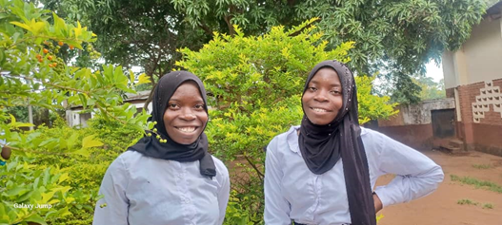
Double smiles as Amina and Joyce, the twines from the same primary school have been selected to Mangochi secondary school. Amina and Joyce come from a humble background. It was not easy for them to concentrate and do well in class and late alone been selected to Mangochi secondary school. Life skills training provided them necessary skills such as goal setting, decision making, critical thinking, problem solving, and interpersonal communication that built their confidence and self-esteem.
We would like to say thank for supporting the noble cause. Continue helping them to realize their dream.

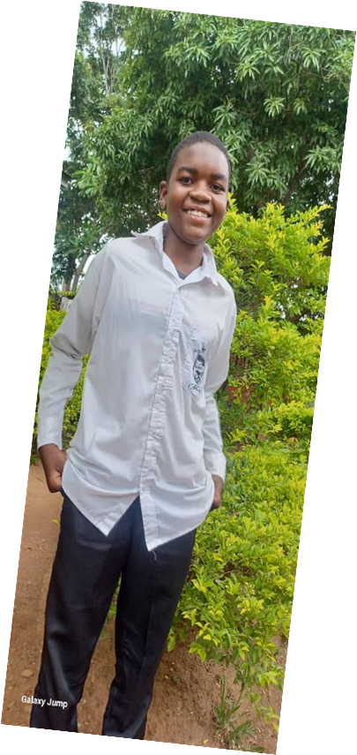 Chimwemwe is another genius who has been selected to Dedza secondary school from Majuni primary school. The ever smile young boy is unique and hard working. We are proud of him. Your support motivated him to work hard and eventually secure a place at a national secondary school where he is fulfilling his dream.

Cecilia
Cecilia, Form 3 is another hardworking girl from Majuni Secondary School. She want to be a Nurse. She comes from Luchichi village, she is the only and first girl to go to a secondary school in her village. Loosing her father was not easy for her. It meant losing her education, her childhood and exposed to child labour to support herself and her old mother. We say thank you for your kindness and generosity that has renewed her dream to become a Nurse.

