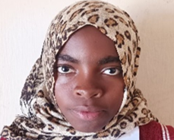
Enipher, a 14-year-old girl, is another genius who wants to be a nurse. She was excited to be selected to Likuni Girls Secondary School, one of the best national secondary schools in Malawi. However, the excitement was short lived because she could not afford to pay school fees and eventually, she was chased away.
Enipher lost both parents when she was very young and is staying her uncle who has other children to take care of. Loosing both parents means losing your childhood, parental guidance, love and affection and your entitlements. “I was confused and disturbed. I could not imagine fulfilling my dreams” Enipher recalled.
We are proud of you; your donation and kindness are unlocking the potential of young girls like Enipher who had nowhere to go in time of need. Enipher’s renewed hope and determination is our motivation.

