MpowR Program Term 3 / Semester 2 Outcome Report, 2013-2014
Jose Arciga, Juniper Gardens, Elm Park, and Sunset Gardens Clubs – April 2014 to June 2014
Background:
With solid academic progress already made over the course of Term 1 and 2, students in MpowR Club were looking to learn as much as possible and cement their skills before they left school for the summer. Term 3 (or quarter 4 in the Hillsboro School District) began in April and lasted until mid-June. The 4 clubs that were open during Term 2 (Jose Arciga, Juniper Gardens, Elm Park, and Sunset Gardens) continued operating through term 3. Students attending these clubs came from the Jose Arciga 1, 2 and 3, Jose Echeverria, Juniper Gardens, Elm Park, and Sunset Gardens properties. The program owes huge thanks to The Jackson Family Foundation, Forest Grove School District, Pacific University, The Herbert A. Templeton Foundation, The Irwin Foundation, and SafeCo Insurance. Without their crucial support, none of the four clubs would be able to operate, and the 66 children that receive assistance in MpowR clubs would be unable to properly develop their potential.
MpowR schedule
Each club met twice a week, either on Monday and Wednesday or Tuesday and Thursday, for an hour and a half. The daily schedule stayed the same as in Terms 1&2. Upon their arrival, students have 10 minutes to eat a snack (provided by the Oregon Food Bank), 30 minutes to work on their homework, 20 minutes to read books of appropriate grade level, 20 minutes for an educational activity focused on Math or Reading, and 10 minutes for clean-up.
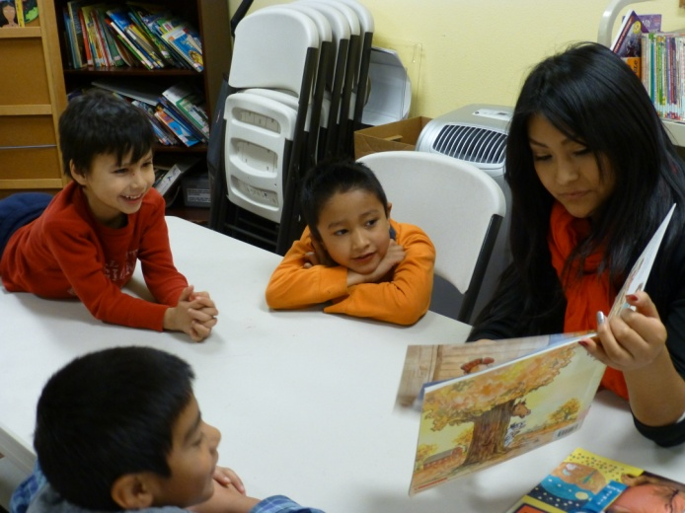
Homework Time
Helping students complete their homework remained the number one priority of MpowR club this year. If a student could not finish their work in the allotted 30 minutes for “homework time,” they would continue to work on it (with assistance) through reading time and, in rare circumstances, activity time. For students with large amounts of homework each week, staff met with parents to formulate a plan so students wouldn’t have to work on homework more than a half hour each time the club met. This way, all students could enjoy reading and activity time. Computers were also available at each property, which were very helpful for the increasing number of students who have online homework on sites such as STmath.com (math) or myon.com (reading).If students didn’t have any homework that day, they were given reading and math worksheets to complete during homework time. Worksheets were handpicked by MpowR club coordinators after meeting with school administrators at the beginning of the year and learning about the Common-Core benchmarks and the curriculum for each grade. Coordinators also monitored students’ report cards to highlight areas of need (within reading, writing, and math disciplines), and provided worksheets to fortify students’ skills in those areas.
Reading time
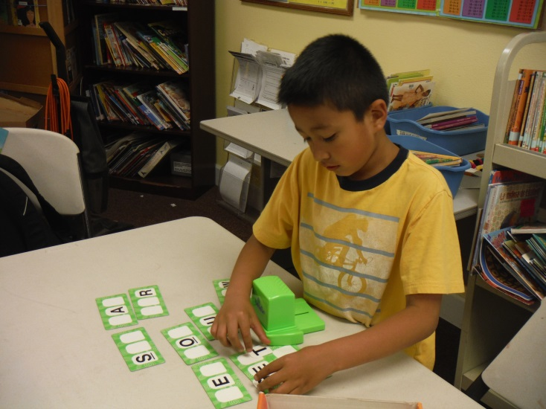
During the last half of the year, MpowR coordinators changed their approach slightly in reading time, focusing on getting students to read together. Students were grouped by reading level, according to their score on a reading test (The CORE Phonics Survey), as well as coordinator knowledge of reading levels. At least every other MpowR club day, these groups of 3 or 4 students would sit around their table and take turns reading a page from that day’s book. Thanks to Forest Grove School District’s donation of large numbers of specifically-leveled reading books, each student was able to have their own copy of the book, so they could follow along when their classmate was reading. MpowR club coordinators always preserved one day a week for optional individual reading, since some students work best on their own, but students repeatedly asked to read together even on days when it wasn’t required!
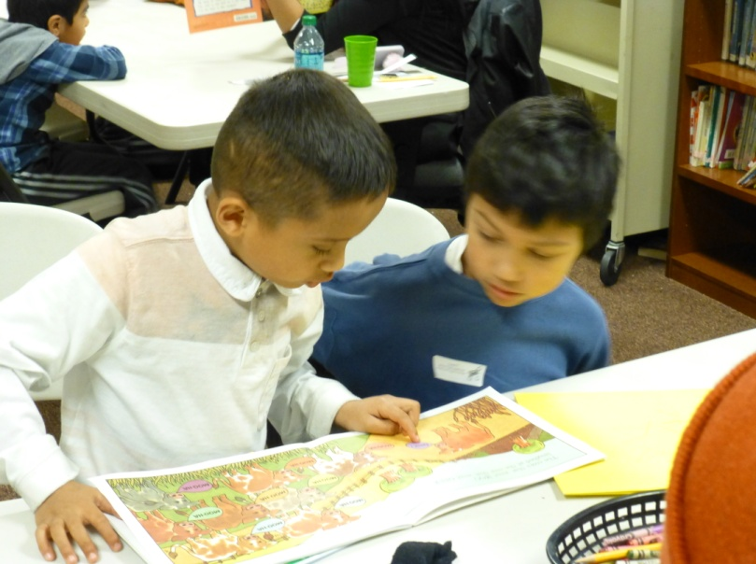
This group-reading approach seemed to be effective for a variety of reasons. What was most clear was that students simply enjoyed working their way through a story together. As coordinators observed tensing up or getting on the edges of their seats as the climax of the story approached, some remarked that it was almost as if they were watching the students watch a movie together, the way they were experiencing emotions simultaneously and connecting to the characters in the story. This experience seemed to bond children together in an enjoyable way. Group reading offered some tangible academic benefits as well. For the students reading at the lower end of the group, it was useful to have a more knowledgeable student help pronounce or define a word when the reading student could not pronounce it, or didn’t know its meaning. Most of the time, a Bienestar staff member or volunteer was able to be present with each group of students to help, but if they weren’t, this was a very helpful dynamic for the lower-level readers. Even with an adult present, we found it preferable to let a student chime in to help their fellow student, rather than have an adult help out. This way, students became accustomed to working together and asking peers for help (a difficult thing for many of us adults!!). Of course, the higher-level readers always enjoyed displaying their knowledge, and in the rare case that a student was slight condescending or impatient in their tone while helping another student, an adult was always able to step in and moderate. This situation was rare due to the proximity of reading level within the small groups, but the few times that it did occur offered a relevant lesson for all on the importance of attitude when helping or serving another person. Overall, the group-reading experience accomplished 2 main objectives: 1) getting students more excited about reading, and 2) increasing teamwork and cooperation. We were shocked at how eagerly our students embraced this new manner of reading!
Activity Time
During “activity time,” students enjoyed a number of new, educational activities focused on math and reading. Among the math activity highlights: Students used plastic coins to practice making change and recognizing patterns, students used different tools like charts and different-colored blocks to convey the concept of place-value, and students made analog clocks to practice telling time and using different colloquial expressions for certain times.
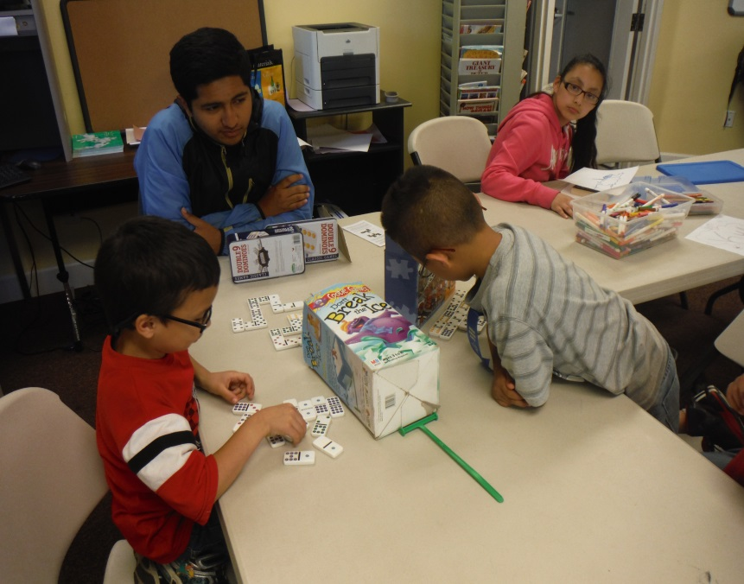
Among the reading activity highlights: students worked together to create “meaning maps” for animals they read about, developing research and organization skills, students played dominoes with rhyming words instead of numbers, and students made and started using “vocabulary journals” to record words they didn’t recognize when reading, so that they could look them up later.

Behavior Incentives/Prizes
During term 3, as throughout the rest of the year, coordinators were able to offer some behavior incentives to encourage students to study hard and behave well. Individual “kindness tickets” were given out, like last term, to students who demonstrated good “team work,” lent a helping hand to a friend or demonstrated respectful behavior for a whole day. Students eagerly awaited the announcements of the recipients of the kindness tickets at the end of each day. Any student that received 10 kindness tickets on their own got to open the “treasure chest,” a box filled with toys, stuffed animals and chocolate, and pick out one prize. In addition to individual kindness tickets, each club started giving away “group tickets,” on days where the entire club was well behaved, respectful and worked as a team. Once the group had accumulated 10 group tickets, they were awarded a “fun day.” Most clubs managed to earn one “fun day” a term. For this day, students would draw from a hat with a number of possible activities for the day. Among these were an ice cream day, scavenger hunt day, art day, and many others. On each of these days, students would first complete their homework, after which there would be a short educational segment (e.g. how ice cream is made, or the history of treasure hunting), and then the fun would begin! Students got really excited about earning a “fun day” and having the privilege of opening the “treasure chest” as well, which resulted in increased focus during study periods!
Grade Statistics
Important Notes:
**Students with Individual Educational Plans were left out of all grade calculations.
**Students from Tom McCall do not receive homework grades, so it is only possible to track homework grades for K-4th graders.
**Student grades are only included if they were in the MpowR club for the whole term; if they joined MpowR midway through Term 3, the difference in their GPA was not calculated.

Jose Arciga
The average calculated GPA (Grade Point Average) for students in the Jose Arciga MpowR club during term 3 was 2.99, an increase of 0.12 over Term 2. Of the 12 students for whom we have complete data, 8 students increased their GPA, 4 decreased it and 0 had the same GPA as Term 2. The average individual difference in GPA for the Jose Arciga students was an increase of 0.08. Of the students that received homework grades, 1 increased in consistency, 0 had a decrease in consistency and the other 8 students’ homework grade stayed the same. Of the students that were in MpowR club for the whole year, 11 increased their GPA from Term 1 to Term 3, 1 decreased it and 2 students’ GPA remained the same. The average difference between each student’s GPA in Term 1 and Term 3 in the Jose Arciga club was a sizable improvement of 0.17, and for those that improved their GPA in that time period, the average improvement was 0.37!

Juniper Gardens
The average calculated GPA (Grade Point Average) for students in the Juniper Gardens MpowR club during term 3 was 2.89, a decrease of 0.12 over Term 2. Of the 11 students for whom we have complete data, 8 students increased their GPA, 3 decreased it and 0 had the same GPA as Term 2. The average individual difference in GPA for the Juniper Gardens students was -0.006. Of the students that received homework grades, 0 increased in consistency, 4 had a decrease in consistency and the other 6 students’ homework grade stayed the same. Of the students that were in MpowR club for the whole year, 5 increased their GPA from Term 1 to Term 3, 2 decreased it and 0 students’ GPA remained the same. The average difference between each student’s GPA in Term 1 and Term 3 in the Juniper Gardens club was a sizable improvement of 0.21, and among those that improved their GPA in that time period, the average improvement was 0.35!

Elm Park
The average calculated GPA (Grade Point Average) for students in the Elm Park MpowR club during term 3 was 3.12, an increase of 0.19 over Term 2. Of the 15 students for whom we have complete data, 10 students increased their GPA, 2 decreased it and 3 had the same GPA as Term 2. The average individual difference in GPA for the Elm Park students between Term 2 and Term 3 was 0.19. Of the students that received homework grades, 2 had a decrease in consistency and the other 9 students’ homework grade stayed the same. Of the students that were in MpowR club for the whole year, 11 increased their GPA from Term 1 to Term 3, 1 decreased it and 2 students’ GPA remained the same. The average difference between each student’s GPA in Term 1 and Term 3 in the Elm Park club was an improvement of 0.36, and among those that improved their GPA, the average improvement was 0.47!

Sunset Gardens
The average calculated GPA (Grade Point Average) for students in the Sunset Gardens MpowR club during quarter 4 was 2.47, an increase of 0.04 over Term 2. Of the 19 students for whom we have complete data, 15 students increased their GPA, 4 decreased it and 0 had the same GPA as quarter 3. The average increase among these students was 0.17 and the average decrease was -0.43. The average individual difference in GPA for the Sunset Gardens students between quarter 3 and quarter 4 was 0.05. Of the students that received homework grades, 3 had an increase in consistency, 3 had a decrease in consistency and the other 13 students’ homework grade stayed the same. Sunset Gardens club only operated in the second half of the school year so we did not perform a year-long analysis.

Compiled MpowR Data
Across the board in all 4 clubs, a total of 40 students raised their GPA from Term 2 to Term 3, 13 students’ GPA decreased, and 4 students’ GPA stayed the same. Overall, the average difference in GPA between the terms (including individuals whose GPA decreased or stayed the same) was an increase of 0.10. Among students who increased their GPA, the average increase was 0.22.
Among Forest Grove MpowR students that were in MpowR for all 3 terms, 24 increased their GPA over the year, 6 decreased their GPA over that period and 3 students’ GPAs stayed the same. The average difference in GPA (including those with decreases and unchanged GPAs) for all these students was an increase of 0.25, and the average improvement was 0.41. .
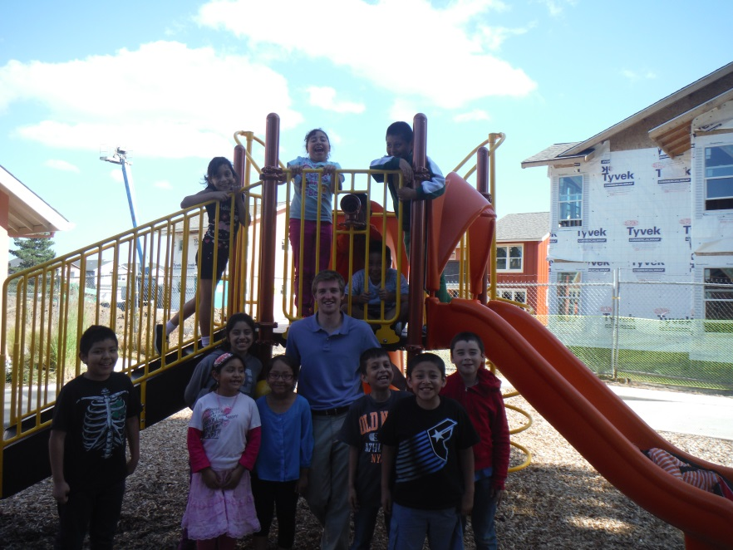
Grade Statistics Analysis/ Compiled Forest Grove Data
It was great news to see students continue to improve their GPAs and academic abilities this term.
It is worthy to note a bit of a statistical anomaly that occurred in the Juniper Gardens club this term – even though 8 of 11 students increased their GPA, the average difference in GPA from Term 2 to Term 3 was a slight decrease of 0.006. Also, the average GPA of the club decreased from 3.01 to 2.89. This happened for a couple reasons. Firstly, Juniper Gardens had several students pulled into after-school programs by their respective schools in Term 3, resulting in more new students than usual. These students had lower GPAs, which pushed the average for the club down. (This is why average club GPA is a metric of the general academic level of the club, not of individual or even group progress). More new students also meant less longitudinal GPA data to track and a smaller data set. In this small data set, the 3 students who had decreases in GPA had relatively large decreases (an average of 0.45), while the 8 students who increased their GPA had more modest increases (average of 0.16). The median difference in GPA was an increase of 0.08, which is more representative of the general progress of the group.
A similar phenomenon occurred in the Sunset Gardens club. Although 15 students increased their GPA from the previous term, and only four students’ GPA decreased, the average difference in GPA was only 0.05. Once again, the few students with decreases in GPA had much more significant decreases (average of 0.43) than the students with increases in GPA (average increase of 0.17). The median of the data set was an increase of 0.15, which is more indicative of the progress of the average student in the club.
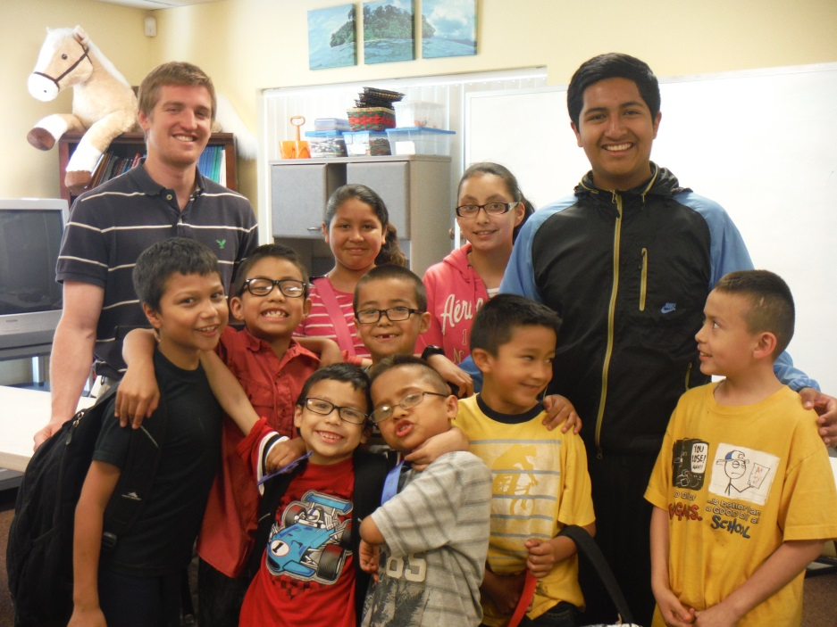
Overall, although students continued progressing in Term 3, the gains were a little less significant than in Term 2. As coordinators, this makes sense with our experience of seeing students struggling to stay motivated as the end of the school year approaches and sunny skies replace gray rain clouds. As coordinators, we tried to encourage these students with extra behavioral incentives, which included some outside activities and more treats, which were somewhat effective. However, some students still struggled, and their homework grade declined because of their decreased diligence. In many of these cases, GPA improved less than from Term 1 to Term 2, or even declined a bit. We knew that many of these students had made significant progress over the course of the year, but perhaps most of that growth occurred in the first 2 terms.
For these reason, we analyzed the grades of all the students who were in the clubs for all three terms, and calculated the difference between their Term 1 GPA and Term 3 GPA. We did indeed find that several of the students that had underwhelming third terms were still making significant progress over the course of the year. Among these students, 24 increased their GPA over the year, 6 decreased their GPA over that period and 3 students’ GPAs stayed the same. The average difference in GPA (including those with decreases and unchanged GPAs) for all these students was an increase of 0.25. When only the students who improved their GPA were isolated, the average increase in GPA for all these students over the course of the year was 0.41! These results clearly show that not only does the average student receive a significant benefit from a year in Bienestar’s MpowR programs, the students who improve their GPA with MpowR assistance improve by a great degree.
We believe that our students’ progress shows that MpowR club’s approach is working, but more importantly, these students from Bienestar families have the same academic potential as children from more socio-economically privileged backgrounds, and that potential shines through when they get the assistance they need.

Special Thanks
Again, we thank The Jackson Family Foundation, Forest Grove School District, Pacific University, The Herbert A. Templeton Foundation, The Irwin Foundation, and SafeCo Insurance, as well as all of the individual donors whose continued support has made all of the MpowR clubs possible. We would also like to thank the volunteers (Blanca Martinez, Paula Green, Gio Tayetto, Juanita Williams, Moryah Schindler, Katie Sale, Anayanu de Paz, Claudia Bueermann, Elli Wiita, Jarod Gowgiel, M. Edens, Maya King, Moss Hardman, Violeta Alvarez and Georgia Godlee-Campbell) at all our sites, who provide invaluable help to the students and also make MpowR clubs possible.
Respectfully Submitted,
Jordan Harbaugh, Whitney Padilla, Geraldine Araujo, and Lexie Bedell
MpowR Team

