MpowR Program Term 1 Outcome Report, 2013-2014
Jose Arciga, Juniper Gardens, Elm Park Clubs – September 2013 to December 2013

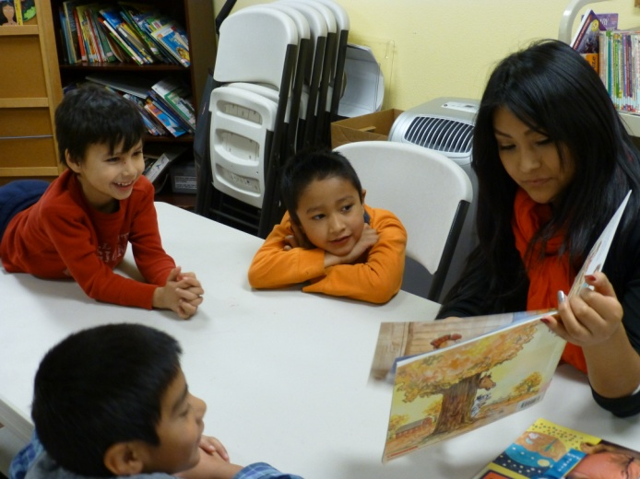
Background: In September 201 3, 48 students walked into 3 separate MpowR clubs at Bienestar properties with homework in hand, ready to take on the new school year. The three clubs took place at Jose Arciga, Juniper Gardens, and Elm Park properties. Students attending the clubs came from Jose Arciga 1, 2 and 3, Jose Echeverria, Juniper Gardens and Elm Park. Each club met twice a week, either on Monday and Wednesday or Tuesday and Thursday. The program owes huge thanks to The Jackson Family Foundation, The Herbert A. Templeton Foundation, The Irwin Foundation, and SafeCo Insurance, because the clubs would not have been happened without their vital support.
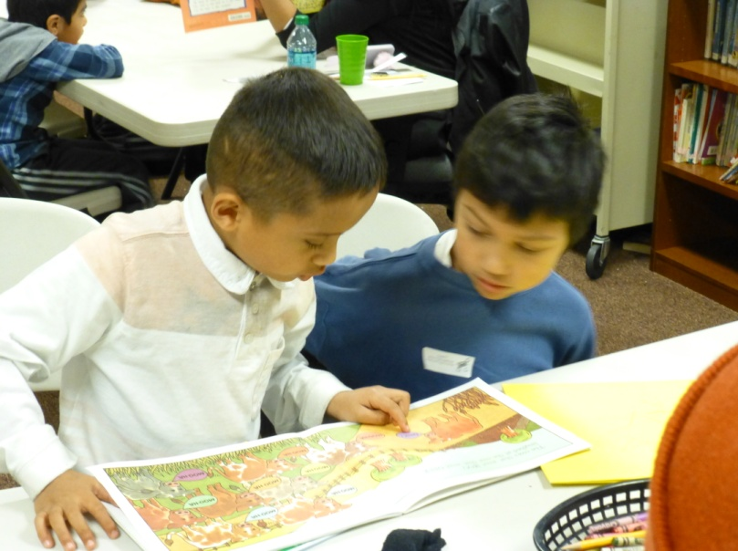
Registration began in August for the clubs, which are available for children in the kindergarten through sixth grades. In the week before school started, backpacks with school supplies were given away to students at Montebello, Sierra West, Elm Park, Jose Arciga, Sunset Gardens, and Reedville properties. This backpack donation drive was coordinated by Kaylen Miller, whom we all thank deeply. MpowR club coordinators also met with parents of students so that parents understood both the rules and the goals of the club. On the first day of each club, coordinators went over the rules with all the students and everyone signed a poster board with all the rules printed on it, to signify an agreement to follow the rules. To encourage good behavior, MpowR club coordinators continued giving out “kindness tickets” to individual students each day. Students received a kindness ticket if they went out of their way to help another student, if they helped the coordinator set up without being asked, if they worked well with others for the whole club, or if they were respectful, focused and on-task for the whole day. Although these tickets were given to individuals, coordinators kept track of how many tickets had been given out throughout the semester, and once any club reached 20 tickets total, they had the opportunity to choose their own activity for activity time. Students relished and enjoyed this opportunity.
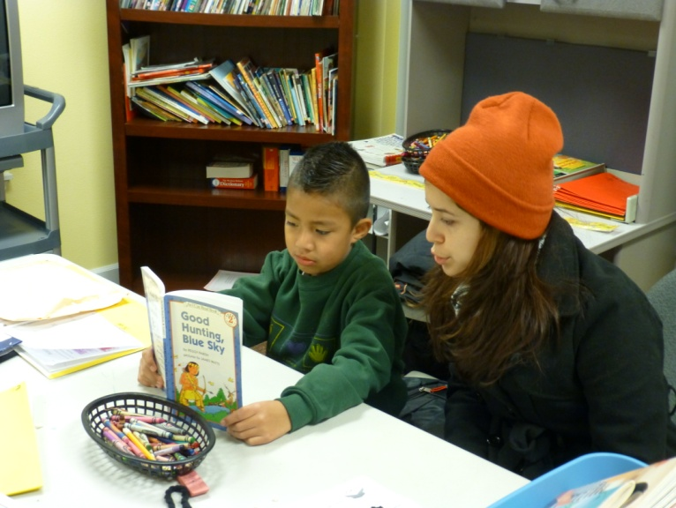
The MpowR program underwent some slight changes this year. Firstly, the starting time for the clubs was moved from 3:30 to 3:45, due to new bus schedules which dropped the children off at their apartments later than last year. MpowR club started at 3:45 and ends at 5:15, and retained the same structure as last years’ clubs. Upon their arrival, students have 10 minutes to eat a snack (provided by the Oregon Food Bank), 30 minutes to work on their homework, 20 minutes to read books of appropriate grade level, 20 minutes for an activity, and 10 minutes for clean-up. As in years past, the schedule was adaptable for each individual student’s needs, and homework was the top priority; if a student could not finish their work in 30 minutes, they would continue to work on it (with assistance) through reading time and, rarely, activity time. For students with large amounts of homework each week, staff met with parents to formulate a plan so students wouldn’t have to work more than a half hour each time the club met; this way, all students could enjoy reading and activity time. Computers were also available at each property, which were very helpful for the increasing number of students who have online homework on sites such as STmath.com (math) or myon.com (reading).
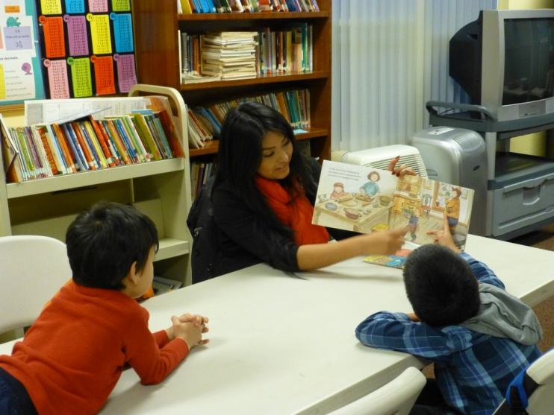
Activity time had a slightly different focus this year. In years past, students would engage in an arts and crafts project or a science experiment each week. This year, after meetings with Forest Grove School district, coordinators of MpowR club decided a different approach would be more beneficial to our students. Now, coordinators plan fun activities with either a math or reading/language component for students to participate in each week. This change was made in large part due to the change in the Common Core standard curriculum for all students nationwide. The benchmarks in Common Core ask students to make more rapid progress in many subject areas, especially math and language arts. For this reason, staff kept the activity time, in which having fun is the primary goal, but now students get some academic benefit from the activities.
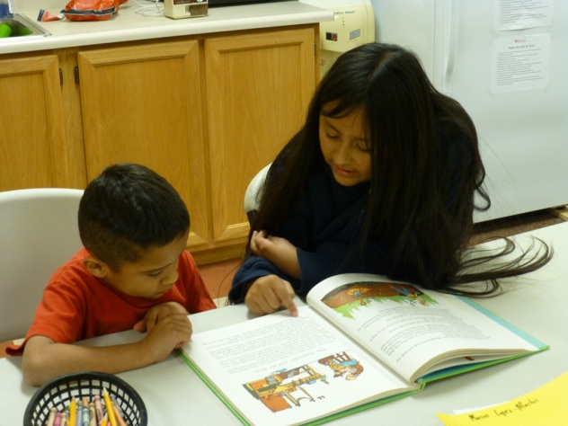
Some example activities: Synonym/antonym Tic-tac toe, where every game has a “start word” and one student must write a synonym of the start word for every “X” they write, and the other student must write an antonym for every “O”; Pig, a dice game in which students race up to 100 while deciding whether or not to gamble to get more points; Word Hat, where a word is placed on a student A’s head, and other students have to describe it to Student A without using the word or any part of the word; Number Hat, where a number is placed on Student A’s head, and other students must tell Student A what number goes with the original number to equal 10; Math Bingo; and Rhyming Bingo. Many students were sad to learn that there wouldn’t be any arts and crafts or science experiments this year, but they were surprised by how much fun the new games were!
On the last day of MpowR club, students were able to relax, enjoy cookies and lemonade, play generic holiday games, and receive a book as a gift from Bienestar. This was made possible by numerous donations from various libraries, individuals, and organizations which have donated large numbers of books to Bienestar.
Grade Statistics:
Juniper Gardens:
The average GPA of students in Juniper Gardens MpowR club for Term 1 of the 2013-2014 school year was 2.65. This was a moderate decrease from the club’s average GPA of 2.91 in Term 3 of last year. However, with the members of each club changing each year, individual increases or decreases in GPA are more telling. Out of the 9 students on which we have complete data, 4 increased their GPA and 5 decreased their GPA from Term 3 of the last school year. The average difference in GPA among individuals was -0.18. Out of the students receiving grades for how consistently they turn in homework, 1 increased their consistency, 3 students decreased their consistency, and 2 students remained the same. The students left out of these statistics did not receive homework grades (e.g., Tom McCall upper elementary students), could not provide last year’s grades, or were not in school (e.g., kindergarten students).

Elm Park:
The average GPA of students in Elm Park MpowR club for Term 1 of the 2013-2014 school year was 2.73. This was a moderate decrease from the club’s average GPA of 3.05 in Term 3 of last year. However, with the members of each club changing each year, individual increases or decreases in GPA are more telling. Out of the 14 students on which we have complete data, 4 increased their GPA and 10 decreased their GPA from Term 3 of the last school year. The average difference in GPA among individuals was -0.23. Out of the students receiving grades for how consistently they turn in homework, 0 increased their consistency, 7 students decreased their consistency, and 3 students remained the same. The students left out of these statistics did not receive homework grades (e.g., Tom McCall upper elementary students), could not provide last year’s grades, or were not in school (e.g., kindergarten students).

Jose Arciga:
The average GPA of students in Elm Park MpowR club for Term 1 of the 2013-2014 school year was 2.61. This was a decrease from the club’s average GPA of 3.03 in Term 3 of last year. However, with the members of each club changing each year, individual increases or decreases in GPA are more telling. Out of the 11 students on which we have complete data, 2 increased their GPA and 9 decreased their GPA from Term 3 of the last school year. The average difference in GPA among individuals was -0.38. Out of the students receiving grades for how consistently they turn in homework, 1 increased their consistency, 3 students decreased their consistency, and 4 students remained the same. The students left out of these statistics did not receive homework grades (e.g., Tom McCall upper elementary students), could not provide last year’s grades, or were not in school (e.g., kindergarten students).

Grade Analysis:
We suspect that the decline in GPAs in every club is due to a well-documented phenomenon known as “summer learning loss.” The majority of our students return to school after three months of not practicing reading, writing, or math. Entering a new classroom environment, a new teacher, and new grade material takes time to get accustomed to. The teachers and students learn how the other works and functions inside the classroom during the first term, and students begin developing the skills they need to succeed in their current grade. When students return for the second term, they know what the expectations are and are more comfortable with their environment. The teachers also know how the students learn and are better equipped to support them academically. For these reasons, we expect better grade results next term for our students. “Summer Learning Loss” affects students across all demographics, but it likely affects students such as those who reside in Bienestar’s properties more deeply. Not only are these students away from academic study for 3 months; often they are not exposed to the language that they study in (English) because Spanish is the primary language spoken in their homes. For this reason, it is often very difficult for our students to “get back in the swing of things” during the first few months of school.
Conclusion and Special Thanks:
Again, we thank The Jackson Family Foundation, The Herbert A. Templeton Foundation, The Irwin Foundation, and SafeCo Insurance, whose support has made MpowR clubs possible. We would also like to thank Elena Barreto, former MpowR Program Coordinator, whose years of hard work and dedication made the MpowR program what it is today.

Respectfully Submitted,
Jordan Harbaugh, Geraldine Araujo, Karina Soriano, and Lexie Bedell
MpowR Team

