Train 100 Youths in
South Sudan

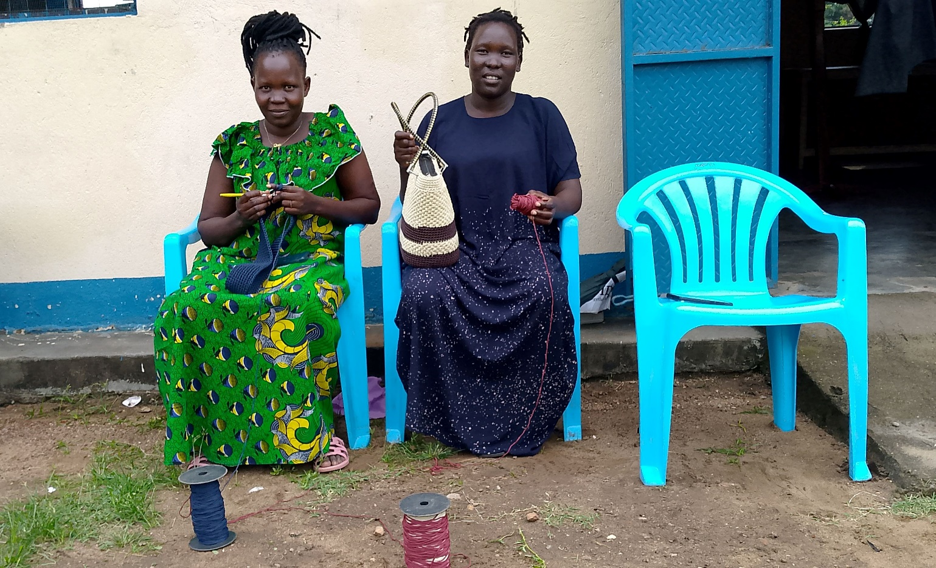

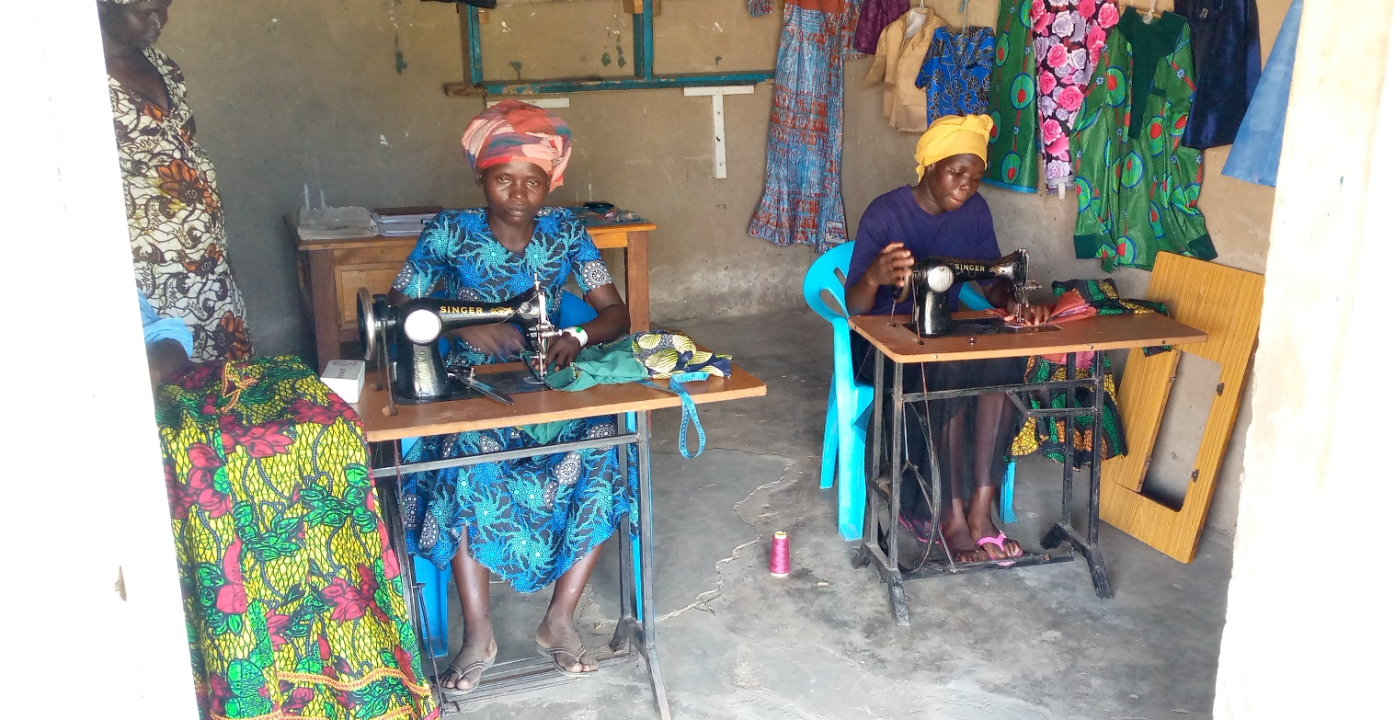

 Tell Our Story
Project Title: | TRAIN 100 YOUTHS IN SOUTH SUDAN
Implementing partner: | FOCUS ON THE VULNERABLE
Brief Introduction to  FOCUS ON THE VULNERABLE: | FOCUS ON THE VULNERABLE (FOV) is a National Non-Governmental Organization, headquartered in Eastern Equatoria State at Nimule Town Council - South Sudan. The organization is registered with RELIEF AND REHABILITATION COMMISSION (RRC) of Government of South Sudan on 15th June, 2022 Under Chapter 3, Section 10 of NGOs Act, 2016. Registration Number: 4298.  The Organization is initiated to address the needs of Persons with Disabilities, Women, Children, and Marginalized Youth. True to this spirit the organization was initiated and named FOCUS ON THE VULNERABLE (FOV).
Mission: | Creating opportunities to overcome vulnerabilities
Vision: | Empower vulnerable with equal opportunities
Our Services: | - Protection  - Livelihoods and Resilience  - Education  - Health
Summary: What will this project do?

FOCUS ON THE VULNERABLE is committed to breaking this cycle. Our "Train 100 Youth in South Sudan" project aims to provide vocational training, life skills, and entrepreneurship support to these youths, including young women and persons with disabilities. Through this program, we will equip them with the tools they need to secure meaningful employment, start their own businesses, and contribute positively to their communities.
Funding Amount/Goal: | Amount we hope to raise is $375185
Project location: | South Sudan
Project stake holders: | - Pageri Payam  - Mugali Payam  - Anzara Quarter Council
Project beneficiary: | 70 female youth and 30 male youth

Challenge  What is the problem or need? |  | Solution  How will this project solve the problem? | Long-Term Impact  How will this make a lasting impact in your community?
In South Sudan, youth represent both the present and the future. Yet, many of these young people face enormous challenges—lack of access to quality education, unemployment, and a shortage of skills necessary to build a stable and prosperous life. This severely affects vulnerable groups, like disabled persons, women, and marginalized youth. Without immediate action, these young individuals risk falling deeper into cycles of poverty and dependency. |  | By equipping youth with vocational skills, they can pursue sustainable employment opportunities, reducing their dependence on harmful practices. This training fosters economic independence, diminishes the appeal of early marriages, and curbs drug addiction by offering constructive, future-oriented activities. | By empowering these 100 youth, we are not just changing individual lives—we are building a stronger, more resilient South Sudan. Each young person trained through this program has the potential to become a leader, a job creator, and a force for peace and development.
Donation option/Project budget:
$10 | Can buy two packages of training toolkit to 2 students of tailoring for learning
$25 | Can provide roll of clothe to 1 student of tailoring for learning
$50 | Will provide sewing needles for 17 students
$100 | Can buy one sewing machine for 1 student
$5000 | Can provide different learning materials for 100 students
$100000 | Can pay cost of training for 100 students
$150000 | Will provide business startup capital for 100 students after training
$120000 | Will provide project management costs

Project anecdote:
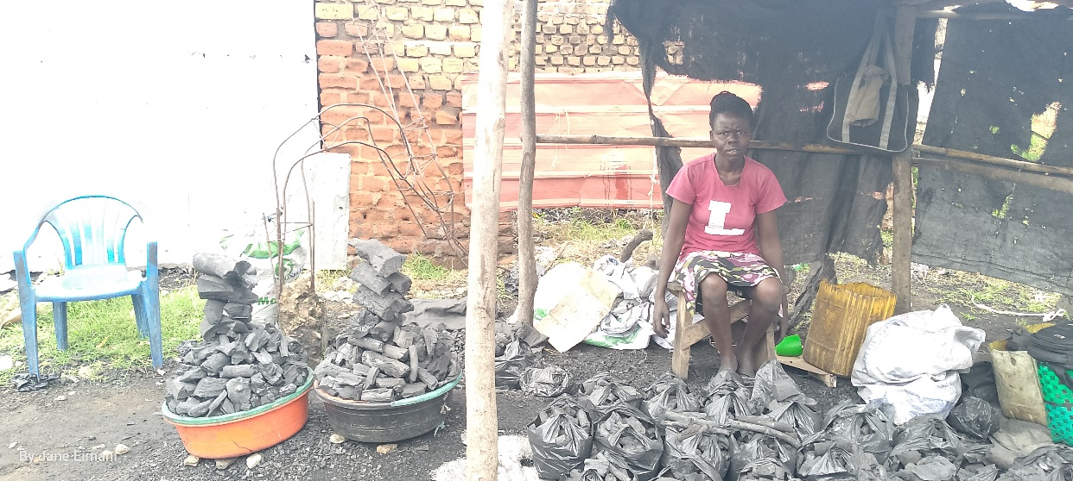
Photo by FOV.

JACKLIN ASIENZO who told us she sells the charcoal us her daily business

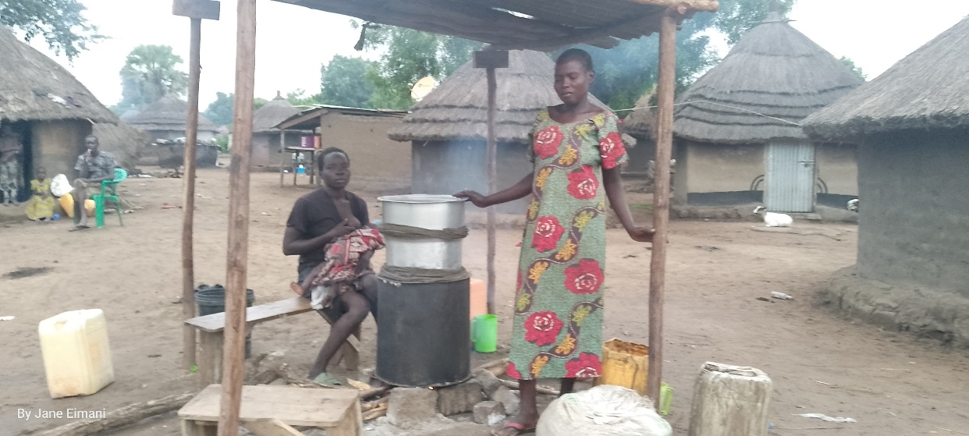
Photo by FOV.

LEMIA JANE (standing) and MANDERA FLORENCE (nursing baby) told us they brough the alcohol for their daily survival

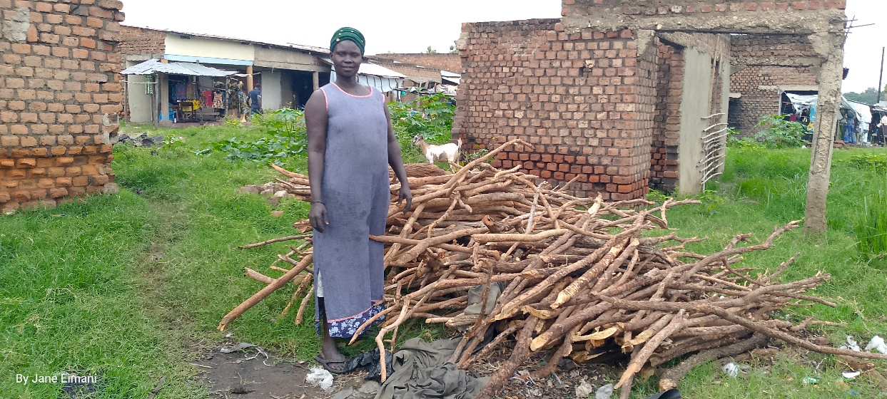
Photo by FOV.

MARY KAPILI told us her stories that she cuts firewood and then sells to people for her living and this is her daily business

Project management plan:
- Monitoring and Evaluation Plan
- Monitoring
Baseline Data Collection:
- Purpose: Establish a baseline to measure progress.
- Activities: Conduct surveys and focus groups to assess current skills, income sources, education levels, and social issues among the target youth.

Regular Monitoring:
- Frequency: Monthly
- Methods: Site visits, attendance records, participant feedback, and progress reports.
- Tools: Checklists, attendance sheets, and data collection.

Output Monitoring:
- Indicators: Number of youths enrolled, number of training sessions conducted, completion rates, and types of skills taught.
- Data Sources: Training logs, participant records, and trainer reports.

Outcome Monitoring:
- Indicators: Employment rates, new businesses started, reduction in firewood and charcoal selling, decreased drug addiction, and reduction in early marriages.
- Data Sources: Follow-up surveys, interviews, and community reports.

- Evaluation
Mid-term Evaluation:
- Purpose: Assess the project’s progress and make necessary adjustments.
- Methods: Surveys, interviews, and focus group discussions with participants, trainers, and community members.

End-term Evaluation:
- Purpose: Measure the overall impact of the project.
- Methods: Comprehensive surveys, impact assessments, and success stories.
- Indicators: Long-term employment, business sustainability, and social changes among the youth.

Reporting:
- Frequency: Quarterly and annual report.
- Content: Progress against indicators, challenges faced, success stories, and recommendations.
- Audience: Donors, stakeholders, community leaders, and project staff.

- Sustainability Plan
- Capacity Building
Training of Trainers:
- Purpose: Develop local trainers who can continue the training programs.
- Activities: Train selected participants in teaching methods, and project management.

Community Involvement:
- Purpose: Foster local ownership and support.
- Activities: Engage community leaders in the planning and implementation process.

- Financial Sustainability
Income-Generating Activities:
- Purpose: Ensure the participants are provided startup capital to extent their knowledge further.
- Activities: Establish small businesses to generate income to support their business.

Partnerships and Sponsorships:
- Purpose: Leverage additional resources.
- Activities: Form partnerships with local businesses, NGOs, and government agencies for funding, mentorship, and resource sharing.

- Policy Advocacy:
- Purpose: Create a supportive environment for youth employment and entrepreneurship.
- Activities: Advocate for policies that support vocational training, youth employment, and social protection.

- Follow-Up Support
Mentorship Programs:
- Purpose: Provide ongoing support to graduates.
- Activities: Establish mentorship networks where experienced professionals guide and support new graduates.

Continuous Monitoring and Feedback:
- Purpose: Ensure the project adapts and evolves.
- Activities: Regularly collect feedback from participants and stakeholders to improve and adjust the program as needed.

