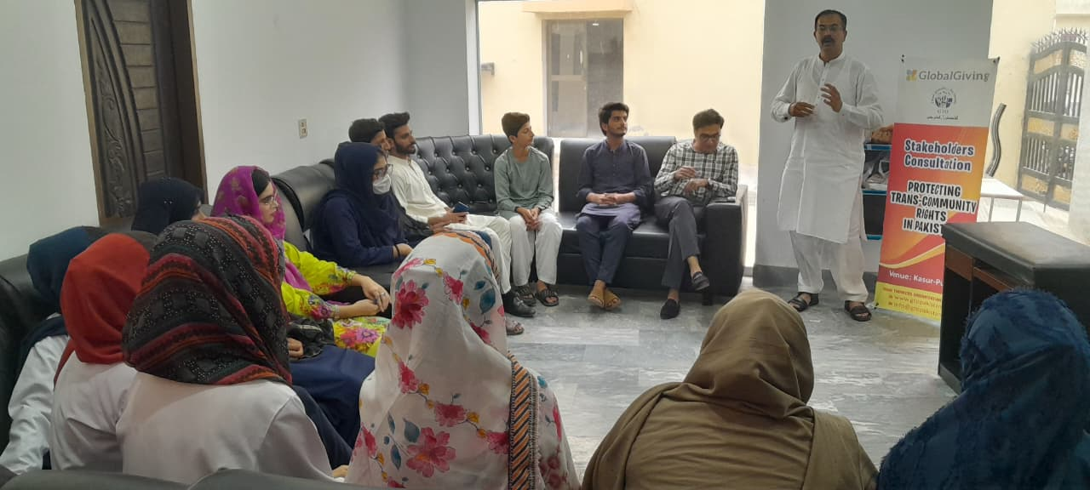
Report on Consultation: Strengthening Transgender Rights in Pakistan
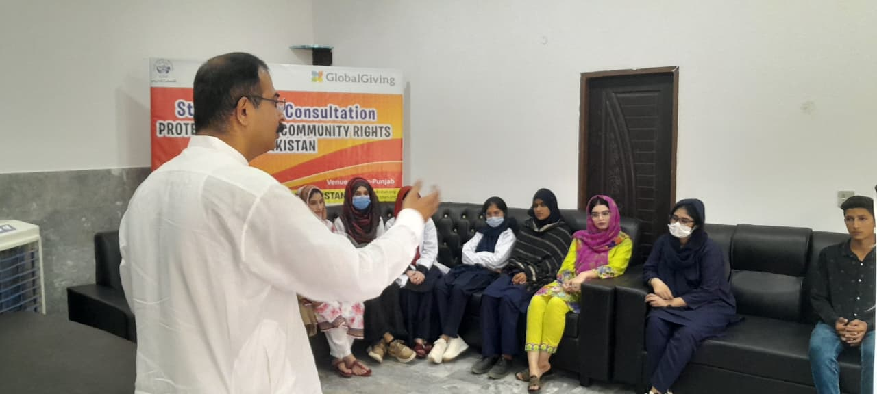
Venue: Office of Good Thinkers Organization-Pakistan
Facilitator: Waqas Abid (Advocate, President, Good Thinkers Organization)
Co-Facilitator: Muhammad Awais (Program Officer, Good Thinkers Organization)
Participants (17 in total: 10 female, 4 male, 3 Transgenders):

Findings
Participants identified a variety of identity issues, systemic challenges, cultural barriers, and legal gaps. Below are the main ones:
Issue | Details / Examples raised by Participants
Legal Identity & Documentation | • Many transgender individuals still face difficulty in getting Identity Documents (CNIC, passports etc.) reflecting their self-perceived gender.  • NADRA rules are legally supportive (as per Transgender Persons (Protection of Rights) Act, 2018) but enforcement is inconsistent.  • The problem of name change along with gender; sometimes ID only reflects gender “X” but name remains unchanged, which causes problems socially and legally.
Discrimination in Education & Healthcare | • Trans persons face bullying, harassment in schools; teachers often untrained; many drop out early.  • In healthcare, medical professionals lack sensitivity; refusal of care, misgendering, stigma in hospitals.  • Lack of separate or inclusive facilities; also mental health issues not addressed.
Employment and Livelihood | • High unemployment or under-employment. Due to stigma, many forced into informal economy or begging.  • Lack of vocational training or skill development programs tailored to their needs.
Social & Cultural Stigma | • Family rejection; discrimination at community level, including from religious leaders.  • Misconceptions and lack of awareness among public.  • Religious and cultural arguments used to oppose transgender rights, particularly self-identified gender.
Enforcement Gaps in Law | • Although Transgender Persons (Protection of Rights) Act, 2018 provides rights (education, employment, inheritance, public places, etc.), there are gaps: lack of penalties in some cases; weak grievance redressal mechanisms.  • Federal Shariat Court in 2023 struck down parts of the Transgender Act (especially those relating to self-perceived gender identity) as being incompatible with religious injunctions.  • Participants noted challenges in actual implementation of the law and in public awareness of the law.

Proposed Solutions from Participants
Participants also came up with several solutions—some specific, some broader. Below are some with names when the idea was attributed.
Solution / Recommendation | Proposed by
Training & Sensitization for Youth, Religious Leaders & Civil Society | Ms. Kiran Khalid emphasised awareness campaigns involving religious leaders, to correct misconceptions.  Ms. Tahira Kanwal (Youth Activist) proposed peer-led workshops in schools/universities.
Capacity-building for Transgender Persons | Muhammad Sharif (Quaid Welfare Society) suggested vocational training, life skills, mentorship programs so transgender individuals can access better employment.  Dr. Fiza Aslam proposed health-literacy programmes (including mental health support) within community clinics.
Legal Aid & Support Services | Ms. Iman Shahid proposed establishing free legal aid clinics, helplines, to assist in documentation issues and rights violations.  Ms. Aasia Sharif advocated having designated legal caseworkers to accompany transgender individuals during interactions with institutions (like police, NADRA, hospitals).
Community Dialogue & Social Support | Dr. Faisal Shafi urged regular community meetings involving trans persons, families, NGOs to foster understanding.  Ms. Kiran Khalid suggested inclusive media campaigns – involving trans persons’ stories to humanize and reduce stigma.
Policy & Legislative Amendments** | Some participants asked for amending the 2018 Act to re-introduce or strengthen penalties for harassment or violation of rights.  Also, to ensure that “name change” is legally as simple as gender change, with minimal bureaucratic burden.  Strengthening grievance redressal mechanisms.

Context: Legal & Policy Background
To situate the consultation findings, here is brief background from national law and recent developments:
- Transgender Persons (Protection of Rights) Act, 2018 provides legal recognition of transgender persons based on self-perceived gender identity, ensures rights to education, health, inheritance, employment, holding public office, property, assembly, access to public places, prohibition of discrimination.
- Federal Shariat Court ruling (2023) challenged parts of the Act, declaring sections on self-perceived gender identity (among others) incompatible with Islamic injunctions. That ruling is being appealed.
- There are recognized gaps: implementation is uneven, penalties for violations are weak or missing in some areas; education & healthcare sectors often lack mechanisms or awareness to enforce non-discrimination.
Recommendations & Roadmap
Based on the consultation and national context, here are recommended steps:
- Strengthen Legal Protections & Clarify Legislation
  - Push to ensure that appeal against the Federal Shariat Court ruling upholds the self-identification rights under the 2018 Act.
  - Amend the Act (or via rules) to ensure name change is as accessible as gender change.
  - Introduce clear, enforceable penalties for violations (harassment, discrimination), including in sectors like education, health, employment.
- Enhance Implementation & Institutional Capacity
  - Train public servants (NADRA officials, hospital staff, teachers, law enforcement) in transgender rights, sensitivity, procedures.
  - Establish or strengthen grievance redressal mechanisms (helplines, legal aid, ombudsman offices) that are accessible, trusted, and safe.
- Awareness and Cultural Change
  - Conduct awareness campaigns; produce media materials incorporating voices of transgender persons; involve religious leaders and community elders to address cultural resistance.
  - In schools/universities: incorporate inclusive curricula, safe-spaces, anti-bullying policies.
- Support Services & Empowerment
  - Vocational training, skill development for trans persons to improve economic independence.
  - Mental health services, peer support networks.
  - Community meeting forums to connect trans persons with families, society, reduce isolation.
- Monitoring, Data Collection & Research
  - Collect disaggregated data on incidents of violence, discrimination, health, education access, etc. to inform policy.
  - Evaluate implementation of the law across provinces, service delivery, to identify best practices and gaps.
- Policy Frameworks & Political Inclusion
  - Advocate for the activation and implementation of the National Strategic Framework for the Protection and Political Inclusion of Transgender Persons that UNDP and partners have helped draft.
  - Encourage political parties to include trans persons and their issues in manifestos, enable voting and holding public office without barriers.

Expected Outcomes
If the above solutions are implemented, anticipated outcomes include:
- More transgender individuals able to secure IDs with correct gender and name, reducing everyday legal and social obstacles.
- Improved access to education and healthcare without stigma or harassment.
- Better employment opportunities and economic stability for transgender persons.
- Increased societal understanding; reduced stigma, fewer instances of family rejection or community abuse.
- Greater political participation and visibility.
- More consistent and enforceable legal protection with accountability when rights are violated.

Conclusion
The consultation confirms that the legal framework (the 2018 Act) is a strong starting point, but there are substantial gaps in implementation, enforcement, and social acceptance. The solutions proposed by participants reflect both immediate interventions (legal aid, awareness, etc.) and structural changes (legislative amendments, capacity building). For real impact, coordinated effort is needed: civil society, government (at national and provincial levels), religious leaders, and the transgender community itself must work together.

