***Justice for the Vulnerable: Empowering Women in Uganda***

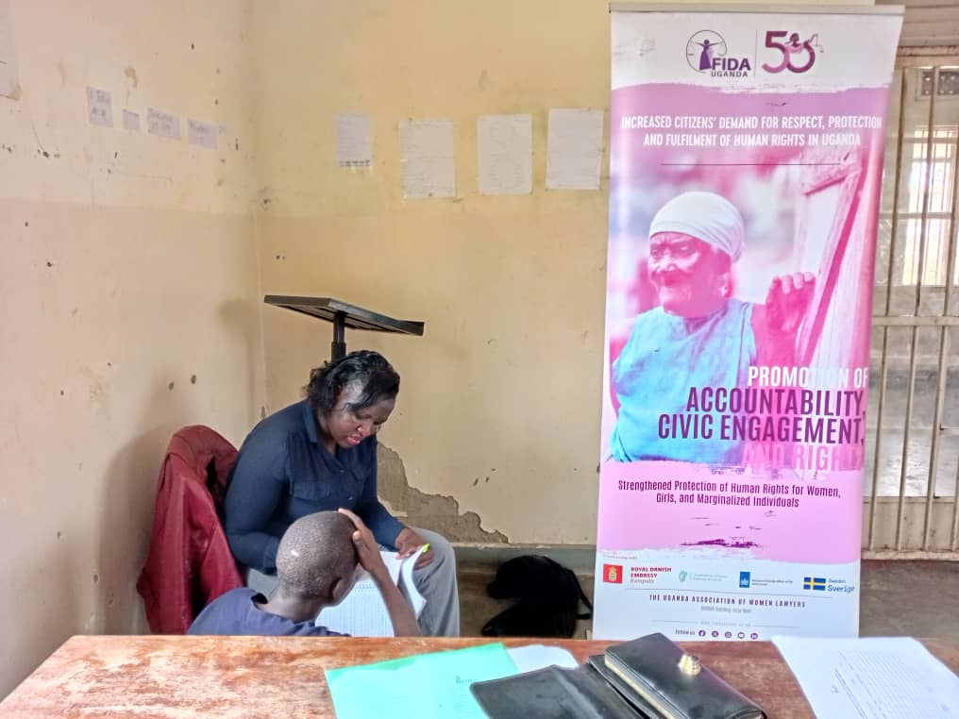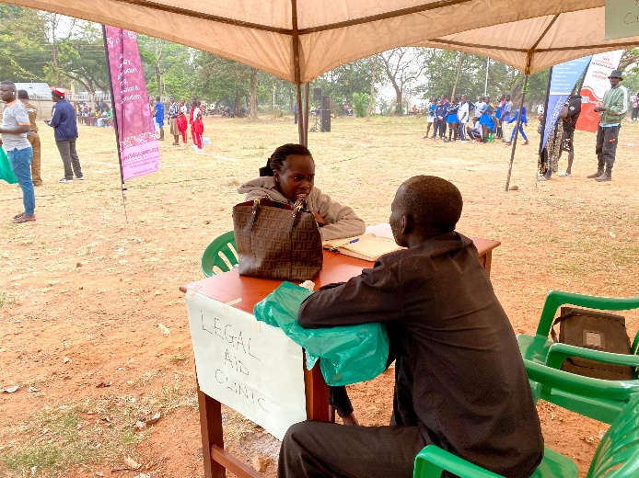

In Uganda, thousands of vulnerable women and individuals face daunting challenges every day. Domestic violence, child neglect, and land disputes are just a few of the pressing issues that threaten their well-being and dignity. But there is hope.

FIDA-Uganda has been working tirelessly to provide critical legal aid services to those who need it most. Between December 2024 and February 2025, we supported an astonishing 3,326 vulnerable individuals, with a significant focus on supporting vulnerable women (73.9% of the clients) to access justice and build resilience.

Our efforts have yielded remarkable results:

* 65.7% of cases were successfully resolved through legal advice, mediations, and court interventions.
* 19.5% of clients were referred to partner organizations for additional support services, including shelter, health, and police assistance.
* Vulnerable women received crucial counselling to address psychosocial and mental health issues that exacerbate their vulnerabilities.

However, our work is far from over. Systemic issues continue to perpetuate vulnerability, particularly among women. That's why we need your support.

Your Donation Can Make a Difference. By contributing to FIDA-Uganda, you'll be helping us:

* Provide critical legal aid and psychosocial support services to vulnerable women.
* Advocate for policy changes that promote gender equality and justice.
* Empower women to claim their rights and build a brighter future through economic empowerment and agency building.

Every donation, no matter how small, counts. Together, we can create a more just and equitable society for all.

***Success story: Lucy’s rescue from Child Marriage***

In Uganda, where 43% of women are married off before the age of 18, Lucy's story could have ended in tragedy.[1] But thanks to FIDA-Uganda's intervention, Lucy was saved from child marriage and can now continue her education.

At 14, Lucy's father, who had abandoned her since childhood, asked to see her. Lucy had never had the chance of enjoying a father’s love or knowing what it means to have a father. But instead of reconnecting, he had sinister plans to marry her off.

Florence started worrying when school time came, and Lucy hadn’t returned from her father’s home as agreed; yet the father had blocked all access to the child. Her anxiety was further escalated by the realization that her father had taken her to a village notorious for child marriages and teenage pregnancies. Florence had secured a scholarship for Lucy's education, but her father's actions threatened to derail her future. Desperate for help, Florence approached FIDA-Uganda for legal aid in April 2025.

FIDA-Uganda's legal officer invited the parties for mediation, but Lucy's father refused to attend. Undeterred, the legal officer filed an application for maintenance and custody, which resulted in a ruling in Florence's favor. The court granted Florence immediate custody of Lucy and ordered the father to provide monthly maintenance, scholastic materials, clothing, and medication.

Child marriage is not only a human rights violation, but it also increases the risk of teenage pregnancy, which can have a profound effect on the physical and mental health and lives of young girl mothers, increasing their vulnerability to serious health complications if they give birth at a very young age.[2] Thanks to FIDA-Uganda's intervention, Lucy is back in school, and her future looks brighter. Lucy’s mom is grateful for the support, saying, *"You saved my daughter from being denied her right to education, and getting married at a younger age. I have finally gotten my daughter back, and I will protect her from child marriage at all costs."*

Lucy's story is a testament to FIDA-Uganda's tireless efforts to protect women's and children's rights in Uganda. With your support, FIDA-Uganda can continue to provide legal aid and advocacy services to those who need it most.

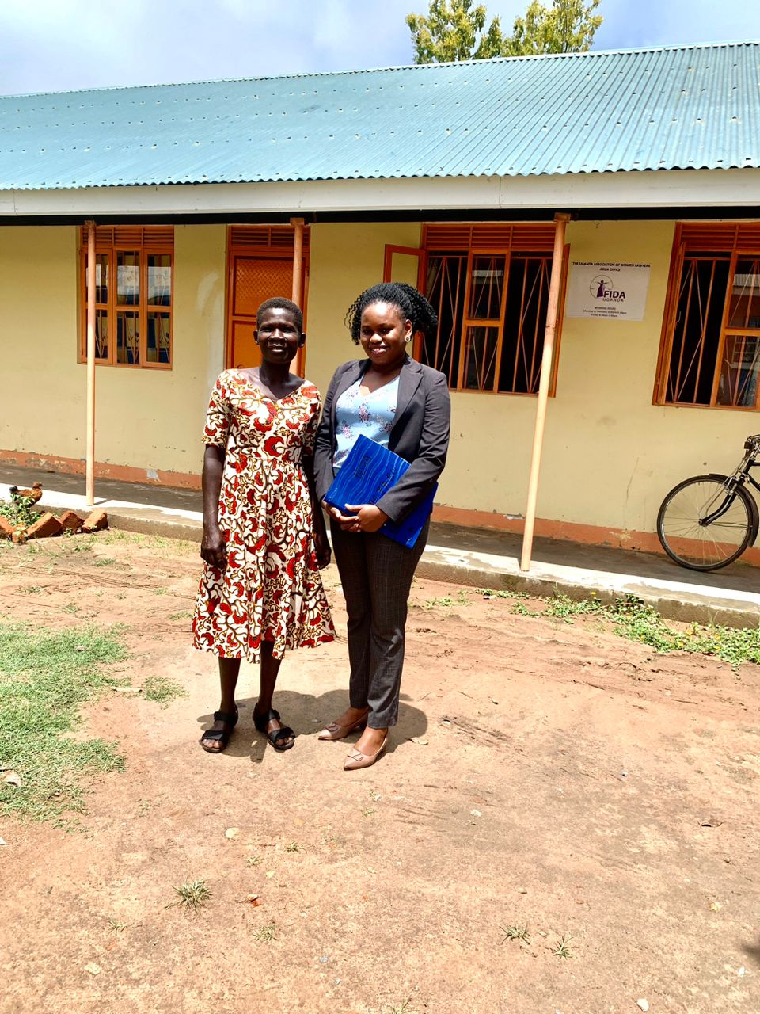

A photo of the Legal Officer and Lucy’s mom (Florence) at the FIDA-Uganda Arua office after receiving the Court Ruling*.*

***FIDA-Uganda Marks 50 Years of Fighting for Women's Rights:***

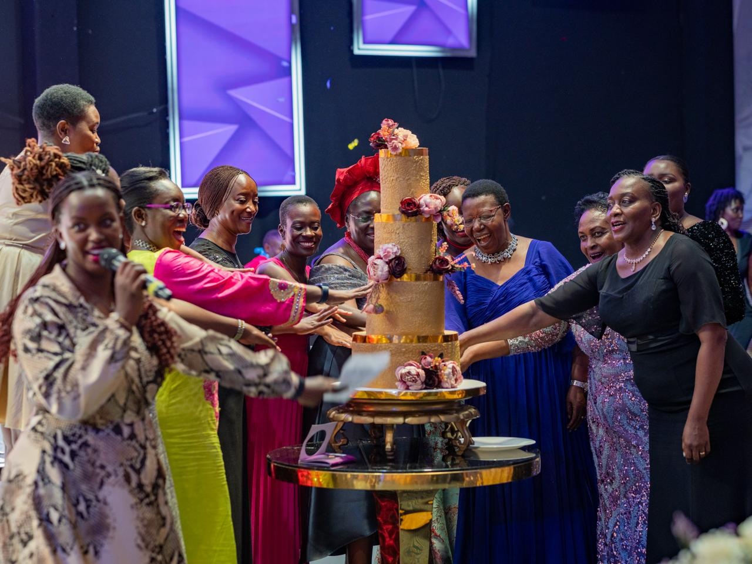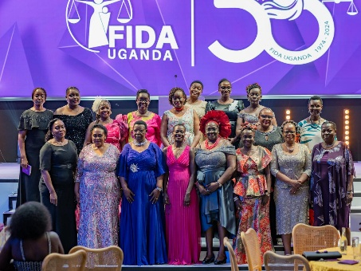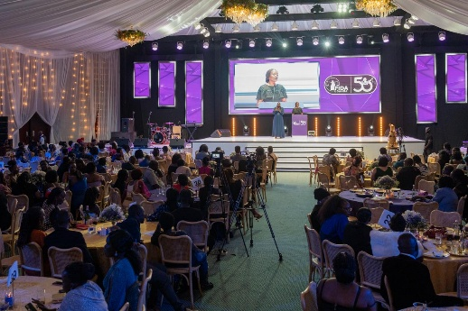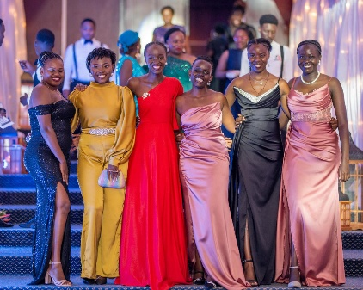

On December 7, 2024, FIDA-Uganda celebrated a major milestone – its 50th anniversary at the Kampala Serena Hotel, a momentous occasion, celebrating five decades of tireless efforts to promote women's rights and gender equality in Uganda. The grand celebratory dinner brought together over 450 participants, including founders, long-serving staff, members, Community Legal Volunteers, and beneficiaries. The 50th-anniversary celebration was a testament to FIDA-Uganda's resilience and determination to create a more just and equitable society.

Since its inception in 1974, FIDA-Uganda has been at the forefront of promoting women's rights and gender equality in Uganda. The organization has provided critical legal aid services to vulnerable women and children, advocated for policy changes, and empowered local communities. FIDA-Uganda's 50-year journey has been marked by numerous achievements, including, among others:

* Providing essential legal aid services to over 20,000 vulnerable women and children annually, promoting women’s socio-economic justice; and providing legal education and training.
* Advocating for gender considerations in over 15 laws and policies in Uganda.
* Collaborating with partners to pilot special court sessions on Sexual Gender-Based Violence (SGBV) in November 2016 to deal with the great backlog of sexual violence cases in the country. Since then, special SGBV court sessions have been held every year, expanded into various districts in Uganda and institutionalized through the national Justice, Law and Order Sector.
* Empowering local communities in Alternative Dispute Resolution (ADR) and self-representation to sustain access to justice for vulnerable women and children.

As FIDA-Uganda marks this significant milestone, the organization remains committed to fighting for gender justice, empowering women and children to claim their rights, and addressing the systemic issues that perpetuate vulnerability; ensuring continuous provision of critical support to those who need it most.

Join FIDA-Uganda in celebrating this remarkable achievement and in supporting their ongoing efforts to create a brighter future for all.

1. https://uganda.unfpa.org/sites/default/files/pub-pdf/issue_brief_14._child_marriage_and_teenage_pregnancy._ready_to_print_1.pdf
2. https://uganda.unfpa.org/sites/default/files/pub-pdf/issue_brief_14._child_marriage_and_teenage_pregnancy._ready_to_print_1.pdf