About
Indonesian House of Hope
Rumah Harapan Indonesia (RHI) is a halfway house for children aged 17 years who are undergoing treatment for serious non-communicable diseases. Generally, patients at RHI come from poor families who come from outside the big cities in Indonesia.

History

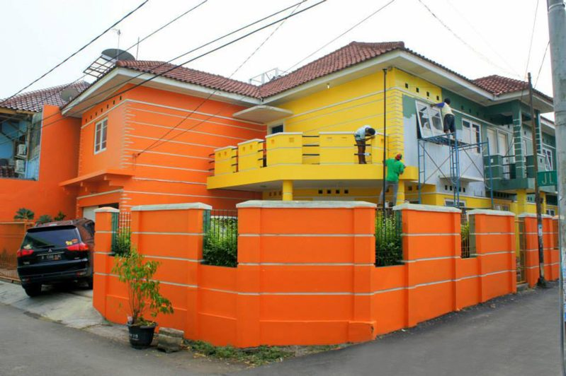

History

Founded in 2014 by Valencia Mieke Randa in Jakarta. At the beginning of its establishment, RHI used the name Rumah Harapan Valencia Care Foundation (RHVCF). RHI is under the auspices of the Friends of Valencia Peduli Foundation which was established based on Notarial Deed Number 493 dated 23 December 2014 made before Notary Rosita Rianauli Sianipar, SH. MKn in Jakarta and SK. Minister of Human Rights & Human Rights of the Republic of Indonesia Number AHU-0000159.AH.01.04.TH.2015 January 7 2015. For less than 2 (two) years, RHVCF has been in Jakarta, Bandung, Bali and Aceh. In 2017, the Aceh branch was independent so it was no longer under RHI management.

In mid-2016, RHVCF changed its name to RHI with the mission of building more shelter homes in all major cities in Indonesia. Simultaneously with the name change to RHI, Raline Shah joined as Co Founder of RHI. In line with RHI's mission, in 2017 the RHI halfway house was present in Semarang.

VISION

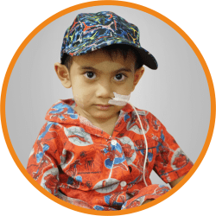

Giving new hope to sick children who almost lost hope.

MISSION



Providing temporary housing and supporting facilities for patients undergoing treatment.

As a forum for everyone who wants to share through Rumah Harapan Indonesia.

Ensure that sick children still have the right to be healthy, play and learn.

Our Founder

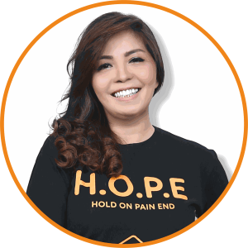

Valencia Mieke Randa

Valencia Mieke Randa is the Founder of Rumah Harapan Indonesia. Since 2009, Valencia has been involved in the social world and founded several social movements in Indonesia, whose focus is on services in the health sector, because it is based on her personal experience in dealing with her mother who was sick with cancer and dialysis as well as her experience of raising special children who have special needs. specifically what God has placed in his life.

Valencia started his social activities in 2009, by establishing Blood For Life Indonesia (BFL), a community that connects people who need donors with people who want to donate blood. It didn't stop there, in 2011, Valencia founded the 3 Little Angels (3LA) community to help child patients who were seeking treatment at RSCM, and in 2014 finally founded Rumah Harapan Indonesia (RHI) and formed the Friends of Valencia Peduli Foundation which oversees RHI and BFL.

Through this social activity, Valencia received awards both from within and outside the country such as: Google Web Hero (internet hero) 2011 by Google Chrome Singapore, L'oreal Paris Women of Worth 2014, SK II Most Inspiring Woman 2015, Indonesian Women in the History of Struggle Nation by Musium Bank Indonesia 2015, CNN Heroes 2016, Coverage 6 SCTV awards 2017, Wardah Inspiring woman 2018, SASC Inspiring Woman 2019, 74 ICON Pancasila Achievement 2019, People Choice Award 2019 and 2020.

Our Team

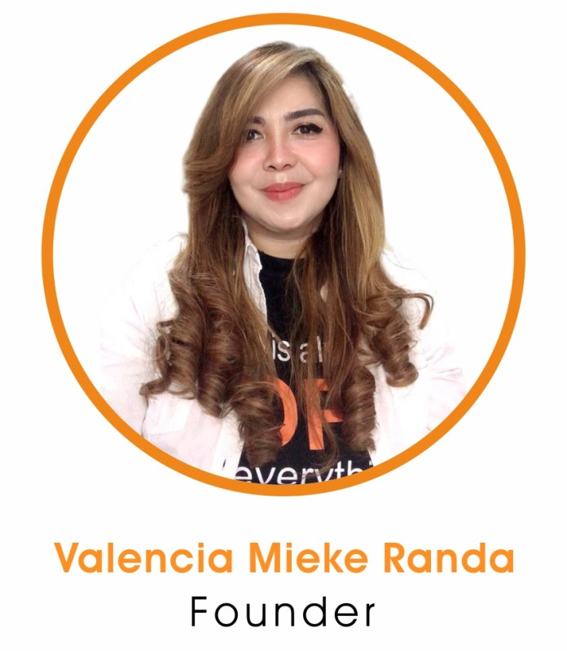

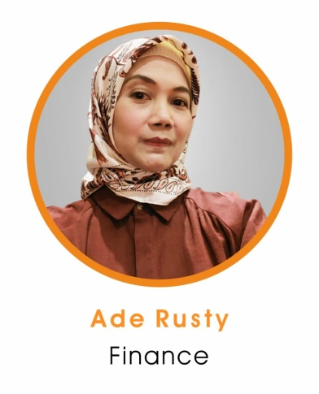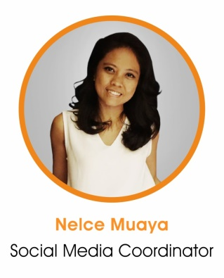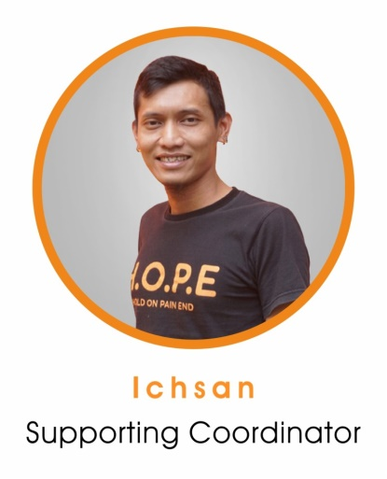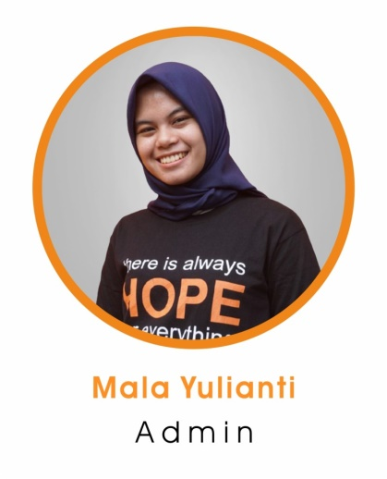

​Coordinator

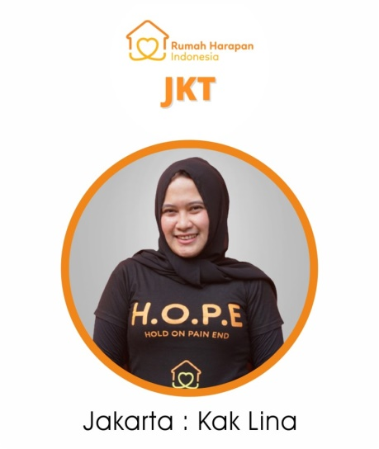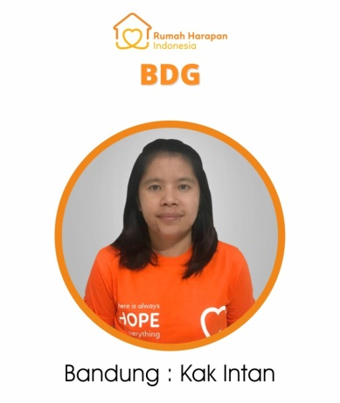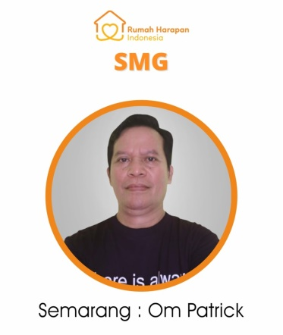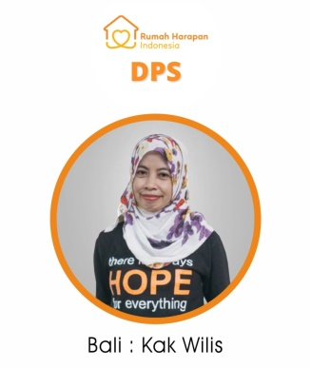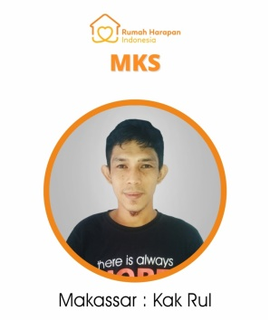

Rumah Harapan Indonesia
Jl. Talaud No.12, RT.10/RW.4, Cideng, Kecamatan Gambir, Kota Jakarta Pusat, Daerah Khusus Ibukota Jakarta 10150
+62811 1145 2788
rumahharapanindonesia@gmail.com

Any question ?

