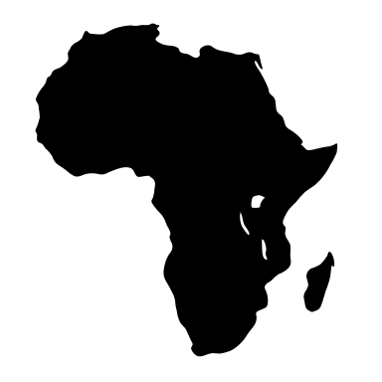

**BIO-BENIN FISH FARMING PROJECT**

**NATITINGOU, BENIN, WEST AFRICA**

**Empower 100 students each year to earn a productive living and feed their families with a nutritious source of healthy protein. With expertise in fish-farming, we need to build a fishpond on our organic farm to make their dreams come true.**

**The original pond that washed away when the dam broke after torrential rains.**

**With your help we will rebuild the dam, stock the pond with tilapia and start the training.**