CRIME CHECK FOUNDATION (CCF)

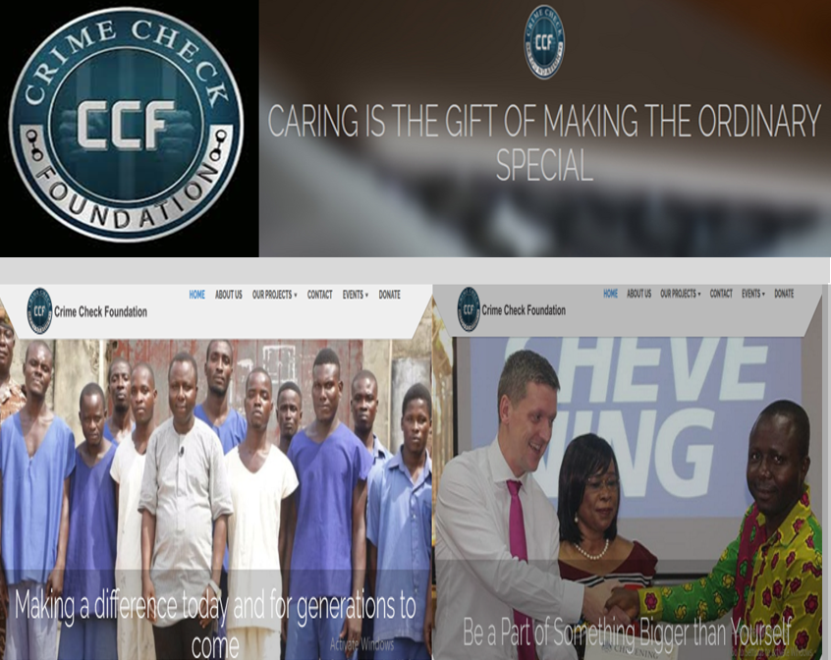

STRATEGIC PLAN

2020 - 2025
Address: P.O.BOX 16750 Accra, Ghana
Office location: McCarthy Hill traffic light,
Good Shepherd Plaza, Second floor, Accra.
Phone: (+233) 024 207 4276 / (+233) 055 829 5335
Office: (+233)0302350057
Email: info@crimecheckfoundation.org
Website: https://crimecheckfoundation.org/

Table of Contents

List of Abbreviations 3
EXECUTIVE SUMMARY: 4
ABOUT CRIME CHECK FOUNDATION 5
CCF STRATEGY (2020 - 2025) RESULT FRAMEWORK 6
Sample Achievements of CCF: 7
CCF PROGRAMS 9
APPROACHES TO CCF WORK 10
CONTEXT FOR POVERTY REDUCTION IN GHANA 13
THE JUSTICE SECTOR OF GHANA 13
STRENGTHS, WEAKNESSES & OPPORTUNITIES FOF CCF 16
CCF’S STRATEGIC OBJECTIVES AND ACTIONS FOR 2020 – 2025 17

List of Abbreviations

CCF: Crime Check Foundation
CSOs: Civil Society Organizations
GH: Ghana
GHS: Ghana Cedis
GTV: Ghana Television
IRs: Intermediate Results
NGOs: Non-Governmental Organizations
SDGs: Sustainable Development Goals
SOs: Strategic Objectives
TV: Televisions
UTV: United Television

Executive Director, Mr Ibrahim Oppong-Kwarteng

Mr Ibrahim Oppong-Kwarteng is the Ambassador Extraordinaire of Ghana’s Prisons, and a prisons’ journalist with the Ghana Broadcasting Corporation. He is also a Chevening Alumni, a human rights activist, and a key advocate for legal reforms. For years he has led advocacy campaigns for the passage of the Non-Custodial Sentencing Bill aimed at ending the jailing of the poor and voiceless youth, men, and women for petty offences. Mr Kwarteng is also one of the lead advocates for decriminalization of drug use in Ghana, urging government to review the country’s drug policy to help decriminalize petty drug related offences, and allocate resources for rehabilitating and supporting chronic drug users. This is because criminalization of drug use and possession has led to the arrests, prosecution, and incarceration of thousands of Ghanaians across the country.

EXECUTIVE SUMMARY:

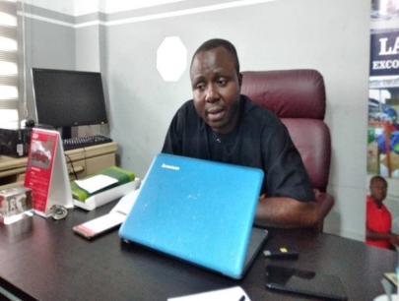
Since Ghana’s return to constitutional rule in 1993, stable democratic governance has led to improved economic development and justice delivery. However, the economic gap between the rich and the poor has widened. Many Ghanaians live in extreme poverty, and are struggling to fulfill the basic needs in education and health. This state of affairs has led to intense competition for economic survival, unemployment, and high crime rate, while many youths have resorted to crime and end up in prison as petty offenses.

Over the years, CCF has focused on crime prevention advocacy through direct financial support to the vulnerable and underprivileged. Through collaboration with individuals, donor organizations and state institutions, CCF gets petty offenders out of prison, pays medical bills for the poor who are sick, pays schools fees for many brilliant-but-needy students; and provides start-up capital for ex-convicts and many street women.
CCF is convinced that poverty contributes to poor health, affects personal development, and is the cause and effect of crime. With the absence of a Non-Custodial law in Ghana, CCF’s interventions through its ‘Petty Offenders’ project has led to the release of many petty offenders jailed for their inability to pay court fines imposed on them. The implementation of SDGs which has targets on poverty reduction as well as rule of law and access to justice in SDG#1 and SDG#16 presents a great opportunity for improved justice delivery and poverty reduction. But, this requires effective mobilization of efforts and resources of all.

ABOUT CRIME CHECK FOUNDATION
Crime Check Foundation (CCF) was incorporated on 6th November, 2015 under the Companies Act 1963, Act 179 as a company limited by guarantee. CCF is a crime prevention advocacy organization that uses Life in Prison Documentaries to sensitize the public to the dangers of crime. CCF also focuses on strengthening institutions in rights protection to perform their constitutional mandate to protect citizens.
The organization undertakes this initiative by producing and screening of prison documentaries, schools, churches, mosques, communities and other trouble spots in Ghana. CCF’s ‘Time with the Prisoner’ series (a One-on-One engagement with prisoners) is accessible to millions of Ghanaians within and outside the country, on television, and on the organization’s social media platforms- Crime Check TV Gh- (Facebook), Crime Check TV (YouTube) which have massive following. The series, the first of its kind in Africa has not only served as a crime deterrent tool, but has been instrumental in highlighting:
- Major infractions of the law in Ghana’s Justice Delivery System
- Abuse of the rights of Prisoners, the poor and the voiceless
- Deplorable conditions in Ghana’s forty-four prisons
- The need for a review of Ghana’s Criminal Justice System.
- The need for reform measures to strengthen Ghana’s prisons and other institutions in rights protection

Mission Statement
- CCF promotes the rights of prisoners and supports the marginalized and underprivileged persons and groups.
Vision
- To be the foremost crime prevention advocacy and philanthropic organization in Africa with the sole aim of serving humanity without discrimination.
Our Core Values

- Selflessness
- Integrity
- Accountability
- Transparency
- Team work
- Innovation

CCF PROJECTS
Petty Offenders Project
With the absence of a Non-Custodial law in Ghana, CCF’s Petty Offenders project has led to the release of many petty offenders jailed for their inability to pay court fines imposed on them. Through our Ex-Convicts Re-integration project, CCF has successfully reintegrated hundreds of ex-convicts into society by providing livelihood support for them.

Charity Series:
Under this program, CCF provides livelihood support for many poor individuals and families who struggle to make ends meet. Beneficiaries include street hawkers, street beggars, and poor men and women in hard-to-reach districts and communities. This is aimed at reducing the high crime and imprisonment rate due to poverty as well as minimizing abject poverty in Ghana.

Reintegration of Migrants and Returnees:
Due to economic and social factors, many Ghanaians, particularly poor and vulnerable girls travel or are trafficked abroad as migrants. Many of these citizens become stranded or return home with serious physical and psychological problems. CCF’s provides counseling and livelihood support to these migrants who usually return home without any means of livelihood. It also provides medical support through our Health Check series to the many others who return home with health complications. CCF came up with this program following several calls it receives from trafficked Ghanaians who are stranded particularly, in the Gulf countries. They are unable to afford the air fare to return home because they are bonded, beaten and return home, if at all, with medical conditions.

Sample Impact Stories:
Memuna Malik, 29-year old, travelled to Saudi Arabia to seek greener pastures but came home empty handed, and physically deformed due to an acid accident she had. Upon her return, she visited CCF for health support to undergo constructive surgeries. CCF supported her with the full payment of surgeries and also gave her money to start a business.
Jemila Tahiru, a 23-year-old Ghanaian immigrant narrated how she was given a dangerous injection in Oman. The supposed injection which was meant to heal her ulcer rather left her mentally deranged. She was sent back to Ghana penniless, insane and without her clothes. CCF gave her mother an amount of money for their medical bills and upkeep.
The stories of these two young ladies depict the risks and vulnerabilities poor and trafficked Ghanaian migrants face due to poverty. A peculiar challenge CCF faces is that, it is unable to pay for the air fares of several stranded and trafficked Ghanaians migrants who call for help to come back home. Their employers often refuse to pay them their monies to come back home.
Health Check Series: With the understanding that detention in whatever form is injurious to health, CCF has decided to go beyond the prisons, by introducing the Health Check Series. This project provides financial support to those detained in hospitals because of their inability to settle their bills and also solicit support for many others who require surgery and are unable to foot such medical bills because of poverty.
Educational Support: Many brilliant-but-needy students end up on the streets due to poverty. CCF’s educational support fund has paid the admission fees for more than 15 such students who are pursuing degrees in various Ghanaian universities. Primary, junior and senior high students also benefit from this fund.
Ex-convicts Reintegration project: The stigma attached to having been to prison makes many ex-convicts unable to integrate into society. Many commit suicide upon their release from prison while others re-offend and are sent back to prison. CCF has therefore introduced the ex-convicts reintegration project which essentially provides livelihood support for ex-convicts to enable them re-integrate successfully into society. This project has since its conception successfully reintegrated hundreds of ex-convicts and has trained many inmates through its Inmates Technical Training, which is to prepare them for the outside world when they are finally released.

Clean Water project: Water is one of the basic necessities of life but studies have shown that there are many in rural Ghana who lack portable water. This initiative by CCF provides clean drinking water for these underprivileged communities.

CCF has influenced many policy and legislative reforms in Ghana through its quarterly press conferences:https://www.youtube.com/watch?v=ckGc8WHUU08;https://www.youtube.com/watch?v=OgVrVrQ61J4. Its engagement with Ghana’s Speaker of Parliament, Rt. Hon. Prof. Aaron Mike Oquaye and other high ranking government officials, Amnesty International and other Civil Society Organizations (CSOs) have further given the organization more credibility and visibility. https://www.youtube.com/watch?v=duHuYno6Lwg;https://www.youtube.com/watch?v=naPmbrqgHyY. CCF is currently among a group of CSOs that are implementing USAID/Ghana Justice Sector Support Activity, a project that seeks to strengthen advocacy for improved justice delivery in partnership with Justice Sector Institutions in Ghana. https://www.youtube.com/watch?v=CAOprCm3H_k

CCF STRATEGY (2020 - 2025) RESULT FRAMEWORK
GOAL:
DIRECT SUPPORT FOR POVERTY REDUCTION AND JUSTICE DELIVERY INCREASED

Strategic Objective 3:
Financial support for health care and education outcomes improved for the vulnerable

Strategic Objective 2:

Crime prevention advocacy increased across Ghana

Strategic Objective 1:

Increased strategies for better justice delivery

Strategic Objective 4:

Increased integration of ex-convicts into society

CCF Strategic Objectives (SOs) and Intermediate Results (IRs)
The SOs and their corresponding Intermediate Results (IRs) for CCF are listed below. The four (4) SOs depict the strategic sector focus for CCF based on an analysis of the beneficiary and stakeholder needs assessment and the SDGs that informs Ghana’s development trajectory.

• SO 1: Increased strategies for better justice delivery:

- IR 1.1: Increased CSO/citizens’ monitoring of justice delivery
- IR 1.2: Increased action and redress on issues affecting justice delivery for the vulnerable
- IR 1.2: Strengthened and responsive justice delivery and rights protection institutions

• SO 2: Crime prevention advocacy increased across Ghana
- IR 2.1: Increased CSO/citizens’ voice on crime prevention strategies
- IR 2.1: Improved personal freedom and development

SO 3: Financial support to vulnerable and underprivileged increased
- IR 3.1: Increased cash transfers to the poor and vulnerable for education, health, business needs
- IR 3.2: Reduced incidence of poverty and vulnerability

SO 4: Increased integration of ex-convicts into society
- IR 4.1: Increased release of petty offenders from prisons
- IR 4.2: Provision of start-up capital for ex-convicts enhanced

Sample Achievements of CCF:
With support of benevolent individuals and institutional donors, Christian Atu (Ghana Black Stars player), Nene Tetteh Oklemke, Tell It Moms, Two Tap Ministry Foundation, CCF has undertaken several interventions within its programs between 2017 to 2019. With the absence of a Non-Custodial law in Ghana, CCF’s Petty Offenders project has led to the release of many petty offenders jailed for their inability to pay court fines imposed on them.

CCF understands that detention in whatever form is injurious to health. In this light, CCF has gone beyond the prisons. Through our Health Check Series, we have come to the aid of many Ghanaians who have been detained in hospitals because of their inability to settle their bills and solicited support for many others who require surgery. We have also provided prosthetic hands and legs for many children whose parents have either neglected them or cannot afford medical care for them.

Our philanthropy project, premised on the idea that- (there are many in Ghana who live virtually in prisons outside prison because of poverty) has provided livelihood support for many poor individuals and families.

The stigma attached to having been to prison makes many ex-convicts unable to integrate into society. Many commit suicide upon their release from prison while others re-offend and are sent back to prison. CCF has therefore introduced the ex-convicts reintegration project which essentially provides livelihood support for ex-convicts to enable them re-integrate successfully into society.

CCF results of the years are summarized below:
- disbursed GHS61,350 to release of about 741 petty offenders from various prisons in Ghana
- spent GHS182,162 on the medical bills of the vulnerable and less privileged
- donated items worth GHS80,262 to various prisons in Ghana
- spent GHS103,942 on educational for the vulnerable and less privileged
- provided GHS45,945 as start-up capital for ex-convicts

CCF PROGRAMS

The main areas of focus for CCF are Philanthropy, Crime Prevention Advocacy, Justice Delivery Tracking, Petty Offenders, Reintegration, Health Check, and Fans for Prisoners, which are explained below:

PHILANTHROPY
Most of our prison interviewees admit poverty and frustration pushed them into crime. This program is devoted to helping the poor, the voiceless and the underprivileged to skip the trap of crime and imprisonment. This program also shares the stories of ex-convicts and their families that have received support from Crime Check Foundation as well as others who require support to re-integrate successfully into society. CCF features their concerns and solicits support to make their life worth living.

JUSTICE DELIVERY MONITORING:
CCF also tracks the performance of justice delivery to inform advocacy and redress actions aimed at improving effective justice delivery for the voiceless. CCF focuses on the all the justice delivery institutions in this regard
PETTY OFFENDERS:

With the absence of a Non-Custodial law in Ghana, CCF’s Petty Offenders project advocates for the release of many petty offenders jailed for their inability to pay court fines imposed on them.

HEALTH CHECK:

With the understanding that detention in whatever form is injurious to health, the Health Check Series provide direct support to Ghanaians who have been detained in hospitals because of their inability to settle their medical bills. CCF also solicits support for many others who require surgery. CCF has also provided prosthetic hands and legs for many children whose parents have either neglected them or cannot afford medical care for them.

FANS FOR PRISONERS:
This project is to mobilize resources and donations to enable the Foundation fix fans in all the 42 Prisons nationwide as part of the “Support the Operation 2,000 Orbit Fans” project, initiated by Mr. Ibrahim Oppong Kwarteng, the Ambassador Extraordinaire of Prisons.

REINTEGRATION

The program focuses on ensuring prisoners who have been released return and adapt to their community with the aim of reducing recidivism.

PPROACHES TO CCF WORK

In line with the following programs: Philanthropy, Justice Delivery Tracking, Petty Offenders, Reintegration, Health Check, and Fans for Prisoners.

Philanthropy:
Under its charity series, CCF provides direct supports to health and educational needs of the vulnerable and the underprivileged through donations from cherished donors of CCF.
The process for identifying our beneficiaries follows the following steps:
- CCF either scouts for individuals who require assistance or such people call into our office for support.
- Records of such individuals/groups are taken
- Preliminary investigations are carried out to verify the veracity of information provided by such people.
- In the case of medical and legal issues, we the Doctor and Lawyer on the CCF Board for advice.
- After satisfying ourselves, we move to the field to conduct interview.
- Prior to the interview, the people requiring the support must fill a consent form approving of the interview and broadcast of same to solicit support for them.
- After the interview, the video is edited and reviewed for conformity with ethical and professional standards.
- The video is then posted on CCF social media platforms to solicit support from donors.
- Whoever donates towards any CCF project is provided video evidence of utilizing of funds.

Justice Delivery Tracking:

CCF tracks the performance of justice delivery to inform advocacy and redress actions aimed at improving effective justice delivery for the voiceless. CCF focuses on the all the justice delivery institutions in this regard

Crime Prevention Advocacy:

CCF is a crime prevention advocacy organization. Through its Crime Check TV and a YouTube channel dedicated to crime prevention, CCF sensitizes the public on the dangers of crime through the screening of Life in Prison documentaries. The Crime Check TV Channel is liked and followed by over 200k followers.

CCF also undertakes these initiatives through the screening of prison documentaries in schools, churches, mosques, communities and other trouble spots in Ghana. CCF’s “Time with the Prisoner” series is accessible to millions of Ghanaians within and outside the country on television, and on our organization’s social media platforms- Crime Check TV Gh- (Facebook), Crime Check Foundation- (Facebook), Crime Check TV- (YouTube).

The series, the first of its kind in Africa has not only served as a crime deterrent tool, but has been instrumental in highlighting:
- Major infractions of the law in Ghana’s Justice Delivery System
- Abuse of the rights of Prisoners.
- Deplorable conditions in Ghana’s forty two prisons
- The need for a review of Ghana’s Criminal Justice System.

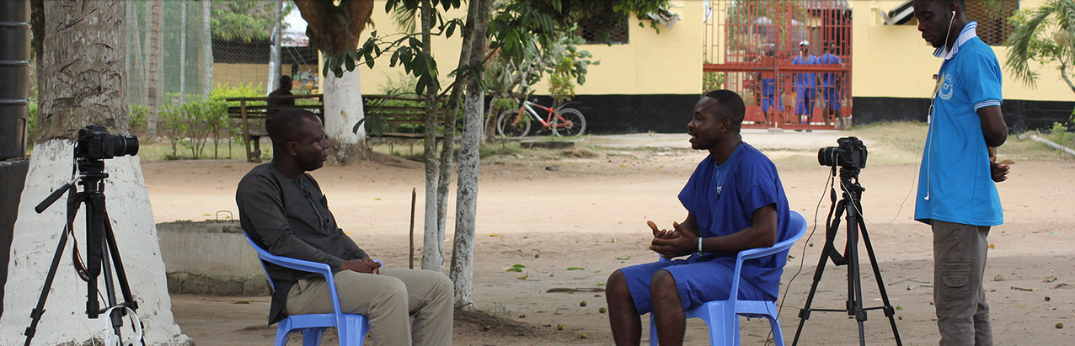

Health Check program:
CCF mobilizes financial and material support to meet the health needs of the vulnerable and health facilities across Ghana. The donation to the Kasoa Mother and Child Hospital, of medical equipment (20 hospital beds and mattresses, 10 wheel chairs, 2 walking aids and 10 ceiling fans were provided) worth over GHS 42,000 to help address the equipment challenges of the eighty-five bed capacity health facility is just one of many such donations.
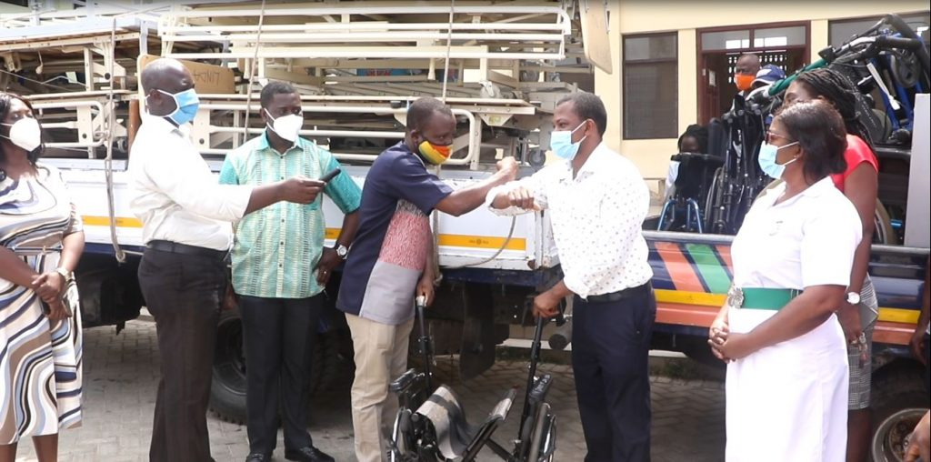

Fans for Prisoners:
CCF organizes donations to prisons and medical assistance for sick and old inmates and other support services to prisoners across Ghana. The organization also providing ceiling fans to prisons under this program. For instance, and as reported on March 27 2020, CCF donated some Covid-19 related items worth GH¢13,000 to the Ghana Prisons Service to help prevent the spread of Covid-19.

CONTEXT FOR POVERTY REDUCTION IN GHANA
According to the World Bank, Ghana’s strong economic growth in the past two decades helped cut the country’s poverty rate in half, from 52.6% to 21.4%, thereby ushering Ghana into a middle income status in 2011. But according to the newly released report on “Poverty Reduction in Ghana: Progress and Challenges”, sustained poverty reduction requires a commitment to reducing inequality and improving access to opportunities for all citizens. The report notes that “to ensure prosperity is shared across the entire population, a multifaceted, well-targeted and fiscally sustainable package of policies that balances the needs of the poor with the needs of the economy will help Ghana move in the right direction.”
Growing inequality in household consumption, regional disparities in welfare and a deteriorating macroeconomic environment are challenging progress in Ghana, the report noted. A recent report by the Ghana Statistical Service also suggests increased incidence of poverty owing to loss of livelihoods and income as a result of Covid-19 pandemic. A key recommendation for poverty reduction in Ghana is the need to focus on expanding social protection and direct support to the vulnerable.

The SDGs provide a huge opportunity to reduce poverty by improving outcomes in health, education, and access to justice in through SDG#1, SDG#3, and SDG#16 which have targets on poverty reduction, health, and access to justice.

THE JUSTICE SECTOR OF GHANA
The justice sector in Ghana consists of relevant government ministries, departments and agencies, including the Ministry of Justice and Attorney General’s Department, the Ghana Police Service, the Ghana Prisons Service, the Social Welfare Department, and the Judicial Service. The sector is also characterized by many institutions and stakeholders in the settlement of disputes.

The Court System in Ghana
At the apex of the court system in Ghana is the Supreme Court, the highest court of the land which also doubles as the Constitutional Court. Immediately below the Supreme Court is the Court of Appeal and below the Court of Appeal is the High Court. Regional Tribunals, roughly equivalent to the High Court, have been introduced into the formal court system under the 1992 Constitution and have concurrent jurisdiction with the High Court in criminal matters. Together, these four courts constitute the Superior Courts of Judicature in Ghana. Below the High Court are the Circuit Courts and the District Courts whose jurisdictions are limited to particular geographical areas and which adjudicate minor civil claims (with a monetary cap) and minor criminal offences.

Civil Procedure in Ghana’s High Court and Causes of Delay
Civil procedure in the High Court involves a number of key steps. These steps may in turn be neatly categorized into four stages, namely: the pre-trial stage; trial and judgment stage; the execution of judgment stage; and the review/appellate stage. The pre-trial stage involves the following steps:
- The issue of a Writ of Summons and a Statement of Claim by the plaintiff.
- The service of these on the defendant personally, by substituted service, or by service out of the jurisdiction.
- The entry of appearance within eight days of service by the defendant either in person or through a solicitor.
- The filing of a statement of defense, with or without a counterclaim, by the defendant within fourteen days after the eight days for the entry of appearance.
- The optional filing of a reply to the statement of defence of the defendant and/or a defence to any counterclaim of the defendant.
- Closure of pleadings at the expiration of seven days after service of the reply, or where there is no reply but only a defense to a counterclaim, the pleadings close seven days after service of the defense to the counterclaim, or where there is no reply or a defense to counterclaim served, then pleadings close at the expiration of seven days after service of the defense.
- Within one month after the close of pleadings, the plaintiff files an application for directions. The purpose of this procedure is to enable the Court to consider the preparations for trial, so that all matters which have not already been dealt with may be dealt with and directions may be given as to the future course of the action as appear best to secure the just, expeditious and inexpensive disposal of the case. In practice, the main outcome of this process is an agreement between the parties as to the main issues that will go to trial.
- The final step is the hearing and determination of the application for directions and this concludes the pre-trial stage.

The pre-trial state alone is ‘laborious’, and the court process continues till the final determination of the case or even to appeal. Due to the long process involved in seeking justice, it is not surprising that illiteracy, poverty, corruption, and other challenges tend to deny many citizens access to effective justice delivery. The focus of CCF is to effectively track and mobilize stakeholders to address emerging challenges.

Likely Factors for Judicial Corruption in Ghana
The following are some of the factors that can contribute to judicial corruption and effective justice delivery for citizens.

- Political interference to influence the outcome of a civil or criminal trial.
- Judicial system actors, as well as victims and witnesses, may be bribed to influence the process and outcome of court cases.
- Judicial system actors may face extortion or coerced to act corruptly under the threat of violence or release of damaging information.
- Judicial system actors may engage in nepotism to enable close contacts or family members to benefit from any transaction in their discretion to distribute, such as awarding procurement contracts for court security services.
- There may be a misuse of public funds and resources that result in trials being delayed or collapsing, etc.

Other important tell-tale signs of judicial corruption will include:
- Recanting of testimony for no apparent reason
- Very significant sudden changes in original testimony
- Unusual delay of proceedings or adjournments for unreasonably long periods
- Uncharacteristic hostility or heavy handedness by a judge or officer of the law
- Court officials soliciting for monies for extra-judicial duties that seek to influence a decision
- Unofficial charges for routine or otherwise free processes
- Withholding important information or correspondence to a party in the court
- Loss of dockets or evidence critical to a case, and
- Unethical behaviour by court officials

STRENGTHS, WEAKNESSES & OPPORTUNITIES FOF CCF:
- Deep knowledge and experience in influencing change in justice sector
- High level of credibility
- Unrestricted access to Prisons, Major Hospitals and other institutions in justice delivery
- Wider media coverage owing to high social media subscribers (Facebook, Youtube)
- Nationwide TV coverage (GTV and UTV)

Strengths

- Difficulty in adequate tracking of progress of work due to limited resources even though efforts are in place to reverse this trend
- Lack of offices in other regions of Ghana to facilitate and complement monitoring of justice delivery through field visit

Weaknesses

- Inadequate funding to reach out to more petty offenders, vulnerable and less privileged
- Inability to undertake some activities notably, screening of prison videos in schools to educate students on the consequences of crime due to logistical and funding challenges.
- Inability to raise enough funds to cater for operational cost and monitoring of progress of activities
- Absence of CCF offices in other parts of the country making coordination of activities difficult
- High cost of screening video documentaries on TV Channels affect the frequency and reach of messages on crime prevention and justice delivery

Challenges

- New donors expressing interest to come on board
- Shifting of focus to remote communities has further enhanced CCF’s credibility
- Introduction of community support to provide social amenities to deprived communities
- Stakeholder commitment for improved outcomes in health, education, poverty reduction, and justice delivery

Opportunities

CCF’S STRATEGIC OBJECTIVES AND ACTIONS FOR 2020 – 2025

In the next 5 years, and within its programs, CCF intends to mobilize adequate resources to expand its efforts in monitoring justice delivery, Crime prevention advocacy, ex-convict reintegration, petty offenders release program, as well as increased charity work through Philanthropy. To achieve this, it is the vision of CCF to:
- To establish offices in every regional capital
- To reach 70% of Ghanaians
- To attract foreign and Corporate donors
- To effectively track and monitor progress of beneficiaries

 | Strategies | Indicators | Expected results
SO1: Increased strategies for better justice delivery:  - IR 1.1: increased CSO/citizens’ monitoring of justice delivery  - IR 1.2: Increased action and redress on issues affecting justice delivery  - IR 1.2: strengthened and responsive justice delivery and rights protection institutions | - Mobilization of citizens and stakeholders on access to justice  - Monitoring of justice delivery  - Advocacy on justice delivery | - Number of issues identified  - And addressed  - Number of citizens receiving justice at the courts  - GHS 1 million mobilized for better justice delivery | Access to justice increased
SO2: Crime prevention advocacy increased across Ghana  - IR 2.1: Increased CSO/citizens’ voice on crime prevention strategies  - IR 2.1: Improved personal freedom and development | - Increasing crime prevention advocacy through CCF TV, YouTube and Facebook  - Increase CCF crime prevention sensitization and Life in Prison documentaries to 15 TV channels | - 15 TV Stations screening CCF crime prevention program  - CCF social media audience expanded to 2 million | Positive behaviour among the youth due to crime prevention advocacy programs TV and social media
SO 3: Financial support to vulnerable and underprivileged increased  - IR 3.1: Increased cash transfers to the poor and vulnerable for education, health, business needs  - IR 3.2: Reduced incidence of poverty and vulnerability | - Expansion of list of individual and corporate donors  - Increased targeting and support for medical, education and start-up needs of the poor and vulnerable | - Number of vulnerable/underprivileged identified though scouting or phone calls for support  - Number of vulnerable/underprivileged supported by CCF to meet medical, health and education needs | - Improved health and livelihood for vulnerable and underprivileged
SO 4: Increased integration of ex-convicts into society  - IR 4.1: increased release of petty offenders from prisons  - IR 4.2: Provision of start-up capital for ex-convicts enhanced | - Expand petty offender program to all prisons  - Increase coverage for start-up capital to more ex-convicts | Ensure release of 1200 petty offenders from prisons  Provide GHS 500,000 as start-up capital for ex-convicts | Congestion in prisons reduced  Reduced incidence of recidivism among ex-convicts

